# OWASP 05 – Broken Access Control

## Walkthrough – Bank App

1. Navigate to the new account creation screen
2. Create a new account and log in
3. Attempt to navigate to the config page through the button on the home page



1. Notice that you do not have access to the page
2. Change the url to make accountAccess=0
3. Notice that you, as a standard user, are able to access the page

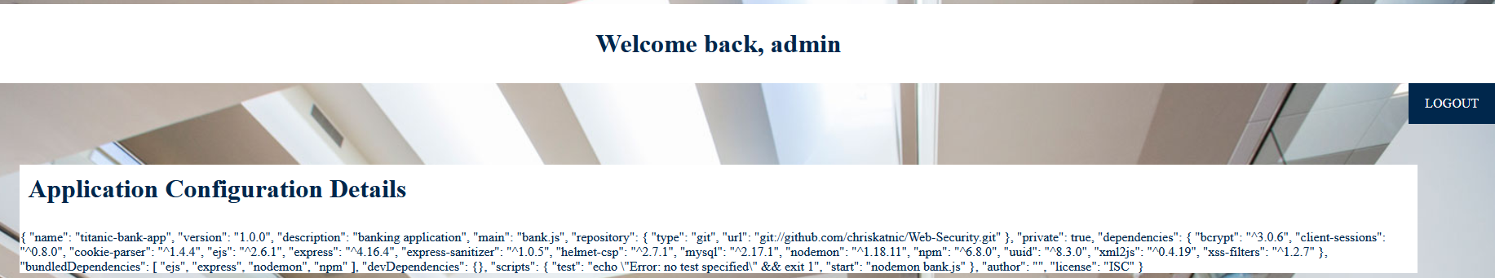

1. Log out of the application
2. Clear local cache of your web browser, or open a new private/incognito window
3. Navigate to the page /appconfig.html
4. Notice that without credentials, you may access the page via a hard link

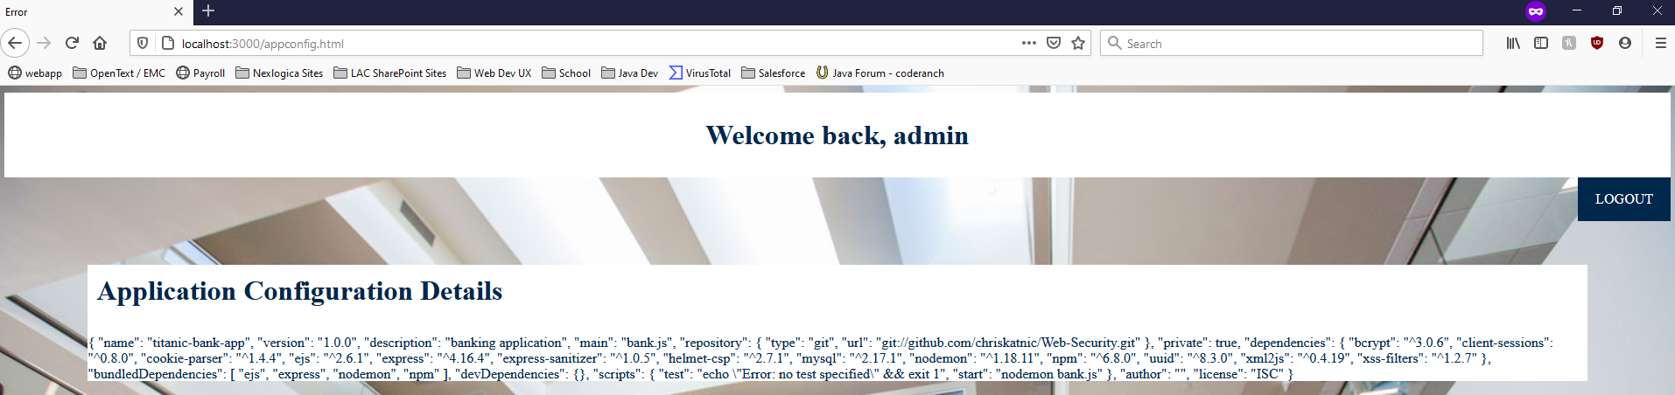

## Exercises – Bank App

1. Update the bank application to use a middleware to check the privilege level of the user before attempting to get to the appconfig page