MCSE Banana Problem

Name: R G Nithik
SRN: PES2UG24CS386
Section: G

The Website that I Scraped for this project was the Billboard Top 100 Chart
Cleaned CSV:
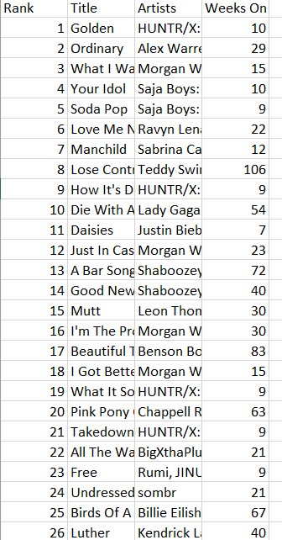
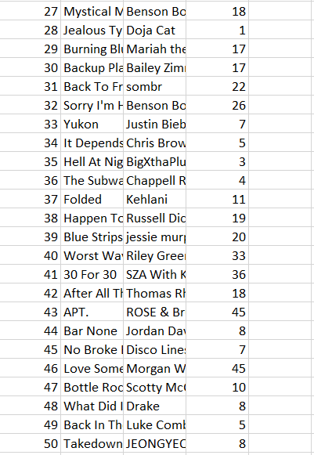
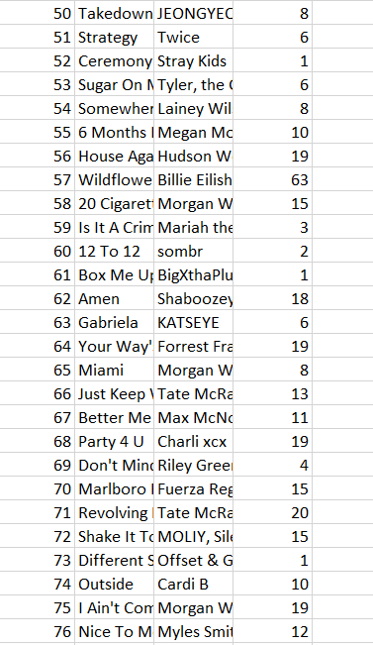
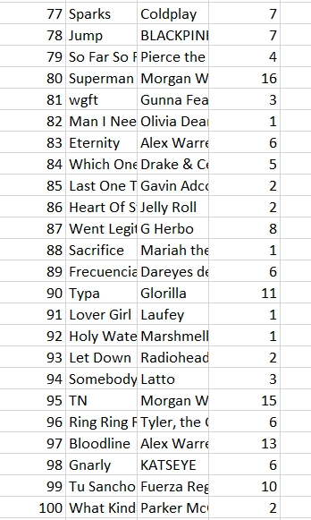
Descriptive Statistics Results:

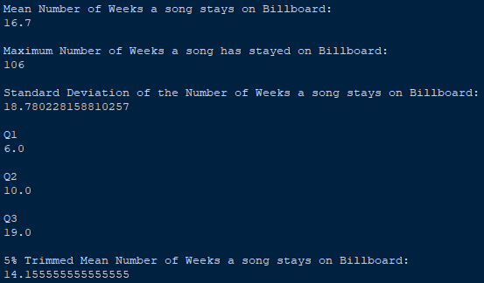

Visualization Results:
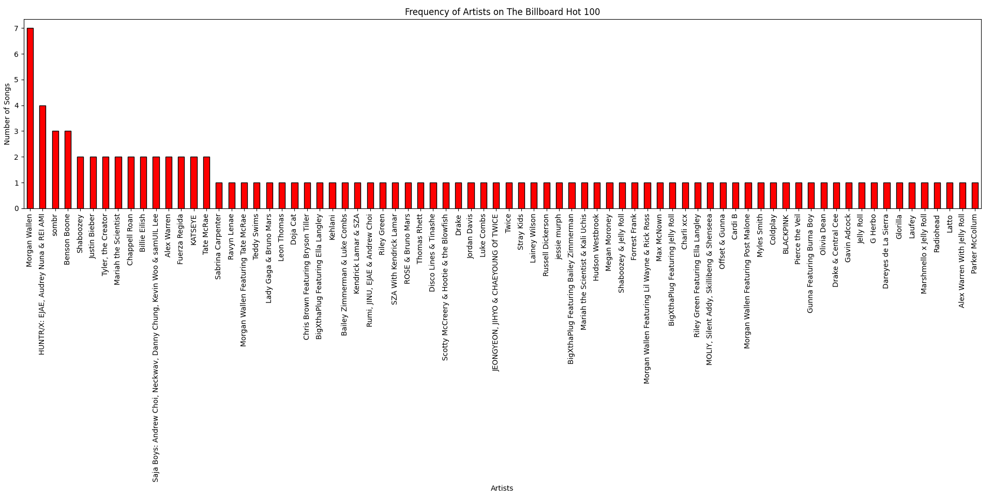
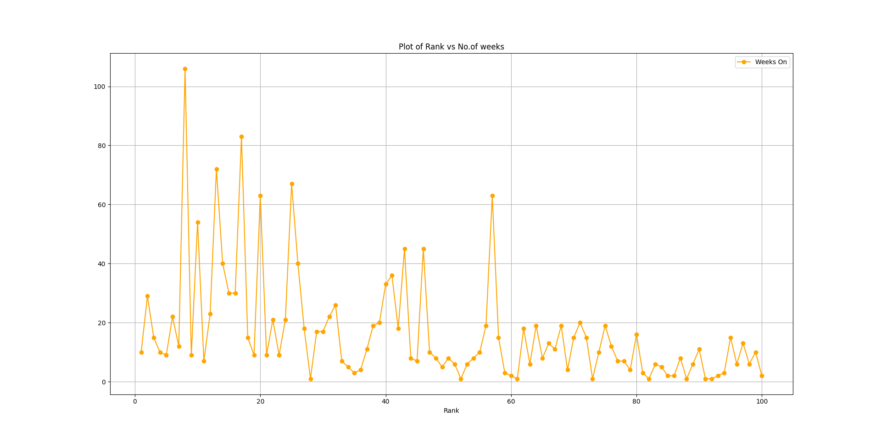

Inferences:

Looking at the frequency of artists in top 100, we can see that it is extremely hard for the same artist(s) to have multiple top 100 songs, as only 15/76 (~20%) of the artists managed to do so. The likelihood of more than 2 or 3 songs dwindles even further, with Morgan Wallen being a clear outlier.
67% of the artists who have multiple entries in the top 100 have at least one of their songs in top 25. This would imply that having one extremely popular song boosts the performance of other songs among listeners.
The plot of Rank vs Number seems counterintuitive. We see that songs that stick around in the billboard 100 do not constantly lose their position, else the frequency would be higher near the right ends. Rather, they stay very popular for a long time, and then fade away rather quickly. The end isn’t concentrated with old songs that are about to go out of fashion, but new songs that probably won’t last very long.
This fact is further reinforced by observing that most songs in the top 20 (15/20 or 75%) have once placed rank 5 or higher.
The fact that 67% of the artists who have multiple entries in the top 100 have at least one of their songs in top 25 coupled with the minimal number of weeks a lower ranking song stays on the billboard also suggests the fact that the popularity of an artist may be significantly boosted by an extremely successful song, even more so than many successful songs as one extremely successful usually leads to a higher number of lesser but still successful songs

Looking at the mean and standard deviation of number of weeks a song stays on the billboard, we tend to conclude that the distribution does not approach a value and is quite spread out. This means that there is no general timeline to an artist’s relevance and it depends upon the initial performance of the song (as seen earlier, higher the rating of the song, more the weeks it stays on billboard)

Comparing mean with the trimmed mean leads to a significant dip in the mean, pointing to obvious outliers in the higher regions (Lose Control).
The difference between Q3 and the Highest value also points to the same (87).
One could infer that one song usually stays very popular and for a very long time, till it is replaced with the next one. However, this inference remains untested without first analysing the data from multiple time frames.

