

A Project Report On

**Tourism Guide System**

**By**

**Nitu Choudhary**

**Batch:** 2021 – 6308

**Post Graduate Certification in Python and Ruby on Rails**

Under the Guidance of,

**Jayant V.**

**Technical Trainer**

**EduBridge**

(School of coding)

## Introduction:

**DressUp**allows people to buy and sell physical goods, services, and digital products over the internet rather than at a brick-and-mortar location**.** Through this website, a business can process orders, accept payments, manage shipping and logistics, and provide customer service.

 Our Project Include **Modules:-**

* Admin Module
* User Module
* Cart Module

I have developed this Application in **Python and Django.** It’s a web-based projects so I have used **HTML, CSS, JavaScript and Bootstrap also**.

The main feature of the project is to make shopping easier. You can access this website from anywhere and everywhere.

In Admin module, admin can add the Category and Products in the specific category. He can also view the total number of users at present in the website. And category and product details also. Admin can only see the admin page and cart if he wants to order something.

In User module, user can access the website and buy products and products to cart and buy and shuffle by category. New user can register and login after that to shop. In Cart, admin and user both can access, they can add the products and buy if they want.

**Software Requirements:**

**Front end:** HTML, CSS, JavaScript, Bootstrap.

**Back end**: Python, Django.

**Browser:** Best result on Google Chrome

**Operating System:** Window 10

# Screenshots:-

## Home Page:

## 

## 

## Products (Dropdown) page:

## 

**Login Page:**

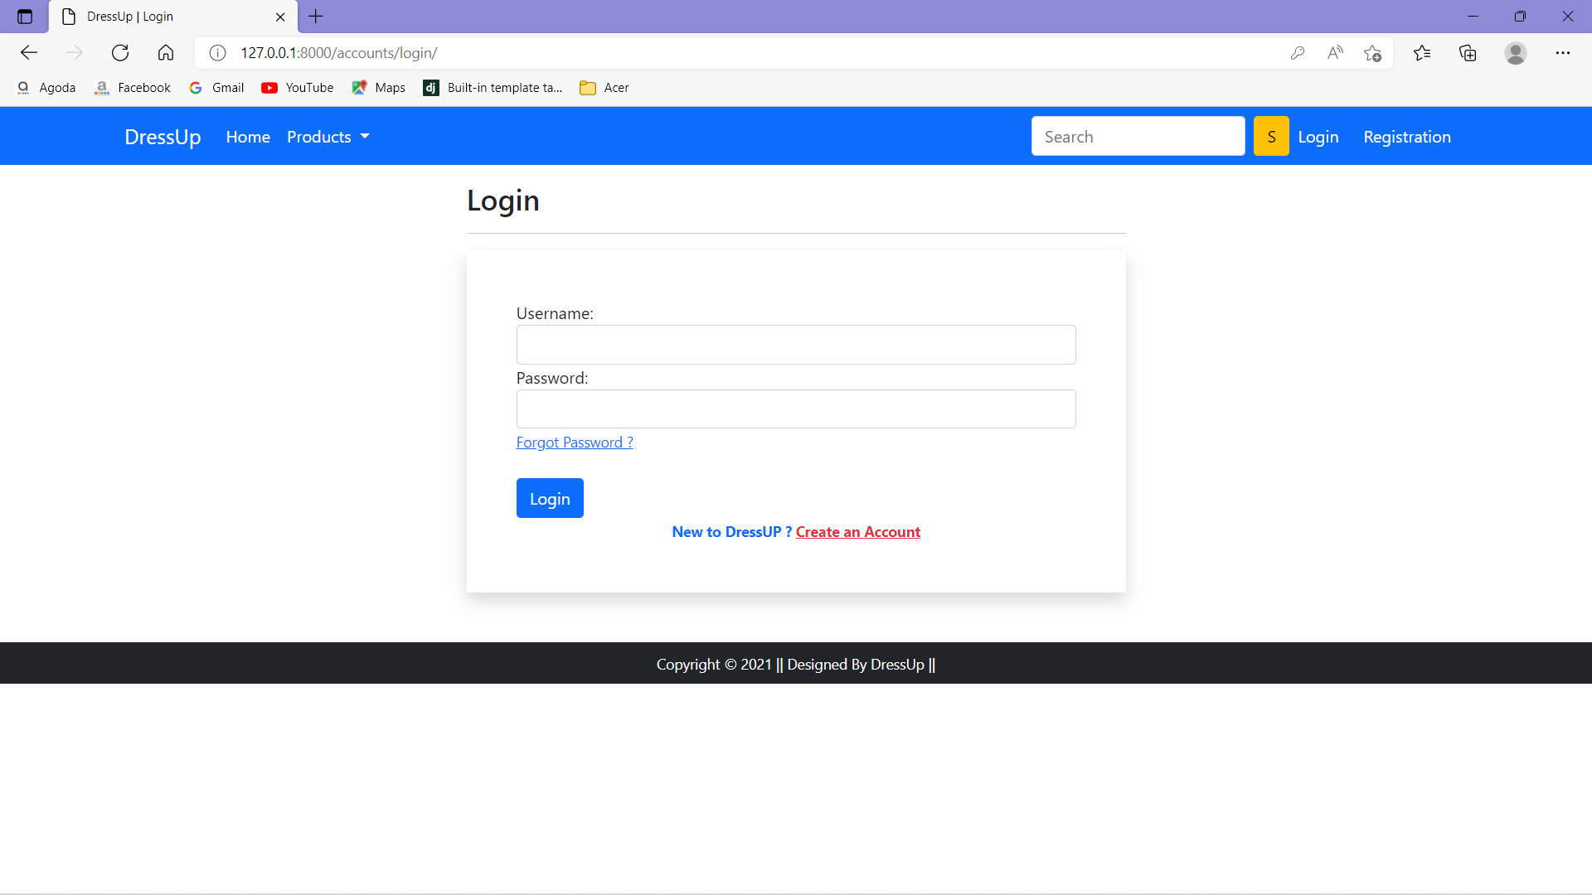

**Register Page:**

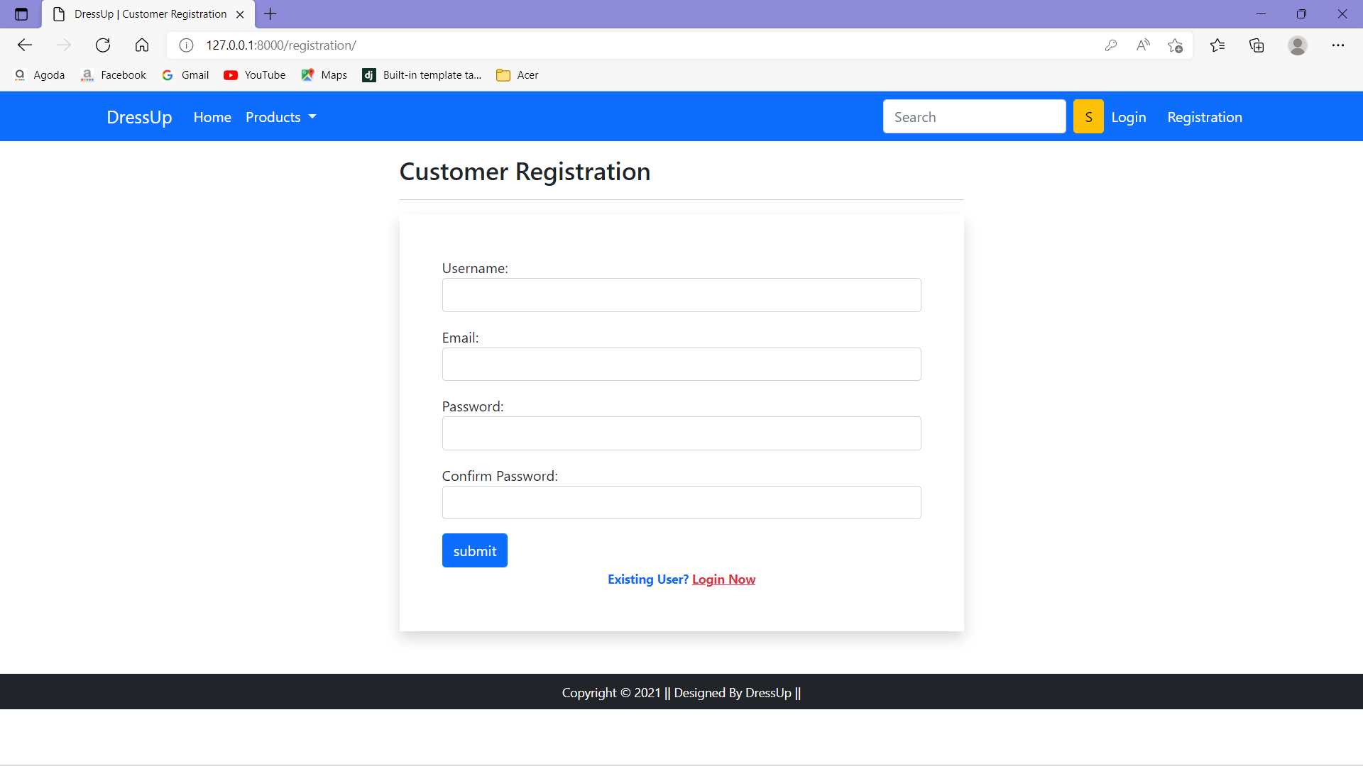

**Registering Done:**

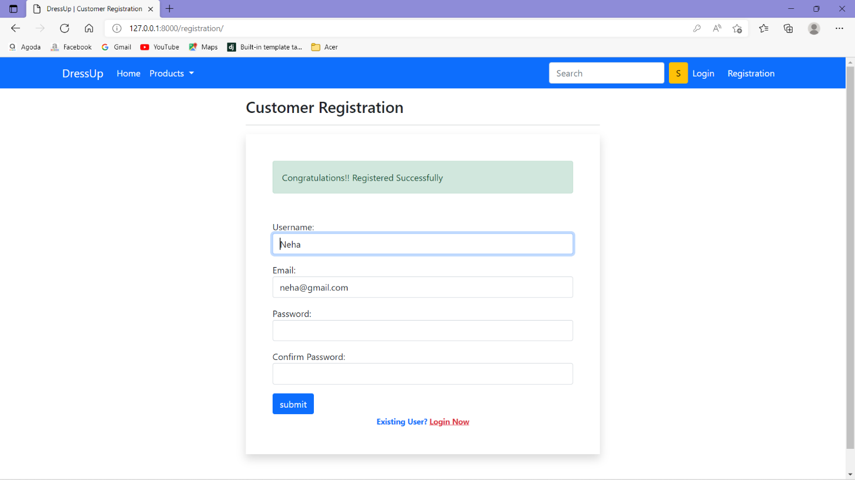

**Change Password Page.**

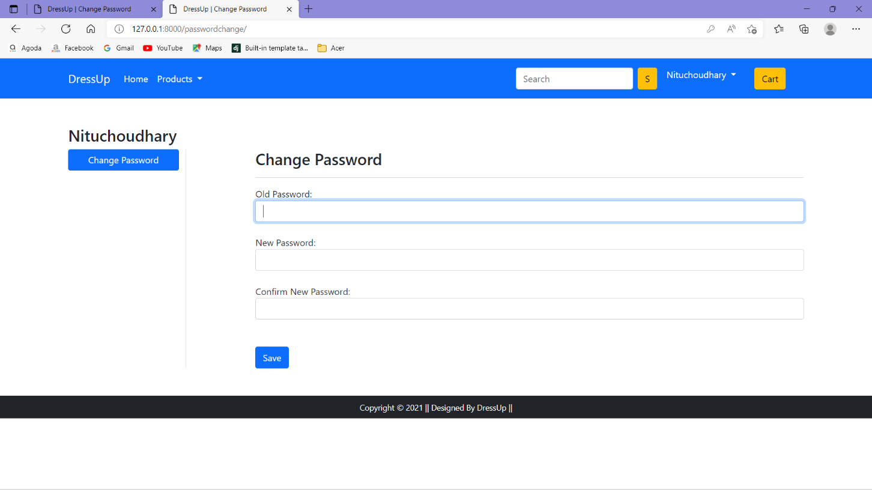

**Change Password Done Page.**

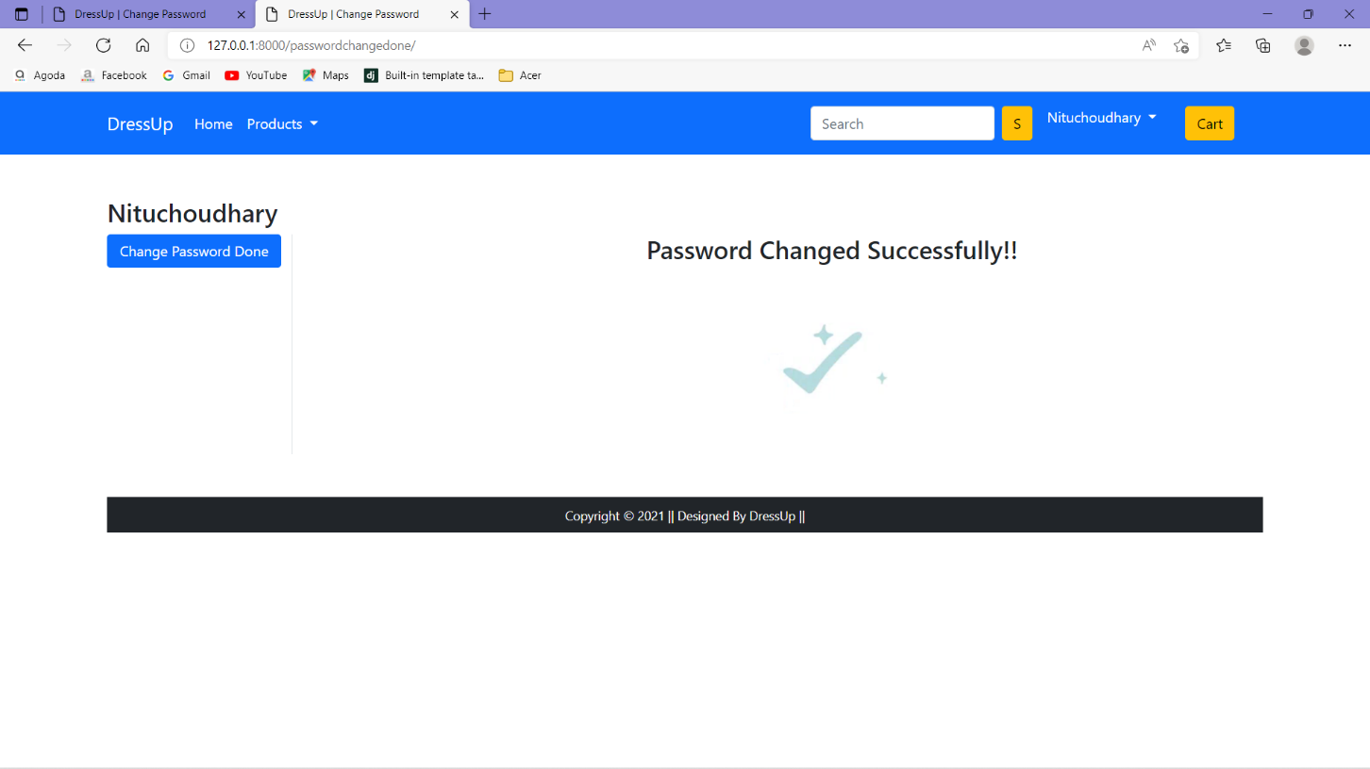

**Profile Page:**

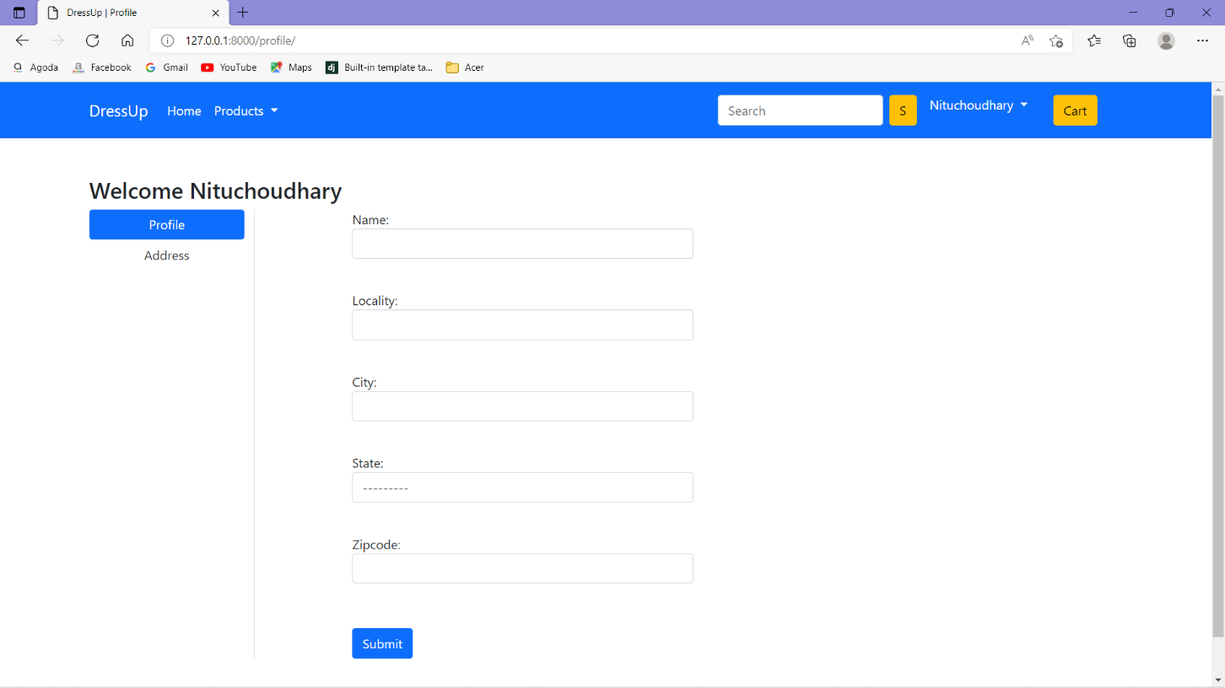

**Address Page:**

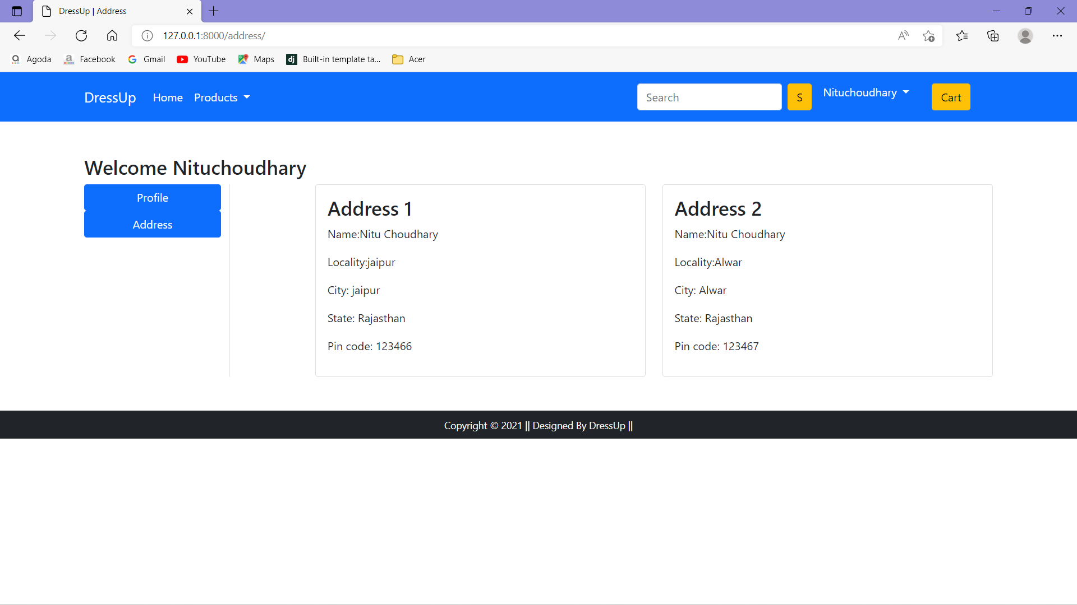

**Product-Detail Page:**

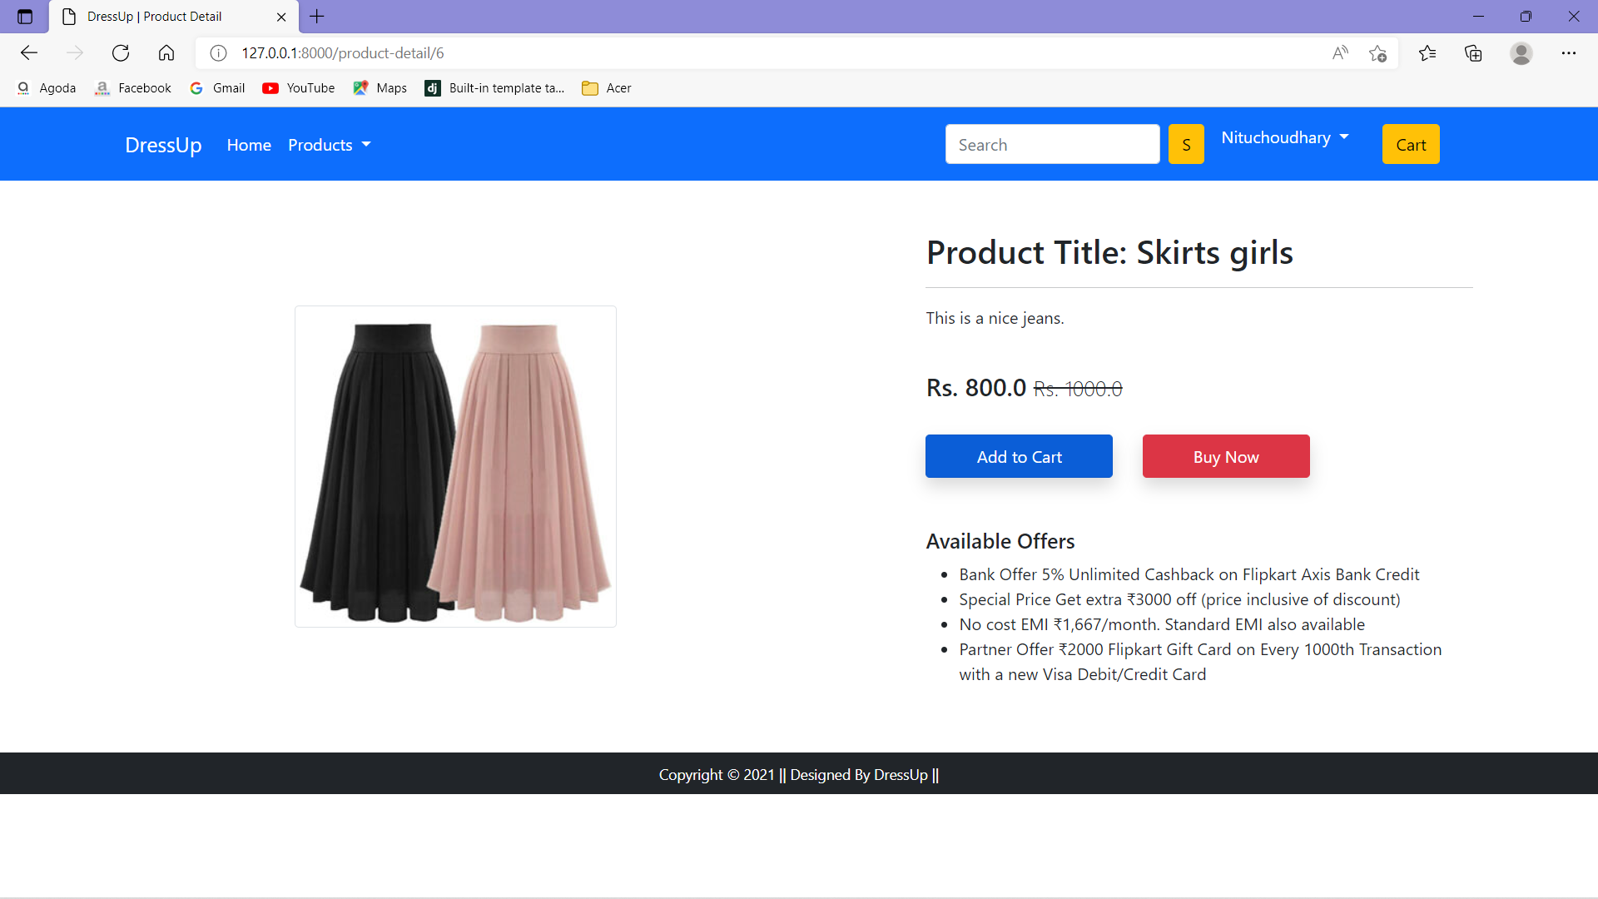

**Add to Cart Page:**

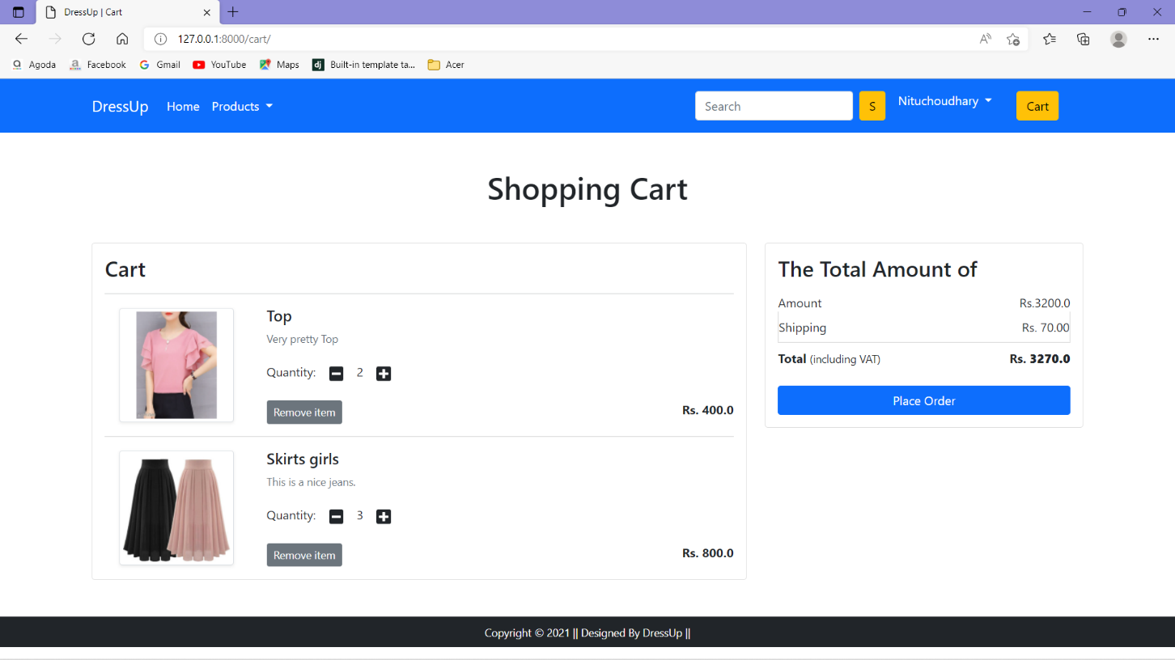

**Checkout Page:**

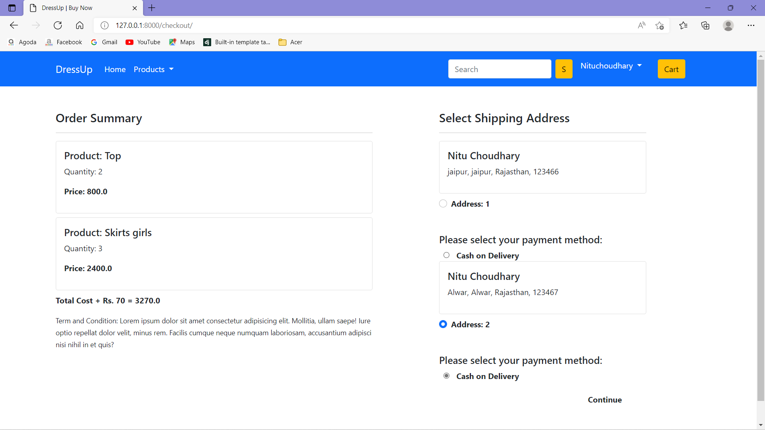

**Order-Status Page:**

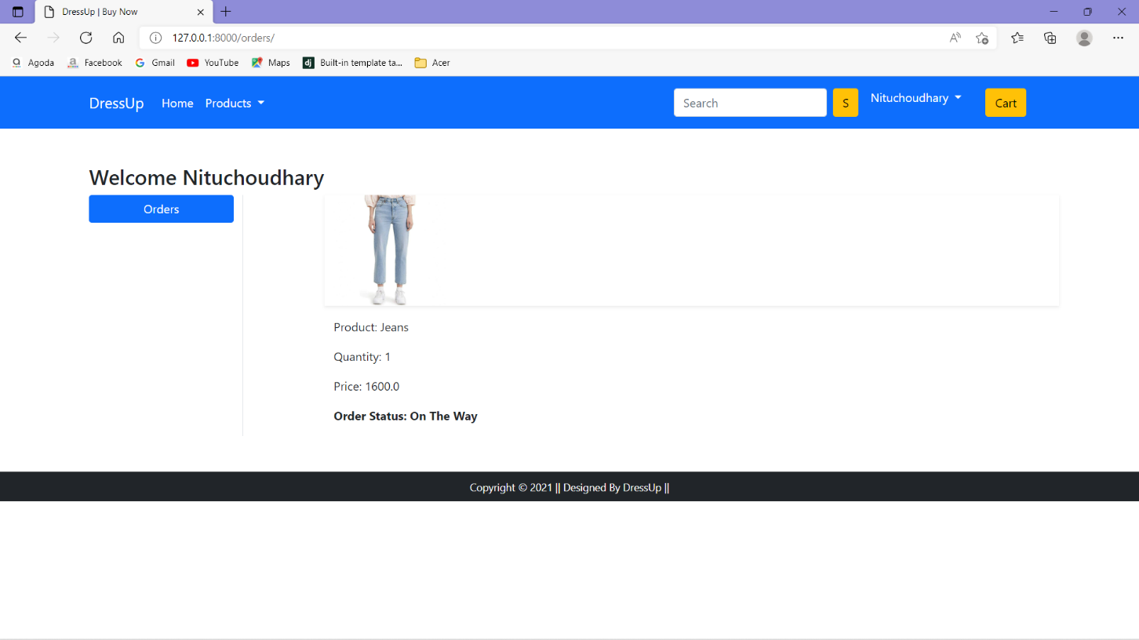

**Data Added in Database SuccessFully:**

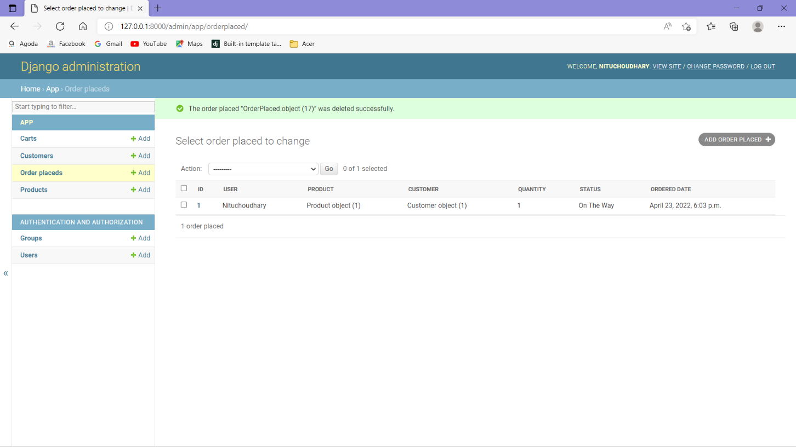

**Thank you**