Exercise 4
Date:12|10|2020
Aim:
To write a python program (function) to print a single string from two set of strings received from user and swap the first two characters of each string.
Program:
def convert(s):
new=""
for x in s:
new+=x
return new

a=input()
b=input()
s1=a.strip()
s2=b.strip()
if(len(s1)>=2 and len(s2)>=2):
t1=list(s1)
t2=list(s2)
c1=t1[0]
c2=t1[1]
t1[0]=t2[0]
t1[1]=t2[1]
t2[0]=c1
t2[1]=c2
s1=convert(t1)
s2=convert(t2)
print(s1," ",s2)
else:
print("invalid")
Link:
http://103.53.53.18/mod/vpl/forms/submissionview.php?id=234&userid=1790
Output:
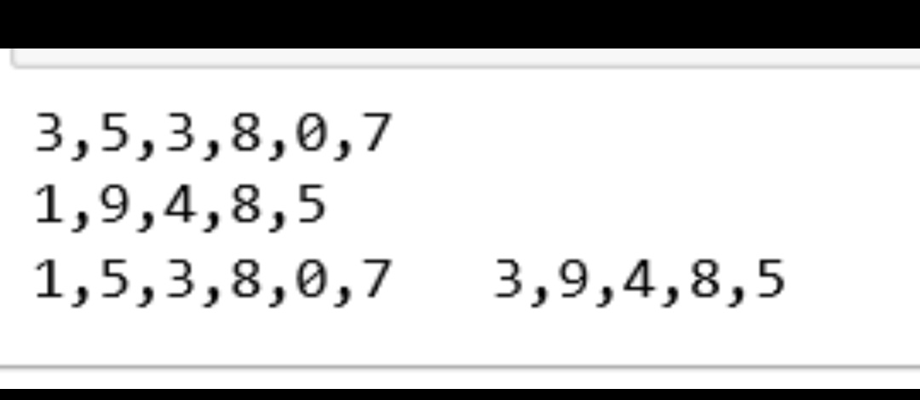
Result:
The output of the program has been obtained successfully.

