Exercise 14
Date:21|11|2020

Aim:
To write a Python class to find validity of a string of parentheses, '(', ')', '{', '}', '[' and '].

Program:
def areBracketsBalanced(expr):
stack = []
for c in expr:
if c in ["(","{","["]:
stack.append(c)
else:
if not stack:
return False
current_c = stack.pop()
if current_c =="(":
if c!=")":
return False
if current_c == "{":
if c!="}":
return False
if current_c == "[":
if c!="]":
return False
if stack:
return False
return True
if __name__ == "__main__":
expr = input("input:")
if areBracketsBalanced(expr):
print("Output: Valid")
else:
print("Output: Invalid")

Link:
http://103.53.53.18/mod/vpl/view.php?id=327

Output:
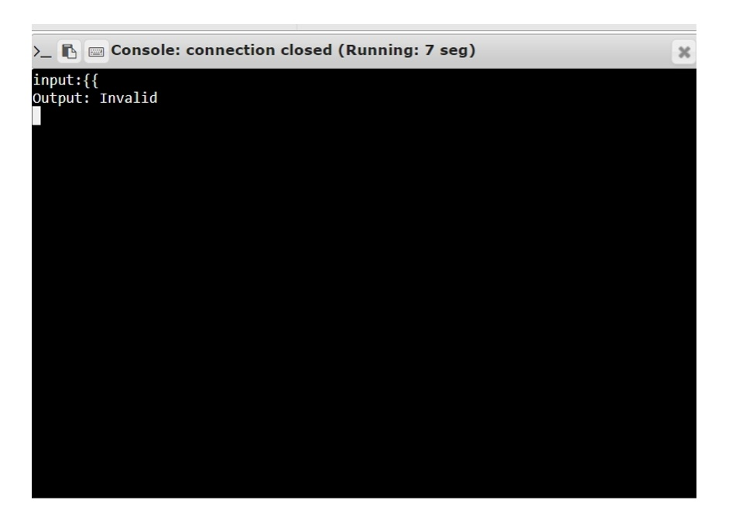

Result:
The output of the program has been obtained successfully.

