Exercise 3
Date:12|10|2020
Aim:
To write a python program to remove and print every second number from a list of numbers until the list becomes empty.
Program:
def removethirdnumber(int_list):
index=0
position=(2-1)
for i in range(0,len(int_list)):
index=(position+index)%len(int_list)
print(int_list[index])
int_list.pop(index)

n=int(input())
list=[]
for i in range(0,n):
a=int(input())
list.append(a)
removethirdnumber(list)
Link:
http://103.53.53.18/mod/vpl/view.php?id=231&userid=1790
Output:
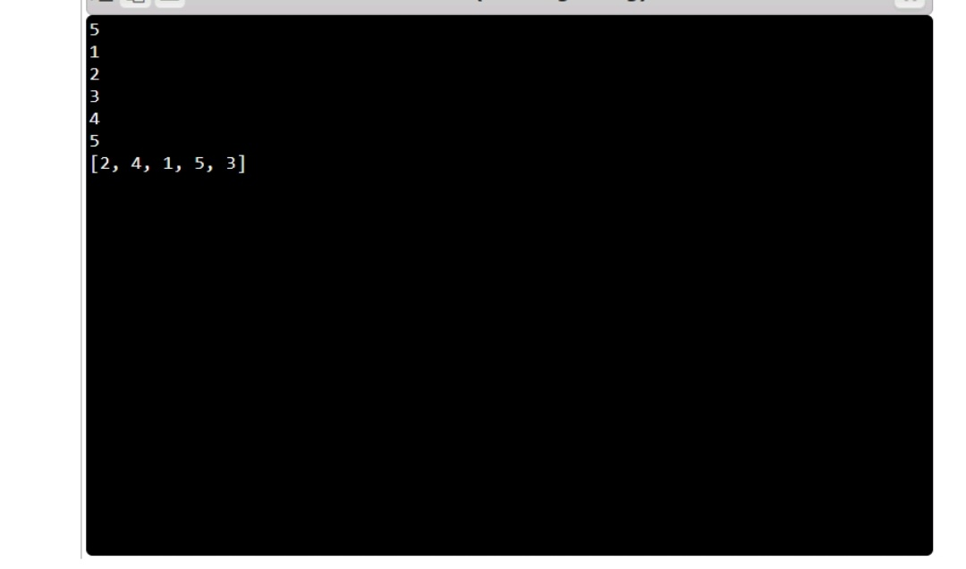
Result:
The output of the program has been obtained successfully.

