Exercise 1
Date:12|10|2020

Aim:
To write a python program to print the calendar of a given month and year.
Program:
import calendar
year=int(input())
month=int(input())
if((year<10000 and year>999) and (month<13 and month>0)):
print(calendar.month(year,month))
else:
print("Invalid Input:")

Link:
http://103.53.53.18/mod/vpl/forms/edit.php?id=229&userid=1790
Output:
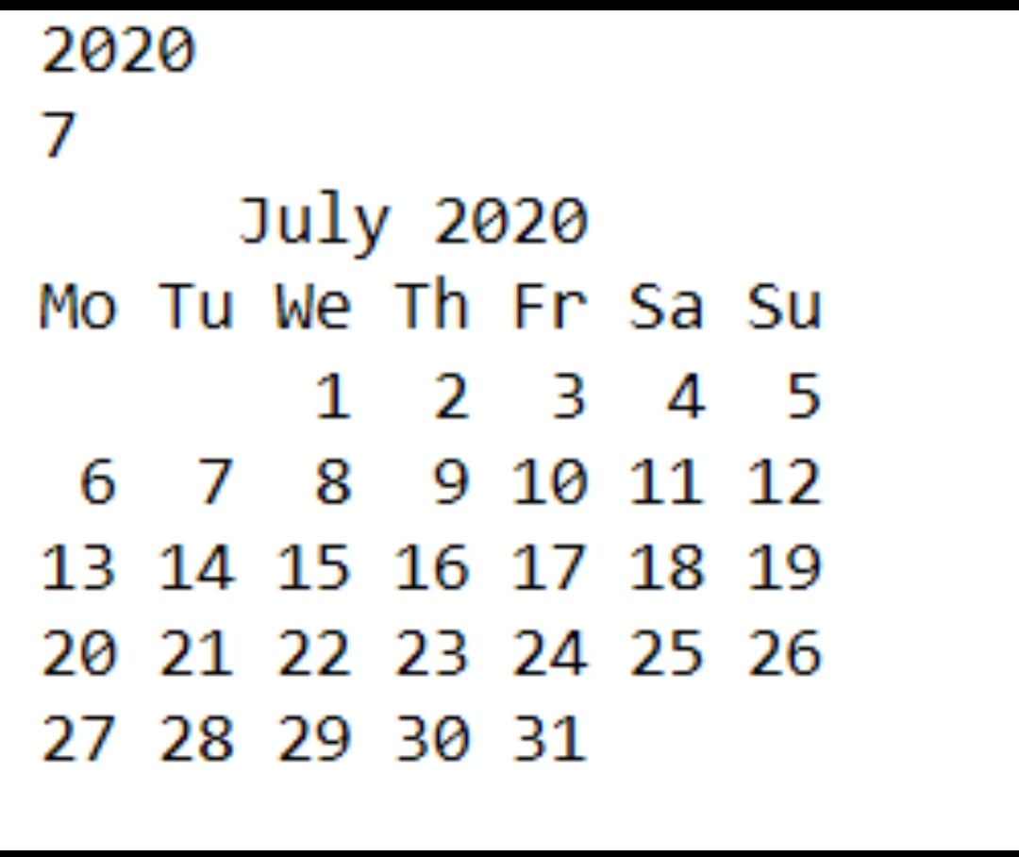

Result:
The expected output is obtained successfully.

