Exercise 5
Date:13|10|2020

Aim:
To write a python function to print missing characters to make string pangram.

PROGRAM:

a=input()
a=set(a.strip())
a.remove(chr(32))
b="abcdefghijklmnopqrstuvwxyz"
b=set(b)
b=b.difference(a)
b=list(b)
b.sort()
print("".join(b))

LINK:
http://103.53.53.18/mod/vpl/view.php?id=235&userid=1790
Output:
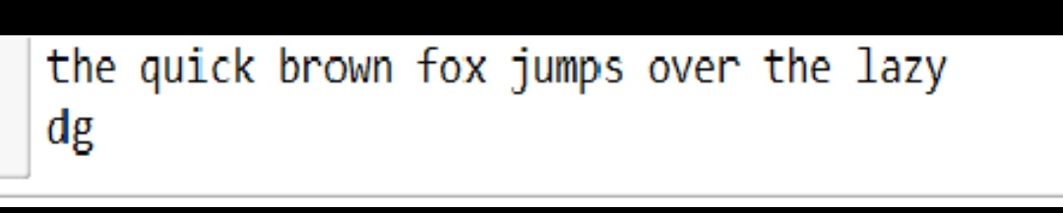
Result:
The output has been obtained successfully.

