Exercise 2
Date :12|10|2020

Aim:
To write a python function countX(lst,x) to count the number x in a given list of numbers.
Program:
def countX(lst,x):
count=0
for num in lst:
if(num==x):
count=count+1
return count

n=int(input())
lst=[]
for i in range(0,n):
a=int(input())
lst.append(a)

x=int(input())
result=countX(lst,x)
print(result)
Link:
http://103.53.53.18/mod/vpl/forms/edit.php?id=230&userid=1790

Output:

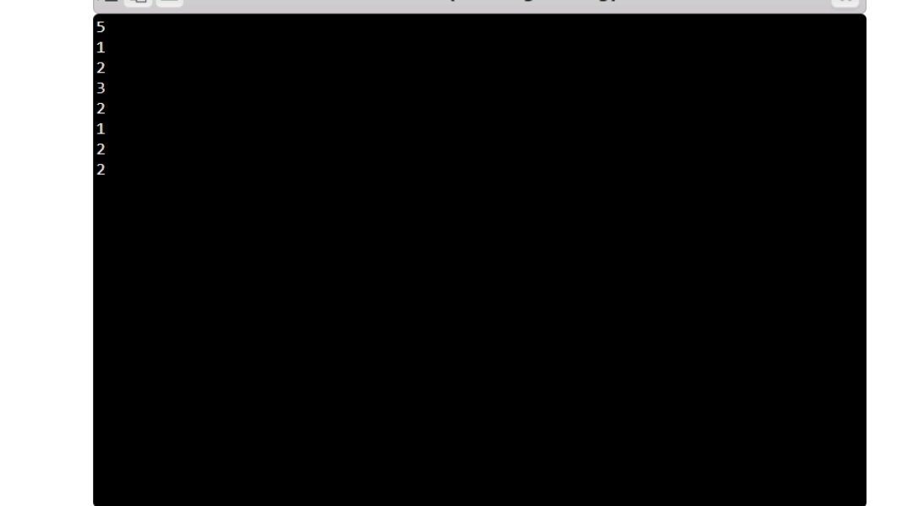
Result:
The expected output has been obtained successfully.

