Exercise 10
Date :21|11|2020

Aim:
To write a python function that accepts a string and calculate the number of upper case letters and lower case letters.

Program:
def string(s):
d={"UPPER_CASE":0,"LOWER_CASE":0}
for c in s:
if c.isupper():
d["UPPER_CASE"]+=1
elif c.islower():
d["LOWER_CASE"]+=1
else:
pass
print("No. of Upper case characters: ",d["UPPER_CASE"])
print("No. of Lower case characters: ",d["LOWER_CASE"])
s=input()
string(s)

LINK:
http://103.53.53.18/mod/vpl/view.php?id=325

Output:
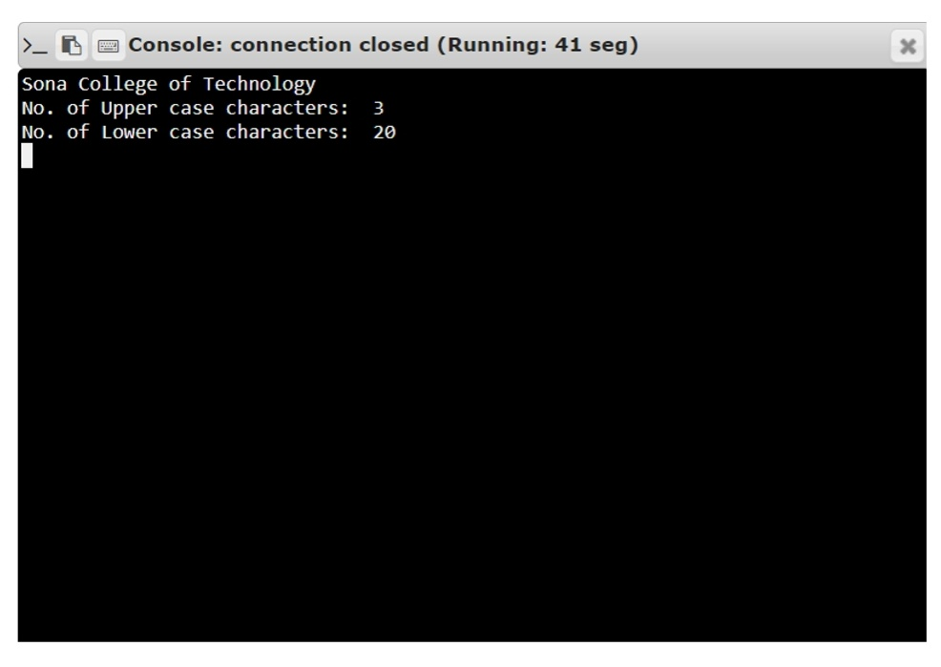

Result:
The output of the program has been obtained successfully.

