Exercise 11
Date :21|11|2020

Aim:
To write a Python program to find the greatest common divisor (GCD) of two integers using recursion.
Program:
def gcd(a,b):
if(b==0):
return a
else:
return gcd(b,a%b)
a = int(input("Enter first number: "))
b = int(input("Enter second number: "))
GCD = gcd(a,b)
print("GCD is: ")
print(GCD)

Link:
http://103.53.53.18/mod/vpl/view.php?id=326
Output:
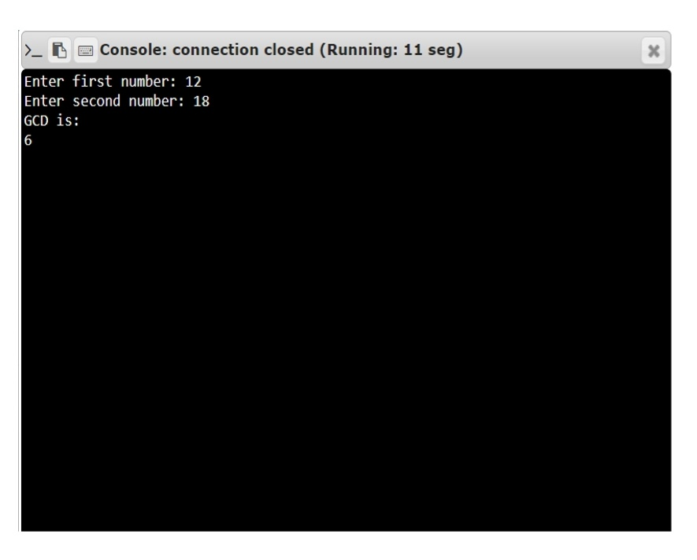
Result:
The output of the program has been obtained successfully.

