Implement a custom dynamic array class that supports basic operations like insertion, deletion, resizing, and clearing.

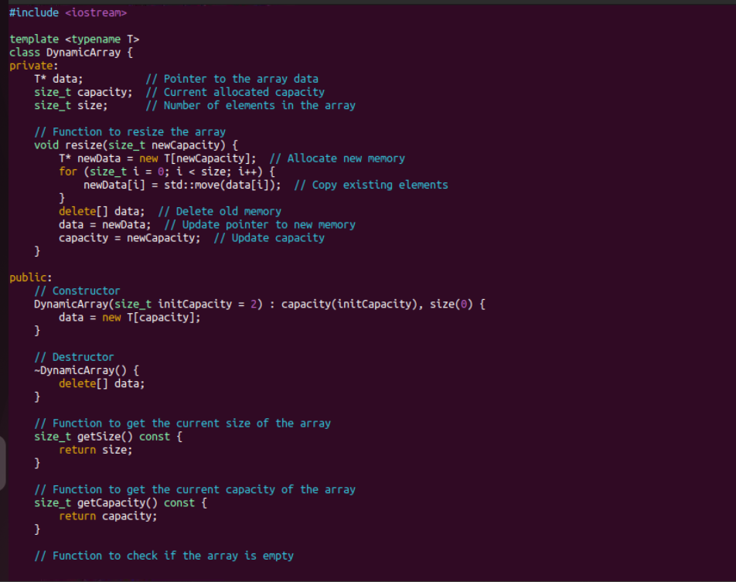

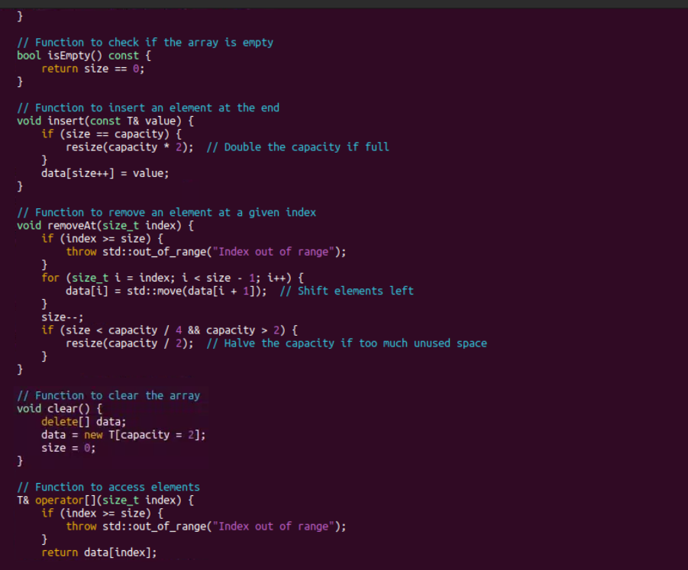

Output:

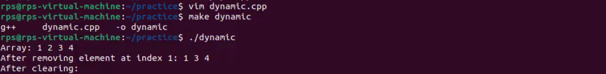

2) Create a template-based stack class supporting push, pop, and peek operations. Implement it for different data types like int, float, and std::string.

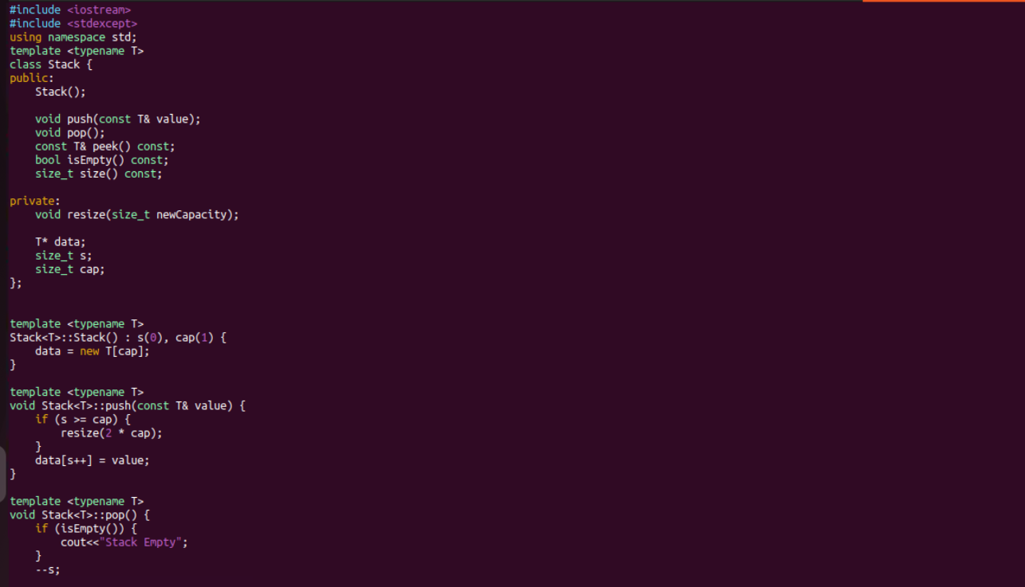

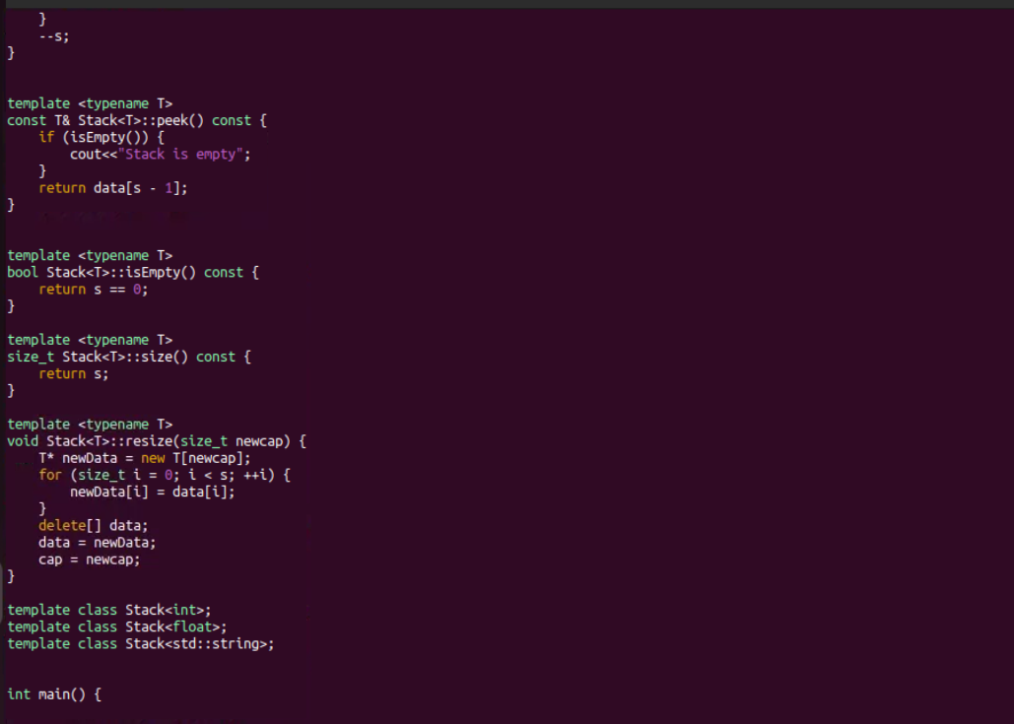

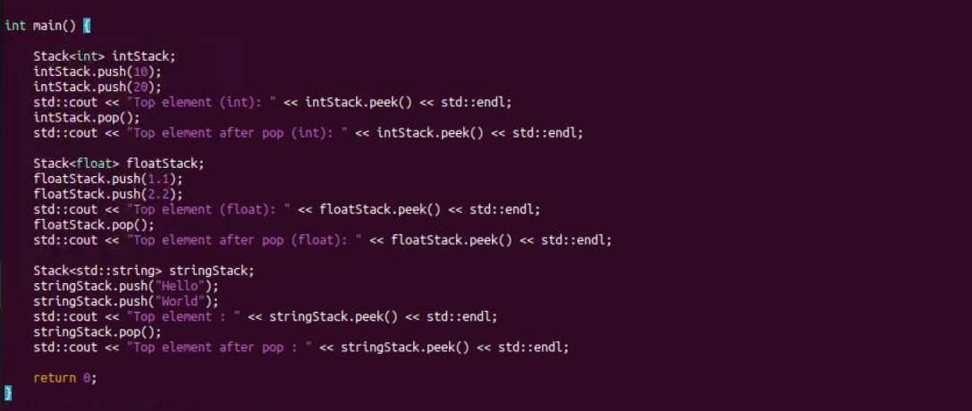

Output:

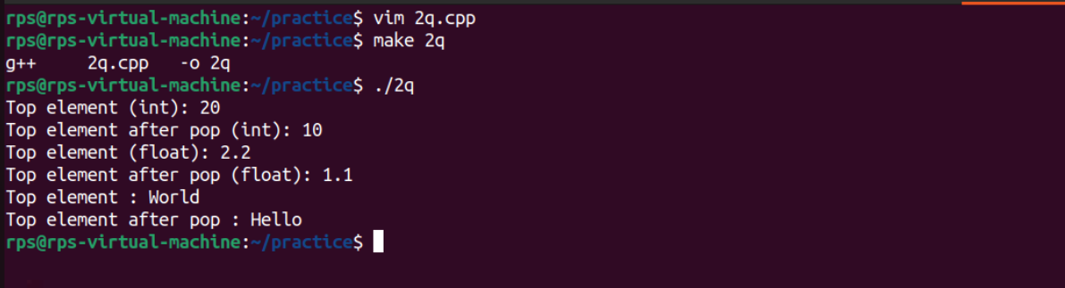

3) Write a program that reads from a file and handles various exceptions such as file not found, read errors, and unexpected data formats.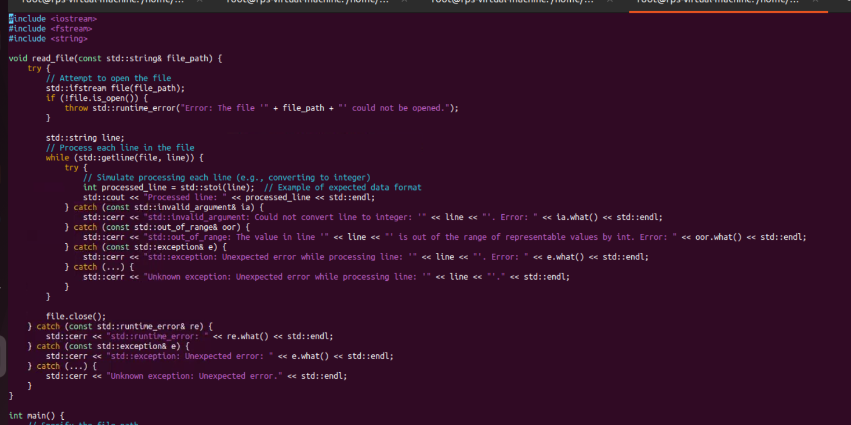

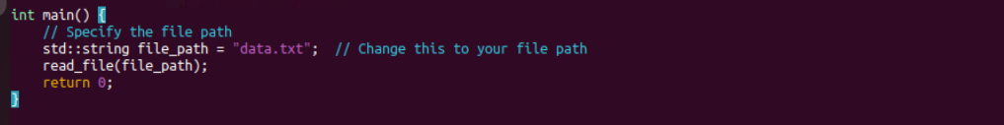

Output:

