TASK DAY_17

Commands ls show files in current position cd change directory cp copy file or directory mv move file or directory rm remove file or directory pwd show current position mkdir create directory rmdir remove directory less, more, cat display file contents man display online manual

1.ls command to list the files

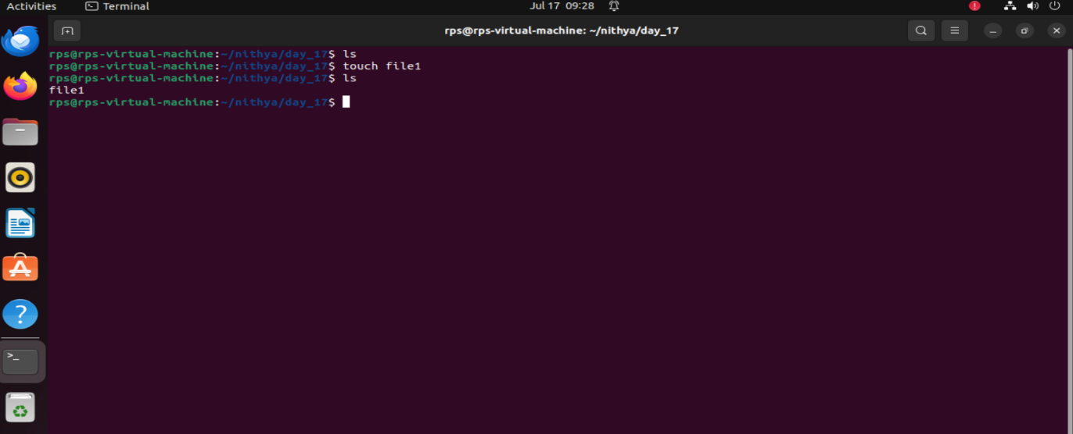

Cd command

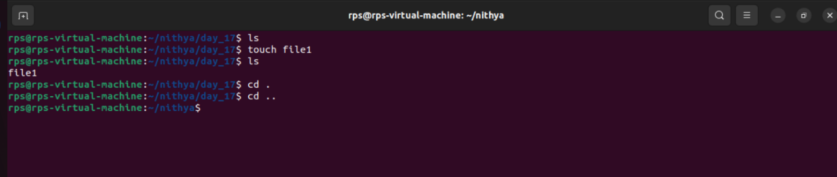

3 Cp command

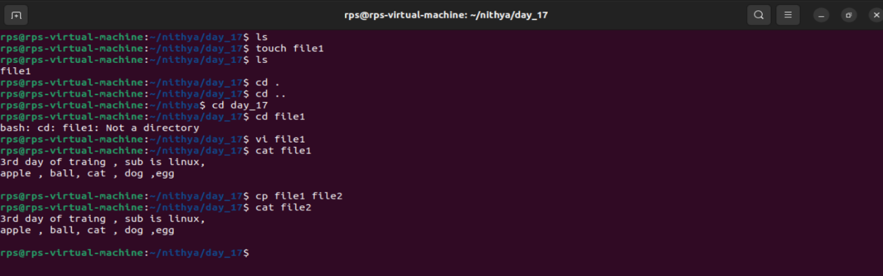

4 mv command

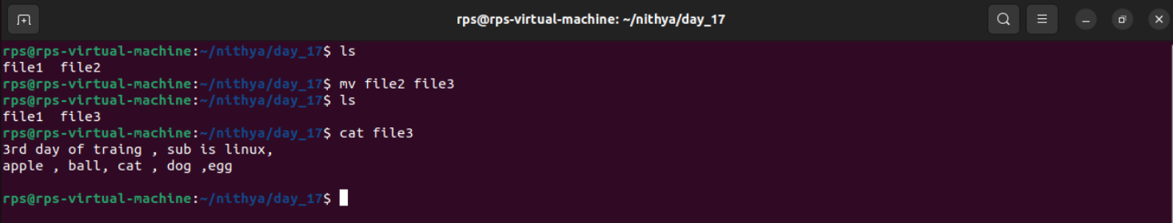

5 rm command

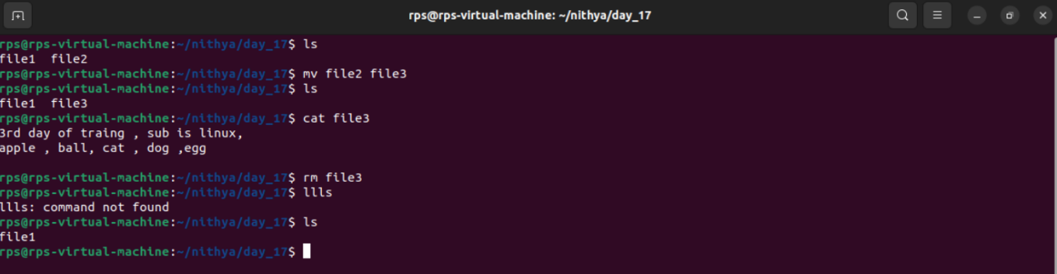

6 pwd command

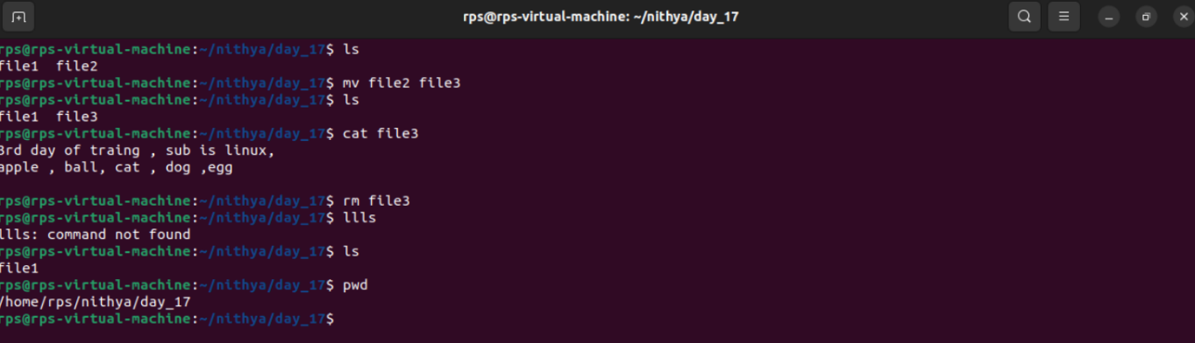

7 mkdir command

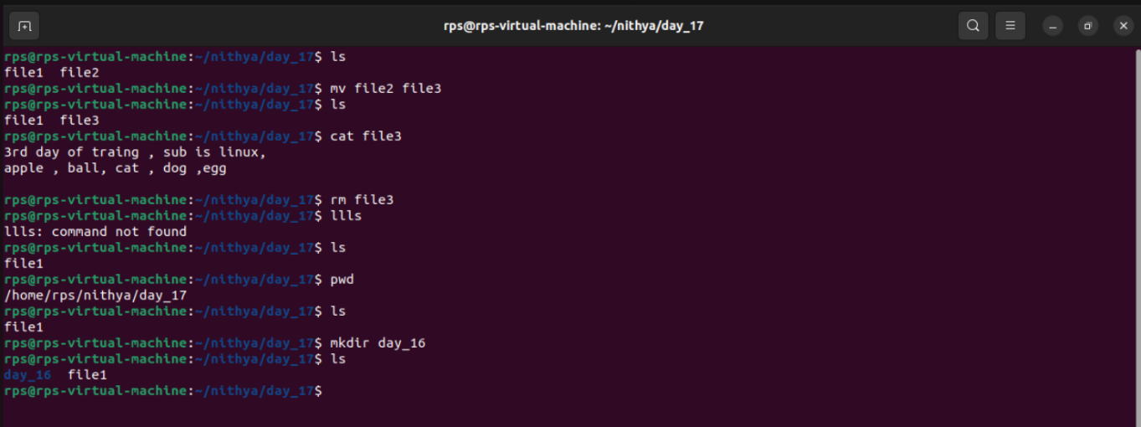

8 rmdir command

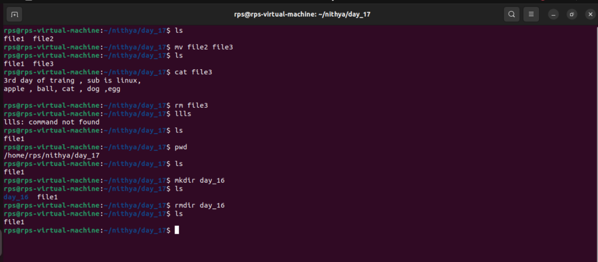

9 less command

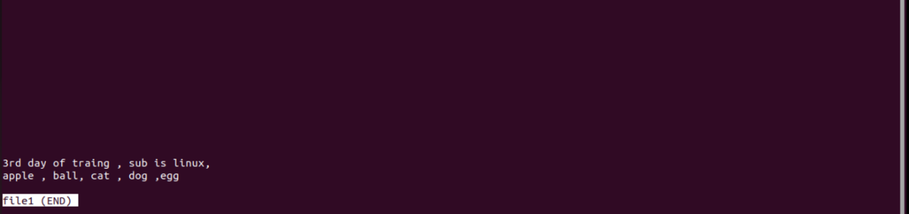

10 more command

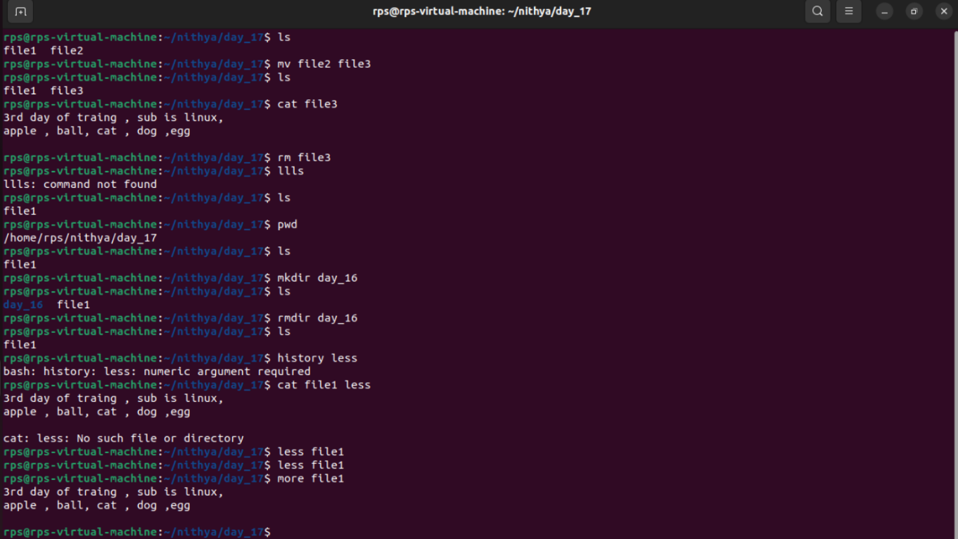

11 cat command

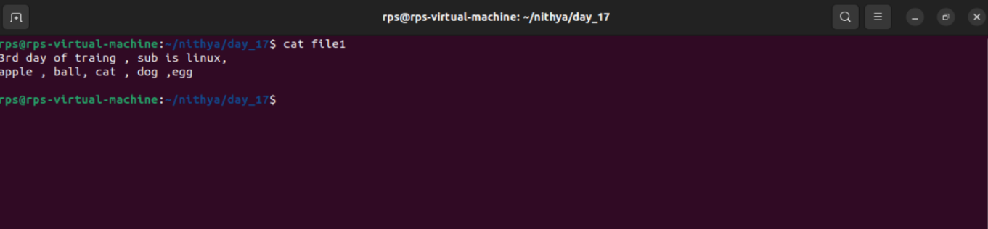

12 man command

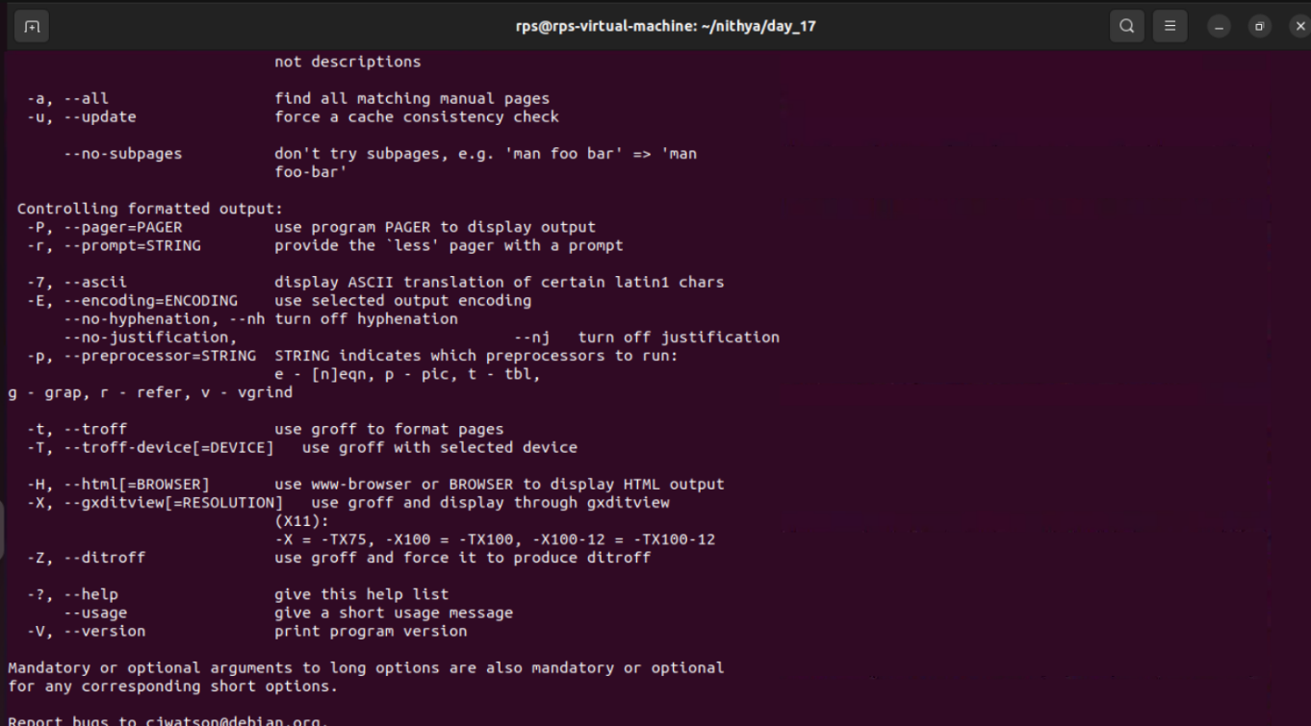

13 relative path

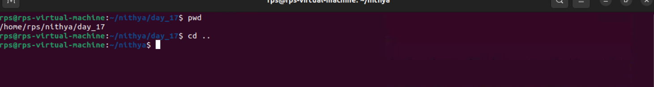

14 absolute path

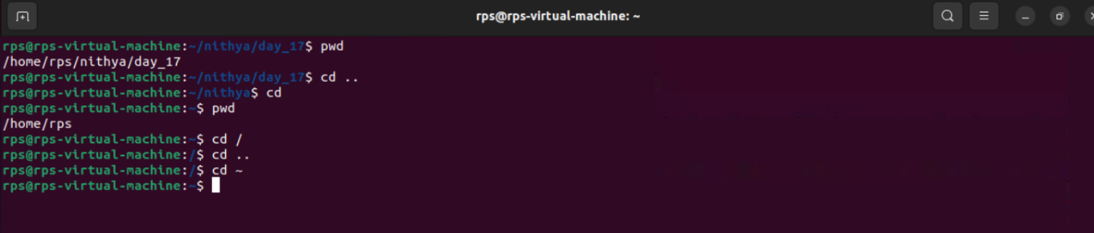

1. Type following command in your directory.

ls

ls –a

ls –la

ls -Fa

• ls: Lists the files and directories in the current directory.

• ls -a: Lists all files and directories, including hidden ones (those starting with a dot).

• ls -la: Lists all files and directories, including hidden ones, in long format, showing detailed information like permissions, number of links, owner, group, size, and modification date.

• ls -Fa: Lists all files and directories, including hidden ones, and adds a trailing / for directories, * for executables, and @ for symbolic links.

