SupersetId-6419073
WEEK 8 - GIT
1.Git-HOL
Git commands like git init, git status, git add, git commit, git push, and git pull.
create a new repository, signup with GitLab and register your credentials
Login to GitLab and create a “GitDemo” project
Step 1: Setup your machine with Git Configuration
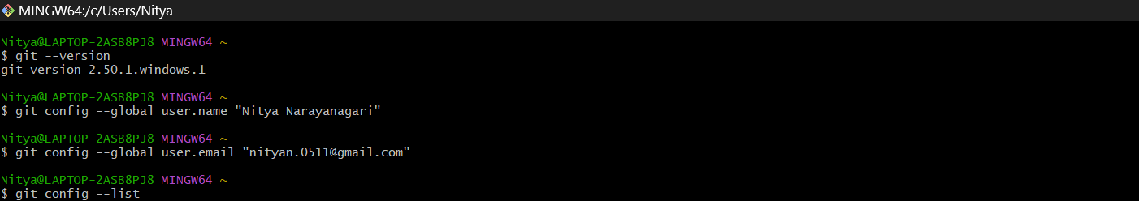
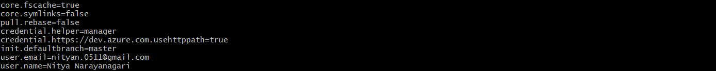
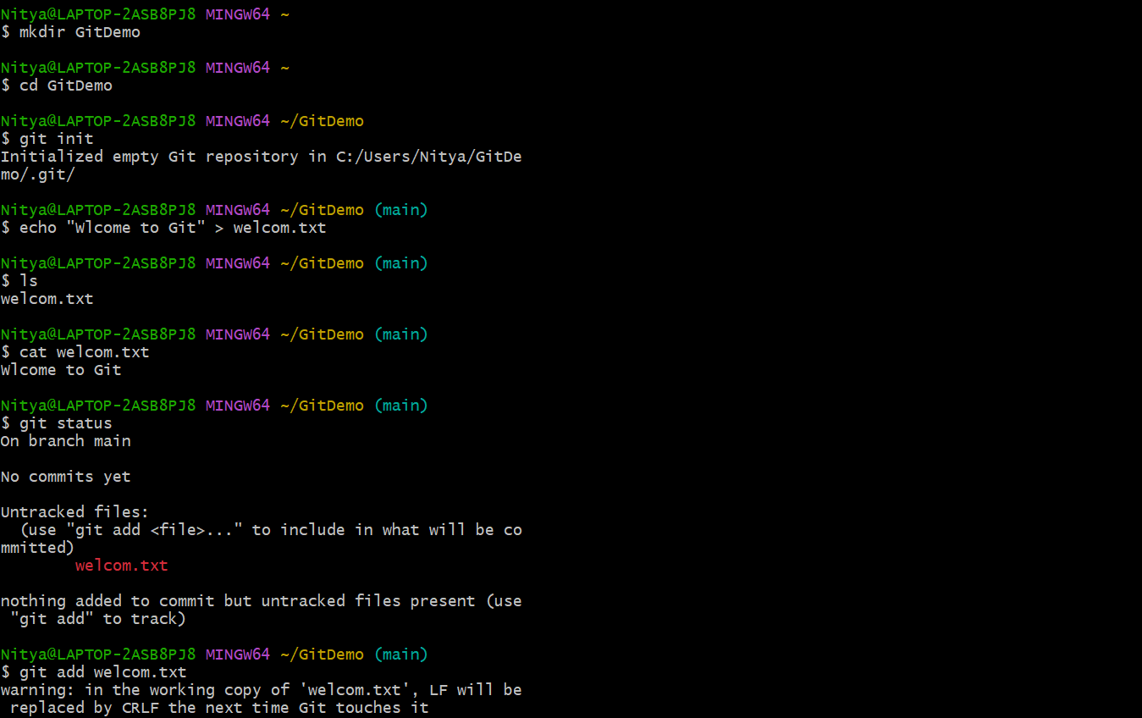
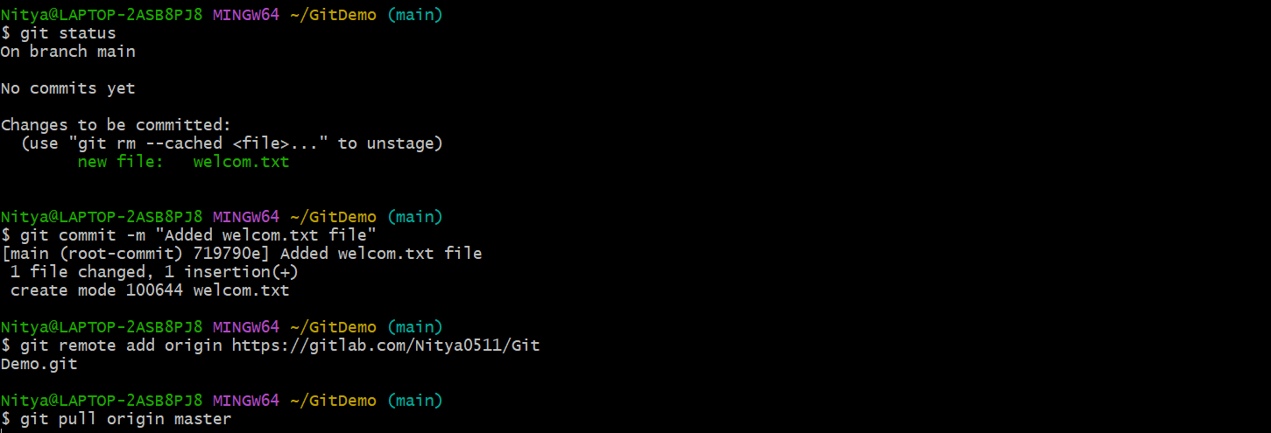
Step 2: Integrate notepad++.exe to Git and make it a default editor
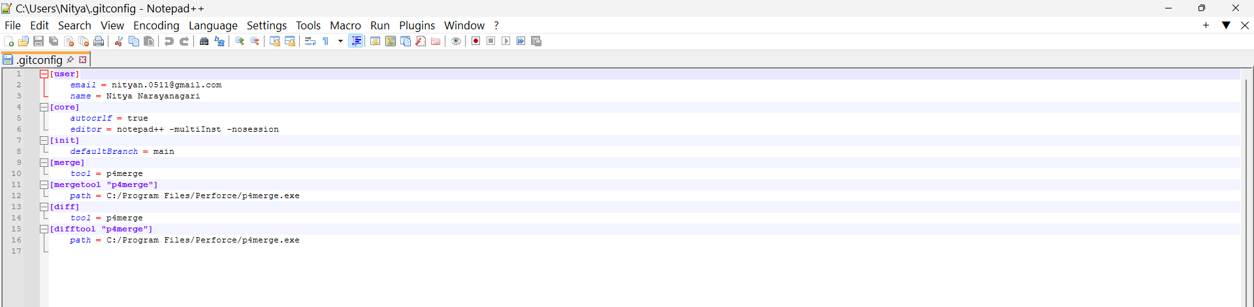
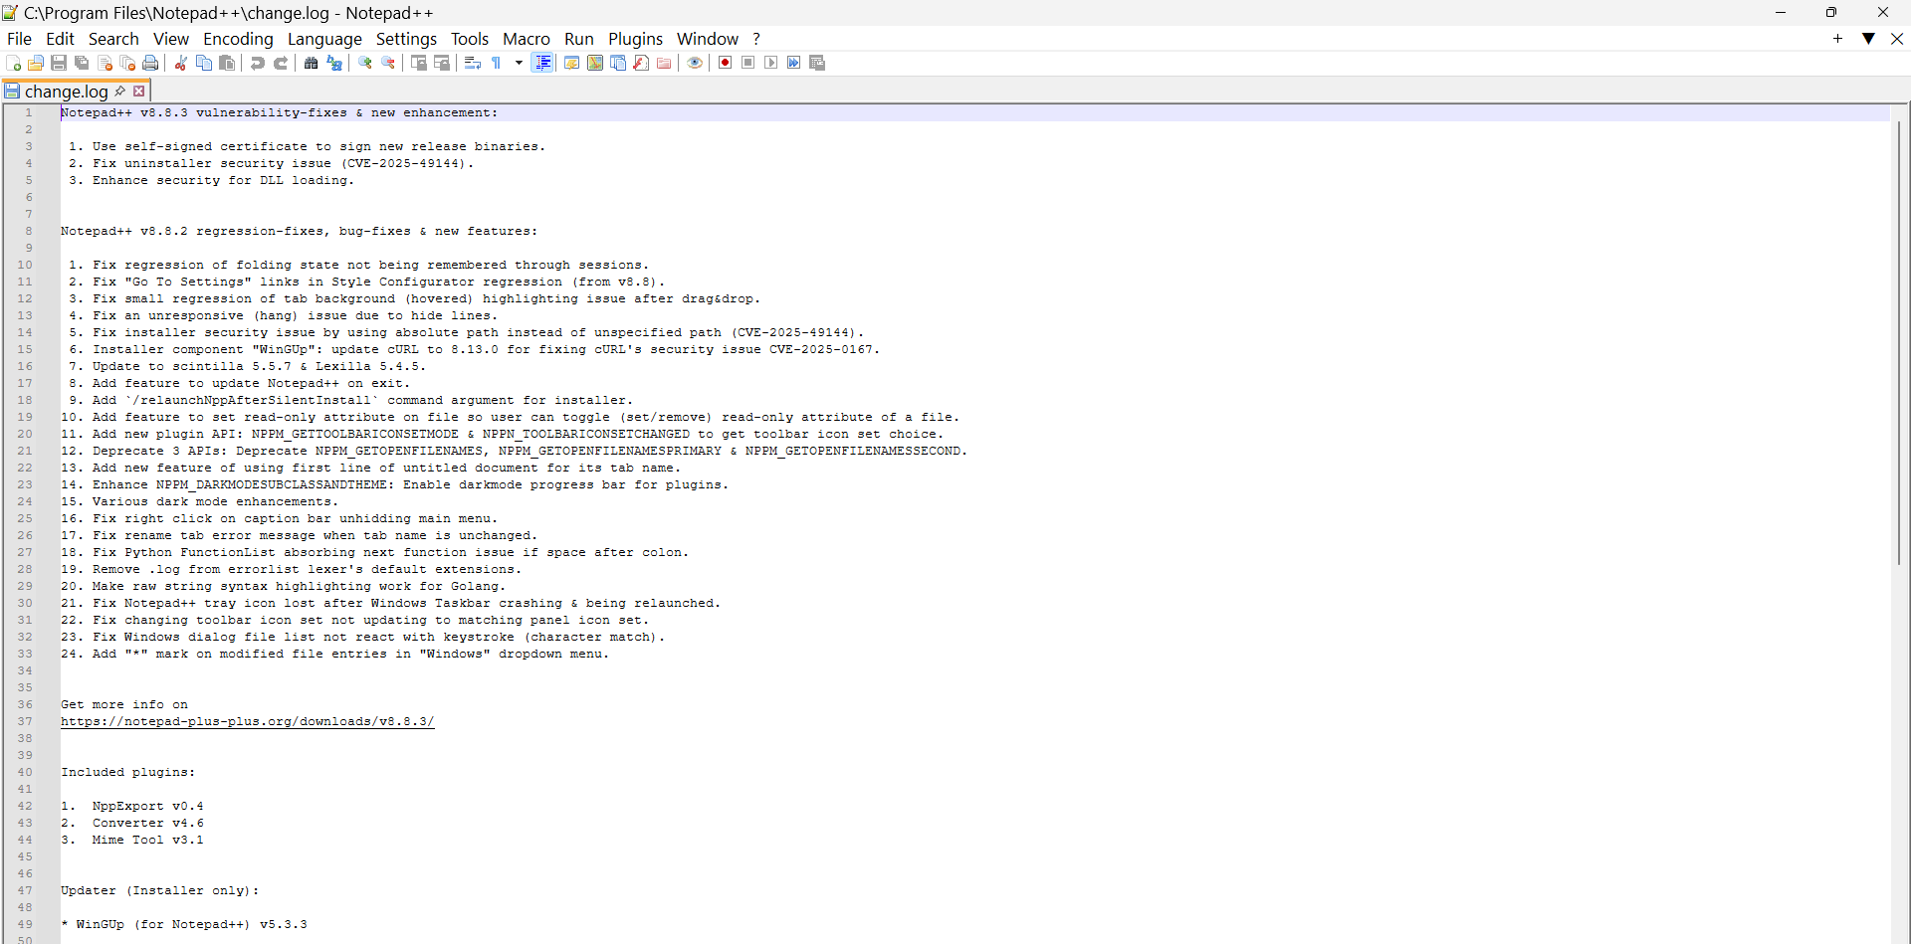

2.Git-HOL
Create a “.log” file and a log folder in the working directory of Git. Update the .gitignore file in such a way that on committing, these files (.log extensions and log folders) are ignored.
- Setting up Git environment
- Integrate notepad++ as a default editor
- A Git repository in the local system and a remote repository in GitLab

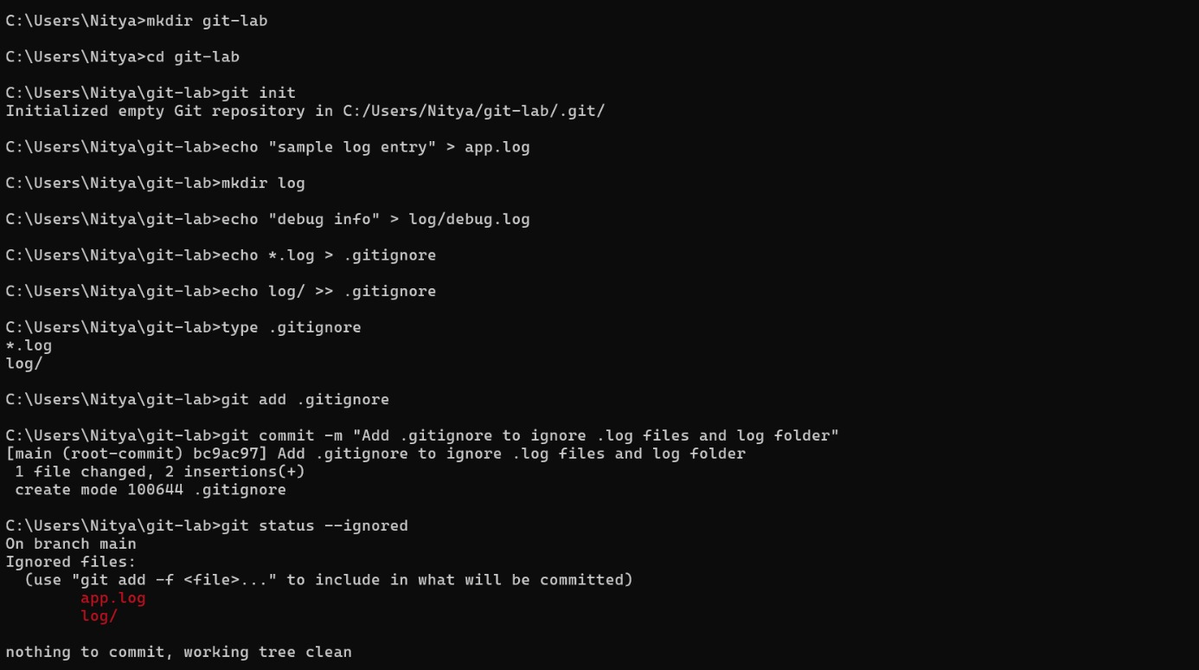

3.Git-HOL
Construct a branch, do some changes in the branch, and merge it with master (or trunk)
Setting up Git environment with P4Merge tool for Windows
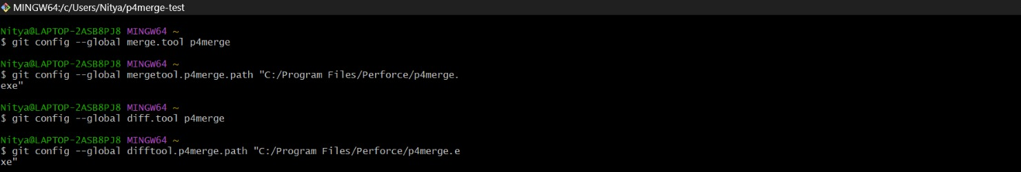
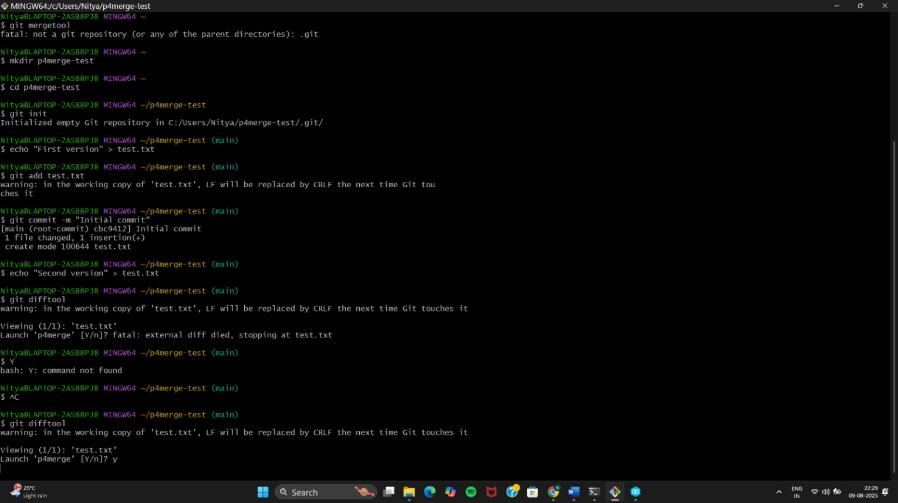
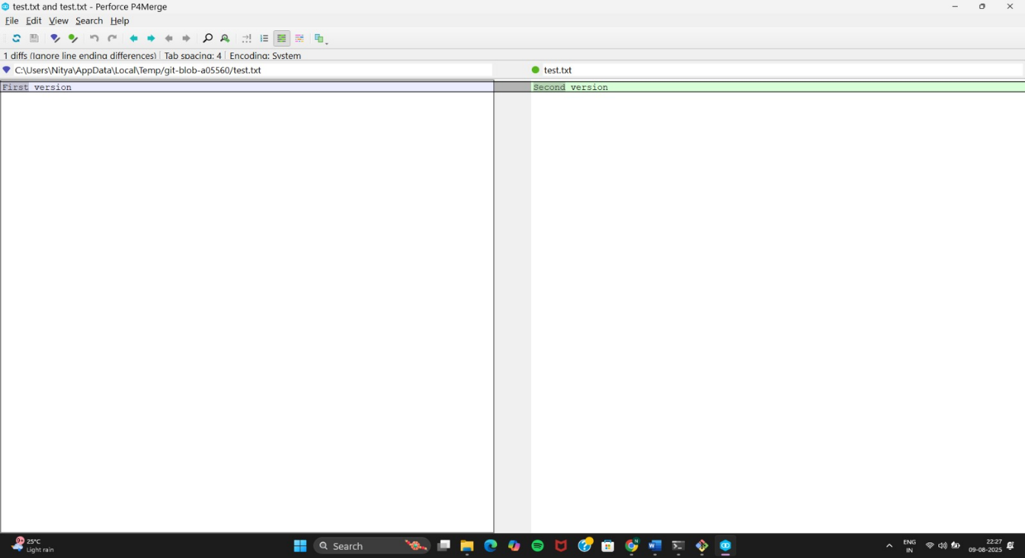

4.Git-HOL
Implement conflict resolution when multiple users are updating the trunk (or master) in such a way that it results into a conflict with the branch’s modification.
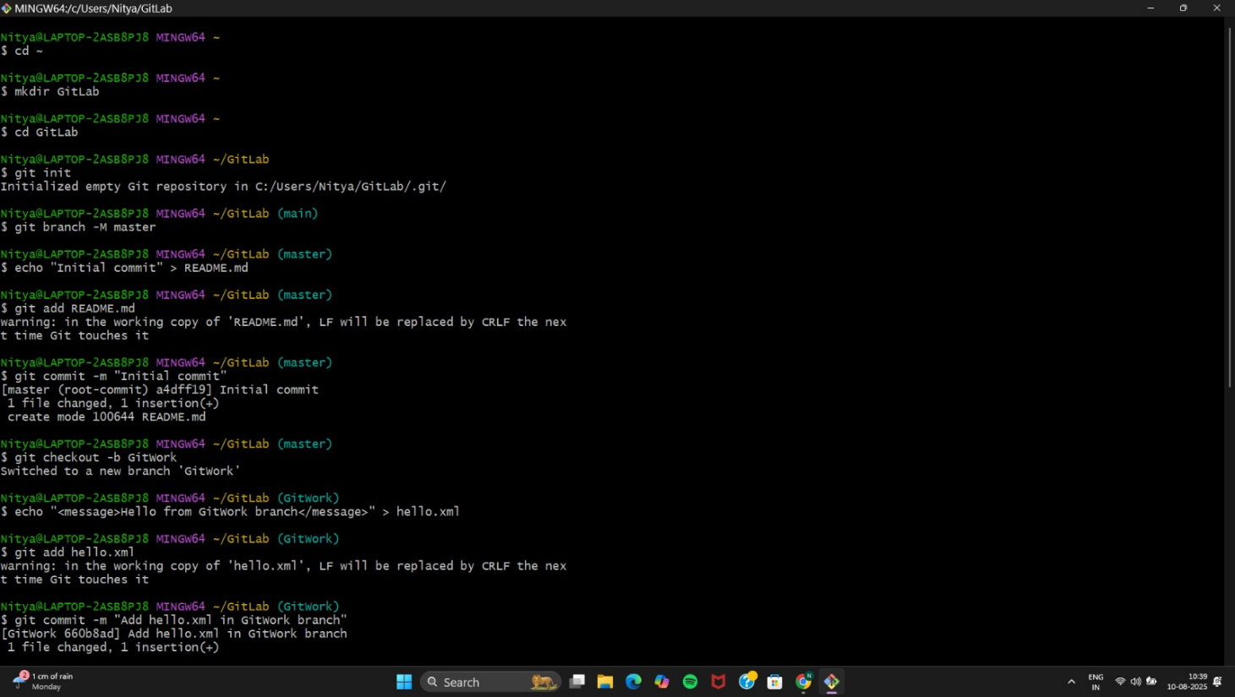
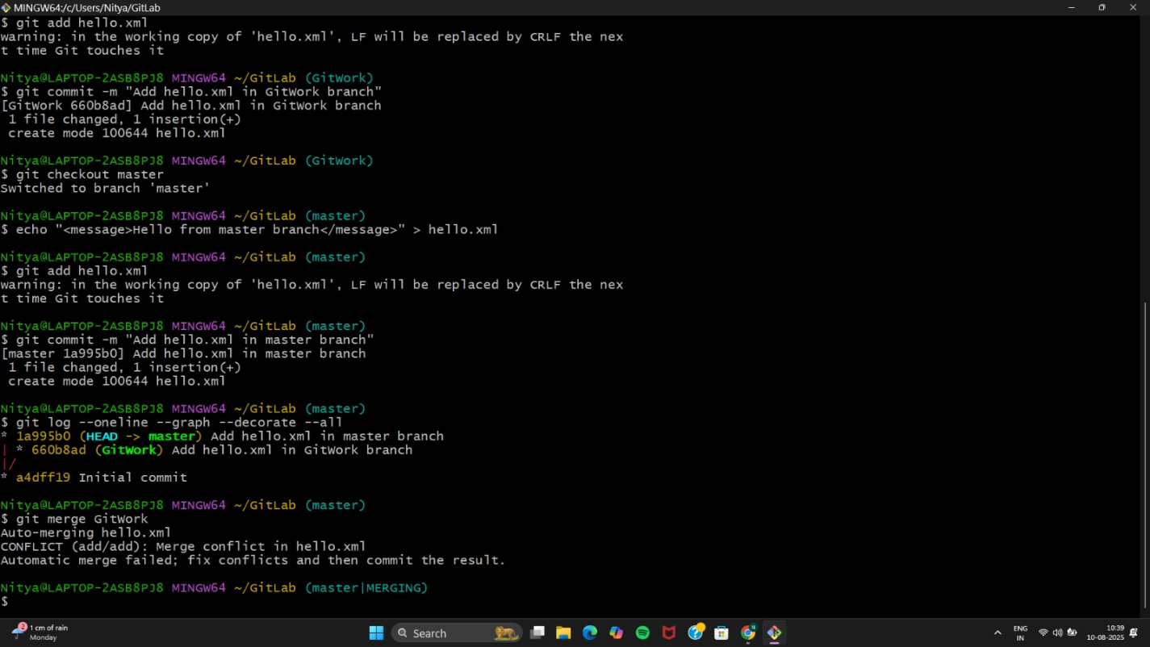
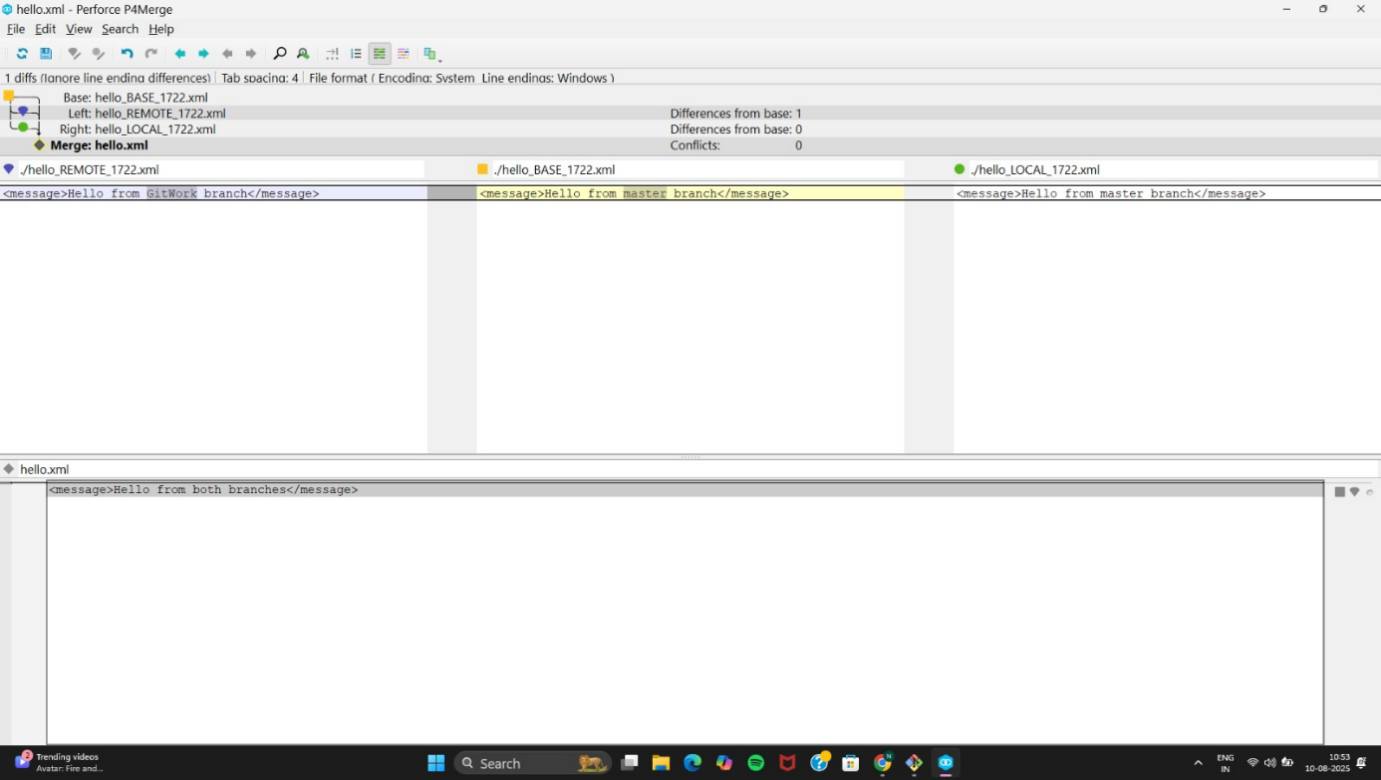

5.Git-HOL
Execute steps involving clean up and push back to remote Git.
