WEEK 7 - React
Additional Handson

14.ReactJS HOL
React Context API
(i)Folder structure
bloggerapp/
└── src/
├── App.js
├── context/
│ └── ThemeContext.js
├── components/
│ ├── EmployeesList.js
│ └── EmployeeCard.js
└── index.css / mystyle.css

ThemeContext.js
import { createContext } from "react";
const ThemeContext = createContext("light");
export default ThemeContext;

App.js
import React, { useState } from "react";
import EmployeeList from "./components/EmployeeList";
import ThemeContext from "./context/ThemeContext";
import "./index.css";
const App = () => {
const [theme, setTheme] = useState("light");
const toggleTheme = () => {
setTheme(prev => (prev === "light" ? "dark" : "light"));
};
return (
<ThemeContext.Provider value={theme}>
<div className={`app-container ${theme}`}>
<h1>👩‍💼 Employee Dashboard</h1>
<button onClick={toggleTheme}>
Switch to {theme === "light" ? "Dark" : "Light"} Mode
</button>
<EmployeeList />
</div>
</ThemeContext.Provider>
);
};
export default App;

EmployeeList.js
import React from "react";
import EmployeeCard from "./EmployeeCard";
const employeeData = [
{ id: 1, name: "Amit", role: "Frontend Developer" },
{ id: 2, name: "Sneha", role: "UI Designer" },
{ id: 3, name: "Rahul", role: "QA Engineer" },
];
const EmployeeList = () => {
return (
<div className="employee-list">
{employeeData.map((emp) => (
<EmployeeCard key={emp.id} employee={emp} />
))}
</div>
);
};
export default EmployeeList;

EmployeeCard.js
import React, { useContext } from "react";
import ThemeContext from "../context/ThemeContext";
const EmployeeCard = ({ employee }) => {
const theme = useContext(ThemeContext);
return (
<div className={`card card-${theme}`}>
<h3>{employee.name}</h3>
<p>Role: {employee.role}</p>
<button className={`btn btn-${theme}`}>Contact</button>
</div>
);
};
export default EmployeeCard;
mystyle.css
.app-container {
font-family: Arial, sans-serif;
padding: 30px;
transition: background-color 0.4s ease;
}
.app-container.light {
background-color: #f9f9f9;
color: #222;
}
.app-container.dark {
background-color: #1e1e1e;
color: #fff;
}
.card {
padding: 20px;
margin: 10px 0;
border-radius: 8px;
}
.card-light {
background-color: #ffffff;
border: 1px solid #ccc;
}
.card-dark {
background-color: #333;
border: 1px solid #444;
}
.btn {
padding: 10px 14px;
border: none;
margin-top: 10px;
border-radius: 5px;
cursor: pointer;
}
.btn-light {
background-color: #007bff;
color: white;
}
.btn-dark {
background-color: #28a745;
color: white;
}

(ii)run the app
npm start
OUTPUT:
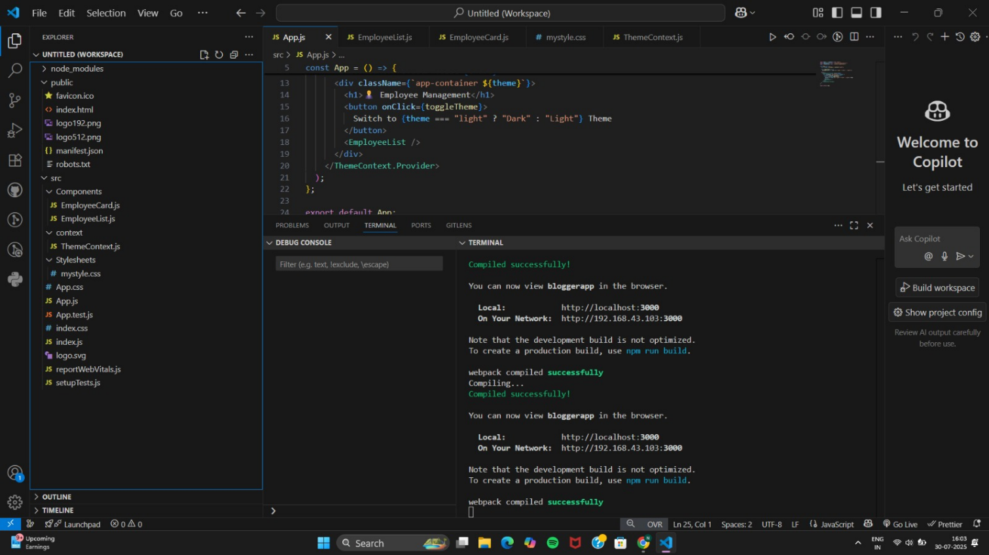
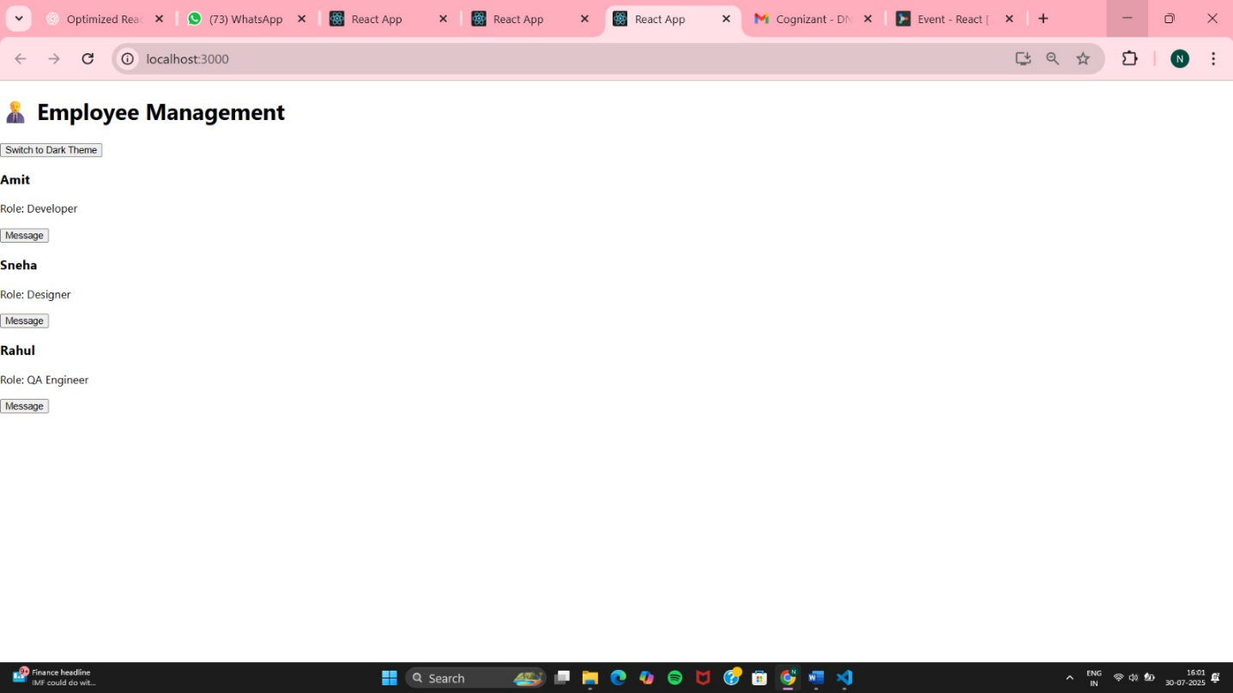

15.ReactJS-HOL
React App named “ticketraisingapp” which will help to raise a complaint and get it resolved.

(i)Project setup
npx create-react-app ticketraisingapp
cd ticketraisingapp

(ii)Folder structure
src/
┣ components/
┃ ┗ ComplaintRegister.js
┣ styles/
┃ ┗ formStyle.css

ComplaintRegister.js
// src/components/ComplaintRegister.js
import React, { useState } from "react";
import "../styles/formStyle.css";
const ComplaintRegister = () => {
const [employeeName, setEmployeeName] = useState("");
const [complaint, setComplaint] = useState("");
const handleSubmit = (e) => {
e.preventDefault();
if (employeeName.trim() === "" || complaint.trim() === "") {
alert("Please fill in all fields.");
return;
}
const referenceNumber = `REF${Date.now().toString().slice(-6)}`;
alert(
`Complaint submitted successfully!\n\nEmployee: ${employeeName}\nReference No: ${referenceNumber}`
);
// Clear form
setEmployeeName("");
setComplaint("");
};
return (
<div className="form-container">
<h2>Raise a Complaint</h2>
<form onSubmit={handleSubmit}>
<label htmlFor="employeeName">Employee Name:</label>
<input
type="text"
id="employeeName"
placeholder="Enter your name"
value={employeeName}
onChange={(e) => setEmployeeName(e.target.value)}
/>
<label htmlFor="complaint">Complaint:</label>
<textarea
id="complaint"
placeholder="Describe your issue..."
value={complaint}
onChange={(e) => setComplaint(e.target.value)}
/>
<button type="submit">Submit Complaint</button>
</form>
</div>
);
};
export default ComplaintRegister;
formStyle.css
/* src/styles/formStyle.css */
.form-container {
width: 400px;
margin: 60px auto;
background: #fff;
padding: 30px 40px;
border-radius: 12px;
box-shadow: 0 0 20px rgba(0, 0, 0, 0.1);
font-family: 'Segoe UI', sans-serif;
}
.form-container h2 {
text-align: center;
margin-bottom: 25px;
color: #333;
}
.form-container label {
display: block;
margin-bottom: 8px;
font-weight: 600;
color: #555;
}
.form-container input,
.form-container textarea {
width: 100%;
padding: 10px 12px;
margin-bottom: 20px;
border: 1px solid #ccc;
border-radius: 8px;
transition: border 0.3s;
}
.form-container input:focus,
.form-container textarea:focus {
border-color: #007bff;
outline: none;
}
.form-container button {
width: 100%;
padding: 12px;
background: #007bff;
color: white;
border: none;
font-size: 16px;
border-radius: 8px;
cursor: pointer;
transition: background 0.3s;
}
.form-container button:hover {
background: #0056b3;
}
App.js
// src/App.js
import React from "react";
import ComplaintRegister from "./components/ComplaintRegister";
function App() {
return (
<div className="App">
<ComplaintRegister />
</div>
);
}
export default App;
(iii)Run the app
npm start
OUTPUT:
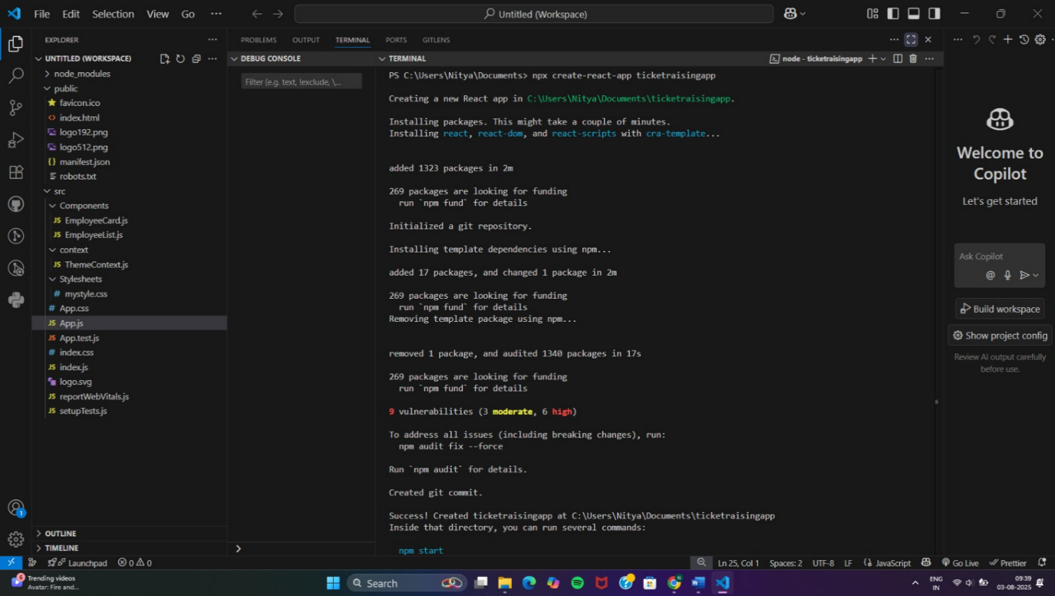
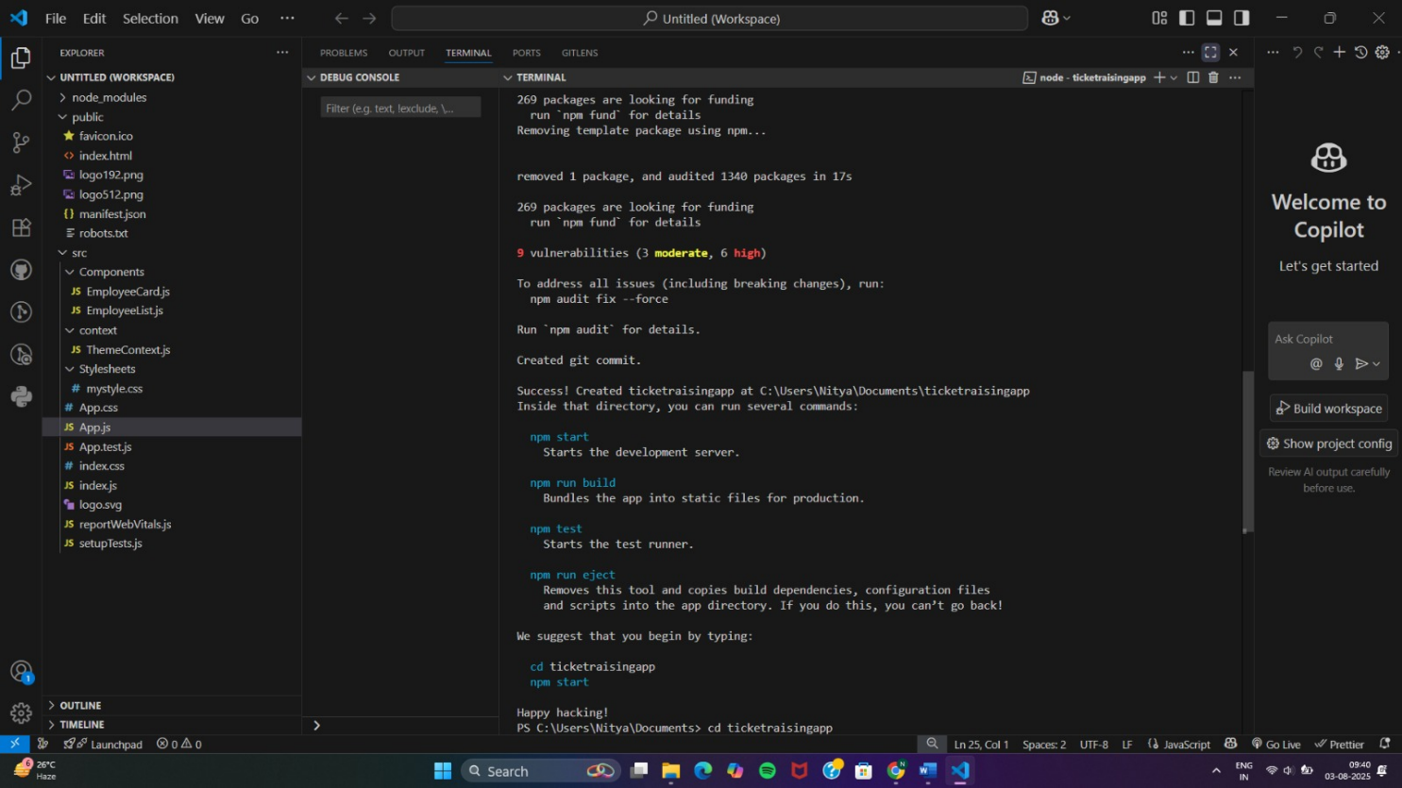
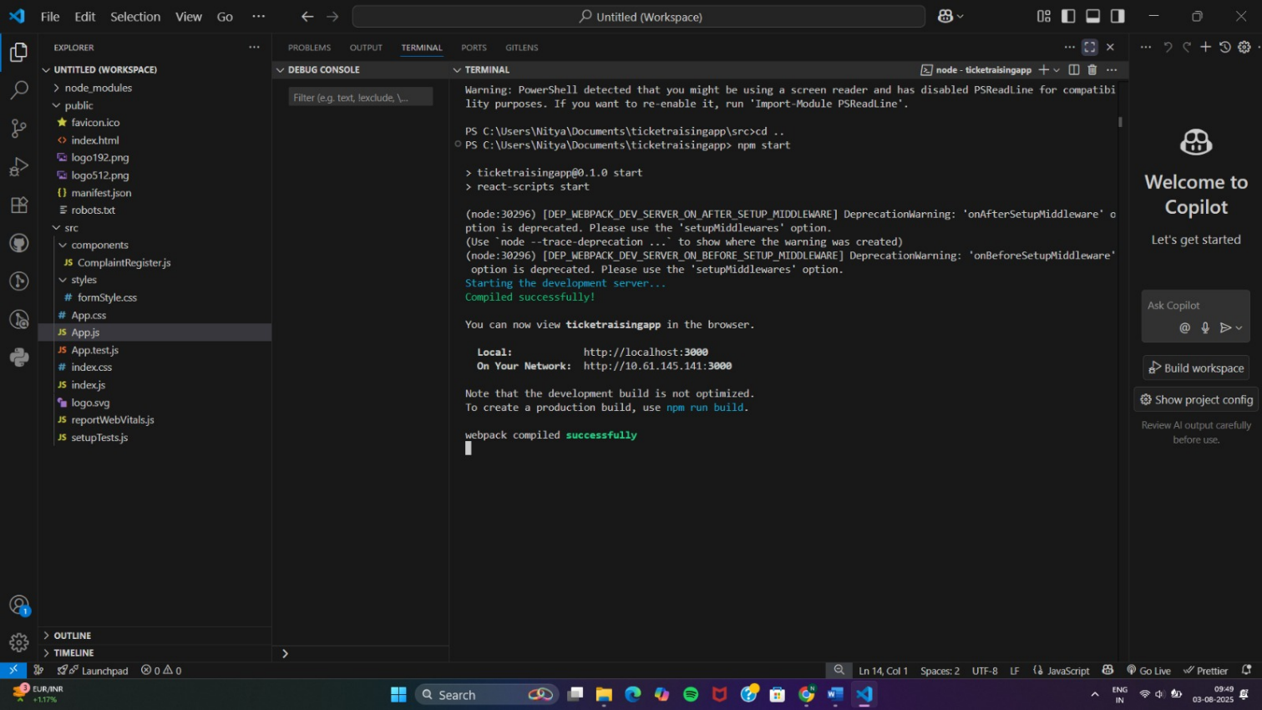
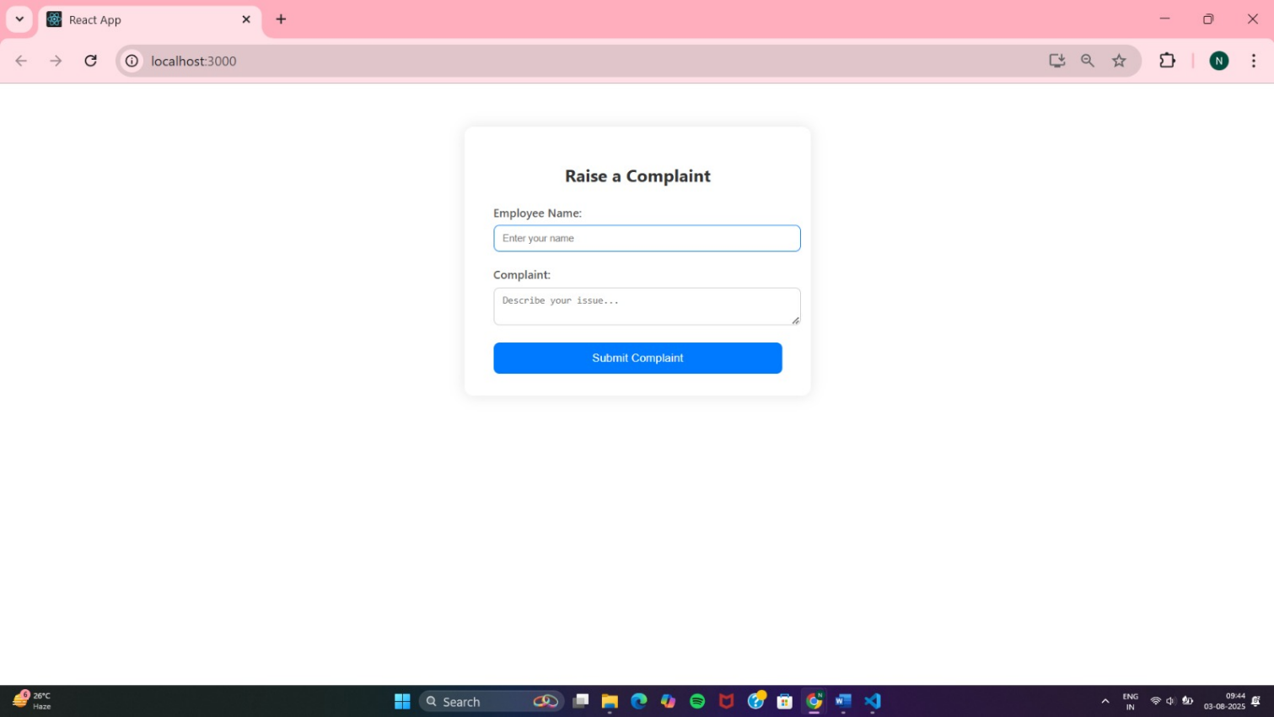
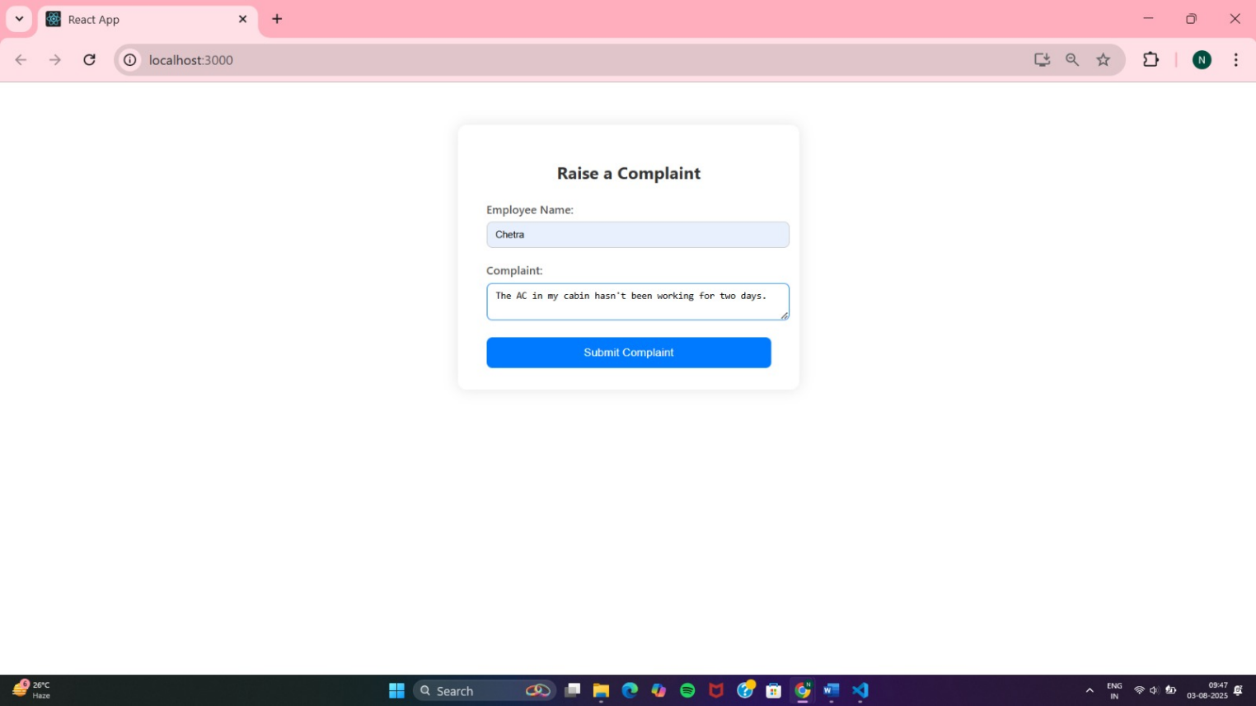
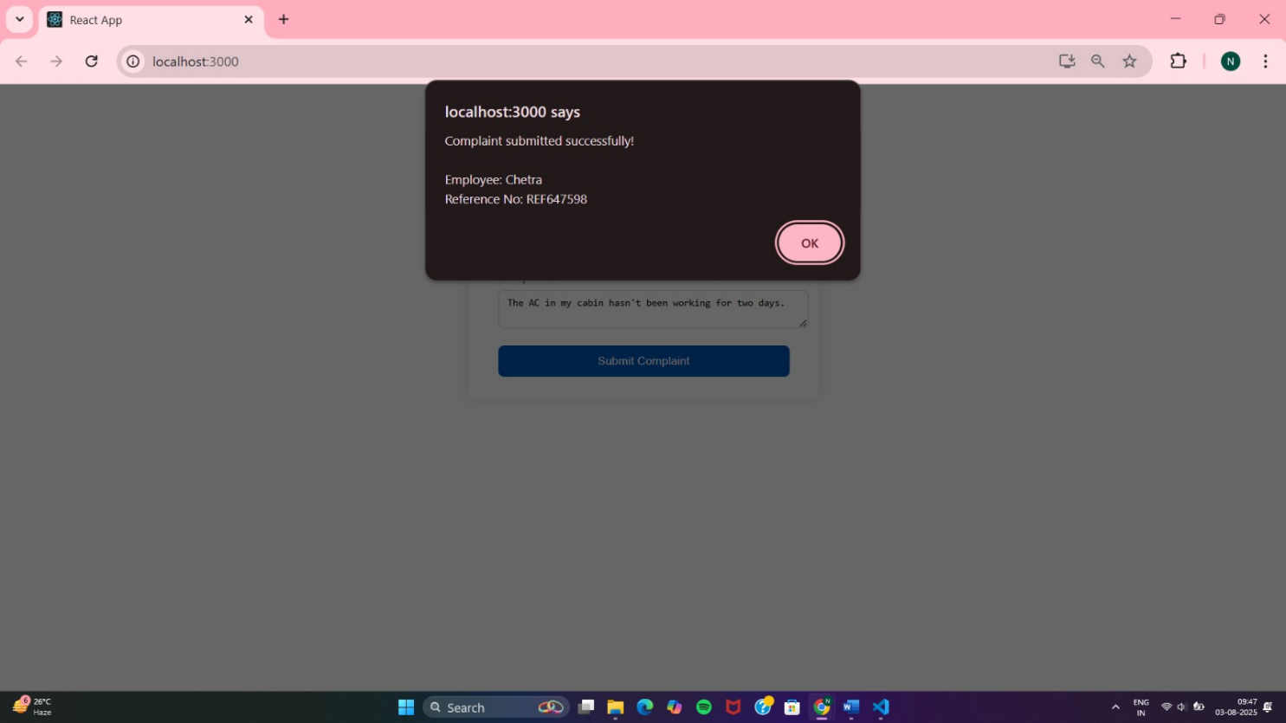

16.ReactJS-HOL
Create a React App named “mailregisterapp” which will have a component named “register.js”.

(i)Project setup
npx create-react-app mailregisterapp
cd mailregisterapp
(ii) Folder Structure
src/
├── components/
│ └── Register.js
├── styles/
│ └── formValidation.css
└── App.js

Register.js
// src/components/Register.js
import React, { useState } from "react";
import "../styles/formValidation.css";
const Register = () => {
const [formData, setFormData] = useState({
name: "",
email: "",
password: "",
});
const [errors, setErrors] = useState({});
const validate = () => {
const newErrors = {};
const { name, email, password } = formData;
if (name.trim().length < 5)
newErrors.name = "Name must be at least 5 characters long.";
if (!email.includes("@") || !email.includes("."))
newErrors.email = "Enter a valid email address.";
if (password.length < 8)
newErrors.password = "Password must be at least 8 characters.";
return newErrors;
};
const handleChange = (e) => {
const { name, value } = e.target;
setFormData({
...formData,
[name]: value,
});
setErrors({
...errors,
[name]: "",
});
};
const handleSubmit = (e) => {
e.preventDefault();
const validationErrors = validate();
if (Object.keys(validationErrors).length > 0) {
setErrors(validationErrors);
return;
}
alert("Registration successful!");
setFormData({ name: "", email: "", password: "" });
setErrors({});
};
return (
<div className="form-container">
<h2>Register</h2>
<form onSubmit={handleSubmit} noValidate>
<label htmlFor="name">Name:</label>
<input
type="text"
id="name"
name="name"
placeholder="Enter full name"
value={formData.name}
onChange={handleChange}
/>
{errors.name && <span className="error">{errors.name}</span>}
<label htmlFor="email">Email:</label>
<input
type="email"
id="email"
name="email"
placeholder="Enter valid email"
value={formData.email}
onChange={handleChange}
/>
{errors.email && <span className="error">{errors.email}</span>}

<label htmlFor="password">Password:</label>
<input
type="password"
id="password"
name="password"
placeholder="Min 8 characters"
value={formData.password}
onChange={handleChange}
/>
{errors.password && (
<span className="error">{errors.password}</span>
)}
<button type="submit">Submit</button>
</form>
</div>
);
};
export default Register;

formValidation.css
/* src/styles/formValidation.css */
.form-container {
width: 400px;
margin: 50px auto;
background: #ffffff;
padding: 30px 40px;
border-radius: 12px;
box-shadow: 0 0 15px rgba(0, 0, 0, 0.1);
font-family: 'Segoe UI', sans-serif;
}

.form-container h2 {
text-align: center;
color: #333;
margin-bottom: 25px;
}
label {
display: block;
margin-bottom: 6px;
font-weight: bold;
color: #444;
}
input {
width: 100%;
padding: 10px 12px;
margin-bottom: 15px;
border: 1px solid #ccc;
border-radius: 8px;
transition: border 0.3s;
}
input:focus {
border-color: #007bff;
outline: none;
}
button {
width: 100%;
padding: 12px;
font-size: 16px;
background: #007bff;
color: white;
border: none;
border-radius: 8px;
cursor: pointer;
transition: background 0.3s;
}
button:hover {
background: #0056b3;
}
.error {
color: red;
font-size: 14px;
margin-bottom: 10px;
display: block;
}

App.js
// src/App.js
import React from "react";
import Register from "./components/Register";
function App() {
return (
<div className="App">
<Register />
</div>
);
}
export default App;
(iii)Run the app
npm start

OUTPUT:
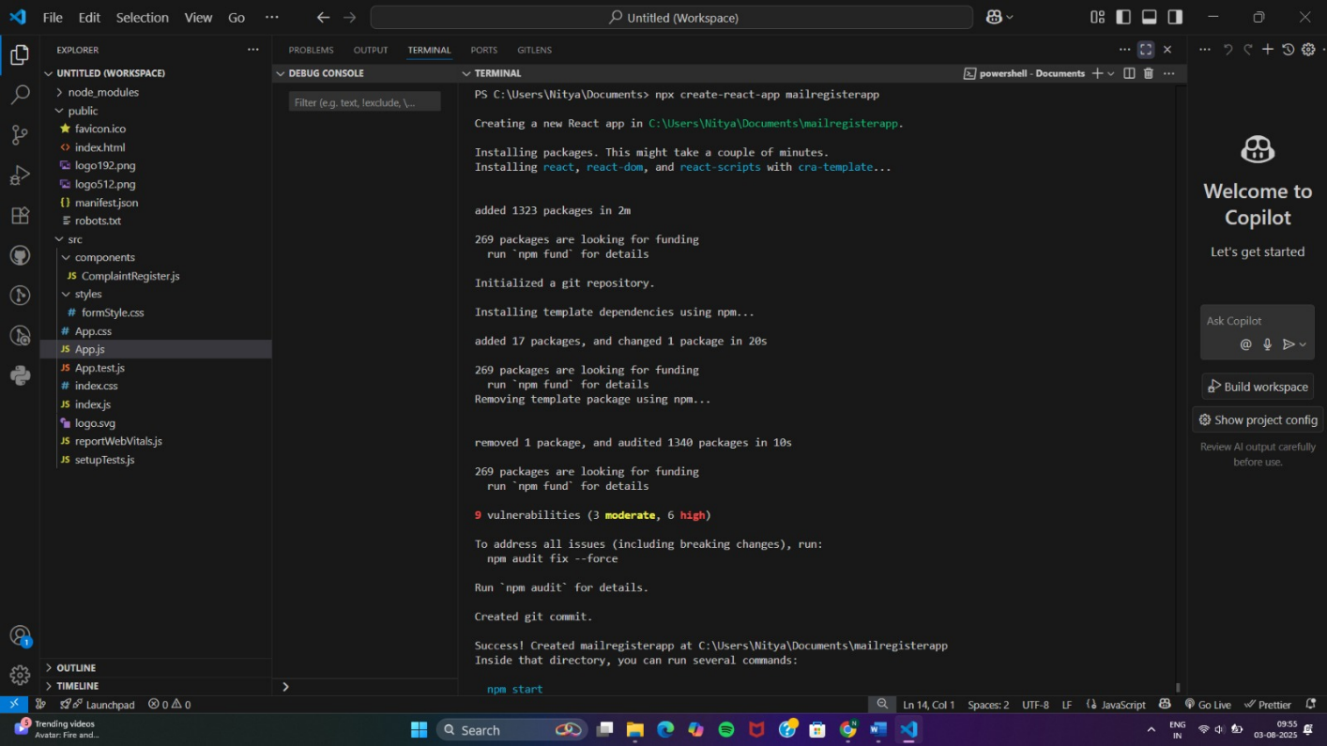
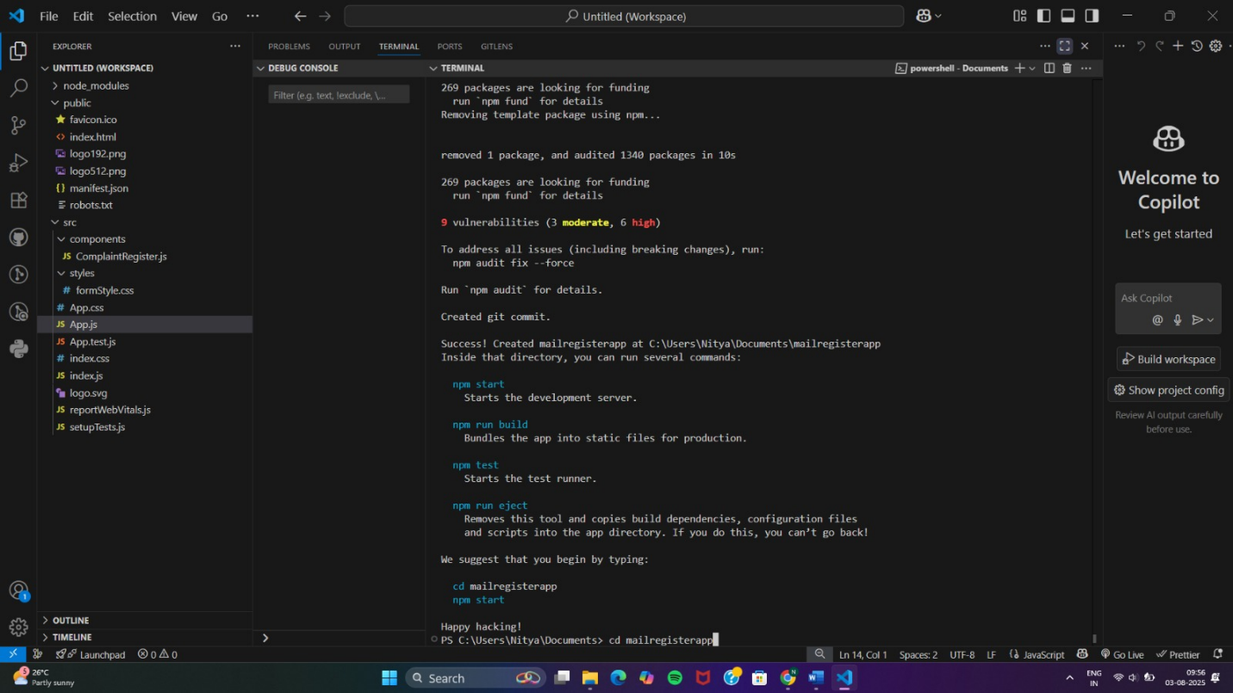
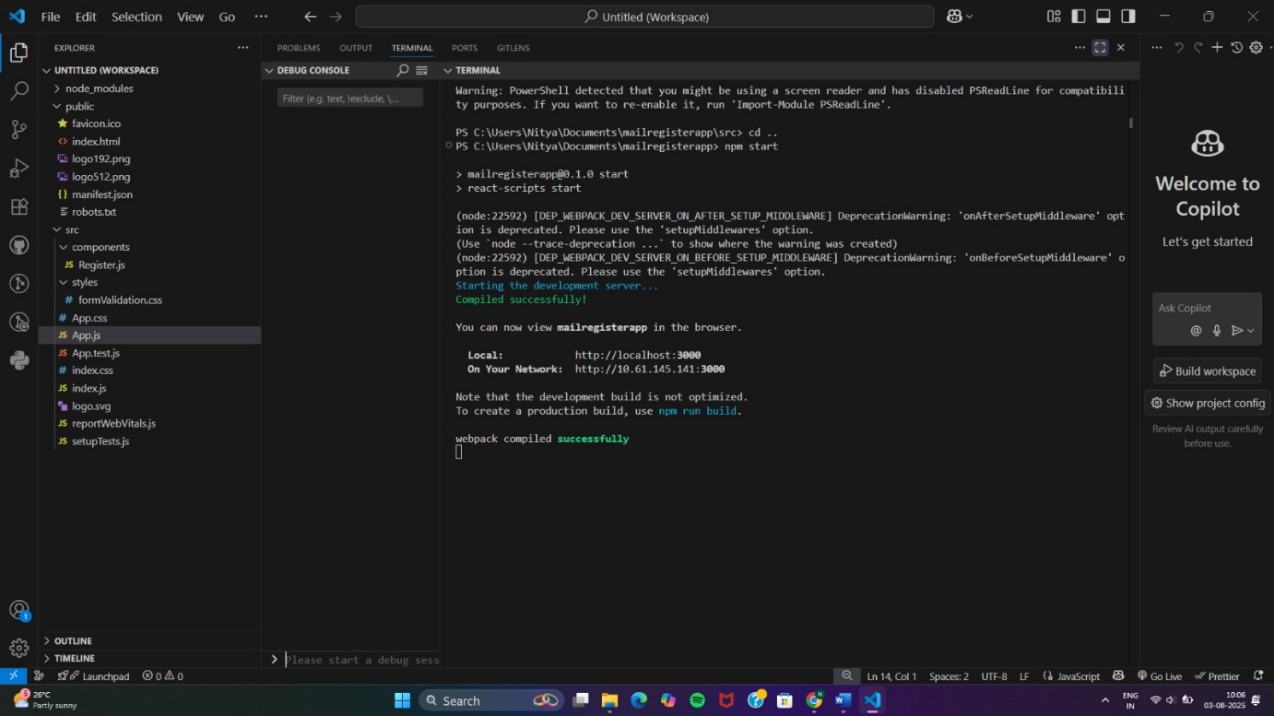
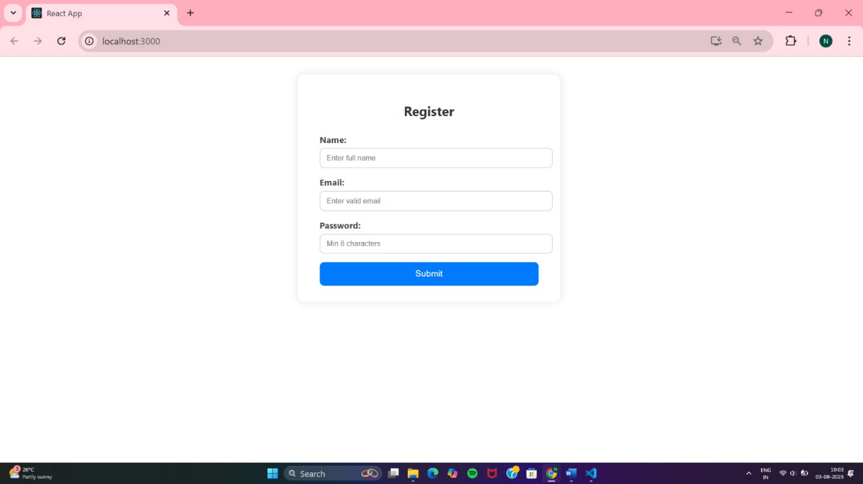
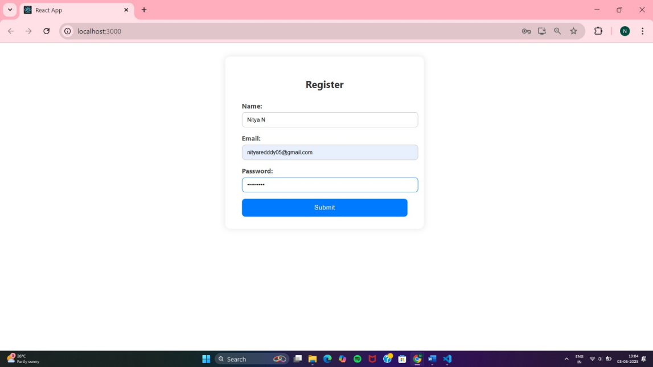
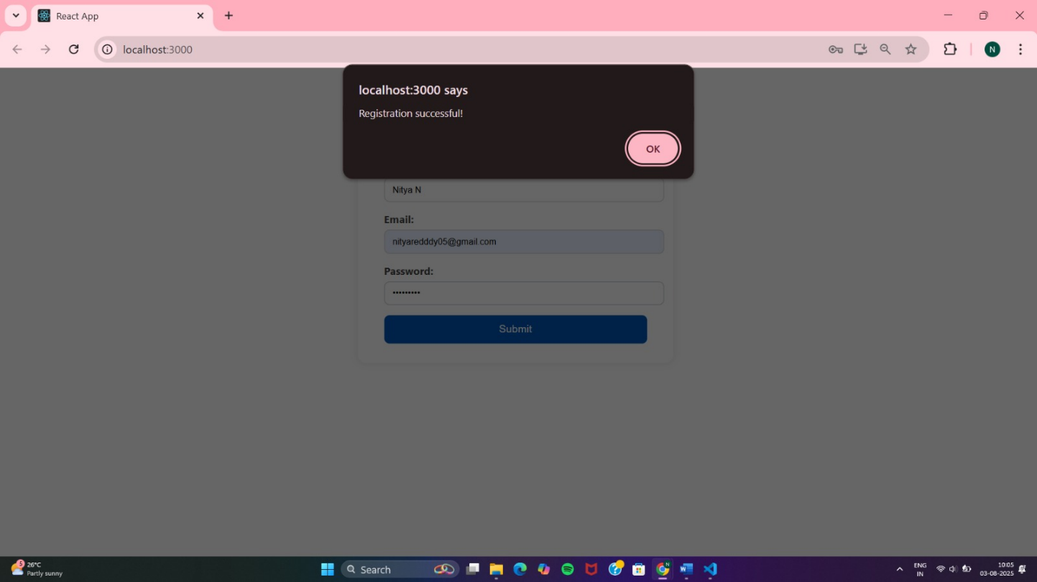

17.ReactJS-HOL
React Application “fetchuserapp” which will retrieve the user details from https://api.randomuser.me/ and display the title, firstname and image of a user.

(i)Project setup
npx create-react-app fetchuserapp
cd fetchuserapp

(ii)Folder structure
src/
├── components/
│ └── GetUser.js
├── styles/
│ └── userStyle.css
└── App.js
GetUser.js
// src/components/GetUser.js
import React from "react";
import "../styles/userStyle.css";
class GetUser extends React.Component {
constructor(props) {
super(props);
this.state = {
user: null,
loading: true,
error: null,
};
}
async componentDidMount() {
try {
const response = await fetch("https://api.randomuser.me/");
if (!response.ok) throw new Error("Failed to fetch user data.");
const data = await response.json();
const user = data.results[0];
this.setState({ user, loading: false });
} catch (err) {
this.setState({ error: err.message, loading: false });
}
}
render() {
const { user, loading, error } = this.state;
if (loading) return <p className="status">Loading user data...</p>;
if (error) return <p className="status error">Error: {error}</p>;
return (
<div className="user-card">
<img
src={user.picture.large}
alt={`${user.name.first}`}
className="user-image"
/>
<h2>
{user.name.title} {user.name.first} {user.name.last}
</h2>
<p className="location">{user.location.city}, {user.location.country}</p>
<button onClick={() => window.location.reload()}>Get New User</button>
</div>
);
}
}
export default GetUser;

userStyle.css
/* src/styles/userStyle.css */
.user-card {
width: 300px;
margin: 60px auto;
padding: 25px;
text-align: center;
background-color: #f5f9ff;
border-radius: 12px;
box-shadow: 0 6px 18px rgba(0, 0, 0, 0.1);
font-family: 'Segoe UI', sans-serif;
}
.user-image {
width: 120px;
border-radius: 50%;
margin-bottom: 20px;
}
h2 {
margin-bottom: 10px;
color: #333;
}
.location {
color: #555;
font-style: italic;
}
button {
margin-top: 20px;
padding: 10px 20px;
background: #007bff;
color: white;
font-size: 15px;
border: none;
border-radius: 8px;
cursor: pointer;
transition: background 0.3s ease;
}
button:hover {
background: #0056b3;
}
.status {
text-align: center;
margin-top: 50px;
font-size: 18px;
color: #444;
}
.status.error {
color: red;
}

App.js
// src/App.js
import React from "react";
import GetUser from "./components/GetUser";
function App() {
return (
<div className="App">
<GetUser />
</div>
);
}
export default App;
(iii)Run the app
npm start

OUTPUT:
