A REPORT

ON
FUEL CONSUMPTION ESTIMATOR FOR FUTURE UAV’S

Submitted by

Ms. Nitya C Madiwal - 20241CSE0853

Under the guidance of,
Mr. Chenna Aditya Vardhan
Ms. Megha Karil

in partial fulfillment for the award of the degree of
BACHELOR OF TECHNOLOGY

IN

COMPUTER SCIENCE AND ENGINEERING

AT



PRESIDENCY UNIVERSITY
BENGALURU
AUGUST 2026

PRESIDENCY UNIVERSITY

PRESIDENCY SCHOOL OF COMPUTER SCIENCE AND ENGINEERING

CERTIFICATE

This is to certify that the report of CSE7000 – Internship on “Fuel Consumption Estimator for Future UAVs” being submitted by Mr. Nitya C Madiwal bearing roll number 20241CSE0853 in partial fulfillment of the requirement for the award of the degree of Bachelor of Technology in Computer Science and Engineering (Computer Science and Engineering) is a Bonafide work carried out under our supervision.

Mr. Chenna Aditya Vardhan  Assistant Professor  PSCS  Presidency University | Ms. Megha Karil  Assistant Professor  PSCS  Presidency University | Dr. R. Balakrishnan  PSCS  Presidency University

Dr. Bhuvaneshwari Patil  School level coordinator  PSCS  Presidency University | Dr. Asif Mohamed  HOD  PSCS  Presidency University | Dr. Duraipandian N  Dean – PSCS & PSIS  Presidency University

PRESIDENCY UNIVERSITY

PRESIDENCY SCHOOL OF COMPUTER SCIENCE AND ENGINEERING

DECLARATION

I hereby declare that the work, which is being presented in the report entitled Fuel Consumption Estimator for Future UAVs in partial fulfillment for the award of Degree of Bachelor of Technology in Computer Science and Engineering (Computer Science and Engineering), is a record of my own investigations carried under the guidance of Mr. Chenna Aditya Vardhan, Assistant Professor and Ms. Megha Karil, Assistant Professor Presidency School of Computer Science and Engineering, Presidency University, Bengaluru.

I have not submitted the matter presented in this report anywhere for the award of any other Degree.

Nitya C Madiwal
20241CSE0853

INTERNSHIP COMPLETION CERTIFICATE

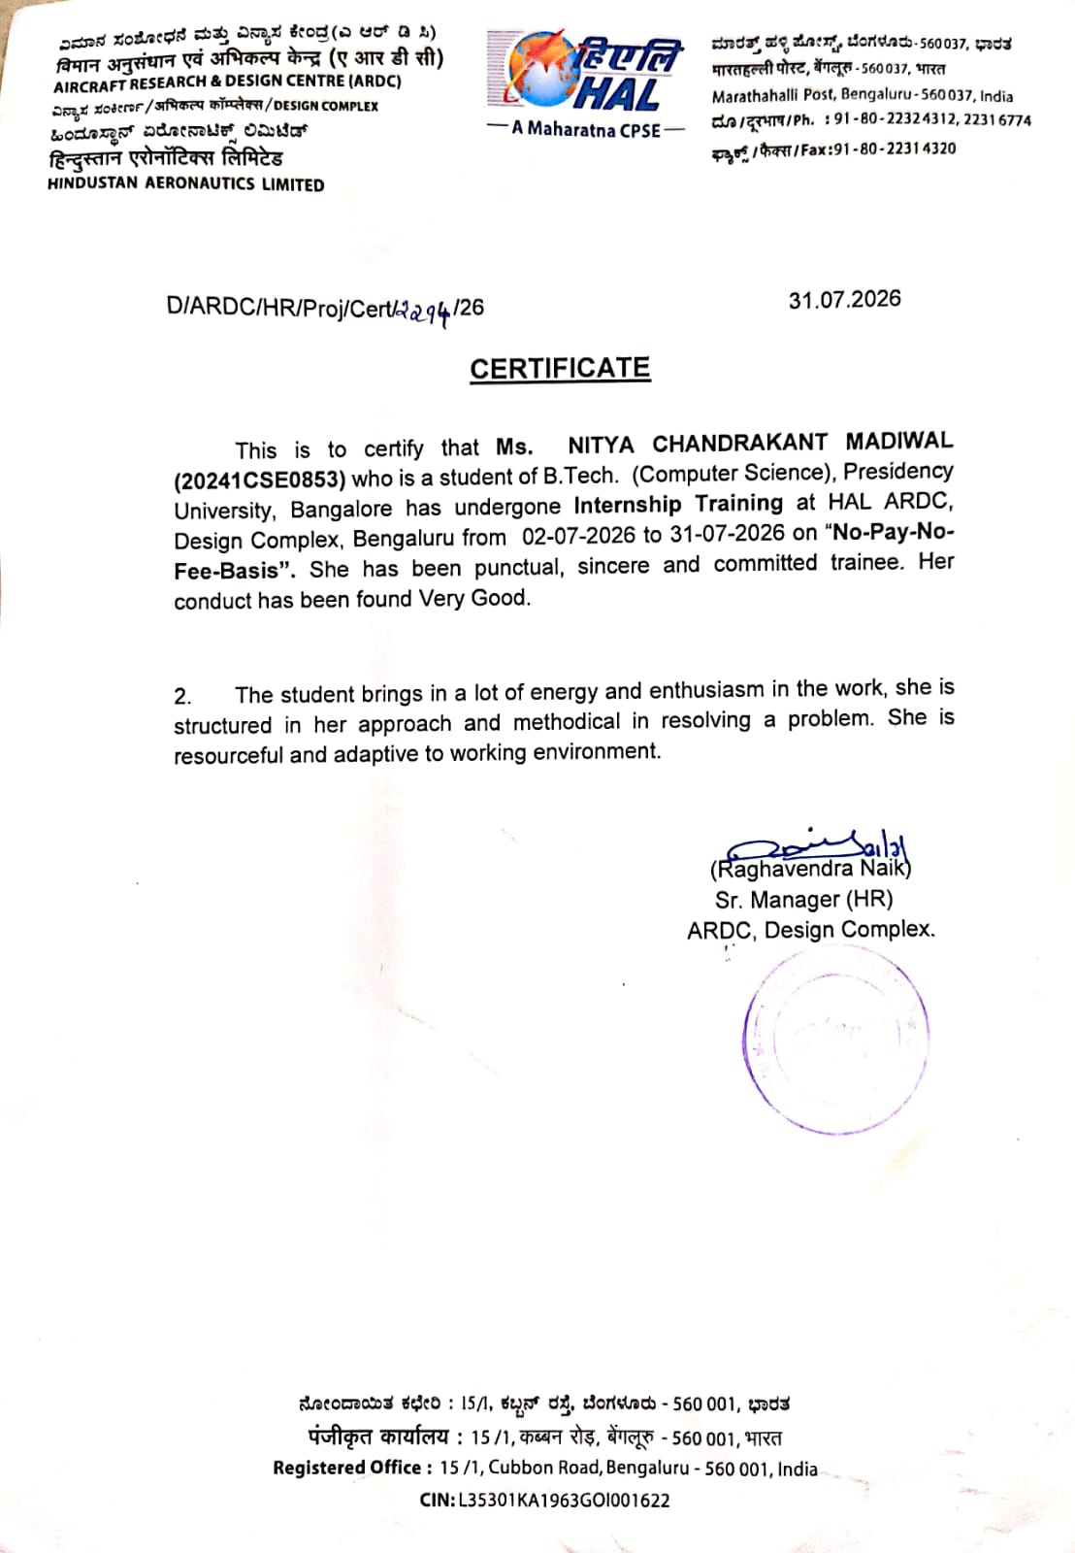

ACKNOWLEDGEMENTS

First of all, I indebted to the GOD ALMIGHTY for giving me an opportunity to excel in our efforts to complete this internship on time.
I express sincere thanks to our respected Dean Dr. Duraipandian N, Presidency School of Computer Science and Engineering & Presidency School of Information Science, Presidency University for getting us permission to undergo the internship.
I express heartfelt gratitude to our beloved Dr. Asif Mohamed, Head of the Department, Presidency School of Computer Science and Engineering, Presidency University, for rendering timely help in completing this internship successfully.
I am greatly indebted to my reviewers Mr. Chenna Aditya Vardhan and Ms. Megha Kargil, Presidency School of Computer Science and Engineering, Presidency University for their inspirational guidance, and valuable suggestions and for providing a chance to express technical capabilities in every respect for the completion of the internship work.
I would like to convey gratitude and heartfelt thanks to the Internship Coordinator Dr. Bhuvaneshwari Patil and Program Internship Coordinator Dr. R Balakrishnan . I also thank my family and friends for the strong support and inspiration they have provided us in bringing out this internship.

Nitya C Madiwal
20241CSE0853

ABSTRACT

The increasing complexity of modern UAV missions demands accurate monitoring of fuel usage to improve mission planning, operational efficiency, and flight safety. While flight simulators provide real-time aircraft telemetry, they do not directly estimate important fuel-related parameters required for performance analysis. This internship project, titled "Fuel Consumption and Estimator for Future UAVs," was carried out at the Aircraft Research and Design Centre (ARDC), Hindustan Aeronautics Limited (HAL), Bengaluru, to develop a software-based system capable of estimating aircraft fuel performance using real-time flight data.
The developed system receives live telemetry from the FlightGear Flight Simulator through UDP communication and processes parameters such as altitude, throttle position, true airspeed, Mach number, engine characteristics, and fuel quantity. A Python-based backend performs real-time calculations to estimate fuel flow, fuel consumed, fuel remaining, endurance, operational range, reserve fuel, landing fuel, and bingo fuel. The estimated values are displayed through an interactive dashboard developed using HTML, CSS, and JavaScript, providing continuous visualization of aircraft fuel status.
The proposed framework demonstrates the integration of flight simulation, real-time data processing, and software engineering to create a practical fuel estimation system. Its modular architecture allows future enhancement for different UAV platforms, advanced prediction models, and integration with real-world avionics systems.
INTRODUCTION

Aircraft fuel management is an important part of flight operations as it directly affects the endurance, range, and overall performance of an aircraft. During a flight, fuel consumption changes continuously based on factors such as throttle position, altitude, aircraft speed, and engine operating conditions. Monitoring these changes helps in understanding the aircraft's performance and ensures that sufficient fuel is available to complete the mission safely. Therefore, estimating fuel consumption in real time is useful for both pilots and mission planners.
This internship project, "Fuel Consumption and Estimator for Future UAVs," was carried out at the Aircraft Research and Design Centre (ARDC), Hindustan Aeronautics Limited (HAL), Bengaluru. The main objective of the project was to develop a software application that estimates important fuel-related parameters using live flight data obtained from the Flight Gear Flight Simulator. The simulator provides aircraft parameters such as altitude, throttle position, true airspeed, Mach number, engine data, and fuel quantity, which are received by the application through UDP communication.
The application was developed using Python for processing the incoming flight data and estimating parameters such as fuel flow, fuel consumed, fuel remaining, endurance, operational range, reserve fuel, landing fuel, and bingo fuel. A web-based dashboard built using HTML, CSS, and JavaScript displays these values in real time, making it easier to monitor the aircraft's fuel status throughout the simulation.
The project provided practical experience in flight simulation, real-time data communication, software development, and dashboard integration. It also demonstrated how simulation data can be processed to generate useful information that supports aircraft performance analysis. The developed system can be further improved by integrating aircraft-specific models and applying it to real UAV platforms in the future.

OBJECTIVE

The primary objective of this internship was to design and develop a software application capable of estimating aircraft fuel consumption using real-time flight telemetry obtained from the Flight Gear Flight Simulator. The project aimed to convert raw flight parameters into meaningful fuel-related information that could assist in analysing aircraft performance and mission capability. The system was also intended to provide a simple graphical interface for monitoring fuel parameters continuously during simulation while maintaining a modular architecture suitable for future enhancements and integration with UAV platforms.
The specific objectives of the project are as follows:
- To understand the fundamentals of aircraft fuel consumption and the factors affecting fuel usage during different flight conditions.
- To establish reliable communication between the Flight Gear Flight Simulator and the developed application using UDP protocol.
- To acquire real-time flight telemetry, including altitude, throttle position, true airspeed, Mach number, engine parameters, temperature, and fuel quantity.
- To process the received telemetry using Python and implement fuel estimation models for continuous calculation of fuel-related parameters.
- To estimate important operational parameters such as fuel flow, fuel consumed, remaining fuel, endurance, operational range, reserve fuel, landing fuel, and bingo fuel.
- To verify and improve the accuracy of true airspeed calculations for obtaining more reliable estimation results.
- To design and develop an interactive dashboard using HTML, CSS, and JavaScript for real-time visualization of flight and fuel parameters.
- To validate the developed application under different simulated flight conditions by varying throttle settings, speed, and altitude.
- To develop a modular software architecture that simplifies maintenance, debugging, and future enhancement of the application.
- To provide a scalable framework that can be extended for different aircraft models and future UAV applications.
- To gain practical exposure to flight simulation, software development, real-time communication, and aerospace system integration in an industrial research environment.

WORK PROGRESS
The internship was carried out in a systematic manner, beginning with understanding the project requirements and progressing through software development, system integration, testing, and validation. The work was divided into different phases to ensure the successful development of the Fuel Consumption and Estimator for Future UAVs.
Requirement Analysis
The first phase of the internship involved understanding the objectives and scope of the project. A detailed study was carried out on aircraft fuel management and the factors affecting fuel consumption during flight. Concepts such as fuel flow, fuel consumption, endurance, operational range, reserve fuel, landing fuel, and bingo fuel were studied to understand their significance in aircraft operations. Simultaneously, the Flight Gear Flight Simulator was explored to identify the flight parameters available during simulation and determine the data required for fuel estimation.
Flight Gear Configuration
After analysing the project requirements, the FlightGear Flight Simulator was configured to generate real-time aircraft telemetry. Communication between Flight Gear and the developed application was established using the User Datagram Protocol (UDP) over the local loopback interface. The simulator continuously transmitted flight parameters required for fuel estimation.
The parameters received from Flight Gear included:
- Altitude
- Throttle Position
- True Airspeed (TAS)
- Mach Number
- Outside Air Temperature
- Fuel Quantity
- Engine Parameters
- Aircraft Position
- Waypoint Information
Successful communication was verified by continuously monitoring the incoming telemetry data and ensuring stable transmission throughout the simulation.
Development of Python Backend
The backend application was developed using Python, which served as the core processing unit of the system. The application continuously received telemetry data through UDP sockets and converted the incoming packets into usable flight parameters. The received data was validated before being processed to eliminate inconsistencies and ensure reliable calculations.
The software was developed using a modular approach by separating communication, telemetry processing, estimation algorithms, and configuration handling into independent modules. This structure simplified debugging, improved maintainability, and made future enhancements easier to implement.
Fuel Estimation Model
Once telemetry communication was established successfully, the fuel estimation algorithms were implemented. The received flight parameters were processed to estimate important fuel-related values, including:
- Fuel Flow
- Fuel Consumed
- Fuel Remaining
- Flight Endurance
- Operational Range
- Landing Fuel
- Reserve Fuel
- Bingo Fuel
Since fuel consumption varies continuously with changing flight conditions, the calculations were updated dynamically using the real-time telemetry received from Flight Gear. During implementation, additional verification of True Airspeed (TAS) was also carried out to improve the consistency and reliability of the estimated values.

Dashboard Development
To provide an interactive interface for monitoring the estimated parameters, a web-based dashboard was developed using HTML, CSS, and JavaScript. The dashboard was integrated with the Python backend and displayed both flight telemetry and estimated fuel parameters in real time.
The dashboard was designed to display:
- Flight Parameters
- Fuel Flow
- Fuel Consumed
- Fuel Remaining
- Endurance
- Operational Range
- Landing Fuel
- Reserve Fuel
- Bingo Fuel
The interface updated automatically whenever new telemetry was received, allowing continuous monitoring of aircraft fuel status throughout the simulation.
Testing and Validation
After completing the implementation, the developed application was tested under different simulated flight conditions. Parameters such as throttle position, altitude, aircraft speed, and fuel quantity were varied to analyse their effect on the estimated fuel parameters. The application was monitored throughout the testing process to verify stable communication, correct telemetry reception, and proper execution of the estimation algorithms.
The testing phase confirmed:
- Stable UDP communication between Flight Gear and the Python application.
- Continuous reception of flight telemetry without data loss.
- Accurate updating of the dashboard in real time.
- Dynamic estimation of fuel-related parameters under varying flight conditions.
- Reliable performance of the developed software throughout the simulation.
Final Integration
The final phase involved integrating all software modules into a single application. Communication, telemetry processing, fuel estimation, and dashboard visualization were successfully synchronized to provide continuous real-time monitoring of aircraft fuel performance. The completed application achieved the objectives defined at the beginning of the internship and demonstrated the successful integration of flight simulation, real-time communication, software development, and fuel estimation techniques. The developed framework also provides a foundation for future enhancements and integration with advanced UAV platforms.

RESULTS
The developed Fuel Consumption and Estimator for Future UAVs was successfully implemented and evaluated using the Flight Gear Flight Simulator. The application established continuous communication with the simulator through the User Datagram Protocol (UDP), enabling the reception of real-time aircraft telemetry. Flight parameters such as throttle position, Mach number, true airspeed, altitude, engine thrust, and available fuel were received by the Python backend and processed continuously throughout the simulation.
Figure: Initialization of the Python API for receiving FlightGear telemetry.
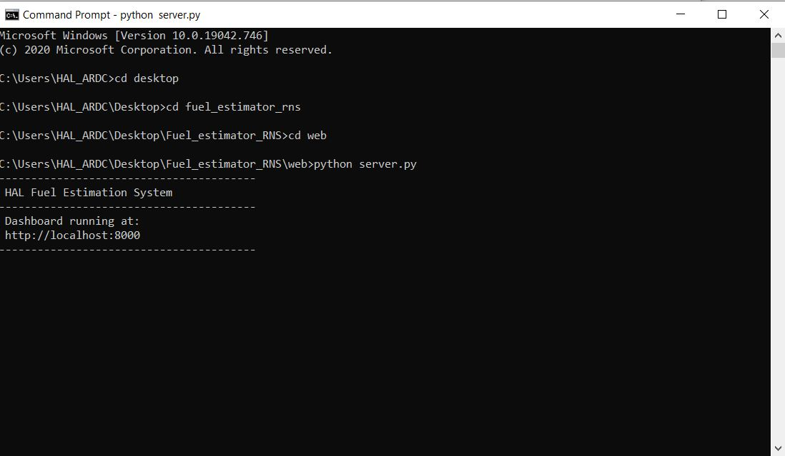

Once the communication was established, the system continuously processed the incoming telemetry and computed important fuel-related parameters, including fuel flow, specific fuel consumption (SFC), fuel remaining, endurance, operational range, reserve fuel, landing fuel, and bingo fuel. The estimation process remained active throughout the flight, allowing the calculated values to update automatically as the aircraft operating conditions changed.
Figure: FlightGear Flight Simulator used for generating real-time flight telemetry.
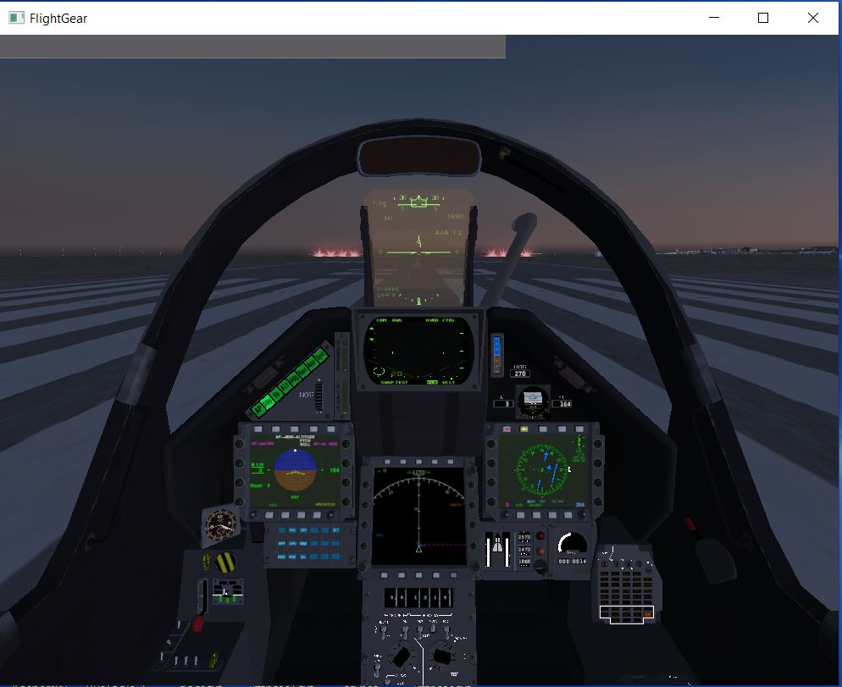

The processed values were displayed through the Fuel Estimation Dashboard developed using HTML, CSS, and JavaScript. The dashboard presented all estimated parameters in an organized layout, enabling users to monitor the aircraft's fuel condition in real time. The interface refreshed automatically whenever new telemetry was received, eliminating the need for manual updates.
Figure : Fuel Estimation Dashboard displaying the aircraft in the NORMAL operating state.
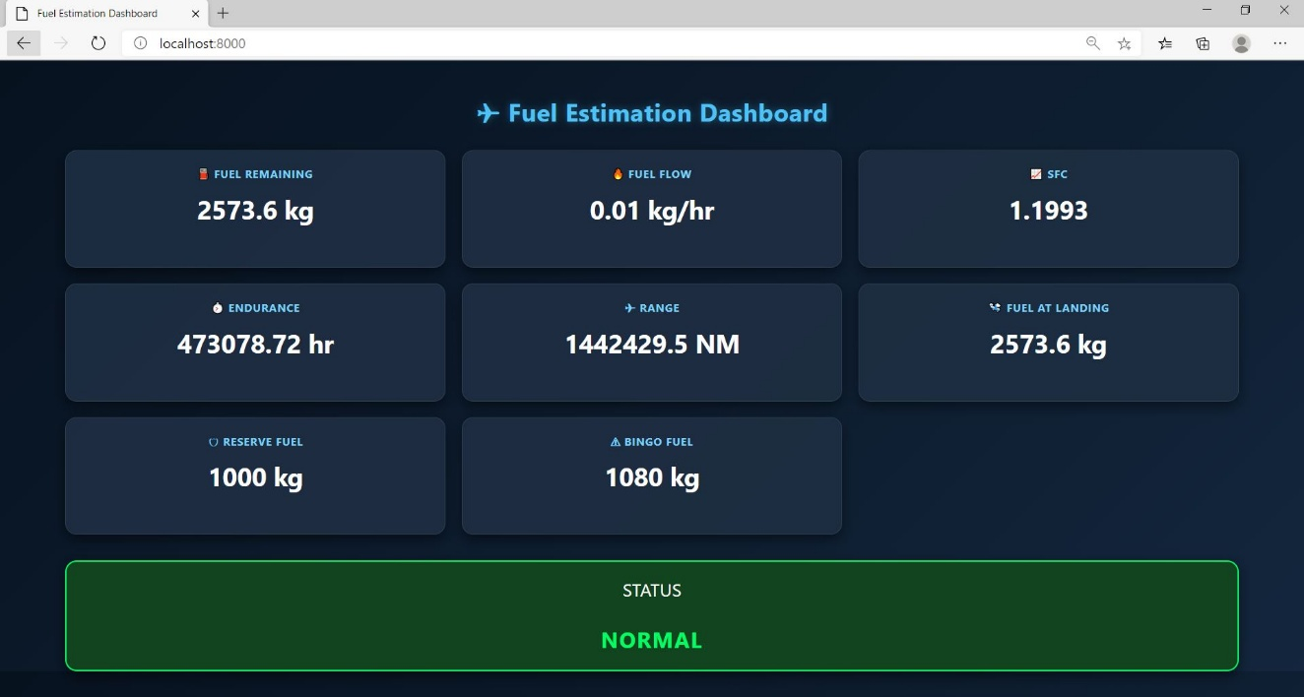
To verify the functionality of the warning logic, the application was also tested under conditions where the available fuel dropped below the predefined safety threshold. Under these conditions, the dashboard successfully identified the critical fuel state and displayed the BINGO warning. This demonstrated that the implemented decision logic correctly recognized low-fuel situations and provided an immediate visual indication to the user.

Figure: Dashboard indicating the BINGO fuel condition during simulation. 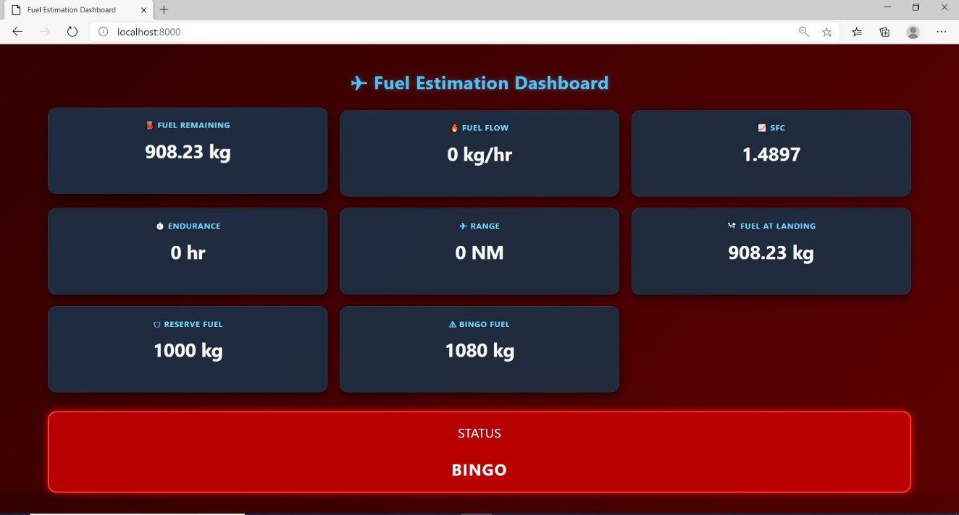

Different flight scenarios were simulated by varying throttle settings, aircraft speed, and fuel quantity. The estimated fuel parameters changed consistently with the aircraft's operating conditions, confirming the effectiveness of the implemented estimation model. During all test cases, communication between the FlightGear simulator, Python backend, and dashboard remained stable, ensuring continuous acquisition, processing, and visualization of flight data without interruption.
Figure: Live telemetry and computed fuel parameters received by the Python backend.
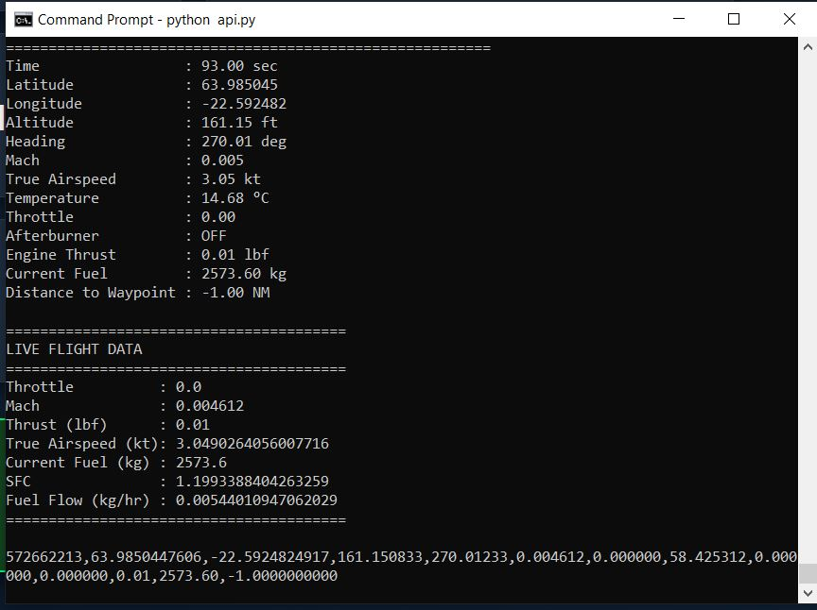

The final integrated system successfully combined the FlightGear simulator, Python backend, and web dashboard into a single application. Real-time telemetry was received from the simulator, processed using the fuel estimation algorithms, and displayed instantly through the dashboard. The developed system achieved the objectives of the project by providing continuous fuel estimation and visualization in a simulated UAV environment.
Figure: Complete integrated system showing Flight Gear, Python backend, and Fuel Estimation Dashboard operating simultaneously. 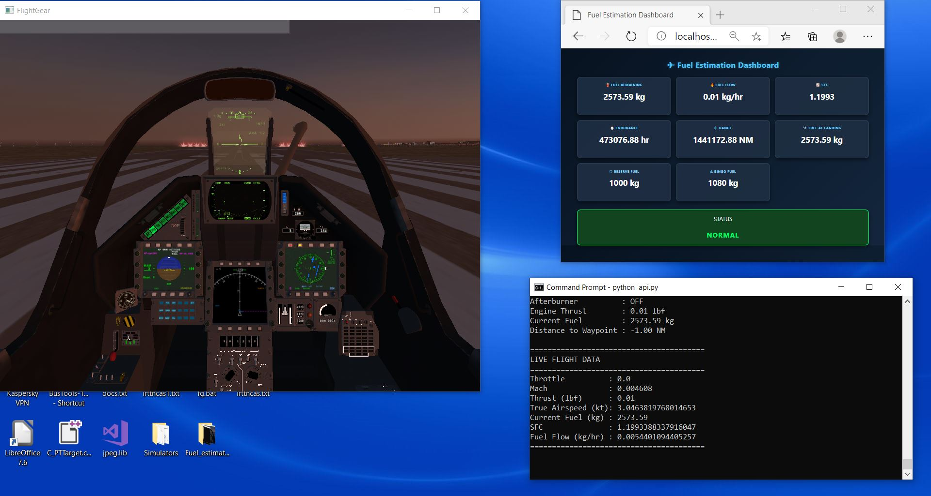

CONCLUSION
The internship at the Aircraft Research and Development Centre (ARDC), Hindustan Aeronautics Limited (HAL), provided valuable exposure to software development for aerospace applications. The project, "Fuel Consumption and Estimator for Future UAVs," was successfully completed by developing a real-time fuel estimation system that integrates the Flight Gear Flight Simulator, a Python-based backend, and an interactive web dashboard.
The developed application successfully received real-time flight telemetry through UDP communication, processed the incoming data, and estimated important fuel-related parameters such as fuel flow, fuel remaining, specific fuel consumption (SFC), endurance, operational range, reserve fuel, landing fuel, and bingo fuel. These parameters were continuously updated and displayed through a user-friendly dashboard, enabling real-time monitoring of aircraft fuel status during simulated flight operations.
The project demonstrated the effective integration of flight simulation, networking, data processing, and web technologies into a single software solution. Testing under different simulated flight conditions confirmed the stability of the communication system and the correct functioning of the implemented fuel estimation logic. The modular design adopted during development also provides flexibility for future improvements and integration with more advanced simulation environments or real UAV platforms.
Overall, the internship enhanced practical knowledge in Python programming, real-time data communication, system integration, and web application development while providing an understanding of software applications in the aerospace domain. The developed system serves as a useful foundation for further research in UAV fuel management and intelligent mission planning, contributing to the development of efficient and reliable fuel estimation techniques for future aviation systems.

REFERENCE

- Hindustan Aeronautics Limited (HAL). Official Website. Available at: https://hal-india.co.in
- FlightGear Development Team. FlightGear Flight Simulator. Available at: https://www.flightgear.org
- FlightGear Development Team. FlightGear Wiki Documentation. Available at: https://wiki.flightgear.org
- Python Software Foundation. Python 3 Documentation. Available at: https://docs.python.org/3/
- Mozilla Developer Network (MDN). HTML, CSS and JavaScript Documentation. Available at: https://developer.mozilla.org
- Internet Engineering Task Force (IETF). RFC 768: User Datagram Protocol (UDP). Available at: https://www.rfc-editor.org/rfc/rfc768
- Technical training sessions, project discussions, and guidance conducted at the Aircraft Research and Development Centre (ARDC), Hindustan Aeronautics Limited (HAL), Bengaluru, during the internship period.

