Python Assignment
Name: Nitya Jaradi

Question 1: Grade Checker
Program
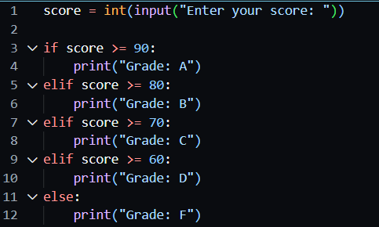
Explanation
This program takes the student's marks as input and uses if-elif-else statements to determine the grade.
Output
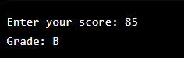

Question 2: Student Grades Dictionary
Program
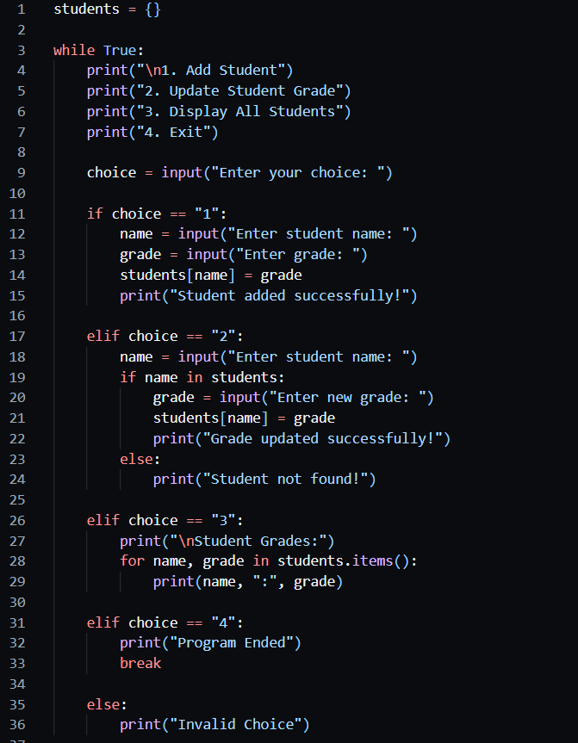
Explanation
This program uses a dictionary to store student names and grades. It allows the user to:
- Add a student
- Update a student's grade
- Display all students

Output
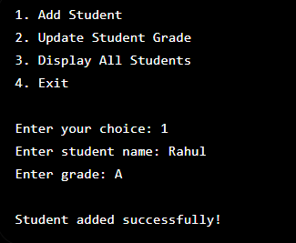

Question 3: Write to a File
Program
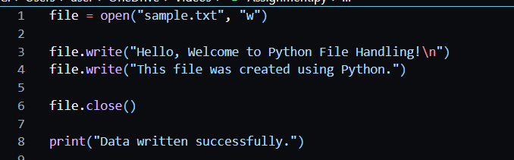
Explanation
This program creates a text file named sample.txt and writes content into it using the write() function.
Output


Question 4: Read from a File
Program
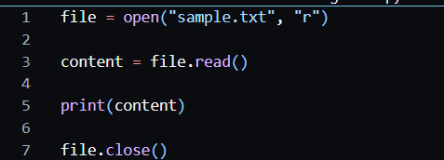
Explanation
This program opens the file in read mode, reads all its contents using read(), and displays it on the screen.
Output
