Game Design Document

Fill up the following document

1. Write the title of your project.

Abandoned toy factory

1. What is the goal of the game?

The PC has to stay alive by avoiding the obstacles coming his way and has to run from the demon chasing him.

1. Write a brief story of your game.

Bob was hanging out with his friends when they challenged Bob to go

In a haunted toy factory where he encounters a ghost named ‘THE HATTER.’

The hatter is chasing Bob throughout the whole building and there are many obstacles such as old toys and non-working machines.

He also encounters some jetpacks to escape the ghost but The Hatter is dead-set to not let this person who disturbs his slumber let-go

1. Which are the playing characters of this game?

* Playing characters are the ones who respond to the user based on the input from the user.
* Cars, monkeys, dinos, wizards, etc., are the playing characters in the game.

|  |  |  |
| --- | --- | --- |
| Number | Character Name | What can this character do? |
| 1 | Bob | He is a PC and can move using the arrow keys. He can avail jetpacks and can also trip over the obstacles |
| 2 |  |  |
| 3 |  |  |
| 4 |  |  |
| 5 |  |  |
| 6 |  |  |
| 7 |  |  |
| 8 |  |  |

1. Which are the Non-Playing Characters of this game?

* Non-Playing characters are the ones that don't have an action or behavior when the user interacts with the game.
* Hurdles, stones, bananas, coins, etc., are non-playing characters in the game.

|  |  |  |
| --- | --- | --- |
| Number | Character Name | What can this character do? |
| 1 | The Hatter | It is a demon that is chasing Bob throughout the building… and has a keen interest to terminate Bob, this person can catch bob if he hits obstacles twice in a row |
| 2 | Old machines | Helps is defeating the PC |
| 3 | Old Toys | Helps is defeating the PC |
| 4 |  |  |
| 5 |  |  |
| 6 |  |  |
| 7 |  |  |
| 8 |  |  |

Draw your imagination of this game. What does this game look like?

* Draw the game either on your computer or on paper.
* Add images of the game scenes to show each of the playing and non-playing characters at least once.

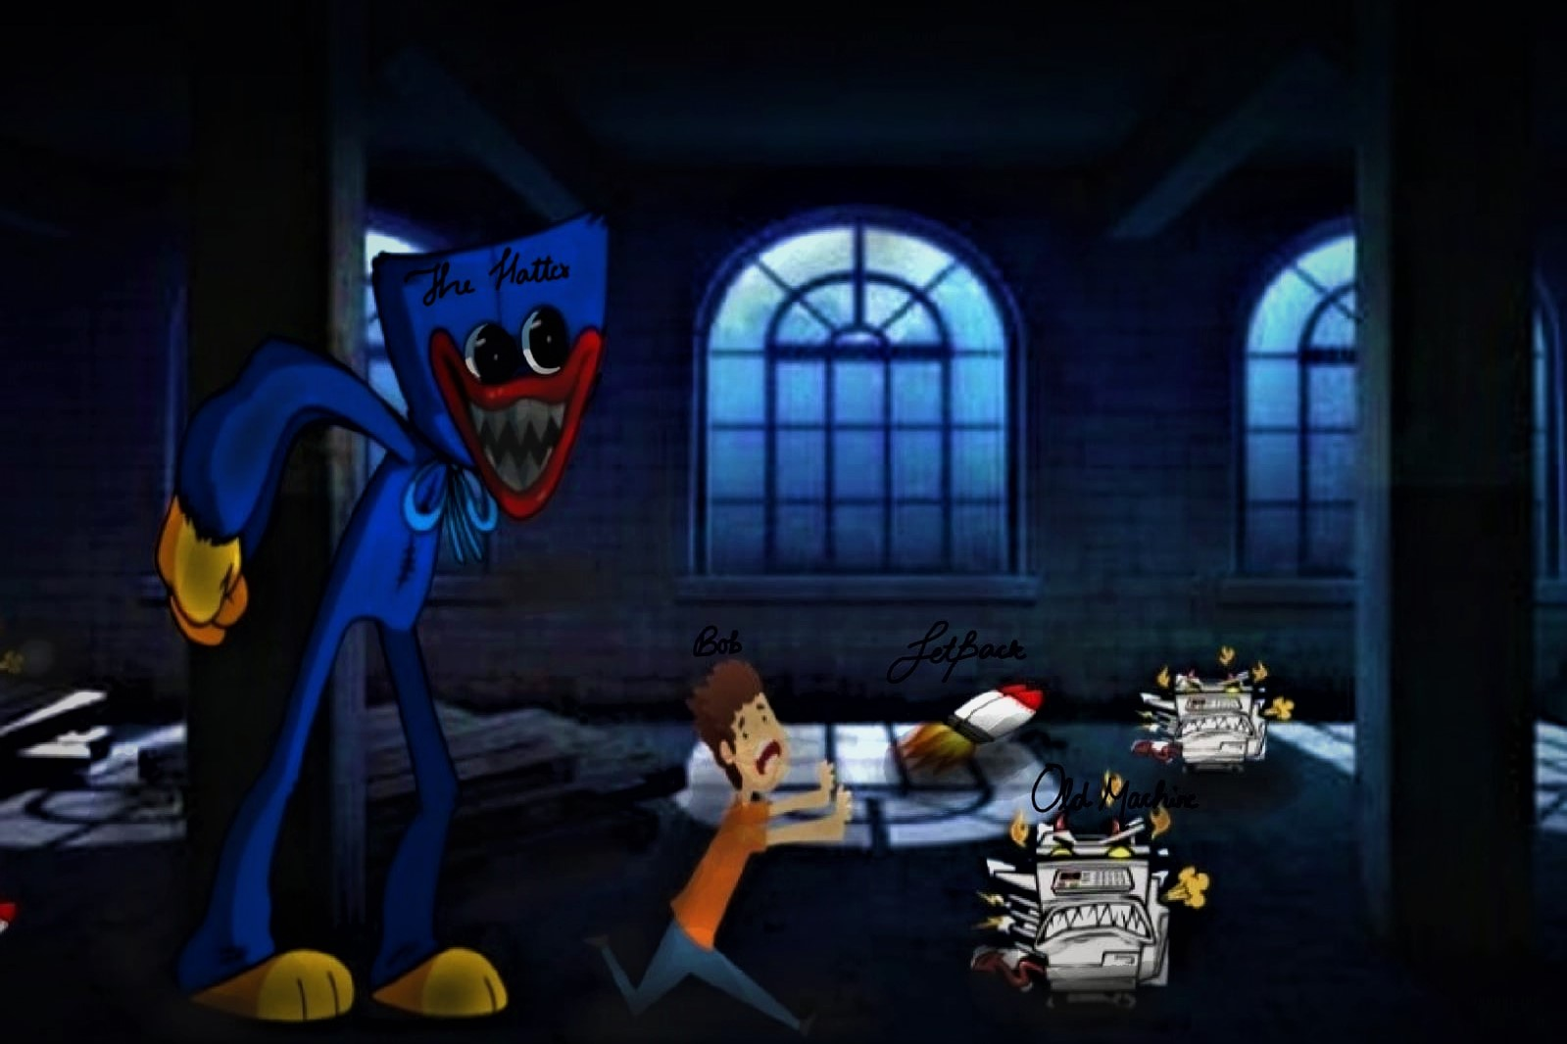

How do you plan to make your game engaging?

In my opinion… teenagers like me enjoy playing spooky games and especially those who have a keen interest in it. It has all the different elements of game designing and this is an infinite runner game so the player can beat his high score.