**Software Requirement**

**Specification**

for

**Notelog**

By:

Amaan Mithani – 19070122108

Ronak Malkan – 19070122100

Nitya Mehta - 19070122118

Contents:

1. INTRODUCTION ................................................................................................................. 3
   1. Purpose .................................................................................................... 3
   2. Definition...................................................................................................3
   3. Overview .................................................................................................. 3
2. OVERALL DESCRIPTION .................................................................................................. 4
   1. Product perspective .................................................................................................... 3

2.1.1 System interfaces ............................................................................... 3 2.1.2 User interfaces.................................................................................... 3

2.1.3 Hardware interfaces ............................................................................

2.1.4 Communications interfaces................................................................. 4

2.2 Product functions ....................................................................................................... 4

* 1. User characteristics...................................................................................................... 5
  2. Constraints...................................................................................................6
  3. Assumptions & dependencies………………………………………………6

1. SPECIFIC REQUIREMENTS

3.1 Login requirements …………………………………………………….

3.2 Sign Up requirements …………………………………………………....

1. DIAGRAMS ........................................................................................................................ 7
   1. Use Case ................................................................................................................. 7
   2. Activity Diagram ............................................................................................................7

4.1.1User Login..................................................................................................8

* + 1. Create ....................................................................................................... 9
    2. Edit ...........................................................................................................10
    3. Delete ………………………………….….……………………………11
  1. Deployment Diagram ……………………………………………………………….12

1. INTRODUCTION
   1. Purpose

This document specifies all the requirements for the Notelog web application. These requirements relate to the functionality, constraints, performance, attribute and the system interface.

Notelog will have an easy to use interface connected directly to a central server. On the server, users can create notes using date and time that can be accessed from any device by logging on to one’s account. It will have create, delete and edit operations for the notes.

* 1. Definitions

Log in- allows users to access their account.

Sign Up- allows users to create an account.

Create- create a new note.

Delete- remove an existing note.

Edit- modify an existing note.

View- to display the note.

Save- to store the created/modified note.

Share- send notes to others.

1.3 Overview

The rest of this document describes the system requirements for the Notelog.

1. OVERALL DESCRIPTIONS

2.1 Product perspective

People need a device independent way of saving notes or thoughts. Hence this web application will allow users to save their notes and access them from any device with internet connection.

2.1.1 System interfaces

Notelog web application integrates two internal systems to provide functionality:

**Client:** Notelog has an interface to the user’s client to receive user input.

**Network:** Notelog has an interface to the network in order to transmit information.

It uses servlets, Java language and servers to interact with users. Depending on the web browser some features may or may not be affected.

2.1.2 User interfaces

Notelog includes several web pages, one for log in, one for sign up, one for viewing the list of notes, etc. It integrates all these web pages into one web application. It will utilize HTML, CSS, JS to make a frontend which will be user friendly and easy to use.

#### 2.1.3 Hardware interfaces

It can be accessed through any device which has internet connection and web browser.

#### 2.1.4 Communications interfaces

Communication between the clients is facilitated by HTTP protocol.

2.2 Product functions

1. Log in –

User need to login into his/her account in order for them to access their notes or create new notes.

1. Sign Up –

If user does not have an account, they need to sign up and create a new account to use the features provided.

1. Create –

This option allows the user to create a new note. When user clicks on button it sends a request and is processed by opening a new note on the screen which allows the user to type the required text.

1. Delete –

This option allows the user to remove/delete the selected note permanently from the database.

1. Edit –

This option allows the user to open the existing note and make changes required by the user.

1. View –

This option allows the user to open the exiting file only for viewing purpose. User cannot manipulate text using this option

1. Save –

This option allows the user to save the created/edited note on the database.

1. Share –

If the user wants to share the note this option allows them to do it via e-mail.

2.3 User Characteristics

Basic knowledge of computer/mobile is adequate to use this web application. The user interface will be friendly enough to guide the user.

## 2.4 Constraints

Some features will suffer based on the version of the web browser used. Sufficient internet speed is necessary to be able to load the web page. Cannot handle large number of users due to memory limitation.

2.5 Assumptions and dependencies

Notelog is device independent and will work on any up to date web browser. It is assumed that the user is familiar with an internet browser and also familiar with handing keyboard and mouse if application is accessed on computer/laptop, if accessed by mobile they should be familiar with touch screen.

1. SPECIFIC REQUIREMENTS
   1. Login Requirement

Purpose: Provides member authentication

Inputs: Inputs are through the keyboard and mouse clicks.

Processing: The input is verified by checking if the member already exists in the database.

Outputs: The correct input will result in the next If the input is incorrect then an error message will be displayed.

* 1. Sign Up Requirement

Purpose: Registration of a non-member.

Inputs: Inputs are through the keyboard and mouse clicks.

Processing:  The input is validated using client side as well as server side validation. The client side validation will include check for username. The server side validation will involve checking if the username entered is already used by a member in the database. The appropriate error messages are displayed if the input is not acceptable

Outputs: The member is directed to the main page on successful sign up.

1. DIAGRAMS
   1. Use Case

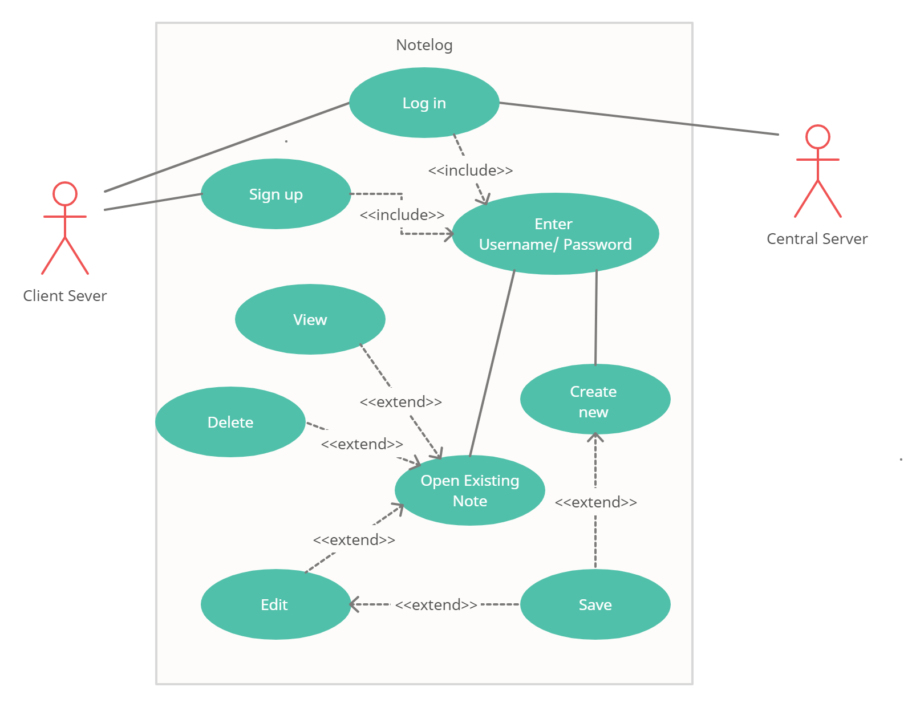

* 1. Activity Diagram

4.2.1 User Login

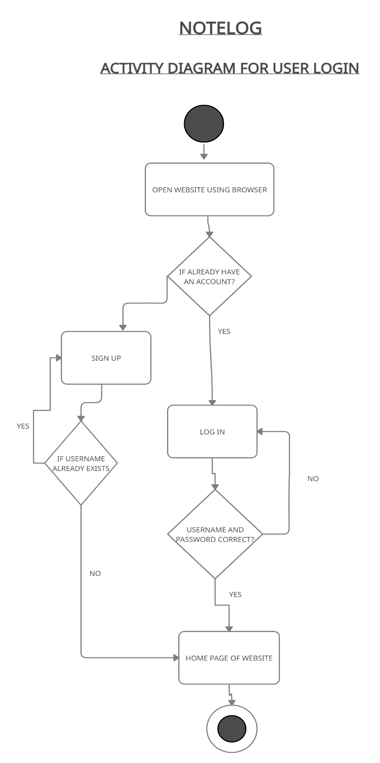

4.2.2 Create Note

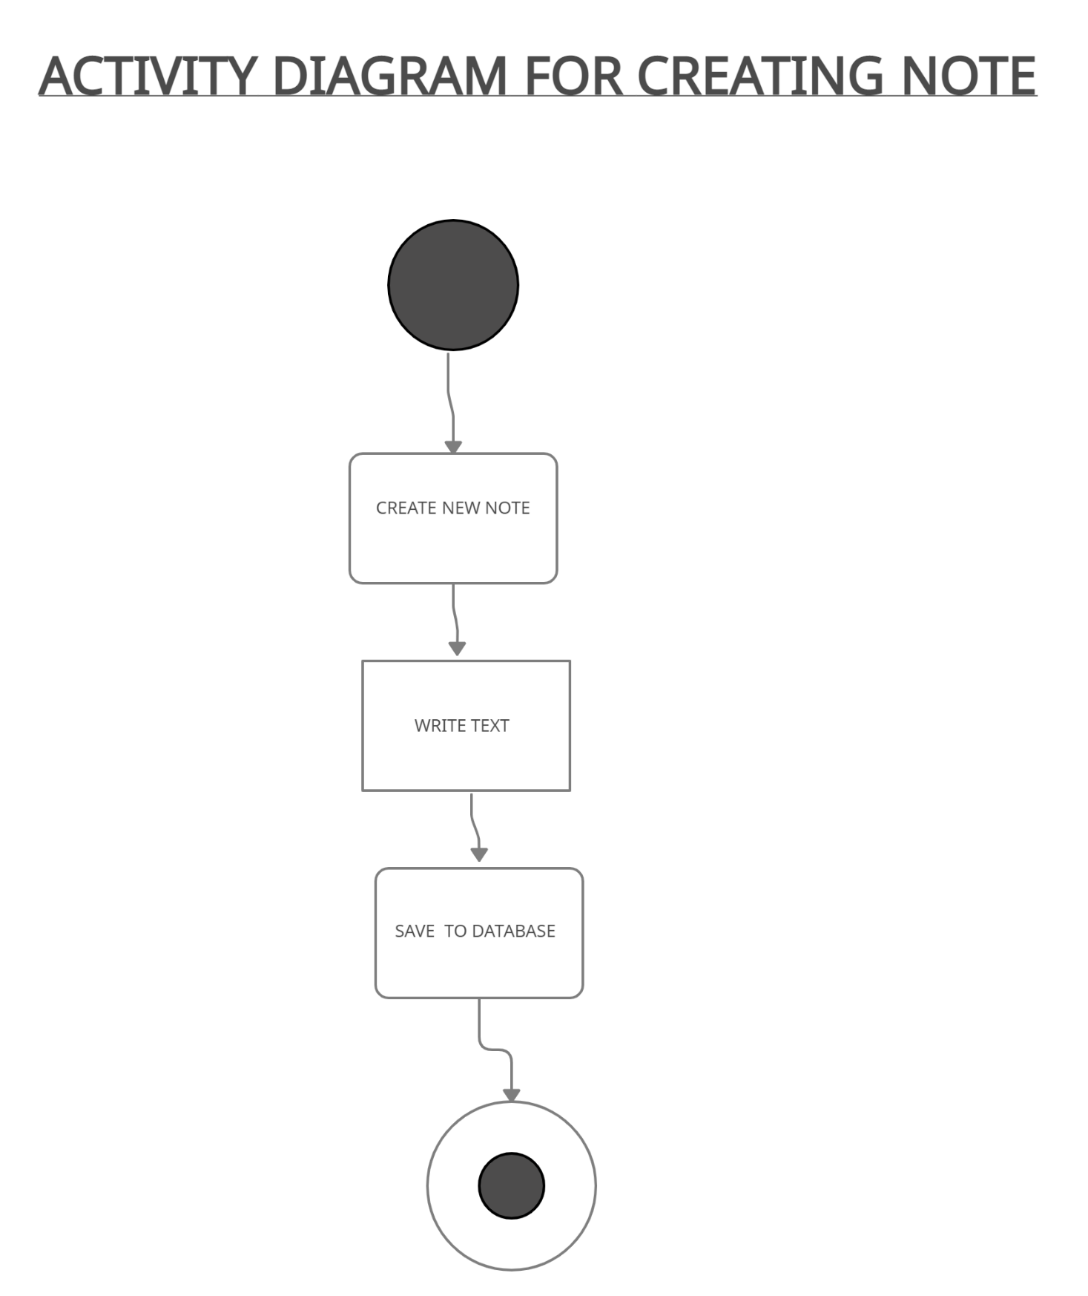

4.2.3 Edit Note

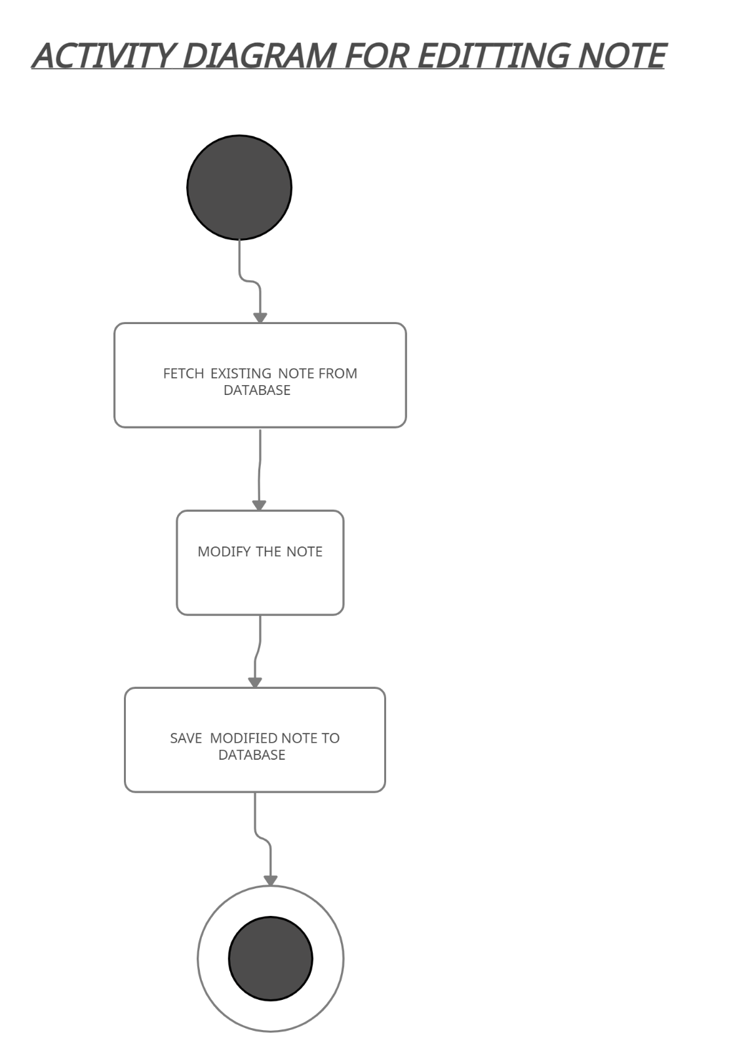

4.2.4 Delete Note

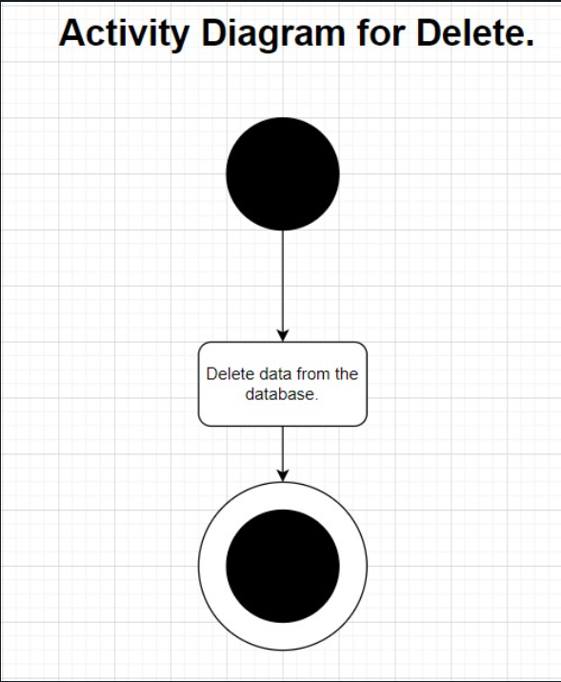

* 1. Deployment Diagram

