Narsee Monjee Institute of Management Studies (NMIMS), Indore
PROJECT REPORT
Wingardium Leviosa
A Real-Time, Gesture- and Voice-Controlled Object Levitation System Using Image and Video Processing
Course: Image and Video Processing

Student Names | Samriddhi Tongia, Saumya Sharma, Nitya Saxena
Sap ID | 70022400054, 70022400341, 70022400740
Programme | B.Tech Computer Engineering
Faculty Name | Dr. Raj Gaurav Mishra
Table of Contents
Abstract 3
1. Introduction 4
1.1 Background of the Problem 4
1.2 Relevance of the Problem 4
1.3 Role of Image and Video Processing 4
1.4 Motivation for Selecting the Project 4
2. Problem Statement and Objectives 5
2.1 Problem Statement 5
2.2 Objectives 5
2.3 Evaluation Criteria 5
3. Scope of the Project 6
3.1 What the Project Covers 6
3.2 What the Project Does Not Cover 6
3.3 Type of Images and Videos Used 6
3.4 Application Domain 6
4. Dataset / Input Description 7
5. Methodology / Proposed Approach 8
6. Techniques / Algorithms Used 9
6.1 Image Processing Techniques 9
6.2 Video Processing Techniques 9
6.3 Key Equations 10
7. Implementation 11
7.1 Language, Tools and Libraries 11
7.2 Hardware 11
7.3 Software Structure 11
7.4 Important Implementation Steps 11
8. Results and Discussion 13
8.1 Evaluation Setup 13
8.2 Input versus Output and Intermediate Results 13
8.3 Object Segmentation 14
8.4 Background Reconstruction 15
8.5 Motion Model and Spell Behaviour 16
8.6 Temporal Smoothing of Hand Tracking 17
8.7 Gesture Recognition 17
8.8 Real-Time Performance 18
8.9 Summary of Findings 18
9. Challenges / Limitations 19
10. Conclusion 20
References 21

Abstract
Making a real object appear to float inside live video normally requires green screens, dedicated tracking hardware or frame-by-frame editing. This project, Wingardium Leviosa, addresses that gap with a real-time image and video processing system that levitates a physical object in a webcam stream using hand gestures and spoken or on-screen spell commands. The user selects an object by drawing a circle with the index finger or by clicking it. The object is segmented with GrabCut, refined with morphological operations and converted into a feathered alpha cut-out. The region it leaves behind is rebuilt from a stored reference background, with Telea inpainting as a fallback. A spring–damper model drives 2D affine transformations, and the result is alpha-blended with shadow, glow and particle layers. MediaPipe hand landmarks and exponential smoothing provide stable control. On four test scenes with known ground truth, segmentation reached an IoU of 0.93–0.98 on three scenes and failed on a low-contrast object (0.25). The finger-circle gesture was recognised in 99–100% of trials, except for very small, noisy circles, and the stages after selection took about 4.5 ms per frame.
Keywords: image segmentation, GrabCut, inpainting, affine transformation, alpha compositing, hand tracking, real-time video processing.

1. Introduction

1.1 Background of the Problem
Making an object rise and float is one of the oldest effects in film and stage magic. In professional production it is created offline, with wires or green screens, manual masking and frame-by-frame compositing. At the same time, webcams are everywhere and real-time computer vision has matured: lightweight neural models can locate the 21 joints of a hand on an ordinary CPU [6], while classical algorithms such as graph-cut segmentation [2] and fast-marching inpainting [3] are available in open libraries such as OpenCV [1]. Together they make it possible to create the levitation illusion live, with no special hardware.
A live system must solve several linked problems at once: the object has to be separated from its surroundings, the scene it leaves behind has to be filled convincingly, the object has to be moved, rotated and scaled, and the whole pipeline has to keep pace with about 30 frames per second, a budget of roughly 33 ms per frame.

1.2 Relevance of the Problem
The problem is relevant for three reasons. First, touch-free gesture and voice control is an active area of human–computer interaction and is useful wherever touching a device is inconvenient. Second, the same building blocks used here (object extraction, background reconstruction or object removal, geometric transformation and alpha compositing) underlie augmented-reality filters, virtual try-on, video-conferencing backgrounds and video-editing tools. Third, a themed application is an engaging way to demonstrate image processing, because every stage produces a visible result.

1.3 Role of Image and Video Processing
Each sub-problem of the levitation illusion is solved with an image or video processing technique:
- Seeing the user: frame acquisition, colour-space conversion and hand-landmark detection, followed by temporal smoothing of the tracked fingertip.
- Choosing an object: contour analysis of the finger-drawn loop, a pointing ray, or a mouse click, followed by edge- and region-based candidate detection.
- Cutting the object out: GrabCut segmentation, morphological clean-up and Gaussian feathering to obtain a soft alpha matte [2].
- Erasing it from the scene: replacement from a clean reference background, with Telea inpainting as a fallback [3].
- Making it float: 2D affine transformation, a spring–damper motion model and layered alpha compositing with shadow, glow and particles [8].

1.4 Motivation for Selecting the Project
The project was chosen because it brings almost every major topic of an Image and Video Processing course (filtering, edge detection, thresholding, morphology, segmentation, geometric transformation, inpainting, colour spaces and video-rate temporal processing) into one working system whose output is immediately visible and easy to demonstrate. A second motivation was robustness: the application should still run when a camera, microphone or hand-tracking model is missing, on a standard laptop without a GPU. The levitation charm from the Harry Potter books [14] provided a recognisable theme.

2. Problem Statement and Objectives

2.1 Problem Statement
Real-world problem: creating convincing interactive visual effects, and manipulating on-screen objects without touching a device, normally needs specialised hardware (depth sensors, motion-capture rigs, green screens) or lengthy offline video editing. This project asks whether an object seen by an ordinary webcam can be lifted out of the scene and moved by hand and voice, in real time, using only image and video processing on a standard computer.

2.2 Objectives
The objective of this project is to make a physical object appear to levitate in a live webcam video, and to let the user control it with hand gestures and voice commands, using image and video processing and hand-landmark detection techniques. The specific objectives are:
- To acquire a live 1280×720 webcam stream and process it in real time (30 FPS target), with a synthetic fallback scene when no camera is available.
- To detect the user’s hand with MediaPipe landmarks, smooth the fingertip track, and recognise the gestures POINT, PALM, FIST and PINCH as well as a closed finger-drawn circle used to select an object.
- To segment the selected object with GrabCut and morphological refinement and extract it as a feathered alpha cut-out.
- To reconstruct the background revealed behind the object so that it appears to leave the table.
- To animate the cut-out with affine transformations, a spring–damper motion model and visual effects, controlled by the four spells (Wingardium Leviosa, Accio, Expelliarmus and Finite), and to evaluate the quality and speed of the result.

2.3 Evaluation Criteria
The following criteria are used in Section 8 to judge whether the objectives were met:
- Segmentation overlap (IoU) of at least 0.90 against ground truth for objects that contrast with their background.
- Faithful scene restoration after object removal, measured with PSNR and SSIM against the true clean scene.
- Recognition of deliberate finger circles in at least 95% of trials, with no false triggers on non-circular strokes.
- Stable, jitter-free motion and a per-frame processing time well inside the 33 ms budget.

3. Scope of the Project

3.1 What the Project Covers
- Real-time capture, processing and display of a live webcam stream in a desktop application.
- Single-hand tracking, rule-based gesture recognition and finger-circle object selection; a colour-based wand tracker is used as a fallback.
- Selection of one object at a time by finger circle, mouse click or pointing ray.
- GrabCut segmentation, background reconstruction, affine transformation and compositing of the selected object.
- Four spells (Wingardium Leviosa, Accio, Expelliarmus, Finite) triggered by voice, on-screen buttons or the keys 1–4, plus a debug overlay.
- Fallbacks for a missing camera, microphone or MediaPipe model, and packaging as a Windows executable.

3.2 What the Project Does Not Cover
- Depth estimation or 3D reconstruction: the effect is a 2D simulation with no true perspective or occlusion handling.
- Multiple simultaneous objects or hands, and moving cameras: a static camera and an essentially static scene are assumed.
- Training of any neural network: the only learned component is the pre-trained MediaPipe hand-landmark model.
- Real physics such as gravity and collisions, and processing of pre-recorded video files.
- Offline speech recognition: voice commands use the Google web recognition service and need an internet connection.
- A user study or field testing on many real webcams and lighting conditions.

3.3 Type of Images and Videos Used
The system processes live colour video from a standard webcam (8-bit, 3-channel frames at 1280×720 requested). When no camera is found it generates a synthetic indoor scene (wall, wooden table and a book). Evaluation in Section 8 uses still frames and scripted sequences derived from this synthetic scene.

3.4 Application Domain
The main domains are interactive and educational media, entertainment and augmented-reality-style effects, and gesture-based human–computer interaction. The same pipeline (selection, matting, background reconstruction, transformation and compositing) also applies to object removal, video editing and virtual try-on.

4. Dataset / Input Description
The project is an interactive, real-time application, so it has no fixed image dataset: its input is the live video stream from the user’s webcam. Table 1 summarises the inputs, and Figure 1 shows the sample frames used for evaluation.
Table 1. Input specification.
Item | Description
Source | Live webcam via OpenCV VideoCapture (DirectShow backend on Windows); built-in synthetic scene generator if no camera is available.
Dataset name | None (real-time input). One pre-trained asset is used: MediaPipe hand_landmarker.task (7.8 MB).
Number of images / videos | Continuous stream. For evaluation: 4 still scenes, one scripted 9 s sequence (270 frames) and 1,300 simulated gesture trials.
Image resolution | 1280×720 requested (the camera’s actual size is used); synthetic frames are 1280×720. Hand tracking runs on a copy resized to 640 px width.
Image format | 8-bit, 3-channel BGR arrays (OpenCV), mirrored horizontally. Cut-outs are 4-channel BGRA. RGB, HSV and grayscale are derived as needed.
Video resolution / duration | 1280×720 at a 30 FPS target; a session lasts as long as the user runs the application. The evaluation sequence lasts 9 s.

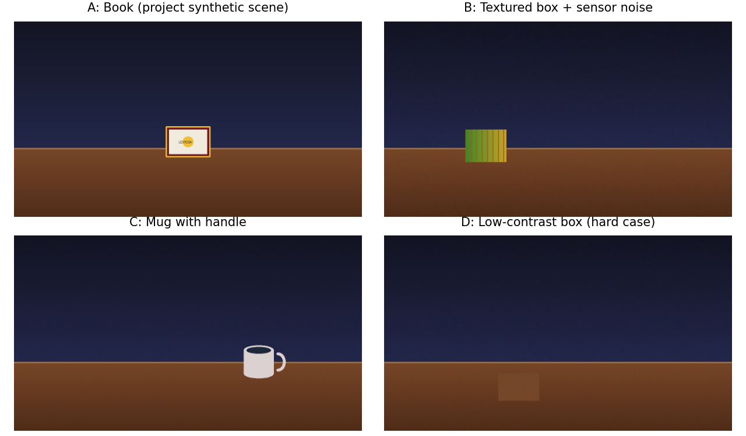
Figure 1. Sample input frames (1280×720, shown reduced). A: the application’s built-in synthetic scene; B: textured box with Gaussian sensor noise (σ = 4); C: mug with a thin handle; D: low-contrast box (hard case). Scenes B–D are synthetic extensions with known ground-truth masks.
No recorded webcam footage is included in the project archive, so the sample frames in Figure 1 are synthetic. Scene A is produced by the application’s own camera module, and scenes B–D were drawn with the same background to test noise, curved shapes and low contrast.

5. Methodology / Proposed Approach
Figure 2 shows the complete processing pipeline. Each frame is captured and mirrored (1), the hand is tracked and its fingertip filtered (2–3), and spell commands arrive from voice, buttons or keys through a thread-safe queue (4). An object is selected from a finger circle, click or pointing ray (5) and segmented in a background thread so that the display never stalls (6). On every frame, the spell controller sets the motion target and the physics engine advances the object (7). The reference background replaces the object’s original footprint (8), the cut-out is transformed (9), and the layers are composited (10) and displayed (11).
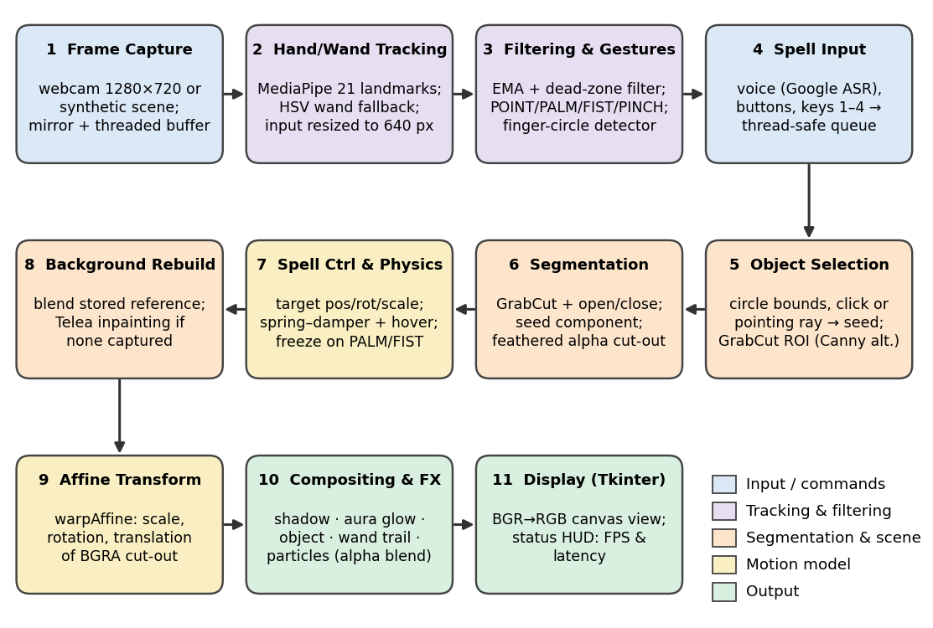
Figure 2. Block diagram of the complete processing pipeline (stages 1–11).
Algorithm 1: Real-time levitation loop (one iteration per frame)
Input : video stream V, spell commands Q (voice / buttons / keys)
Output: composited frame shown in the GUI
1 B <- reference background (auto-captured after 5 frames or on demand)
2 while application is running:
3 F <- mirrored frame from V
4 L <- HandLandmarker(resize(F, 640 px wide)) # 21 landmarks
5 p <- EMA-filtered index fingertip; g <- gesture(L)
6 if finger path forms a closed circle: start async selection(bounds)
7 if spell in Q or click and no object: start async selection(seed)
8 async selection: bbox <- GrabCut ROI around seed
9 (M, O) <- GrabCut(F, bbox); open/close(M); O.alpha <- blur(M)
10 apply spell: set target position, rotation, scale
11 if g in {PALM, FIST}: freeze else: target <- p (for Leviosa / Accio)
12 spring-damper step; add sinusoidal hover offset
13 R <- F with feathered mask footprint replaced by B (Telea if no B)
14 T <- warpAffine(O, scale, rotation, position)
15 Out <- blend(R, shadow, glow, T, wand trail, particles)
16 display(Out)

6. Techniques / Algorithms Used

6.1 Image Processing Techniques
Table 2. Image processing techniques, where they are used, and key parameters.
Technique | Purpose in the project | Key parameters / module
Colour-space conversion | BGR→RGB for MediaPipe and display; BGR→HSV for the wand tracker; BGR→gray for edges and thresholding | cv2.cvtColor
Grayscale conversion and Gaussian filtering | Noise suppression before edge detection and thresholding | 5×5 kernel; detector, segmenter
Edge detection (Canny) [4] | Fallback candidate-object detection when GrabCut ROI selection fails | thresholds 30/120; then 5×5 dilation × 2
Thresholding | Otsu (inverse) fallback segmentation [5]; HSV range threshold for the wand colour | Otsu automatic; HSV (15–35, 100–255, 100–255)
Morphological operations | Opening and closing remove specks and fill holes in the object mask; dilation widens the erase region | 5×5 ellipse; 7×7 ellipse × 2 for erasing
Image segmentation (GrabCut) [2] with connected components | Extracts the selected object; the component containing the seed is kept | 3 iterations; mask-initialised; seed = sure foreground
Feature extraction | 21 hand landmarks; pointing vector from index MCP to tip; contour area, perimeter, bounding box and circularity for circle detection | circularity ≥ 0.48; aspect 0.55–1.8
Alpha matting (feathering) | Soft object edges to avoid staircase artefacts | Gaussian blur of the mask, 5×5
Image inpainting (Telea) [3] | Fills the vacated region when no clean reference exists | radius 5
Geometric (affine) transformation | Rotates, scales and translates the cut-out | warpAffine, bilinear interpolation
Alpha compositing [8] | Combines shadow, glow, object, trail and particles | shadow blur up to 81×81; glow blur 31×31

6.2 Video Processing Techniques
Table 3. Video processing techniques.
Technique | Purpose in the project | Key parameters / module
Frame acquisition and buffering | Threaded capture keeps only the newest frame so latency stays low | buffer size 1; horizontal mirror
Hand and wand tracking across frames | MediaPipe HandLandmarker in VIDEO mode (detection plus temporal tracking) [6, 7]; colour-based wand tip as a fallback | confidence 0.7; one hand
Temporal filtering (EMA) | Removes jitter from the fingertip, wrist, pointing ray and rotation signals | α = 0.3; dead-zone 1.5–2 px
Temporal background model | Running average of the static scene outside the object mask keeps the reference current | α = 0.02, every 30th frame
Not used: histogram equalisation, DFT/DCT, optical flow, frame differencing and background subtraction. The object does not need to be detected by motion, because the user selects it directly, and the reference-frame replacement used instead of subtraction is simpler and faster for a static scene.

6.3 Key Equations
S_{t} = α·Y_{t} + (1 − α)·S_{t−1}, α = 0.3 (1)
v = (P₈ − P₅) / ‖P₈ − P₅‖ (2)
M = [ s·cosθ s·sinθ t_{x} ; −s·sinθ s·cosθ t_{y} ] (3)
I_{out} = (1 − α)·I_{bg} + α·I_{fg} (4)
C = 4πA / P² (5)
a = k·(x_{target} − x) − c·v; v ← v + a; x ← x + v (k = 0.12, c = 0.78) (6)
Here (1) is exponential smoothing of a tracked coordinate, (2) the pointing direction from index-finger landmarks 5 and 8, (3) OpenCV’s rotation–scale–translation matrix, (4) alpha blending with the feathered matte, (5) the circularity of the finger-drawn loop (A = area, P = perimeter), and (6) the per-frame spring–damper update.

7. Implementation

7.1 Language, Tools and Libraries
The system is written in Python 3.11 (about 2,700 lines in 16 modules). It was developed in Visual Studio Code on Windows and packaged into a stand-alone executable with PyInstaller. Table 4 lists the libraries.
Table 4. Libraries and frameworks.
Library | Used for
OpenCV (opencv-python and contrib ≥ 4.8) [1] | Capture, colour conversion, Canny, morphology, GrabCut, inpainting, warpAffine, drawing
MediaPipe ≥ 0.10 (Tasks HandLandmarker) [6, 7] | 21-point hand landmark detection and tracking (VIDEO mode)
NumPy ≥ 1.24 [11] | Frame and mask arrays, vector arithmetic, physics state
SpeechRecognition ≥ 3.10 and PyAudio ≥ 0.2.14 [13] | Microphone capture and voice-command recognition (Google web API)
Pillow ≥ 9.5 and Tkinter [16] | Dark-themed GUI, live viewport, buttons, status bar
Matplotlib, scikit-image [12] (evaluation only) | Report figures and SSIM; not needed to run the application

7.2 Hardware
The application needs only a standard Windows PC or laptop with a webcam; a microphone is optional and no GPU is used. The measurements in Section 8 were obtained on a single-core Linux container (Python 3.12.3, OpenCV 4.13.0, MediaPipe 0.10.33, NumPy 2.4.4) with a synthetic camera, so absolute timings are indicative rather than those of a typical laptop.

7.3 Software Structure
The code follows the pipeline of Figure 2: camera (capture, FPS, synthetic scene), tracking (hand and wand trackers), detection (Canny and GrabCut candidate search), segmentation (GrabCut, morphology, matting), processing (background, transformation, compositing, effects, smoothing), magic (spell state machine and physics), speech (voice listener), ui (Tkinter interface) and config (constants), orchestrated by main.py.

7.4 Important Implementation Steps
- Capture: a daemon thread reads and mirrors frames and keeps only the latest one; if the camera cannot be opened, a synthetic scene is generated.
- Hand tracking: frames are shrunk to 640 px width before MediaPipe is called, and the landmarks are scaled back to full resolution.
- Selection: a finger path counts as a circle when it has at least 12 points, a bounding box of at least 40 px, aspect ratio 0.55–1.8, a start-to-end gap of at most 30% of the radius and circularity of at least 0.48.
- Segmentation: selection runs in a single-worker thread pool. GrabCut is initialised from a mask (sure-foreground seed disc, probable foreground inside the box, background border) and then cleaned with opening, closing and seed-component selection.
- Background: a reference frame is stored after 5 warm-up frames or on demand (key B) and slowly refreshed outside the object mask; inpainting is used only when no reference exists.
- Motion: Leviosa lifts the object 120 px and then follows the fingertip; Accio pulls it to the fingertip at ×1.4 scale; Expelliarmus throws it 220 px away at ×0.85 scale; Finite returns it to the origin and re-attaches it within 12 px. Palm or fist freezes it.
- Compositing and UI: layers are blended in the order shadow, glow, object, wand trail, particles. Spell commands from the voice thread and the GUI are queued and applied by the render thread only.

8. Results and Discussion

8.1 Evaluation Setup
Because the application is interactive, the project archive contains no recorded webcam footage. To obtain repeatable, quantitative results, the project’s own modules were executed headlessly in an evaluation harness on (i) synthetic scenes with exact ground-truth masks, (ii) simulated fingertip trajectories and (iii) a scripted 9 s spell sequence at 30 FPS. The hand-landmark model was exercised only for timing, as no real hand images were available. Metrics used:
- IoU = |P∩G| / |P∪G| and Dice = 2|P∩G| / (|P| + |G|) between predicted mask P and ground truth G.
- PSNR = 10·log₁₀(255² / MSE) and SSIM [10] between a reconstructed region and the true clean scene.

8.2 Input versus Output and Intermediate Results
Figure 3 follows scene A through the pipeline. The Canny edge map (b) is only the backup candidate detector; the main path uses GrabCut inside a ROI around the seed (a), giving the mask in (c). The feathered BGRA cut-out (d) is later transformed, while the original footprint is rebuilt (e). Figure 4 shows the final output for each spell.
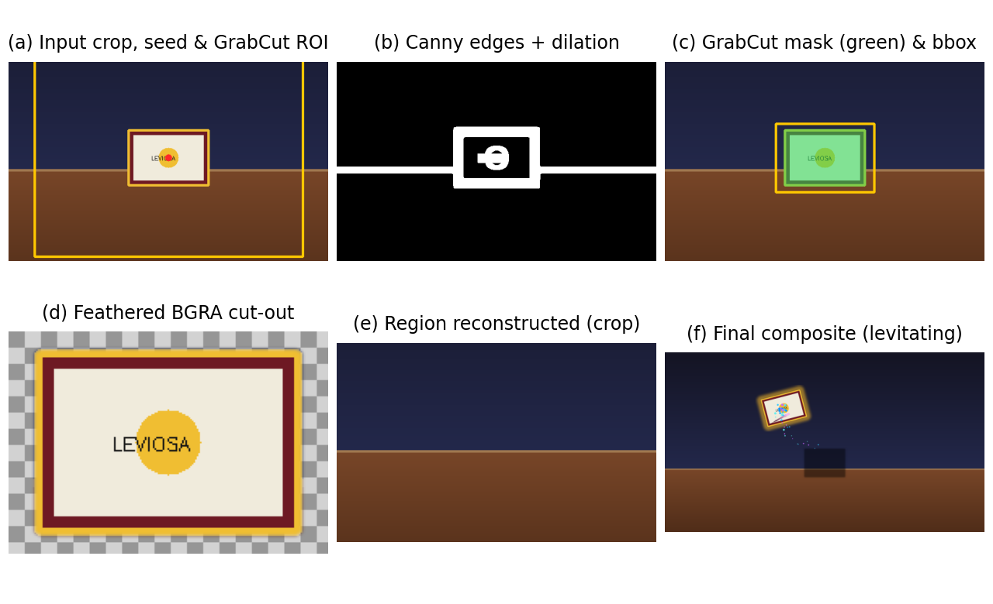
Figure 3. Intermediate results for scene A: (a) input with seed point (red) and GrabCut ROI (yellow); (b) Canny edges after dilation; (c) GrabCut mask; (d) feathered cut-out over a checkerboard; (e) reconstructed region; (f) final composite while levitating.
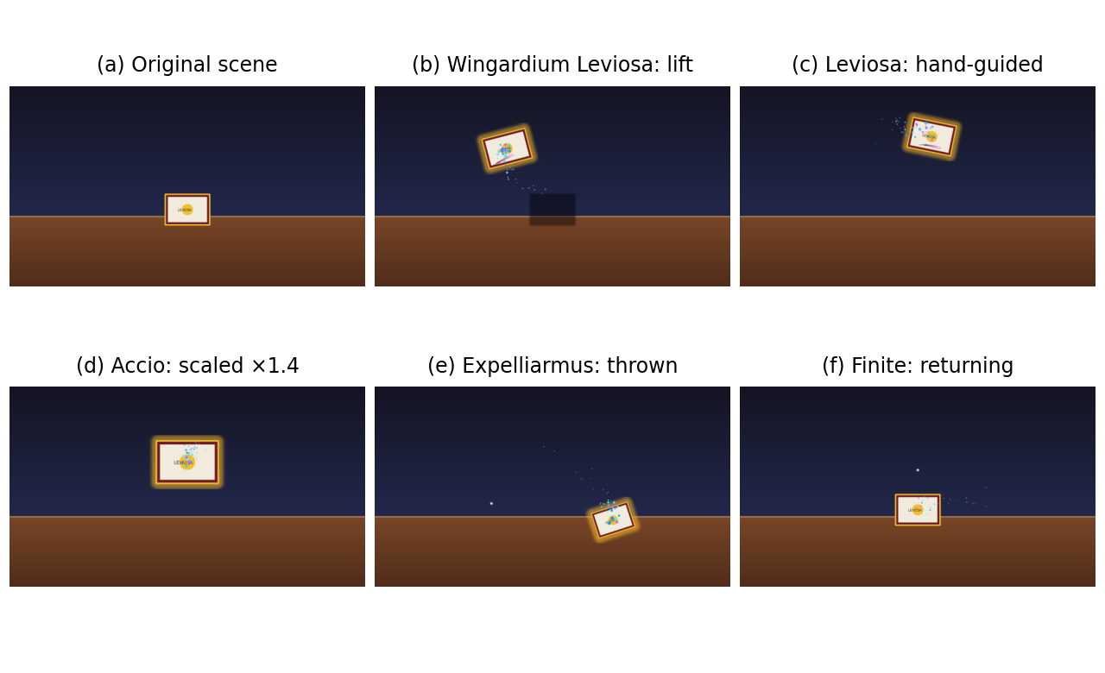
Figure 4. Output frames of the scripted sequence: (a) original scene; (b) Wingardium Leviosa lift; (c) hand-guided motion with rotation; (d) Accio at ×1.4 scale; (e) Expelliarmus throw at ×0.85 scale; (f) Finite returning the object. Once the object is lifted, the table is empty where it stood, and the object carries a golden aura; a soft shadow appears when it is raised.
In all lifted frames the original location is empty, the object keeps sharp but soft-edged boundaries, and rotation and scaling are smooth. The shadow appears only while the object is more than 5 px above its origin, and fades as the height grows.

8.3 Object Segmentation
Table 5. Segmentation results (GrabCut path used by the application, and Otsu fallback on the same box).
Scene | ROI selection (ms) | Segmentation (ms) | IoU | Dice | Otsu fallback IoU
A: Book | 775 | 36 | 0.943 | 0.970 | 0.138
B: Textured box + noise | 880 | 30 | 0.980 | 0.990 | 0.007
C: Mug with handle | 1057 | 29 | 0.925 | 0.961 | 0.066
D: Low-contrast box | 4177 | 3258 | 0.245 | 0.394 | 0.000
Mean, A–C | 904 | 32 | 0.949 | 0.974 | 0.070
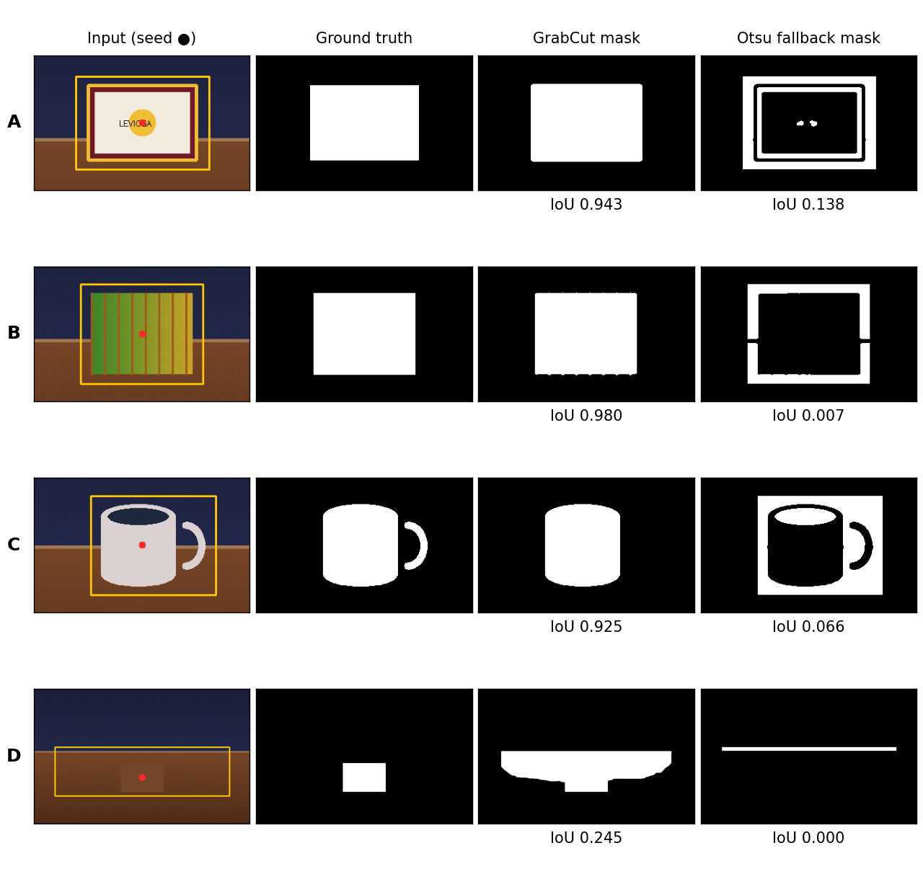
Figure 5. Segmentation results. Columns: input with seed (red) and detected box (yellow); ground truth; GrabCut mask; Otsu fallback mask.
GrabCut met the 0.90 IoU criterion on all three contrasting objects (mean IoU 0.949), including the noisy scene B. In scene C, the thin handle was lost, because morphological opening and the seed-component step remove thin structures, which explains the lower IoU of 0.925. In scene D the box differs from the table by only about 8–12 grey levels, so GrabCut leaked into the table (IoU 0.245) and was also much slower (4.2 s). The Otsu fallback performed poorly everywhere: it is an inverse threshold that assumes a dark object, and it is used only when GrabCut raises an error. Selection takes about 0.8–1.1 s in this environment, which is why it runs in a background thread.

8.4 Background Reconstruction
Table 6. Quality of the reconstructed region (object bounding box plus 16 px margin).
Condition | PSNR (dB) | SSIM
Object not removed (live frame) | 7.59 | 0.542
Clean reference captured before selection | ∞ (identical) | 1.000
Clean reference, scene 15% brighter afterwards | 31.25 | 0.983
No reference: Telea inpainting fallback | 25.67 | 0.923
Reference captured with the object present | 7.59 | 0.542
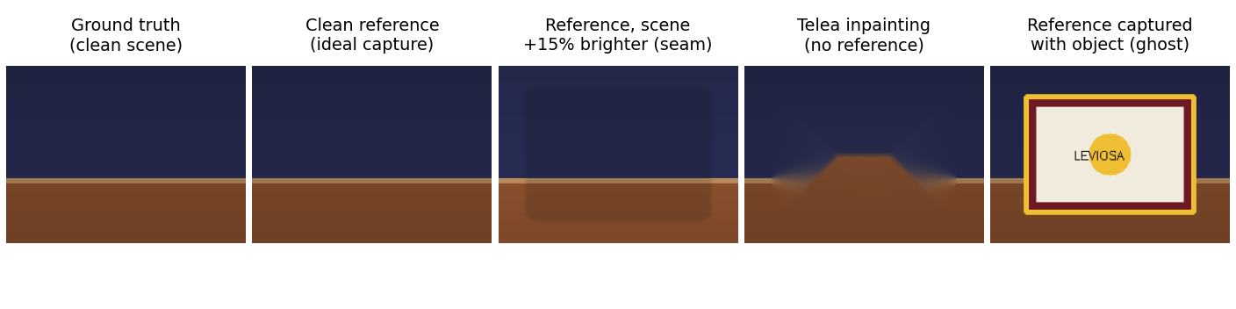
Figure 6. Reconstructed region under each condition, compared with the true clean scene.
With a clean reference the erased region is restored exactly in this static synthetic scene. A brightness change after capture leaves a visible seam (31.3 dB), and the Telea fallback smears the table edge (25.7 dB). When the reference was captured with the object still present, as happens if the automatic capture at frame 5 is not repeated on an empty table, the object is not erased at all (identical to the unprocessed frame). A clean capture (key B) is therefore important.

8.5 Motion Model and Spell Behaviour
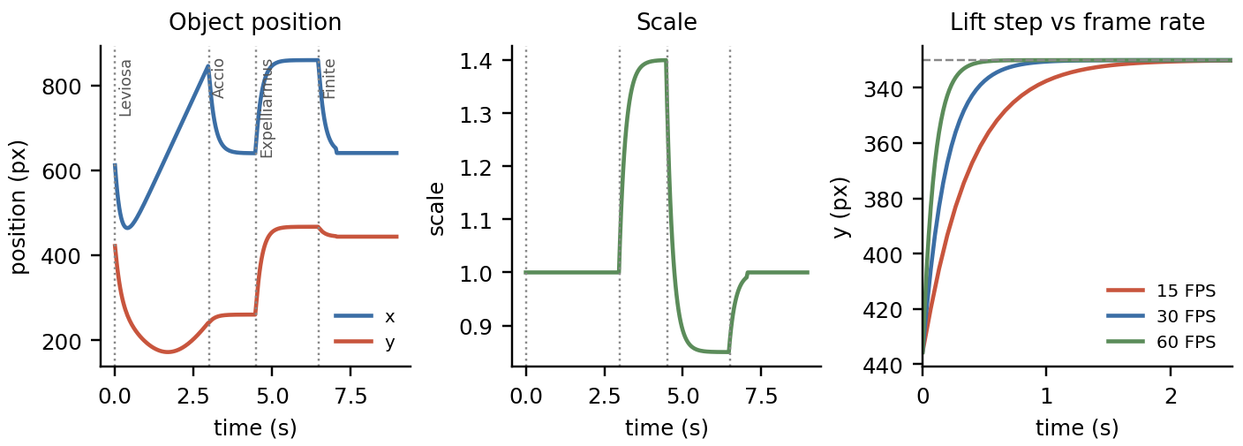
Figure 7. Left: object position over the scripted sequence (dotted lines mark the spell commands). Centre: scale. Right: response of a 120 px lift to the spring–damper model at 15, 30 and 60 FPS.
The spring–damper model with k = 0.12 and c = 0.78 is heavily damped: a 120 px lift reaches 90% of its target in 0.43 s at 30 FPS with no overshoot. Accio raised the scale smoothly to 1.40, Expelliarmus reduced it to 0.85, and after Finite was cast at 6.5 s, the object returned to its origin and was re-attached at 7.07 s (0.57 s later). The update is applied once per frame and not scaled by the elapsed time, so the 2 px settling time is 0.38 s at 60 FPS, 0.77 s at 30 FPS and 1.53 s at 15 FPS. Motion speed therefore depends on the achieved frame rate.

8.6 Temporal Smoothing of Hand Tracking
Table 7. Effect of the EMA coefficient on a simulated noisy fingertip path (Gaussian noise σ = 3 px per axis, 300 frames).
α | Lag error vs true path (RMS, px) | Jitter (RMS 2nd difference, px)
0.1 | 90.4 | 1.02
0.2 | 47.3 | 1.66
0.3 (used) | 28.8 | 2.35
0.5 | 12.9 | 4.03
0.7 | 6.3 | 6.15
1.0 (no smoothing) | 4.2 | 10.43
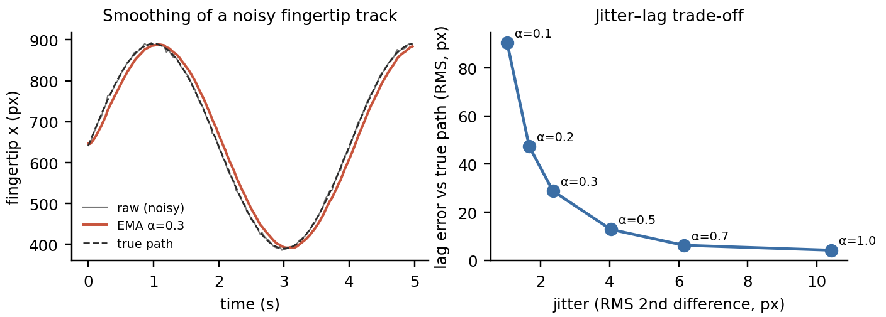
Figure 8. Left: raw, filtered and true x-coordinate. Right: the jitter–lag trade-off for different α.
At the chosen α = 0.3 the jitter falls from 10.4 px to 2.4 px (a 77% reduction), so the levitating object does not tremble. The price is a lag of about 29 px RMS behind a fast sweep; this lag is partly hidden because the object is itself driven through a spring–damper.

8.7 Gesture Recognition
Table 8. Finger-circle recognition on simulated trajectories (100 trials per row, tracker coordinates of 640 px width).
Stroke | Noise σ = 0 px | σ = 3 px | σ = 6 px
Circle, radius 40 px | 100% | 100% | 0%
Circle, radius 70 px | 100% | 100% | 99%
Circle, radius 100 px | 100% | 100% | 100%
False triggers on non-circular strokes (σ = 2 px): straight line 0%, zig-zag 0%, 234° partial arc 0%, ellipse with aspect ratio 2.5 also 0%. Circles are recognised reliably, and incorrect shapes are rejected. The only failure is a very small circle (radius 40 px) with strong jitter, where the circularity test fails.

8.8 Real-Time Performance
Table 9. Processing time per frame (ms) while the object is levitating (212 frames).
Stage | Mean | Median | 95th pct. | Max
Background reconstruction | 0.97 | 0.96 | 1.21 | 2.41
Affine transformation | 0.32 | 0.30 | 0.40 | 2.83
Compositing and effects | 3.18 | 3.17 | 4.14 | 6.65
Total (stages above + physics) | 4.49 | 4.47 | 5.62 | 8.21
MediaPipe hand tracking (frame without a hand) | 14.4 | 13.6 | 18.7 | —
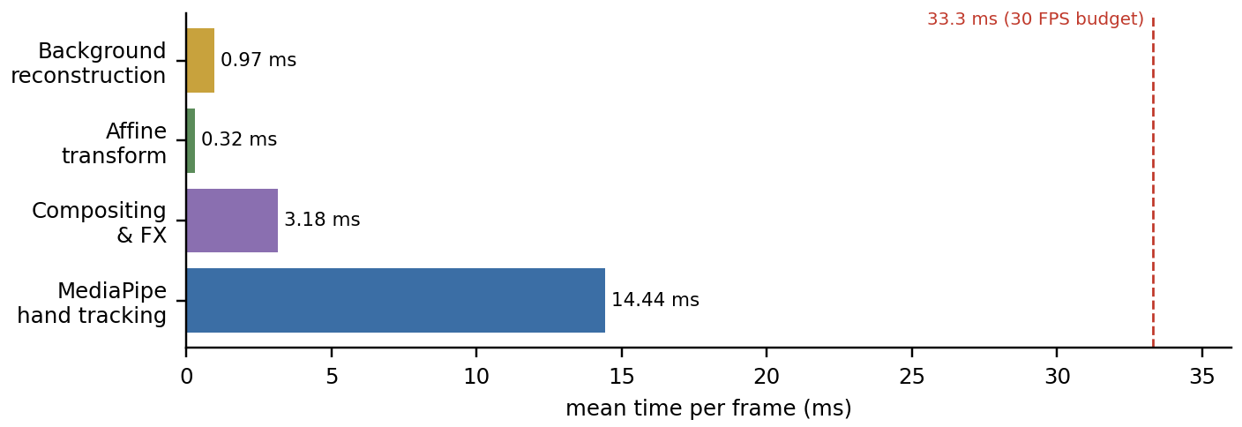
Figure 9. Mean per-frame cost of each stage compared with the 33.3 ms budget of 30 FPS.
The image-processing stages after selection take about 4.5 ms per frame, and with the 14.4 ms hand-tracking step the pipeline needs roughly 19 ms, leaving about 14 ms of headroom for the GUI. Hand tracking was timed on frames without a hand and may cost more when landmarks must be extracted. The one expensive operation is GrabCut selection (0.8–1.1 s), which runs once per selection in a background thread. All timings come from a single-core container, so a typical laptop would be expected to do at least as well.

8.9 Summary of Findings
- Segmentation met the criterion on contrasting objects (mean IoU 0.949) but failed on a low-contrast object (IoU 0.245).
- Background reconstruction was exact with a clean reference, and degraded gracefully under lighting change (31.3 dB) or Telea fallback (25.7 dB).
- Circle recognition reached 99–100% except for small, noisy circles, with 0% false triggers on four non-circular stroke types.
- The post-selection pipeline needed 4.5 ms per frame (about 19 ms with hand tracking), inside the 33 ms budget.
- EMA smoothing removed 77% of jitter at the cost of tracking lag, and the frame-based physics makes motion speed frame-rate dependent.

9. Challenges / Limitations
- Low-contrast objects: when an object’s colour is close to the surface under it, GrabCut leaks into the background (IoU 0.245 and 4.2 s runtime in scene D). Thin parts such as mug handles are lost during morphological clean-up.
- Selection latency: GrabCut takes about 0.8–1.1 s, so the object lifts after a short delay, although the interface stays responsive because selection runs in a background thread.
- Background dependence: erasing works well only if a clean reference was captured on an empty scene. A reference containing the object leaves the object visible, and lighting changes after capture cause a visible seam. Anything entering the original footprint, such as the user’s hand, is also replaced by the reference.
- Tracking lag: EMA smoothing (α = 0.3) removes jitter but causes lag of about 29 px RMS on fast movements.
- Frame-rate dependent motion: the spring–damper step is not scaled by elapsed time, so the object settles twice as slowly at 15 FPS as at 30 FPS.
- Gesture limits: circles with a radius of about 40 px and strong jitter are missed. Finger-extended tests compare image-space y-coordinates, so they assume an upright hand, and only one hand is tracked.
- Voice control: recognition needs a microphone and an internet connection, and short keywords such as “stop”, “fly” or “blast” can trigger spells by accident.
- 2D simulation: there is no depth, perspective or occlusion, and the camera and scene are assumed to be static.
- Computational limits: all processing is CPU-only, and the GUI schedules frames about every 33 ms, which caps the display rate near 30 FPS.
- Dataset limitations: results come from synthetic scenes, simulated trajectories and a single-core test machine. Tests with real webcams, varied lighting, many users and real hand images are future work.

10. Conclusion
What was implemented. A complete real-time levitation system was built in Python: it captures a live webcam stream, tracks the user’s hand, lets the user select an object with a finger-drawn circle or a click, cuts the object out, rebuilds the scene behind it, and animates it with four spells controlled by gesture, voice, buttons or keys. A synthetic camera, button controls and optional hand tracking keep it usable when hardware or models are missing.
Techniques used. The system combines colour-space conversion, Gaussian filtering, Canny edge detection, Otsu and HSV thresholding, morphological operations, GrabCut segmentation, connected components, Gaussian feathering, reference-frame background replacement with Telea inpainting, affine transformation, alpha compositing, hand-landmark feature extraction, exponential temporal filtering and a spring–damper motion model.
What was achieved. On test scenes GrabCut reached a mean IoU of 0.949 on objects that contrast with their surroundings, a clean reference reconstructed the scene exactly, finger circles were recognised in 99–100% of normal trials with no false triggers, and the post-selection stages ran in about 4.5 ms per frame, well inside the real-time budget. The main weaknesses are low-contrast objects, dependence on a clean and stable background, tracking lag and frame-rate-dependent motion.
Learning. The project showed how classical image processing methods can be chained into a working real-time pipeline, and how much practical quality depends on details such as feathered mattes, a clean reference frame and temporal filtering. It also taught the value of quantitative evaluation (IoU, PSNR, SSIM and timing) over visual impression, since measurement exposed failure cases such as scene D and the frame-rate dependence of the physics. Handling threading and latency, so that a one-second GrabCut call does not freeze the interface, was an important engineering lesson.
Future work. Natural next steps are time-scaled physics, automatic reference-background management, a depth or learned segmentation model for low-contrast objects, multi-object support, and evaluation with real webcam recordings and several users.

References
[1] G. Bradski, “The OpenCV Library,” Dr. Dobb’s Journal of Software Tools, 2000.
[2] C. Rother, V. Kolmogorov and A. Blake, “GrabCut: Interactive foreground extraction using iterated graph cuts,” ACM Trans. Graphics (SIGGRAPH), vol. 23, no. 3, pp. 309–314, 2004.
[3] A. Telea, “An image inpainting technique based on the fast marching method,” J. Graphics Tools, vol. 9, no. 1, pp. 23–34, 2004.
[4] J. Canny, “A computational approach to edge detection,” IEEE Trans. Pattern Anal. Mach. Intell., vol. PAMI-8, no. 6, pp. 679–698, 1986.
[5] N. Otsu, “A threshold selection method from gray-level histograms,” IEEE Trans. Syst., Man, Cybern., vol. 9, no. 1, pp. 62–66, 1979.
[6] F. Zhang et al., “MediaPipe Hands: On-device real-time hand tracking,” arXiv:2006.10214, 2020.
[7] C. Lugaresi et al., “MediaPipe: A framework for building perception pipelines,” arXiv:1906.08172, 2019.
[8] T. Porter and T. Duff, “Compositing digital images,” ACM SIGGRAPH Computer Graphics, vol. 18, no. 3, pp. 253–259, 1984.
[9] R. C. Gonzalez and R. E. Woods, Digital Image Processing, 4th ed. New York, NY, USA: Pearson, 2018.
[10] Z. Wang, A. C. Bovik, H. R. Sheikh and E. P. Simoncelli, “Image quality assessment: From error visibility to structural similarity,” IEEE Trans. Image Process., vol. 13, no. 4, pp. 600–612, 2004.
[11] C. R. Harris et al., “Array programming with NumPy,” Nature, vol. 585, pp. 357–362, 2020.
[12] S. van der Walt et al., “scikit-image: Image processing in Python,” PeerJ, vol. 2, e453, 2014.
[13] A. Zhang, “SpeechRecognition: Library for performing speech recognition with several engines and APIs,” Python Package Index. [Online]. Available: https://pypi.org/project/SpeechRecognition/
[14] J. K. Rowling, Harry Potter and the Philosopher’s Stone. London, U.K.: Bloomsbury, 1997.
[15] OpenCV Documentation, “Image Inpainting” and “Interactive Foreground Extraction using the GrabCut Algorithm.” [Online]. Available: https://docs.opencv.org
[16] Python Software Foundation, “tkinter — Python interface to Tcl/Tk.” [Online]. Available: https://docs.python.org/3/library/tkinter.html

