👋 Hi everyone, Hamza here.
Welcome to Edition #0 of a newsletter that 15,000+ people around the world actually look forward to reading.
We're living through a strange moment: the internet is drowning in polished AI noise that says nothing.
This isn't that. You'll find raw, honest, human insight here — the kind that challenges how you think, not just what you know. Thanks for being part of a community that still values depth over volume.
🎓 Want to up-skill in AI?
- Join the next cohort of my Agent Engineering Bootcamp (Developers Edition)
- Watch the free 4-session Agent Bootcamp playlist on YouTube
The environmental cost of AI isn't just a data center problem anymore, it's becoming a hidden infrastructure crisis. And the scariest part? We're barely measuring it.

AI Energy Consumption Is Surging — But Nobody Is Tracking What Agentic AI Actually Costs
Imagine you ask an AI agent to research and book a trip for you. You type one sentence. You wait a few seconds. A moment later, the agent confirms your flights, hotel, and even a restaurant reservation near your gate.
What you picture: one question, one answer.
What actually happened: the agent silently triggered 40 or more individual model inference calls, pinged multiple travel APIs, retrieved prior preferences from a memory database, ran iterative planning loops to compare options, checked its own outputs for errors, and revised its drafts before presenting anything to you. You saw a clean summary. The data center saw a small wildfire.
This is the central illusion at the heart of today's AI energy conversation, and it's one the industry has a powerful incentive to maintain. Every headline, every congressional hearing, and nearly every academic study is measuring a version of AI's environmental footprint that is already out of date. They are counting training runs and aggregate data center loads, while the compounding, never-disclosed energy cost of agentic AI goes unexamined. This article breaks down the scope of that problem, explains why it stays invisible, and identifies what accountability would actually require.

[ IMAGE: Abstract visualization of energy flowing into a data center with digital AI nodes overlaid ]
Source: Visual Capitalist | https://www.visualcapitalist.com/wp-content/uploads/2025/03/Data-Center-Energy-Use_BGO_Main.jpg

The Energy Crisis Hidden in Plain Sight

What We Already Know About AI's Power Appetite
The numbers we already have are alarming enough. The International Energy Agency projects that global data centers could consume over 1,000 terawatt-hours (TWh) of electricity annually by 2026, roughly equivalent to Japan's entire electricity consumption. Source: https://www.iea.org/reports/electricity-2024
Goldman Sachs estimates that AI could drive a 160% increase in data center power demand by 2030, a figure already reverberating through utility planning departments across the United States. Researchers at the University of Massachusetts Amherst have estimated that a single ChatGPT query consumes roughly ten times the electricity of a standard Google search, a gap that seems small in isolation but becomes significant across hundreds of millions of daily users. These figures are extraordinary. They also represent only the visible portion of an iceberg whose base has barely been mapped.

Why Power Grids Are Already Feeling the Pressure
The abstraction of terawatt-hours becomes concrete in places like Northern Virginia, home to "Data Center Alley," the densest concentration of data center infrastructure on Earth. Dominion Energy, the region's primary utility, has warned state regulators that meeting projected data center demand will require building the equivalent of multiple large-scale power plants within the decade. Grid operators in Texas, Georgia, and the broader mid-Atlantic region have issued similar warnings, where surges in demand have already begun straining reliability margins.
The response from major tech companies has been to build fast. Microsoft, Google, and Amazon have each committed to multi-billion-dollar data center expansions, with some projects explicitly requiring the revival of retired nuclear plants or new long-term fossil fuel contracts. This creates a difficult-to-ignore paradox: the same companies publishing aggressive carbon reduction pledges are executing infrastructure expansions that their own engineers acknowledge will consume more energy for years before any renewable contracts take effect. Local ratepayers in Virginia and Georgia have already seen electricity bills rise, partly to fund grid upgrades driven by industrial data center demand rather than residential growth.

The Measurement Gap Nobody Wants to Talk About
Most public reporting on AI's environmental footprint focuses on two things: training energy, the large, one-time cost of teaching a model on vast datasets, and aggregate data center consumption, the total electricity draw of a facility or a company's infrastructure portfolio. Neither captures inference energy cost: the electricity consumed every time a model generates a response. Neither comes close to measuring inference energy at the task level, the product level, or the agent level.
This gap exists partly because no mandatory disclosure standard exists anywhere in the world at this level of specificity, and partly because the industry has financial and reputational incentives not to create one. The frameworks currently in use were designed for a different era of computing.
"If the numbers we have are already alarming, the numbers we don't have should terrify us."

What Is Agentic AI — And Why Does It Change Everything?
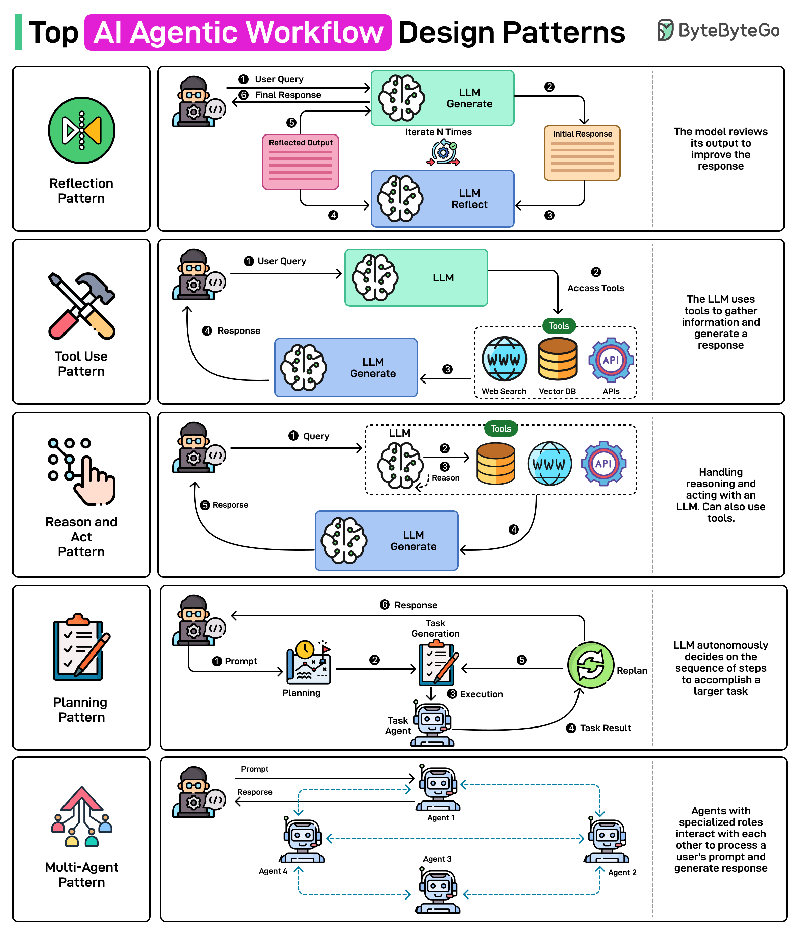
Source: ByteByteGo Newsletter | https://substackcdn.com/image/fetch/$s_!H5U_!,f_auto,q_auto:good,fl_progressive:steep/https%3A%2F%2Fsubstack-post-media.s3.amazonaws.com%2Fpublic%2Fimages%2Fa69ad383-c688-4bc9-8bac-d4855cc2342a_2360x2770.png

Chatbots vs. Agents: A Fundamental Architectural Difference
To understand why the measurement gap matters more now than it did two years ago, you need to understand a distinction the industry often glosses over in its marketing: the difference between a chatbot and an agentic AI system. A standard chatbot interaction is architecturally simple, a user sends a prompt, the model generates a single response, the interaction ends. One inference call. The energy cost, while not trivial, is at least comprehensible as a discrete unit.
An agentic AI system, AutoGPT, Claude with tools, OpenAI's Operator, Google's Project Astra, operates on different logic entirely. A user provides a goal, not a prompt. The agent plans how to achieve that goal, breaks it into subtasks, executes each subtask by calling external tools, checks its own outputs, revises its approach, and finally reports back. The analogy is useful: asking a colleague for a phone number versus asking them to handle all the conference logistics. One ends in a sentence. The other triggers weeks of decisions, each of which costs something. The energy implications of this architectural difference have not yet reached most public discussions of AI.

The Multiplier Effect: How One Request Becomes Dozens of Inference Calls
A single agentic task does not cost one inference call. Depending on the complexity of the goal and the design of the agent, it can cost 20 to 100 or more. Consider a concrete example: you ask an AI agent to analyze Q3 sales data, identify the top three underperforming regions, and draft a summary email to the VP of Sales.
What looks like one request may involve reading and parsing a spreadsheet (1–3 model calls), reasoning about the data structure (2–5 calls), identifying patterns and anomalies (2–4 calls), drafting an initial email (2–3 calls), refining tone based on self-critique (2–4 calls), and formatting the final output (1–3 calls). That is conservatively 10 to 22 inference calls before a single word of the response appears. Each call to an external tool, a web search, a code execution environment, a CRM database, may itself trigger additional model calls to interpret results and decide next steps. No company currently discloses the per-task inference chain energy cost of their agentic products.

Always-On Agents and the Continuous Compute Problem
The multiplier effect of individual agentic tasks is only half the problem. An emerging category of always-on agentic systems does not wait to be queried, it runs continuously in the background, monitoring, deciding, and acting without user initiation. Customer service agents scan inboxes around the clock; AI systems rebalance investment portfolios every few minutes; "digital worker" agents deployed by platforms like Salesforce Agentforce and Microsoft Copilot manage workflows and monitor software repositories without pause.
Unlike a chatbot that consumes energy only when a user sends a message, an always-on agent draws power continuously, with no natural off-switch and no user-visible activity to signal its operation. The energy cost of these systems is not per-query, it is per-hour, per-day, per-deployment, and it scales with every enterprise license sold.
Key Takeaway: A single agentic AI task can require significantly more energy than a standard chatbot query, and always-on agents may draw power continuously without any user-visible activity.

The Water Nobody Is Counting

[ IMAGE: Aerial photograph of large industrial cooling towers adjacent to a data center facility ]
Source: WIRED | https://media.wired.com/photos/6a1f238eaaa9871d34a367b3/4:3/w_1872,h_1404,c_limit/Data-Center-Water-Consumption-Science-2245861123.jpg

How AI Data Centers Drink Water
Energy is only one dimension of AI's environmental footprint. The other, less discussed and in some respects more immediately consequential for local communities, is water. Data centers generate enormous amounts of heat, and the servers running AI inference workloads are, at a physical level, just electricity converting into computation and heat in large quantities. Cooling that heat requires water, typically through evaporative cooling towers that draw in water, use it to absorb heat, and release it as vapor.
Researchers at the University of California Riverside estimated in 2023 that ChatGPT consumes roughly 500 milliliters of water per 20–50 queries, before accounting for the higher inference volumes that agentic workloads generate. Source: https://arxiv.org/abs/2304.03271. Microsoft's own environmental reports acknowledge a 34% increase in global water consumption between 2021 and 2022, a period that corresponded directly to the company's accelerated AI infrastructure deployment. Current public conversations about AI sustainability treat water as a footnote. It is not.

Geographic Concentration and Local Water Stress
The water problem is not evenly distributed, and that is what makes it consequential. The world's largest data center clusters sit disproportionately in regions under significant water stress: the Phoenix metropolitan area in Arizona, Northern Virginia, the Amsterdam region in the Netherlands, and Singapore, all places where water scarcity is either an existing crisis or a fast-approaching one.
Arizona state water regulators have raised explicit alarms about the pace of data center permitting and its impact on an already overextended water supply serving both urban populations and the agricultural sector. Dutch authorities have paused or delayed data center construction permits in the Amsterdam area partly on water consumption grounds, a precedent that regulators elsewhere have been slow to follow. The communities and municipal systems downstream from these decisions have no seat at the table when data center leases are signed.

Agentic Workloads Will Make This Exponentially Worse
The connection between agentic AI architecture and water consumption is direct, even if it has not yet been systematically measured. More inference calls mean more GPU cycles, more heat, more cooling, and more water, particularly in the evaporative cooling systems that dominate large-scale data center design. Always-on agentic systems running year-round represent a fundamentally different water demand profile than episodic chatbot usage concentrated in business hours.
Current water consumption projections from the IEA and academic research teams do not yet model agentic AI deployment at scale, because the enterprise adoption curve for these systems is only now beginning its steep ascent. The environmental consequences are a logical, measurable result of architectural decisions being made now, with no corresponding environmental accounting being required or performed.

The Accountability Vacuum — Why Nobody Is Measuring This
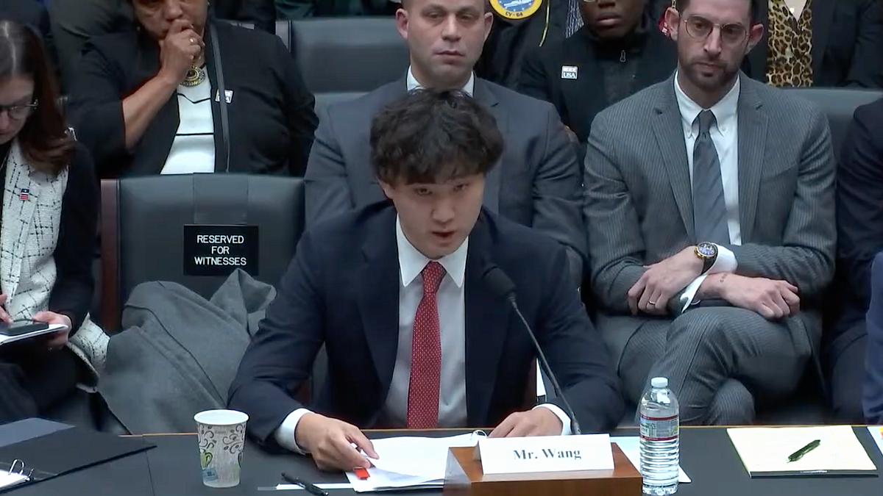
Source: Tech Policy Press | https://cdn.sanity.io/images/3tzzh18d/production/19b4cb0e3c8400c2fd0300353a84fbd615a1d04f-1200x675.png

Corporate Disclosure: Voluntary, Vague, and Strategically Incomplete
Every major AI company publishes an annual sustainability or environmental report. Google, Microsoft, Meta, and Amazon all do it, reporting aggregate Scope 1, 2, and 3 emissions under voluntary frameworks like the GHG Protocol and CDP reporting standards. These reports are not false. But they do not answer the questions that most need answering.
None discloses the per-query, per-task, or per-agent energy cost of any specific product. None distinguishes between the energy profile of a simple chatbot exchange and a complex agentic task chain. The voluntary frameworks they use were not designed with inference-level AI granularity in mind, and providing that granularity would require exactly the kind of internal measurement and external disclosure that no company in a competitive market will do voluntarily. The analogy is apt: imagine if car manufacturers only reported total factory energy usage, never miles-per-gallon for individual models. Regulators would never have accepted that standard, and consumers would have had no basis for comparison. That is the standard AI companies are currently held to, or rather, not held to at all.

The Regulatory Gap — And Who Needs to Fill It
The regulatory situation is shifting, but not in directions that address the agentic AI problem. The EU AI Act, the most comprehensive AI governance framework enacted anywhere in the world, includes provisions related to transparency and risk classification, but does not require inference-level or task-chain-level energy disclosure. The United States has no federal AI energy reporting requirement. The SEC's climate disclosure rules, currently in legal limbo, address Scope 1–3 emissions at the company level, not at the product or workload level.
A disclosure standard specifically designed for AI inference energy costs would require companies to report the average energy cost per inference call, the energy profile of agentic task chains, and the water consumption associated with inference workloads at each facility. Researchers and advocacy organizations, including the Green Software Foundation and academics working on ML CO2 impact tools, have begun developing methodologies for this kind of measurement. Without a regulatory mandate, those tools remain academic exercises.

What Accountability Could Actually Look Like
Mandatory per-product energy reporting, modeled on nutrition labels, would require AI companies to disclose the average energy cost of using a specific product or feature, giving enterprise buyers, consumers, and investors a basis for comparison that currently does not exist. Independent inference energy auditing, reported annually, would produce a more granular picture than aggregate facility data. Agentic workload-specific disclosure standards, developed through collaboration between regulators, researchers, and industry, would ensure that autonomous multi-step AI systems get captured rather than buried inside undifferentiated data center totals.
The barrier to all of these is not technical, the measurement methodologies exist or can be readily developed. The barrier is political will: the willingness of regulators to demand disclosure and of companies to provide it before being legally compelled.

Frequently Asked Questions
Q: How much more energy does an agentic AI use compared to a regular chatbot?
A: Current research suggests that a single agentic task can trigger anywhere from 20 to 100 or more individual model inference calls, compared to a single call for a standard chatbot response. This means the energy cost per user request can be 10 to 50 times higher for agentic systems, potentially more for complex, iterative tasks, though precise figures vary by platform, task type, and system architecture. No major AI company currently discloses this comparison publicly.
Q: Why don't AI companies just publish their energy usage data?
A: There is no legal requirement compelling them to do so at the product or workload level. Voluntary frameworks like the GHG Protocol and CDP reporting capture aggregate company-level emissions, not per-product or per-inference costs. Companies also have competitive and reputational incentives to avoid disclosures that would allow direct comparisons between their products' environmental costs.
Q: What is AI water usage, and why does it matter?
A: AI data centers use large quantities of water for server cooling, primarily through evaporative cooling towers. Studies estimate that ChatGPT alone uses hundreds of milliliters of water per conversation, a figure that scales substantially with always-on agentic systems. This matters especially in water-stressed regions like Arizona and the Netherlands, where data center water demand competes directly with agricultural and municipal needs.
Q: Does the EU AI Act address AI energy consumption?
A: The EU AI Act includes broad transparency and risk provisions, but it does not require inference-level or task-chain-level energy disclosure. It is the most comprehensive AI governance framework in existence, but it was designed primarily around safety and rights concerns rather than the environmental accounting needed to capture agentic AI's energy footprint.
Q: What can individual users or policymakers do about this?
A: Individuals can contact their elected representatives to support AI energy reporting legislation, choose AI tools from companies that voluntarily disclose environmental data, and ask platforms they use for transparency on inference costs. Policymakers can mandate per-product energy reporting, fund independent inference energy auditing, and develop disclosure standards designed specifically to capture agentic workloads, closing a regulatory gap that currently benefits industry at public expense.

Conclusion: The Meter Is Running — Whether We Read It or Not
Every time someone asks an AI agent to draft a proposal, monitor a supply chain, or manage a calendar, a cascade of computation unfolds entirely out of sight, consuming electricity, generating heat, drawing water, and then disappears without a trace in any public accounting. The user sees an answer. The environment absorbs a cost that no one sends and no one receives.
The public conversation about AI energy consumption has been stuck on a version of the problem that was already outdated when it began. Training runs matter. Aggregate data center loads matter. But the commercial direction of every major AI company is deployment at scale through autonomous systems that act continuously on behalf of millions of users. Agentic AI is not a niche research product, and its energy and water costs are currently invisible by design.
That invisibility is a choice, sustained by the absence of mandatory disclosure, the inadequacy of existing regulatory frameworks, and a public conversation that has not caught up to the technology it is trying to assess. The meter is running. The question is whether we will ever be allowed to read it.
What you can do: Contact your congressional representative and ask them to support legislation requiring AI companies to disclose per-product and per-workload energy and water usage. Ask the AI tools you use whether they publish inference-level energy data. When you read an AI sustainability report, pay attention to what it omits, the gap between what is disclosed and what is actually happening is where the real story lives.

Sources
1. https://www.visualcapitalist.com/wp-content/uploads/2025/03/Data-Center-Energy-Use_BGO_Main.jpg
2. https://substackcdn.com/image/fetch/$s_!H5U_!,f_auto,q_auto:good,fl_progressive:steep/https%3A%2F%2Fsubstack-post-media.s3.amazonaws.com%2Fpublic%2Fimages%2Fa69ad383-c688-4bc9-8bac-d4855cc2342a_2360x2770.png
3. https://media.wired.com/photos/6a1f238eaaa9871d34a367b3/4:3/w_1872,h_1404,c_limit/Data-Center-Water-Consumption-Science-2245861123.jpg
4. https://cdn.sanity.io/images/3tzzh18d/production/19b4cb0e3c8400c2fd0300353a84fbd615a1d04f-1200x675.png
5. https://www.iea.org/reports/electricity-2024
6. https://arxiv.org/abs/2304.03271.

Did you enjoy this post?
Here are some other AI Agents posts you might have missed:
- KV Caching and Speculative Decoding
- A deep dive into Quantization: Key to Open Source LLM Deployments
- Agents are here and they are staying
- How Agents Think
- Memory – The Agent's Brain
- Agentic RAG Ecosystem
- Multimodal Agents
- Scaling Agents: Architectures with Google ADK, A2A, and MCP
- Fully Functional Agent Loop
Ready to take it to the next level?
Check out my AI Agents for Enterprise course on Maven and be part of something bigger — join hundreds of builders developing enterprise-level agents.
Use this link to get $201 OFF!
You're receiving this because you're part of our mailing list. We don't spam or sell your information. To unsubscribe, use the link below.

