**Connect4**

Welcome to the Connect4 Game! This repository contains the user interface (UI) and user experience (UX) design for the classic Connect4 board game.

Figma Link: <https://www.figma.com/file/aHMENiKuJZM9gJ2zJq8gyA/Connect4?type=design&node-id=0%3A1&mode=design&t=ODBFrSg9ZutIgtAH-1>

Prototype Link: <https://www.figma.com/proto/aHMENiKuJZM9gJ2zJq8gyA/Connect4?type=design&node-id=26-252&t=ODBFrSg9ZutIgtAH-0&scaling=scale-down&page-id=0%3A1&starting-point-node-id=26%3A252>

**Game Description**

Connect4 is a two-player connection game in which the players choose a color and take turns dropping one colored disc into a seven-column, six-row vertically suspended grid. The game's objective is to connect four of one's own discs of the same color next to each other vertically, horizontally, or diagonally before your opponent does.

**Features**

* Interactive and intuitive design: The game provides a visually appealing and easy-to-use interface for players to enjoy the gameplay seamlessly.
* Responsive design: The game adapts to different screen sizes, making it playable on various devices, including desktops, laptops, and tablets.
* Win and draw detection: The game detects winning combinations and notifies the players when a win or a draw occurs.

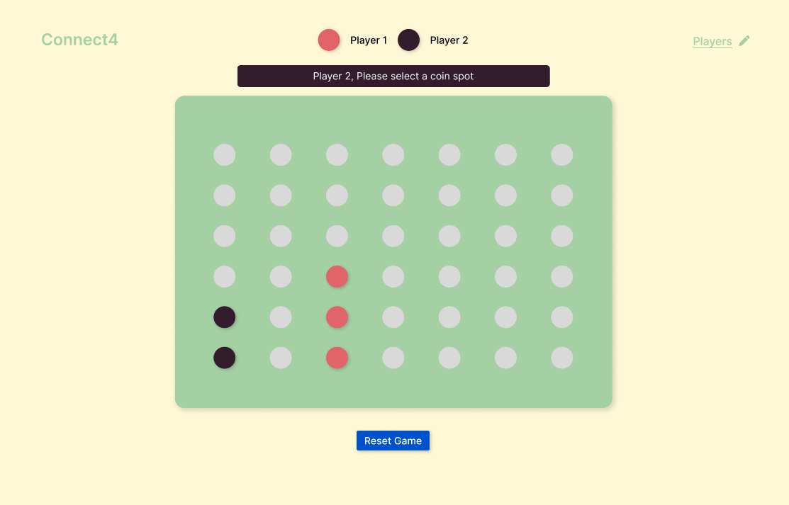**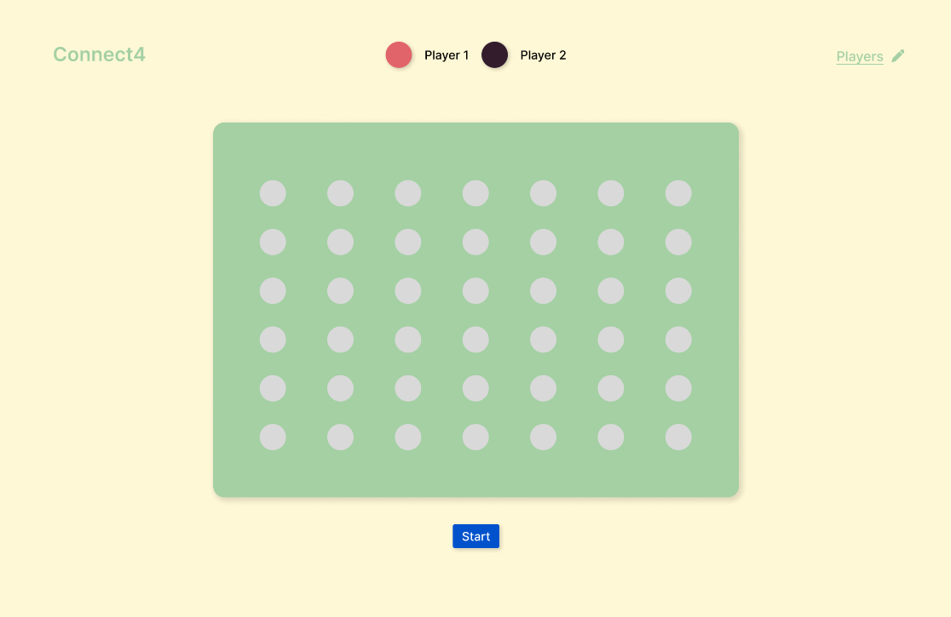Screenshots**

**How to Play**

1. The game starts with an empty board. Player 1 (usually represented by Coral Pink discs) goes first.
2. Click on the column where you want to drop your disc. The disc will fall to the lowest available position in that column.
3. Alternate turns with your opponent (Player 2, usually represented by Dark Plum discs).
4. The first player to connect four discs of their color horizontally, vertically, or diagonally wins the game.
5. The game ends in a draw if all columns are filled without any player achieving four-in-a-row.