Report (V1)

2/22/23

Table of contents

## Trial or half-block?

As a simple examination of which model should be used, I fit two simple models (no random effects) - a model with a (log) linear effect of trial on RT, and a model with a dummy variable for the half-block:

m_lin <- lm(log(RespRT) ~ trial * distPresence, data = data_clean)  
m_step <- lm(log(RespRT) ~ block_half * distPresence, data = data_clean)

| Name | BIC (weights) |
| --- | --- |
| Linear | 29534.9 (0.41) |
| Half-Block | 29534.1 (0.59) |

The BIC weights tell us that there is no clear preference for using a linear model over a half-block model.

Overall, it seems like both don’t fully capture the non-linear effect of trial on RTs (seen here in the loess / moving average lines). (Black lines are the loess / moving average per participant).

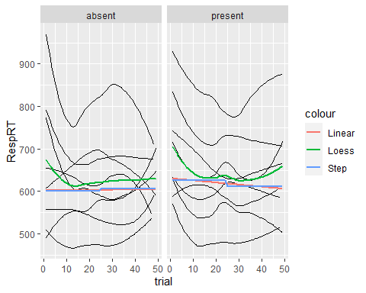

Using a hierarchical (log) linear model:

mod_step <- lmer(log(RespRT) ~ distPresence * block_half +   
 (block_half * distPresence | participant),  
 data = data_clean)

We find essentially the same results as your initial ANOVA:

| Term | Sum Sq | Mean Sq | NumDF | DenDF | F value | Pr(>F) |
| --- | --- | --- | --- | --- | --- | --- |
| distPresence | 0.205 | 0.205 | 1.000 | 8.627 | 4.456 | 0.065 |
| block_half | 0.045 | 0.045 | 1.000 | 213.377 | 0.986 | 0.322 |
| distPresence:block_half | 0.135 | 0.135 | 1.000 | 14.400 | 2.936 | 0.108 |

(Of course tests have very low power.)

## Reliability

We now examine the reliability of the interaction effect by using random co-variances of the interaction effect between sessions:

mod_stepR <- lmer(log(RespRT) ~ session * distPresence * block_half +   
 # This is where the magic happens  
 (0 + session / (block_half * distPresence) | participant),   
 data = data_clean)

| Random | session1 | session2 | session1:block_half1 | session2:block_half1 | session1:distPresence1 | session2:distPresence1 | session1:block_half1:distPresence1 | session2:block_half1:distPresence1 |
| --- | --- | --- | --- | --- | --- | --- | --- | --- |
| session1 | 1.00 | 0.98 | 0.31 | -0.06 | -0.17 | -0.61 | 0.06 | -0.42 |
| session2 | 0.98 | 1.00 | 0.35 | -0.05 | -0.30 | -0.57 | -0.02 | -0.31 |
| session1:block_half1 | 0.31 | 0.35 | 1.00 | -0.53 | -0.81 | -0.84 | -0.89 | 0.05 |
| session2:block_half1 | -0.06 | -0.05 | -0.53 | 1.00 | 0.15 | 0.61 | 0.31 | 0.59 |
| session1:distPresence1 | -0.17 | -0.30 | -0.81 | 0.15 | 1.00 | 0.41 | 0.91 | -0.54 |
| session2:distPresence1 | -0.61 | -0.57 | -0.84 | 0.61 | 0.41 | 1.00 | 0.50 | 0.45 |
| session1:block_half1:distPresence1 | 0.06 | -0.02 | -0.89 | 0.31 | 0.91 | 0.50 | 1.00 | -0.47 |
| session2:block_half1:distPresence1 | -0.42 | -0.31 | 0.05 | 0.59 | -0.54 | 0.45 | -0.47 | 1.00 |

* RED: Reliability of overall means between sessions.
* BLUE: Reliability of block-half effect between sessions.
* ORANGE: Reliability of the distractor effect between sessions.
* GREEN: Reliability of the interaction between sessions.

Reliability is low, but do keep in mind that $N=8$, so these results are perhaps not very informative.

## Mu & Tau (Bayesian Analysis)

I next fit a ex-Gaussian model with Mu and Tau as free parameters.

(I set some loose priors.)

### Model diagnostics

Pretty good:

| Parameter | Rhat | ESS | MCSE |
| --- | --- | --- | --- |
| b_block_half1 | 1.0018346 | 2,409.4622 | 0.0595402791 |
| b_distPresence1 | 1.0003981 | 1,757.9542 | 0.0947466993 |
| b_distPresence1:block_half1 | 0.9996920 | 2,812.5547 | 0.0521663232 |
| b_Intercept | 1.0043746 | 671.8110 | 0.9406437173 |
| b_tau_block_half1 | 0.9998078 | 3,152.1396 | 0.0005323672 |
| b_tau_distPresence1 | 0.9998955 | 3,458.7398 | 0.0005362390 |
| b_tau_distPresence1:block_half1 | 1.0001019 | 2,531.9032 | 0.0007103742 |
| b_tau_Intercept | 1.0064640 | 659.0748 | 0.0069029451 |

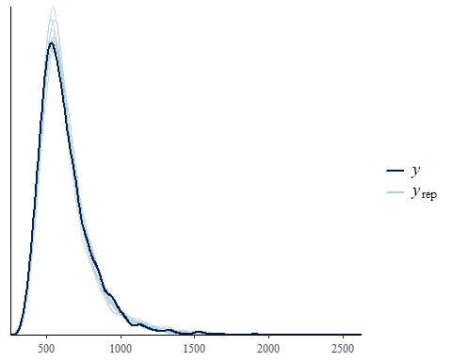

### Effects

| Parameter | Coef | Median | 95% CI | pd |
| --- | --- | --- | --- | --- |
| Mu | Intercept | 488.88 | [441.90, 542.94] | 100% |
| Mu | block_half1 | -3.64 | [ -9.30, 2.05] | 91.38% |
| Mu | distPresence1 | -4.24 | [-12.56, 3.03] | 88.92% |
| Mu | distPresence1:block_half1 | -5.07 | [-10.74, 0.19] | 97.20% |
| Tau | Intercept | 4.93 | [ 4.54, 5.26] | 100% |
| Tau | block_half1 | 0.05 | [ -0.01, 0.11] | 96.47% |
| Tau | distPresence1 | -0.02 | [ -0.08, 0.04] | 77.03% |
| Tau | distPresence1:block_half1 | 3.93e-03 | [ -0.07, 0.07] | 54.67% |

(*Note that the $τ$ parameters are on the $log_{e}$ scale.*)

It seems like the interaction is on Mu, though there might be a main effect for half-block on Tau as well.

