**Assignment 2**

**Bioinformatics Theory and Applications  
  
Nitzan Shpigel 305388746**

**Elad Mizrahi 201481298**

**Part 3**

**NCBI Blast analysis**

**Text T1:**

1. *Hippoglossus hippoglossus* (Atlantic Halibut) – myosin heavy chain, mRNA
2. *Stegastes partitus* (Bicolor damselfish) – myosin heavy chain, fast skeletal muscle-like (LOC103370545), mRNA

**Text T2**

1. *Hippoglossus hippoglossus* (Atlantic Halibut) – complement component C3, mRNA
2. *Paralichthys olivaceus* (Japanese flounder) – mRNA for complement component C3

**Text T3**

1. *Hippoglossus hippoglossus* (Atlantic halibut) – myogenic factor MyoD1 mRNA
2. *Oreochromis niloticus* (Nile tilapia) – niloticus myogenic factor MyoD1, transcript variant X1, mRNA

**Text T4**

1. *Paralichthys olivaceus* (Japanese flounder) – beta-actin mRNA
2. *Seriola quinqueradiata* (Japanese amberjack) – ACTB mRNA for beta-actin

**Text T5**

1. *Hippoglossus hippoglossus* (Atlantic halibut) – mRNA for gonadotropin alpha subunit (GTH gene)
2. *Paralichthys olivaceus* (Japanese flounder) – gonadotropin alpha subunit precursor, mRNA

**Text T6**

1. *Hippoglossus hippoglossus* (Atlantic halibut) – pepsinogen A1 precursor, mRNA
2. *Hippoglossus hippoglossus* (Atlantic halibut) – pepsinogen A2 precursor, mRNA

**Text T7**

1. *Hippoglossus hippoglossus* (Atlantic halibut) – pleurocidin-like peptide Hb18 (ple) gene
2. *Glyptocephalus cynoglossus* (witch) – pleurocidin-like peptide GcSc4B7 (ple) mRNA

**Text T8**

1. *Hippoglossus hippoglossus* (Atlantic halibut) – pleurocidin-like peptide Hb26 (ple) gene
2. *Hippoglossus hippoglossus* (Atlantic halibut) – pleurocidin-like peptide Hb18 (ple) gene

**Text T9**

1. *Hippoglossus hippoglossus* (Atlantic halibut) – myoD gene
2. *Hippoglossus hippoglossus* (Atlantic halibut) – mRNA for myoblast determination protein (myoD2 gene)

**Text T10**

1. *Hippoglossus hippoglossus* (Atlantic halibut) – clone d2-5 immunoglobulin D heavy chain mRNA
2. *Hippoglossus hippoglossus* (Atlantic halibut) – clone d3/4/5/6/7/TM immunoglobulin D heavy chain mRNA

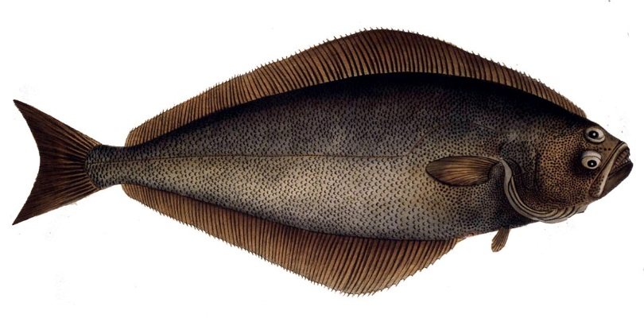

*When you'll see my DNA it will BLAST your mind!*