1. Write a Python script that takes two integers as input and calculates their GCD using the Euclidean algorithm.

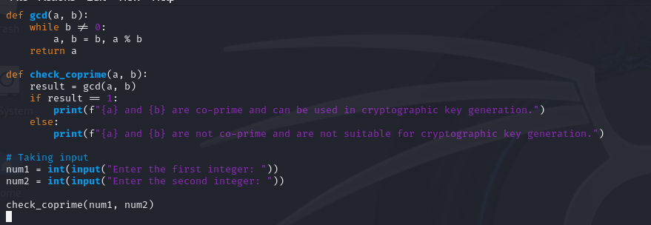

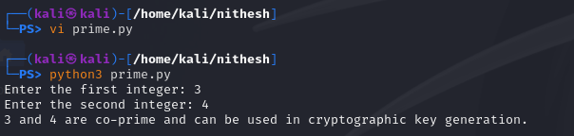

1. Write a python script to take two integer values (number (n) and modulo (m)) from the user and find the modular inverse using extended Euclidean algorithm.

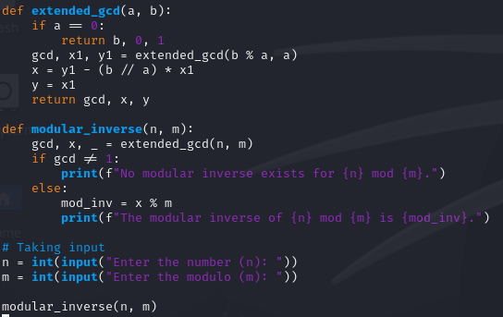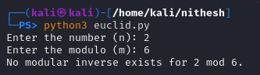

1. Write a Python script that generates a random binary number of length 100. The output should be a string of 100 binary digits (0s and 1s).

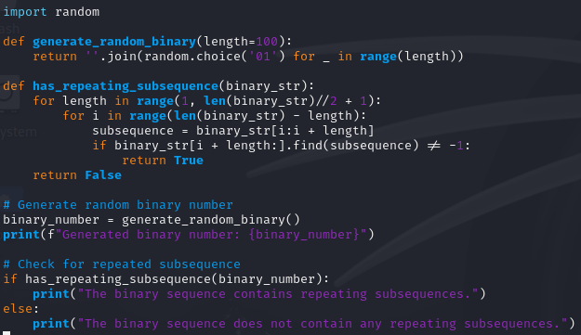



4. Write a Python script that performs the Golomb test to the numbers provided below.

101011001010

