# 课程铺垫：

Anaconda

>>> conda create –name newpy36 python=3.6

>>> activate newpy36

>>> deactivate newpy36

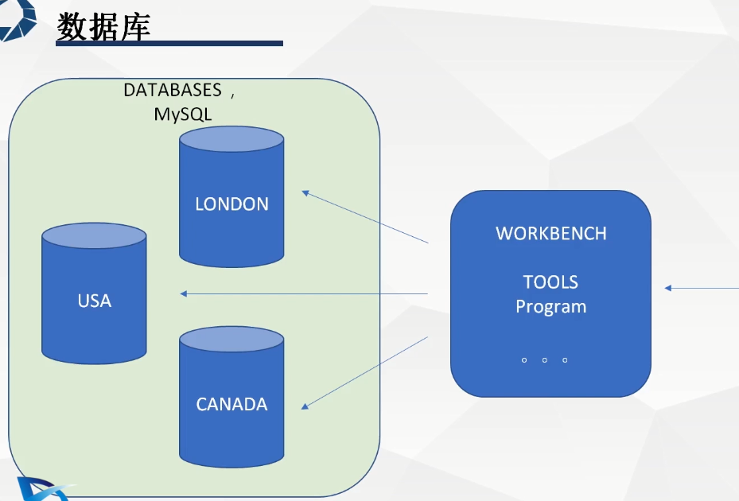

打开jupyter: jupyter notebook



MTIzNDU2