Unsupervised Machine Learning — K-Means Clustering
Activity No. 3 — Invisible Maps

Student
Duvan Lozano Romero

Systems and Computer Engineering Program
University of Cundinamarca — Chia
Course: Machine Learning
April 2026

1. Introduction

1.1 Description of the Application Update
This report documents the third expansion of the Flask web application originally developed in Activity 1 (Linear Regression) and extended in Activity 2 with Logistic Regression and K-Nearest Neighbors classification. In this activity, a new Unsupervised Machine Learning section has been added, dedicated entirely to the K-Means clustering algorithm.
The new section includes three sub-pages:
- Basic Concepts — Conceptual explanation of unsupervised learning, clustering, and the K-Means algorithm.
- K-Means Manual Exercise — A by-hand simulation of the algorithm on 100 video games across three iterations.
- Clustering Application — A full scikit-learn pipeline on 7,017 video games with interactive visualizations.

1.2 General Objective
To analyze and implement the K-Means clustering algorithm through a manual iterative process and a Flask-based application, demonstrating understanding of unsupervised learning, distance calculation, centroid updating, cluster assignment, and variance analysis, while presenting results in a structured and interactive web interface.

1.3 Importance of Unsupervised Learning
Unsupervised learning is essential whenever the data has no labels. Unlike supervised algorithms such as Linear Regression, Logistic Regression or KNN, where the model learns from examples with known answers, unsupervised models discover the inner structure of data by themselves. Clustering — the most common unsupervised task — groups similar instances together based on a distance metric.
In the video game industry, unsupervised learning powers:
- Player segmentation — grouping players by behavior for matchmaking and content design.
- Game catalog grouping — discovering natural segments of titles for recommendation systems.
- Anomaly detection — identifying cheaters, bots, or fraudulent purchases.
- Market analysis — profiling commercial versus critical reception to guide release strategies.

2. Application Structure

2.1 Updated Navigation Menu
The menu now contains four main algorithm sections, including the new Unsupervised Machine Learning block:
Menu Item | Submenu | Route
Home | — | /
ML Use Cases | — | /use-cases
Linear Regression | Basic Concepts | /linear-regression/concepts
 | Application | /linear-regression/application
Logistic Regression | Basic Concepts | /logistic-regression/concepts
 | Application | /logistic-regression/application
KNN | Basic Concepts | /knn/concepts
 | Application | /knn/application
Unsupervised Learning | Basic Concepts | /unsupervised/concepts
 | K-Means Manual Exercise | /unsupervised/manual
 | Clustering Application | /unsupervised/application

2.2 Explanation of the New Section
Unsupervised Learning Section:
- Basic Concepts — Covers the definition of unsupervised learning, the clustering task, the K-Means algorithm, centroids, Euclidean distance, the iterative process, variance (WCSS), convergence, and real-world applications.
- K-Means Manual Exercise — Presents the Part-1 by-hand simulation on 100 video games with two features, three iterations with distance tables, cluster assignments, centroid updates, and a variance line chart.
- Clustering Application — Presents the K-Means clustering problem on 7,017 video games, data preparation, model training with scikit-learn, cluster summary tables, centroids, a scatter plot with colored clusters, and the interpretation of results.

2.3 Screenshots of the Interface
Home page showing the updated navigation menu with the new Unsupervised Learning dropdown:
[ Paste screenshot of the Home page (/) — make sure the Unsupervised Learning dropdown is visible. ]

Unsupervised Learning — Basic Concepts page:
[ Paste screenshot of /unsupervised/concepts. ]

K-Means Manual Exercise page:
[ Paste screenshot of /unsupervised/manual — ideally showing one of the iteration blocks with the distance table. ]

Clustering Application page:
[ Paste screenshot of /unsupervised/application — showing the cluster summary cards or the scatter plot. ]

3. Part 1 — Manual K-Means Simulation

3.1 Dataset Description
For the manual simulation a random sample of 100 games was taken from the Video Games Sales dataset (Kaggle, 22 Dec 2016). Each record is described by two numerical features as required by the activity:
- Critic_Score — Metacritic critical rating on a 0-100 scale.
- Global_Sales — Worldwide sales in millions of units.
The goal is to discover K = 3 natural groups of games, based only on these two reception/commercial features, without any external label.

3.2 Initial Centroids (Manually Chosen)
Three centroids were placed manually, spread across the observed range of the data so that every region has a nearby candidate cluster:
Cluster | Critic_Score | Global_Sales | Description
Cluster 1 | 55.0 | 0.2 | Low critic / Low sales
Cluster 2 | 75.0 | 1.5 | Mid critic / Mid sales
Cluster 3 | 90.0 | 6.0 | High critic / High sales

3.3 Iteration 1
Centroids used in Iteration 1:
Cluster | Critic_Score | Global_Sales
C1 | 55.0 | 0.2
C2 | 75.0 | 1.5
C3 | 90.0 | 6.0

Distance table (sample of first 12 rows — the complete 100-row table is available on the Flask application):
# | Game | Critic | Sales | d(C1) | d(C2) | d(C3) | Cluster
1 | SSX 3 | 92.0 | 0.38 | 37.0 | 17.037 | 5.965 | C3
2 | Valhalla Knights 2 | 50.0 | 0.23 | 5.0 | 25.032 | 40.414 | C1
3 | Battlefield 4 | 85.0 | 3.59 | 30.191 | 10.216 | 5.551 | C3
4 | NBA 2K14 | 86.0 | 0.91 | 31.008 | 11.016 | 6.474 | C3
5 | Resident Evil: Survivor | 39.0 | 0.71 | 16.008 | 36.009 | 51.274 | C1
6 | Gekido Advance: Kintaro's Re | 70.0 | 0.03 | 15.001 | 5.212 | 20.872 | C2
7 | Need For Speed: Undercover | 52.0 | 0.76 | 3.052 | 23.012 | 38.36 | C1
8 | Haven: Call of the King | 69.0 | 0.28 | 14.0 | 6.123 | 21.765 | C2
9 | Phantom Brave | 81.0 | 0.14 | 26.0 | 6.152 | 10.74 | C2
10 | Tales of Legendia | 72.0 | 0.49 | 17.002 | 3.165 | 18.824 | C2
11 | Metal Gear Solid | 94.0 | 6.03 | 39.433 | 19.533 | 4.0 | C3
12 | Phantasy Star Portable | 64.0 | 0.94 | 9.03 | 11.014 | 26.488 | C1

Cluster counts after assignment:
- Cluster 1: 36 games
- Cluster 2: 43 games
- Cluster 3: 21 games
New centroids (mean of each cluster):
Cluster | Critic_Score | Global_Sales
C1 | 53.667 | 0.232
C2 | 74.395 | 0.37
C3 | 88.524 | 2.751

WCSS (Within-Cluster Sum of Squares) = 5044.091

3.4 Iteration 2
Centroids used in Iteration 2:
Cluster | Critic_Score | Global_Sales
C1 | 53.667 | 0.232
C2 | 74.395 | 0.37
C3 | 88.524 | 2.751

Distance table (sample of first 12 rows — the complete 100-row table is available on the Flask application):
# | Game | Critic | Sales | d(C1) | d(C2) | d(C3) | Cluster
1 | SSX 3 | 92.0 | 0.38 | 38.334 | 17.605 | 4.208 | C3
2 | Valhalla Knights 2 | 50.0 | 0.23 | 3.667 | 24.396 | 38.606 | C1
3 | Battlefield 4 | 85.0 | 3.59 | 31.513 | 11.083 | 3.622 | C3
4 | NBA 2K14 | 86.0 | 0.91 | 32.34 | 11.617 | 3.124 | C3
5 | Resident Evil: Survivor | 39.0 | 0.71 | 14.674 | 35.397 | 49.566 | C1
6 | Gekido Advance: Kintaro's Re | 70.0 | 0.03 | 16.335 | 4.408 | 18.723 | C2
7 | Need For Speed: Undercover | 52.0 | 0.76 | 1.748 | 22.399 | 36.578 | C1
8 | Haven: Call of the King | 69.0 | 0.28 | 15.333 | 5.396 | 19.68 | C2
9 | Phantom Brave | 81.0 | 0.14 | 27.333 | 6.609 | 7.964 | C2
10 | Tales of Legendia | 72.0 | 0.49 | 18.335 | 2.398 | 16.678 | C2
11 | Metal Gear Solid | 94.0 | 6.03 | 40.748 | 20.405 | 6.383 | C3
12 | Phantasy Star Portable | 64.0 | 0.94 | 10.358 | 10.411 | 24.591 | C1

Cluster counts after assignment:
- Cluster 1: 33 games
- Cluster 2: 39 games
- Cluster 3: 28 games
New centroids (mean of each cluster):
Cluster | Critic_Score | Global_Sales
C1 | 52.636 | 0.239
C2 | 72.154 | 0.347
C3 | 87.107 | 2.165

WCSS (Within-Cluster Sum of Squares) = 4283.589

3.5 Iteration 3
Centroids used in Iteration 3:
Cluster | Critic_Score | Global_Sales
C1 | 52.636 | 0.239
C2 | 72.154 | 0.347
C3 | 87.107 | 2.165

Distance table (sample of first 12 rows — the complete 100-row table is available on the Flask application):
# | Game | Critic | Sales | d(C1) | d(C2) | d(C3) | Cluster
1 | SSX 3 | 92.0 | 0.38 | 39.364 | 19.846 | 5.208 | C3
2 | Valhalla Knights 2 | 50.0 | 0.23 | 2.636 | 22.154 | 37.158 | C1
3 | Battlefield 4 | 85.0 | 3.59 | 32.537 | 13.249 | 2.544 | C3
4 | NBA 2K14 | 86.0 | 0.91 | 33.37 | 13.858 | 1.673 | C3
5 | Resident Evil: Survivor | 39.0 | 0.71 | 13.645 | 33.156 | 48.129 | C1
6 | Gekido Advance: Kintaro's Re | 70.0 | 0.03 | 17.365 | 2.177 | 17.24 | C2
7 | Need For Speed: Undercover | 52.0 | 0.76 | 0.823 | 20.158 | 35.135 | C1
8 | Haven: Call of the King | 69.0 | 0.28 | 16.364 | 3.155 | 18.205 | C2
9 | Phantom Brave | 81.0 | 0.14 | 28.364 | 8.849 | 6.434 | C3
10 | Tales of Legendia | 72.0 | 0.49 | 19.365 | 0.21 | 15.2 | C2
11 | Metal Gear Solid | 94.0 | 6.03 | 41.767 | 22.573 | 7.903 | C3
12 | Phantasy Star Portable | 64.0 | 0.94 | 11.385 | 8.175 | 23.14 | C2

Cluster counts after assignment:
- Cluster 1: 31 games
- Cluster 2: 39 games
- Cluster 3: 30 games
New centroids (mean of each cluster):
Cluster | Critic_Score | Global_Sales
C1 | 51.903 | 0.224
C2 | 71.282 | 0.361
C3 | 86.7 | 2.034

WCSS (Within-Cluster Sum of Squares) = 3787.158

3.6 Variance Comparison
The WCSS decreases monotonically across the three iterations, confirming the algorithm is converging toward a stable solution:
Iteration | WCSS | Change
1 | 5044.091 | —
2 | 4283.589 | -760.502
3 | 3787.158 | -496.431

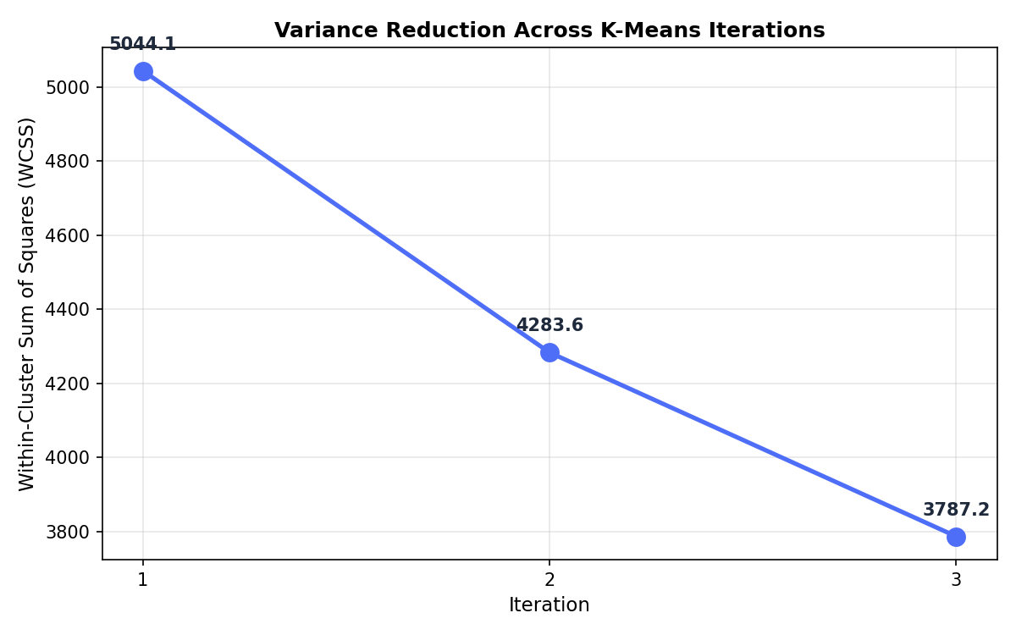
Figure 1. WCSS reduction across the three manual K-Means iterations.

3.7 Final Clustering Result
After three iterations the clusters identified can be characterized as follows:
- Cluster 1 — centroid at (51.903, 0.224) — 31 games with low critic scores and modest sales.
- Cluster 2 — centroid at (71.282, 0.361) — 39 games with mid critic scores and moderate sales (mainstream bulk).
- Cluster 3 — centroid at (86.7, 2.034) — 30 games with high critic scores and the largest commercial success (blockbusters).
The WCSS dropped from 5044.091 to 3787.158 — a reduction of 24.9% in just three iterations — which shows that K-Means makes most of its progress in the very first iterations and then refines the solution with diminishing returns.

4. Unsupervised Learning — Concepts

4.1 Definition of Unsupervised Learning
Unsupervised Learning is a branch of machine learning where the algorithm only receives input data, with no labels or expected outputs. The model must discover the underlying structure of the data on its own, in contrast to supervised algorithms (Linear Regression, Logistic Regression, KNN) which learn from input-output pairs.

4.2 Clustering
Clustering is the most common unsupervised task. Its goal is to partition a dataset into groups (clusters) such that items inside the same group are more similar to each other than to items in other groups. Similarity is measured through a distance metric — usually Euclidean distance.

4.3 K-Means Algorithm
K-Means is the most widely used clustering algorithm. It partitions a dataset into K clusters, where K is chosen by the user. Each cluster is represented by a centroid — the arithmetic mean of all points inside it. The algorithm iteratively refines centroid positions and point assignments until the clusters stop changing (convergence).

4.4 Centroids and Distance Metric
Centroid: the geometric center of a cluster, equal to the mean of the points it contains. Represented as a vector with one component per feature.
Euclidean distance (the metric K-Means uses):
d(P, C) = √( (x₁ − x₂)² + (y₁ − y₂)² )

4.5 Iterative Process
- 1. Initialize centroids — choose K initial positions (random, manual, or via K-Means++).
- 2. Assign points to nearest centroid — compute Euclidean distance from each point to each centroid and assign it to the closest.
- 3. Recalculate centroids — new centroid = mean of the points currently inside its cluster.
- 4. Repeat until convergence — loop steps 2-3 until centroids stop moving or the maximum iteration count is reached.

4.6 Variance (WCSS) and Convergence
The quantity K-Means minimizes is the Within-Cluster Sum of Squares (WCSS) — the sum of squared distances from each point to its assigned centroid. WCSS can only decrease (or stay equal) between iterations. When it stops decreasing, the algorithm has converged.
WCSS = Σ Σ d(xᵢ, cₖ)²

4.7 Advantages and Limitations
Advantages:
- Simple to understand and implement.
- Fast and scales well to large datasets.
- Produces interpretable centroids as group prototypes.
Limitations:
- Requires K to be set beforehand.
- Sensitive to initial centroid placement.
- Assumes roughly spherical, similarly-sized clusters.
- Requires feature scaling because distances are affected by scale.
- May converge to a local minimum rather than the global optimum.

4.8 Real-World Applications
- Player segmentation — grouping gamers by behavior for matchmaking and content design.
- Customer segmentation — clustering buyers by purchasing patterns for targeted marketing.
- Anomaly detection — spotting outliers such as fraud, bots, or cheating.
- Image compression — reducing an image's color palette to K representative values.
- Document grouping — topic discovery inside a text corpus.

5. Clustering Application (Flask + Scikit-learn)

5.1 Problem Description
The video game industry produces two reception signals for every release: the critics' opinion (Critic_Score) and the players' opinion (User_Score). These two signals often agree, but sometimes diverge sharply — creating interesting market segments. This application uses K-Means clustering to discover, without any labels, how games group themselves when described only by their two reception scores.

5.2 Dataset Explanation
- Source — Kaggle, Video Games Sales as at 22 Dec 2016.
- Original records — 16,719 video games.
- Records after cleaning — 7017 games with valid Critic_Score, User_Score and Global_Sales (well above the activity's 1,000-record minimum).
- Features used — 2 numerical features (Critic_Score 0-100 and User_Score 0-10).

5.3 Variables
Input Features:
Feature | Type | Description
Critic_Score | Numeric | Metacritic critical rating (0-100)
User_Score | Numeric | Users' average rating (0-10)

Target Variable:
None. Clustering is an unsupervised task — the model discovers groups by itself.

5.4 Data Preparation
- 1. Load CSV — read the Video Games Sales dataset using pandas.
- 2. Clean missing data — convert User_Score to numeric (remove 'tbd'), drop rows missing critic/user/sales fields, keep only positive values.
- 3. Select features — build the matrix X = [Critic_Score, User_Score].
- 4. Standardize features — apply StandardScaler to give both features zero mean and unit variance (essential for any distance-based algorithm).
- 5. Fit K-Means — KMeans(n_clusters=3, random_state=42, n_init=10) — n_init=10 runs the algorithm ten times with different seeds and keeps the best result.
- 6. Inverse-transform centroids — bring the centroid coordinates back to the original feature space for interpretability.

5.5 Model Training
The model uses scikit-learn's KMeans class with the following configuration:
- n_clusters=3 — discover three natural segments in the data.
- random_state=42 — reproducible results.
- n_init=10 — ten independent initializations, keep the one with the lowest inertia.
Final inertia (WCSS) after training: 4883.341

5.6 Cluster Summary
Cluster | Count | Avg Critic | Avg User | Critic Range | User Range
C1 | 3385 | 80.53 | 8.12 | 61.0 – 98.0 | 5.2 – 9.6
C2 | 2718 | 64.57 | 6.92 | 27.0 – 91.0 | 4.0 – 9.3
C3 | 914 | 49.09 | 4.49 | 13.0 – 88.0 | 0.5 – 7.0

5.7 Final Centroids
Cluster | Critic_Score | User_Score
C1 | 80.53 | 8.12
C2 | 64.56 | 6.92
C3 | 49.09 | 4.48

5.8 Visualization — Scatter Plot with Clusters and Centroids
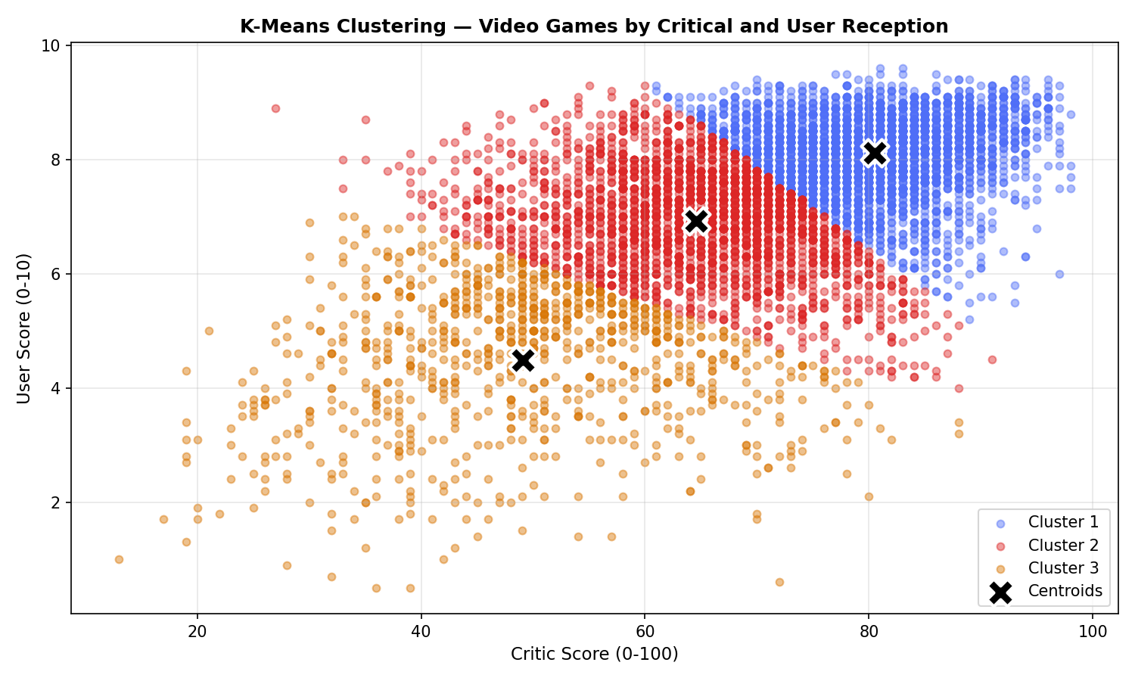
Figure 2. K-Means clustering of 7017 video games. Each point is a game colored by cluster; black X markers are the centroids.

5.9 Interpretation of Results
- Cluster 1 — Acclaimed titles — the largest segment (3385 games), high average Critic_Score (80.53) and User_Score (8.12). Both critics and players praise these games.
- Cluster 2 — Solid mid-tier — the safe-bet segment (2718 games), with moderate scores on both axes (Critic 64.57, User 6.92). Neither praised nor panned.
- Cluster 3 — Underperformers — the smallest segment (914 games), with low scores from both camps (Critic 49.09, User 4.49). Candidates for discount bundles.
- Why K = 3 works well — the three centroids are well separated along the critic-user diagonal; the clusters are stable across runs and easy to characterize.
- Limitations — K-Means assumes roughly spherical clusters of similar size, which is only approximately true here. Games at the boundaries between clusters could plausibly belong to either side.

6. Git and Repository Evidence

6.1 Public Repository URL
https://github.com/Niumaster69/Machinlearning

6.2 Branch Used
Branch | Purpose | Commits
activityClouster | Activity 3 — Unsupervised Learning (K-Means Clustering) | 6

6.3 Evidence of Commits
Progressive commits on branch activityClouster:
Commit | Description
3265ce5 | add Clustering module with manual and sklearn K-Means
3550287 | add unsupervised learning basic concepts page
d5248bd | add K-Means manual exercise page with iteration tables
817426c | add clustering application page with scatter plot
9ded6ed | add unsupervised routes and update navbar across all pages
293b774 | add Activity 3 report document and generator

6.4 Development Process
The development followed a structured, incremental approach: the activityClouster branch was created from master, the Clustering.py module was implemented first (manual K-Means plus scikit-learn pipeline), then the three new HTML templates were added (basic concepts, manual exercise, clustering application), the Flask routes were wired in app.py, and finally the navbar was updated across every existing template. All commits show progressive development.

7. Deployment on Render.com

7.1 Public URL
[ Paste the Render public URL here after deployment. ]

7.2 Deployment Notes
The application is deployed as a Flask web service on Render.com. The repository contains a requirements.txt listing the Python dependencies (Flask, pandas, numpy, scikit-learn, matplotlib, seaborn) and a Procfile declaring the web process (gunicorn app:app). On startup, the Clustering module precomputes both the manual K-Means iterations and the scikit-learn model, and saves the variance and scatter plots into /static.

8. Conclusions

8.1 Learning Outcomes
- Gained hands-on experience implementing the K-Means clustering algorithm both manually (step-by-step Euclidean distances, centroid updates, variance computation) and through scikit-learn.
- Learned the key differences between supervised and unsupervised learning: the absence of labels, the use of a geometric/structural criterion (WCSS) rather than an error against ground truth, and the need to interpret the clusters after training.
- Understood the importance of feature scaling for distance-based algorithms such as K-Means.
- Developed skills in visualizing clustering results through scatter plots with centroids and variance-reduction charts.
- Consolidated Flask development skills by extending a multi-page application with a new algorithm section that integrates consistently with the existing supervised learning modules.

8.2 Reflections on Unsupervised Learning
Clustering opens a very different perspective compared with the supervised algorithms implemented in previous activities. Without labels, the evaluation is no longer about comparing predictions to a known truth but about producing clusters that make sense from a business or domain point of view. This makes interpretability crucial — the final centroids must tell a story that a non-technical stakeholder can act upon.
The manual simulation made the mathematics concrete: watching WCSS drop from 5044 to 3787 across three iterations gave a direct intuition for why the algorithm converges and why its first iterations are the most impactful.

8.3 Comparison with Supervised Models
Aspect | Supervised (Linear / Logistic / KNN) | Unsupervised (K-Means)
Input | Features + labels | Features only
Output | Predicted value/class | Cluster assignment
Training signal | Error against true label | Within-cluster variance (WCSS)
Evaluation | Accuracy, R², F1, ROC/AUC | Inertia, silhouette, domain interpretability
Typical goal | Predict | Discover structure / segment
Project use case | Predict hours, platform, rating | Segment games by reception profile

8.4 Possible Improvements
- Elbow method — plot inertia versus K to justify the choice of K empirically.
- Silhouette score — add an internal validation metric to complement WCSS.
- More features — include regional sales and genre (one-hot encoded) and use PCA to visualize clusters.
- DBSCAN or hierarchical clustering — compare with algorithms that do not require K in advance.
- Interactive dashboard — let the user change K and see clusters update in real time.
- Template inheritance — refactor Flask templates to a base layout to reduce navbar duplication.

