Department of Computer Science
Faculty of Computing
Sri Lanka Institute of Information Technology
IT3021: Data Warehousing and Business Intelligence
Year 3 Semester 1/2 | 2026

Assignment 1
Electricity Transaction Data Warehouse & ETL Development

Table of Contents
Table of Contents 1
1. Introduction 1
2. Task 1 – Dataset Selection 1
2.1 Dataset Description 1
2.2 Business Process Explanation 1
2.3 Dataset Attributes 1
2.4 Entity Relationship Diagram (ERD) 1
3. Task 2 – Preparation of Data Sources 1
3.1 Overview 1
3.2 Data Source Mapping 1
3.3 Description of Each Data Source 1
Source 1 – Participants Core (CSV) 1
Source 2 – Participants CRM (CSV) 1
Source 3 – Network Nodes (Text File) 1
Source 4 – Security Configurations (Database) 1
Source 5 – Transactions (Text File) 1
3.4 Enrichment and Hierarchy Planning 1
4. Task 3 – Solution Architecture 1
4.1 Architecture Overview 1
4.2 Architecture Diagram 1
4.3 Component Descriptions 1
5. Task 4 – Data Warehouse Design & Development 1
5.1 Dimensional Model Overview 1
5.2 Fact Table – FactTransactions 1
Grain Definition 1
5.3 Dimension Tables 1
DimParticipant – SCD Type 2 Detail 1
5.4 Key Design Decision – DimSecurity Not Linked to Fact 1
5.5 Star Schema Diagram 1
5.6 SQL Server Implementation 1
5.7 Design Assumptions 1
6. Task 5 – ETL Development 1
6.1 ETL Architecture Overview 1
6.2 ETL Load Order 1
6.3 SSIS Control Flow 1
6.4 Staging – Data Extraction 1
6.5 Loading DimRegion 1
6.6 Loading DimNetwork – SCD Type 1 1
6.7 Loading DimSecurity 1
6.8 Loading DimParticipant – SCD Type 2 1
6.9 Loading FactTransactions 1
6.10 ETL Execution and Validation 1
7. Task 6 – ETL Development: Accumulating Fact Table Update 1
7.1 Concept 1
7.2 Accumulating Columns 1
7.3 Input Dataset – Completed Transactions 1
7.4 Update Package Architecture 1
7.5 Update Logic – OLE DB Command 1
7.6 Pre- and Post-Update Validation 1
8. Conclusion 1

1. Introduction
This report documents the complete design and implementation of a Data Warehouse (DW) and Business Intelligence (BI) solution for Electricity Transaction Analysis, developed as part of the IT3021 Data Warehousing and Business Intelligence module at SLIIT.
The solution follows the Kimball dimensional modelling approach and is built entirely using Microsoft SQL Server and SQL Server Integration Services (SSIS). It covers all six assignment tasks: dataset selection, data source preparation, solution architecture, dimensional model design and implementation, core ETL development, and accumulating fact table updates.

2. Task 1 – Dataset Selection

2.1 Dataset Description
The dataset selected for this project is the Electricity Transaction dataset, representing a transactional OLTP system used to record electricity trading activities between market participants. The system captures high-frequency trade transactions executed through a digital energy trading platform.
The dataset is a novel OLTP scenario — it does not represent a pre-built OLAP structure and has not been used in practical sessions. It contains approximately 10,000 to 150,000 transaction records covering roughly one year of trading activity, which is sufficient to demonstrate all required data warehousing concepts.

Each transaction record captures:
- Transaction identifier and timestamp
- Participant details (user ID, role, account tier, company, region)
- Network infrastructure used (network slice, data centre, slice type)
- Security configuration applied (security level, encryption method, Zero Trust authentication)
- Financial measures (electricity quantity in MWh, price per MWh, total cost)
- Technical measure (network latency in milliseconds)
- Transaction metadata (type: buy/sell, status: completed/pending)

2.2 Business Process Explanation
The dataset models an electricity spot market trading process where energy generators, dealers, and consumers buy and sell electricity in real time through a digital platform. When a participant initiates a trade, the system records the full transaction event including financial, network, and security details.
Each transaction is associated with three key operational entities:
- A market participant (the user executing the trade)
- A network node (the infrastructure slice used to transmit the trade)
- A security configuration (the encryption and authentication settings active during the trade)

This design ensures traceability, operational auditability, and supports rich analytical querying across time, geography, network performance, and transaction cost dimensions.

2.3 Dataset Attributes

Attribute | Description
TransactionID | Unique identifier for each electricity trade transaction
Timestamp | Date and time when the transaction occurred
UserID | Unique identifier of the market participant
UserRole | Role of the participant (generator, dealer, consumer)
AccountTier | Account classification tier of the participant
CompanyName | Company the participant belongs to
RegionName | Geographic region of the participant
NetworkSliceID | Identifier of the network slice used
DataCenter | Data centre handling the transaction
SliceType | Type of network slice (e.g., eMBB, URLLC)
SecurityConfigID | Identifier of the security configuration applied
SecurityLevel | Level of security applied to the transaction
EncryptionMethod | Encryption algorithm used (e.g., AES-256)
ZTAuthentication | Whether Zero Trust Authentication was applied (Y/N)
TransactionType | Trade direction: Buy or Sell
ElectricityQuantity | Amount of electricity traded (MWh)
PricePerMWh | Price per megawatt-hour (USD)
TotalCost | Total monetary value of the transaction
LatencyMS | Network latency in milliseconds
TransactionStatus | Outcome of the transaction (Completed / Pending)

2.4 Entity Relationship Diagram (ERD)
The ER diagram below illustrates the OLTP structure of the electricity trading system. The central Transaction entity links to Participant, Network Node, and Security Configuration entities through foreign key relationships.

📸 [ INSERT SCREENSHOT HERE ] — Figure 1 – OLTP Entity Relationship Diagram for the Electricity Transaction System

Figure 1 – OLTP Entity Relationship Diagram (ERD)

3. Task 2 – Preparation of Data Sources

3.1 Overview

In a real-world electricity trading environment, operational data is not stored in a single system. Different aspects of the business are managed by separate systems, participant information is maintained by the CRM and HR teams, network infrastructure data comes from the network operations team, security configurations are managed by the IT security department, and transaction records are generated by the trading platform itself.

To reflect this realistic scenario, the data for this project is sourced from five distinct files across multiple formats, representing three separate operational systems. These sources were loaded into five staging tables in the data warehouse pipeline.

3.2 Data Source Mapping

Staging Table | Source File / Format | Contents
stg_Participants_Core | CSV file | UserID, UserRole, AccountTier — core participant identity data
stg_Participants_CRM | CSV file | UserID, CompanyName, RegionName — CRM and geographic data
stg_Network_Nodes | Text file | NetworkSliceID, DataCenter, SliceType — network infrastructure records
stg_Security_Configs | SQL Server Database table | SecurityConfigID, SecurityLevel, EncryptionMethod, ZTAuthentication — security settings
stg_Transactions_Fact | Text File | All transaction records — the primary OLTP transactional source

3.3 Description of Each Data Source

Source 1 – Participants Core (CSV)
This CSV file contains the core identity attributes of each market participant.
- UserID — business key linking to CRM source
- UserRole — generator, dealer, or consumer
- AccountTier — classification of the participant account

Source 2 – Participants CRM (CSV)
This CSV file represents a CRM system holding company and geographic data for participants. It is merged with the Core source during ETL using a Merge Join on UserID to produce the complete DimParticipant dimension.
- UserID — join key to Core source
- CompanyName — name of the participant's organisation
- RegionName — geographic region of the participant

Source 3 – Network Nodes (Text File)
This text file represents network infrastructure records describing the communication slices used during transactions.
- NetworkSliceID — unique identifier for the network slice
- DataCenter — data centre handling network traffic
- SliceType — type of network slice (e.g., eMBB, URLLC)

Source 4 – Security Configurations (Database)
This database table stores security configurations applied during transactions. Storing security settings in a relational database reflects a real-world scenario where a dedicated security management system maintains these configurations.
- SecurityConfigID — unique configuration identifier
- SecurityLevel — security classification level
- EncryptionMethod — encryption algorithm applied
- ZTAuthentication — Zero Trust Authentication flag (Y/N)

Source 5 – Transactions (Text File)
This text file is the primary OLTP transactional source containing all electricity trade event records. It holds the core financial and operational measures along with foreign key references to participants, network nodes, and security configurations.

3.4 Enrichment and Hierarchy Planning
The separation of participants into two sources (Core + CRM) introduces the RegionName attribute, which is used to build the DimRegion dimension. This enables geographic hierarchical analysis (Region → Participant) that would not be possible from the transaction data alone.
The Network source introduces SliceType and DataCenter, enabling network-level analysis and grouping. These enrichments allow the warehouse to support richer analytical queries beyond what the raw transaction data provides.

4. Task 3 – Solution Architecture

4.1 Architecture Overview
The DW & BI solution follows a layered architecture that moves data from raw operational sources through to analytical reporting tools.

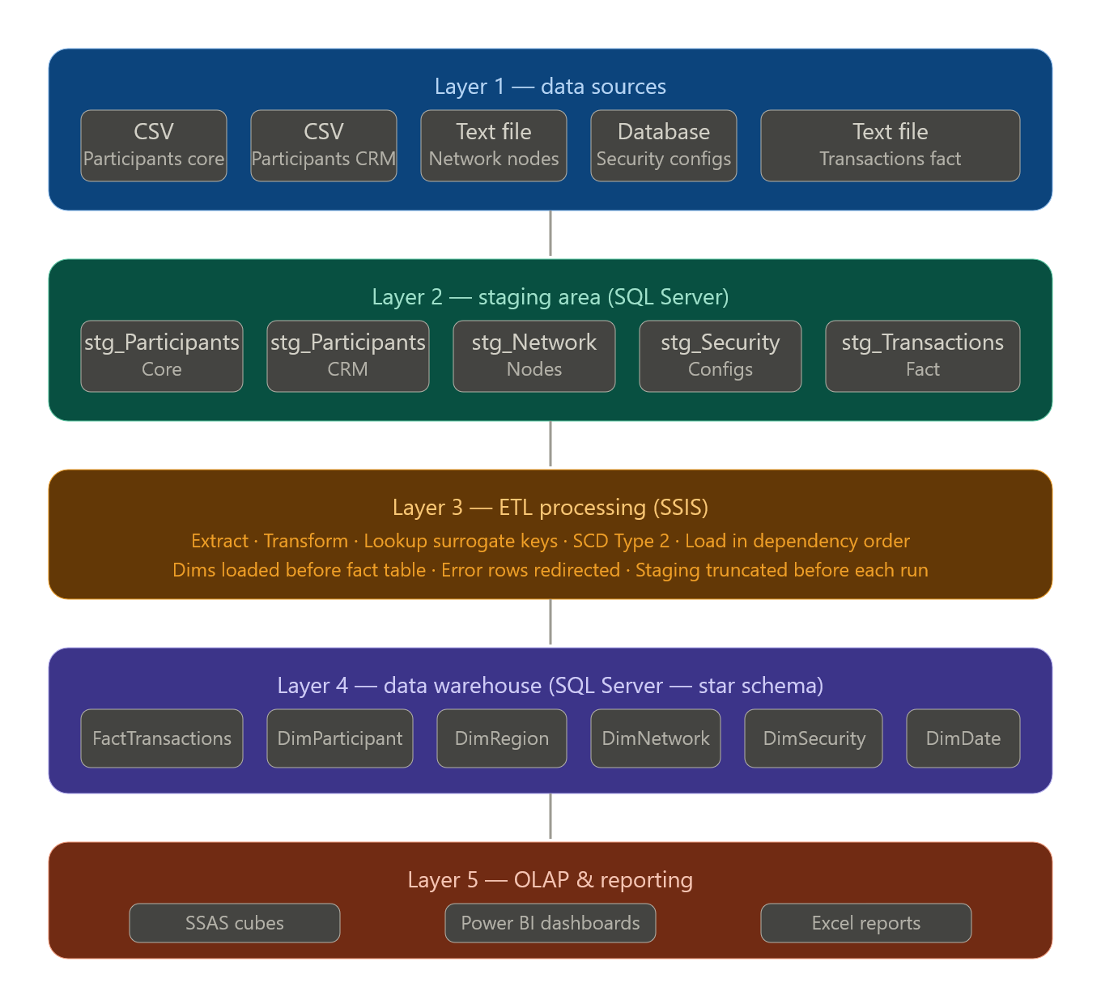
4.2 Architecture Diagram
Figure 2 – Data Warehouse & BI Solution Architecture

4.3 Component Descriptions

Layer | Components | Description
Data Source Layer | CSV, Text files, SQL Server Database | Operational sources holding raw participant, network, security, and transaction data in heterogeneous formats
Staging Layer | stg_Participants_Core, stg_Participants_CRM, stg_Network_Nodes, stg_Security_Configs, stg_Transactions_Fact | Temporary SQL Server tables that hold extracted raw data before transformation. Enables data cleansing, schema alignment, and isolation from production source systems
ETL Layer | SSIS (SQL Server Integration Services) | SSIS packages extract data from all sources, apply transformations (Merge Join, Lookup, SCD, Derived Column), resolve surrogate keys, and load data into the dimensional model in the correct order
Data Warehouse Layer | SQL Server DW Database | Central analytical repository implementing a Star Schema with one fact table and five dimension tables, optimised for query performance
OLAP & Reporting Layer | SSAS, Power BI, Excel | Business intelligence tools that connect to the DW to generate reports, dashboards, and multidimensional analysis cubes

5. Task 4 – Data Warehouse Design & Development

5.1 Dimensional Model Overview
The data warehouse is designed using a Star Schema following the Kimball dimensional modelling methodology. The central fact table FactTransactions is surrounded by five dimension tables, all connected directly to the fact table via surrogate keys.

5.2 Fact Table – FactTransactions
One row in FactTransactions represents one electricity trade transaction executed by a market participant through the trading platform.

The fact table contains three categories of columns:

Category | Column | Description
Foreign Key | ParticipantSK | Surrogate key linking to DimParticipant
Foreign Key | NetworkSK | Surrogate key linking to DimNetwork
Foreign Key | DateKey | Surrogate key linking to DimDate
Measure | ElectricityQuantity | Amount of electricity traded (MWh)
Measure | PricePerMWh | Price per megawatt-hour (USD)
Measure | TotalCost | Total monetary value of the transaction
Measure | LatencyMS | Network latency in milliseconds
Degenerate Dimension | TransactionID | Natural business key — retained in fact, no dimension table
Degenerate Dimension | TransactionType | Buy or Sell — low cardinality attribute stored directly
Degenerate Dimension | TransactionStatus | Completed or Pending
Accumulating | accm_txn_create_time | Timestamp when the record was inserted into the DW
Accumulating | accm_txn_complete_time | Timestamp when the transaction was confirmed complete (initially NULL)
Accumulating | txn_process_time_hours | Computed duration in hours between create and complete time

5.3 Dimension Tables

Dimension | Key | Attributes | SCD Type
DimParticipant | ParticipantSK | UserID, UserRole, AccountTier, CompanyName, RegionSK, StartDate, EndDate, IsCurrent | Type 2
DimRegion | RegionSK | RegionName | Type 1
DimNetwork | NetworkSK | NetworkSliceID, DataCenter, SliceType | Type 1
DimSecurity | SecurityConfigSK | SecurityConfigID, SecurityLevel, EncryptionMethod, ZTAuthentication | Type 1 (not linked to fact — see design decision)
DimDate | DateKey | Date, Day, Month, Quarter, Year, DayOfWeek, IsWeekend | Static (pre-populated)

DimParticipant – SCD Type 2 Detail
The DimParticipant dimension is implemented as a Type 2 Slowly Changing Dimension to track historical changes in participant attributes such as UserRole and AccountTier. When a change is detected, the existing record is expired and a new record is inserted.

SCD Column | Purpose
StartDate | Date from which this version of the participant record became effective
EndDate | Date on which this version expired (NULL for the currently active record)
IsCurrent | Flag indicating the active record: 1 = current, 0 = historical

5.4 Key Design Decision – DimSecurity Not Linked to Fact
DimSecurity is populated and maintained as a dimension table, but it is deliberately not linked to the FactTransactions fact table via a foreign key. This is an intentional design decision based on the following reasoning:
- Security configuration is associated with the network infrastructure, not with individual transactions at the grain level.
- Linking DimSecurity directly to the fact would introduce ambiguity, as multiple security configurations may be associated with a single network node.
- Including a SecuritySK in the fact table could produce duplicate fact rows or incorrect aggregations when analysing measures such as TotalCost or ElectricityQuantity.

Security-level analysis can still be performed by joining DimSecurity to DimNetwork (via NetworkSK) in analytical queries — without compromising fact table integrity.

5.5 Star Schema Diagram
The diagram below shows the complete Star Schema implemented in SQL Server, with FactTransactions at the centre surrounded by all dimension tables.

📸 [ INSERT SCREENSHOT HERE ] — Figure 3 – SQL Server Database Diagram showing the Star Schema (FactTransactions + DimParticipant + DimRegion + DimNetwork + DimDate + DimSecurity)

Figure 3 – Data Warehouse Star Schema

5.6 SQL Server Implementation
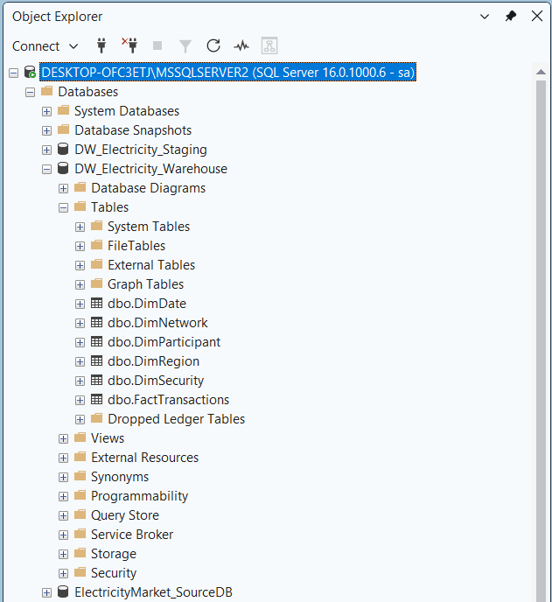
The dimensional model was implemented in SQL Server using CREATE TABLE statements. Below are the key table definitions.

Figure 4 – DW Tables in SQL Server Management Studio

FactTransactions – SQL Definition:
CREATE TABLE FactTransactions (
TransactionSK INT IDENTITY(1,1) PRIMARY KEY,
ParticipantSK INT NOT NULL,
NetworkSK INT NOT NULL,
DateKey INT NOT NULL,
TransactionID NVARCHAR(50), -- degenerate dimension
TransactionType NVARCHAR(10), -- degenerate dimension
TransactionStatus NVARCHAR(20), -- degenerate dimension
ElectricityQuantity DECIMAL(10,2),
PricePerMWh DECIMAL(10,2),
TotalCost DECIMAL(12,2),
LatencyMS INT,
accm_txn_create_time DATETIME DEFAULT GETDATE(),
accm_txn_complete_time DATETIME NULL,
txn_process_time_hours FLOAT NULL,
FOREIGN KEY (ParticipantSK) REFERENCES DimParticipant(ParticipantSK),
FOREIGN KEY (NetworkSK) REFERENCES DimNetwork(NetworkSK),
FOREIGN KEY (DateKey) REFERENCES DimDate(DateKey)
);

DimParticipant – SQL Definition (SCD Type 2):
CREATE TABLE DimParticipant (
ParticipantSK INT IDENTITY(1,1) PRIMARY KEY,
UserID NVARCHAR(50) NOT NULL, -- business key
UserRole NVARCHAR(50),
AccountTier NVARCHAR(50),
CompanyName NVARCHAR(100),
RegionSK INT,
StartDate DATE NOT NULL,
EndDate DATE NULL,
IsCurrent BIT NOT NULL DEFAULT 1
);

5.7 Design Assumptions
- TransactionID is treated as the natural business key and stored as a degenerate dimension in the fact table.
- Surrogate keys are generated using SQL Server IDENTITY columns for all dimension and fact tables.
- DimParticipant implements SCD Type 2; all other dimensions use SCD Type 1 (update in place).
- DimDate is pre-populated to cover the full date range of the dataset before ETL execution.
- DimSecurity is intentionally excluded from the fact table foreign keys — it is linked analytically via DimNetwork.
- Null or unmatched records during Lookup transformations are redirected to error outputs rather than causing ETL failure.
- The grain of the fact table is one row per transaction — no pre-aggregation is applied during ETL.

6. Task 5 – ETL Development

6.1 ETL Architecture Overview
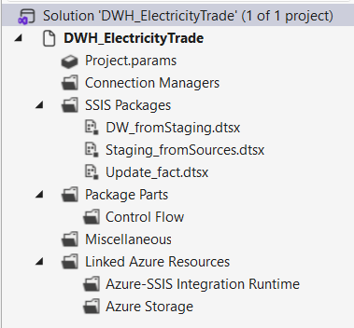
The ETL pipeline was implemented using SQL Server Integration Services (SSIS) within Microsoft Visual Studio. The pipeline is organised into two SSIS packages: one for staging data extraction and one for dimension and fact loading. Data flows from source files through staging tables into the dimensional model.

Figure 5.1 – SSIS Project Structure

6.2 ETL Load Order
Referential integrity requires that all dimension tables are fully loaded before the fact table is populated. The execution sequence is:

Step | Task | Target
1 | Truncate all staging tables | All stg_ tables
2 | Extract from CSV → stg_Participants_Core | stg_Participants_Core
3 | Extract from CSV → stg_Participants_CRM | stg_Participants_CRM
4 | Extract from Text → stg_Network_Nodes | stg_Network_Nodes
5 | Extract from Database → stg_Security_Configs | stg_Security_Configs
6 | Extract from Text → stg_Transactions_Fact | stg_Transactions_Fact
7 | Load DimRegion | DimRegion
8 | Load DimNetwork (Type 1 SCD) | DimNetwork
9 | Load DimSecurity (Lookup NetworkSK) | DimSecurity
10 | Load DimParticipant (Type 2 SCD) | DimParticipant
11 | Load DimDate (if not pre-populated) | DimDate
12 | Load FactTransactions | FactTransactions

6.3 SSIS Control Flow
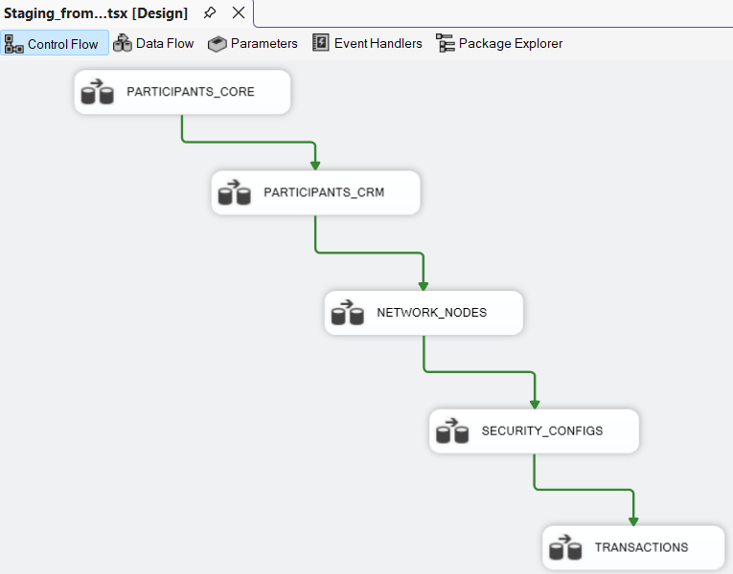
📸 [ INSERT SCREENSHOT HERE ] — Figure 5.2 – SSIS Control Flow showing all Data Flow Tasks connected in correct execution order with precedence constraints

Figure 5.2 – Core ETL Package Control Flow

6.4 Staging – Data Extraction
Each staging table is truncated before extraction using an Execute SQL Task to ensure only the latest data is processed on every ETL run. Data is then extracted using source components appropriate to each file format:

Source | Format | SSIS Source Component | Staging Table
Participants_Core.csv | CSV | Flat File Source | stg_Participants_Core
Participants_CRM.csv | CSV | Flat File Source | stg_Participants_CRM
Network_Nodes.txt | CSV | Flat File Source | stg_Network_Nodes
Security_Configs (DB table) | Database | OLE DB Source | stg_Security_Configs
Transactions_Fact.txt | Text | Flat File Source | stg_Transactions_Fact
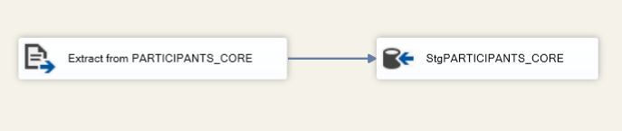
Figure 5.3 – Staging Extraction Data Flow Task

6.5 Loading DimRegion
Region data is derived from the RegionName column in stg_Participants_CRM. Duplicates are removed using a Sort and Aggregate transformation before inserting unique region records into DimRegion.
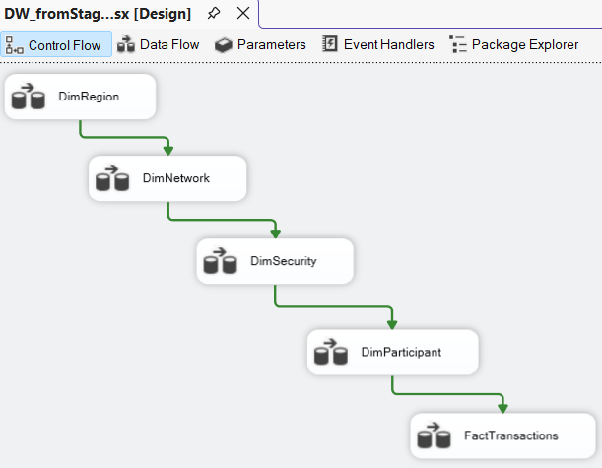
Flow: OLE DB Source (stg_Participants_CRM) → Sort (RegionName) → Aggregate (distinct) → OLE DB Destination (DimRegion)

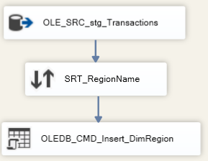
Figure 5.4 – DimRegion Load Data Flow

6.6 Loading DimNetwork – SCD Type 1
Network node records from stg_Network_Nodes are loaded into DimNetwork using a Lookup to check for existing records. New records are inserted; existing records with changed attributes are updated in place (Type 1 — no history preserved).
Flow: OLE DB Source → Lookup (DimNetwork on NetworkSliceID) → [No Match] Insert / [Match] OLE DB Command (UPDATE)
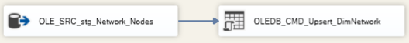

Figure 5.5 – DimNetwork Load Data Flow (SCD Type 1)

6.7 Loading DimSecurity
Security configuration records are extracted from the stg_Security_Configs database table using an OLE DB Source. A Lookup transformation resolves the NetworkSK from DimNetwork before inserting into DimSecurity.
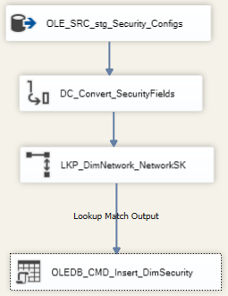
Flow: OLE DB Source (stg_Security_Configs DB) → Lookup (DimNetwork → get NetworkSK) → OLE DB Destination (DimSecurity)

Figure 5.6 – DimSecurity Load Data Flow

6.8 Loading DimParticipant – SCD Type 2
DimParticipant is the most complex dimension load, combining data from two source tables and implementing Type 2 SCD to preserve historical participant records.

Steps in the Data Flow:
- Sort stg_Participants_Core on UserID
- Sort stg_Participants_CRM on UserID
- Merge Join (Inner Join on UserID) to combine role/tier data with company/region data
- Lookup DimRegion on RegionName → resolve RegionSK
- Apply SCD Transformation (business key: UserID; historical attributes: UserRole, AccountTier)
- On change detected: expire old record (update EndDate, set IsCurrent = 0) and insert new record
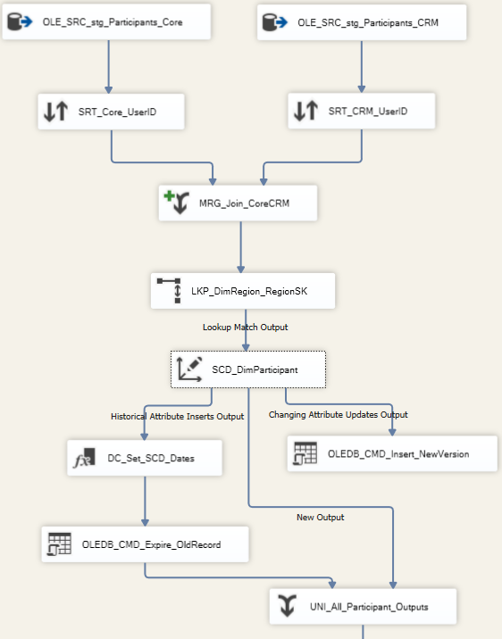
SCD Configuration | Value
Business Key | UserID
Historical Attributes (Type 2) | UserRole, AccountTier
Fixed Attributes | CompanyName, RegionSK
StartDate Column | StartDate
EndDate Column | EndDate
IsCurrent Column | IsCurrent

Figure 5.7 – DimParticipant Load Data Flow (SCD Type 2)

📸 [ INSERT SCREENSHOT HERE ] — Figure 5.8 – SCD Wizard configuration showing UserID as Business Key and UserRole/AccountTier as Historical Attributes
Figure 5.8 – SCD Type 2 Wizard Configuration

6.9 Loading FactTransactions
The fact table is loaded last, after all dimensions are fully populated. Surrogate keys are resolved using Lookup transformations for each dimension.

Steps in the Data Flow:
- Flat File Source from stg_Transactions_Fact (Text file)
- Derived Column: extract DateKey from transaction timestamp
- Lookup DimParticipant on UserID → resolve ParticipantSK (IsCurrent = 1)
- Lookup DimNetwork on NetworkSliceID → resolve NetworkSK
- Lookup DimDate on date value → resolve DateKey
- Derived Column: set accm_txn_create_time = GETDATE()
- OLE DB Destination: insert into FactTransactions

Lookup | Match Key | Output Surrogate Key
DimParticipant | UserID (where IsCurrent = 1) | ParticipantSK
DimNetwork | NetworkSliceID | NetworkSK
DimDate | Derived date from timestamp | DateKey

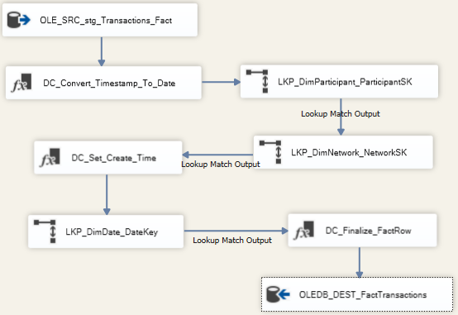
All Lookup transformations are configured to redirect non-matching rows to an error output rather than failing the pipeline, ensuring fault tolerance.
Figure 5.9 – FactTransactions Load Data Flow

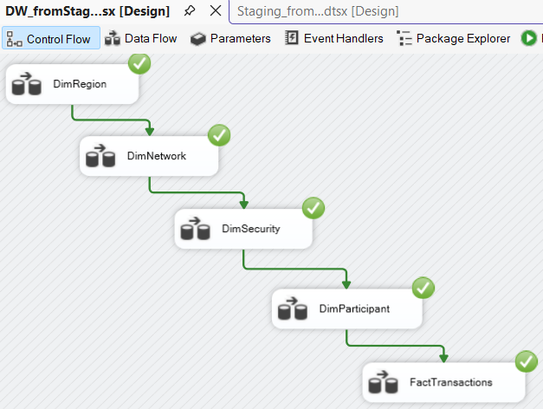
6.10 ETL Execution and Validation

Figure 5.10 – Successful ETL Package Execution

Post-execution validation queries:
-- Total transactions loaded
SELECT COUNT(*) AS TotalTransactions FROM FactTransactions;

-- NULL surrogate key check
SELECT * FROM FactTransactions WHERE ParticipantSK IS NULL;

-- SCD Type 2 verification
SELECT UserID, COUNT(*) AS Versions
FROM DimParticipant GROUP BY UserID HAVING COUNT(*) > 1;

📸 [ INSERT SCREENSHOT HERE ] — Figure 5.11 – SSMS showing validation query results confirming correct row counts and no NULL surrogate keys

Figure 5.11 – ETL Validation Query Results in SSMS

7. Task 6 – ETL Development: Accumulating Fact Table Update

7.1 Concept
An Accumulating Fact Table tracks the full lifecycle of a business process by allowing selected columns to be updated as the process moves through defined milestones. Unlike insert-only fact tables, accumulating fact tables support updates to reflect progress.
In this system, each electricity transaction passes through the following lifecycle stages:
- Transaction Created — recorded when the fact record is first inserted into the DW
- Transaction Processing — ongoing, no update needed
- Transaction Completed — recorded when the trading platform confirms the transaction is finalised

7.2 Accumulating Columns

Column | Type | Description
accm_txn_create_time | DATETIME | Set to GETDATE() at initial fact load. Represents when the transaction entered the DW.
accm_txn_complete_time | DATETIME NULL | NULL at initial load. Updated when transaction completion is confirmed.
txn_process_time_hours | FLOAT NULL | Calculated as DATEDIFF(HOUR, accm_txn_create_time, accm_txn_complete_time) on update.

7.3 Input Dataset – Completed Transactions
A separate CSV file (Completed_Transactions.csv) was prepared to simulate the completion event feed. Its structure is:

Column | Description
TransactionSK | Surrogate key matching the record in FactTransactions to be updated
accm_txn_complete_time | The confirmed completion timestamp for the transaction

Example data:
TransactionSK,accm_txn_complete_time
101,2026-03-10 15:00:00
102,2026-03-11 10:30:00
103,2026-03-12 11:45:00

7.4 Update Package Architecture
A dedicated SSIS package named Update_Accumulating_Fact.dtsx was developed separately from the main ETL package to handle transaction lifecycle updates. This separation ensures that completion updates are processed independently without interfering with the main load pipeline.

7.5 Update Logic – OLE DB Command
Inside the update package, a Flat File Source reads Completed_Transactions.csv. An OLE DB Command transformation then performs a row-by-row parameterised UPDATE on the fact table.

SQL Update Statement used in OLE DB Command:
UPDATE FactTransactions
SET
accm_txn_complete_time = ?,
txn_process_time_hours = DATEDIFF(HOUR, accm_txn_create_time, ?)
WHERE
TransactionSK = ?
AND accm_txn_complete_time IS NULL

Parameter Mapping:
Parameter | Mapped Input Column | Purpose
Param_0 (?) | accm_txn_complete_time | Sets the completion timestamp
Param_1 (?) | accm_txn_complete_time | Used in DATEDIFF to calculate hours
Param_2 (?) | TransactionSK | Matches the fact row to update

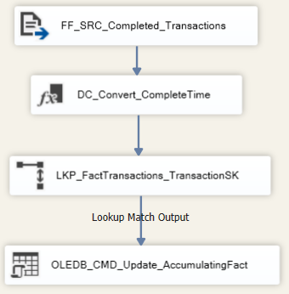
The condition AND accm_txn_complete_time IS NULL ensures that already-completed transactions are never overwritten. If a TransactionSK in the input file does not exist in the fact table, the UPDATE silently affects zero rows — no error is raised and the pipeline continues.
Figure 6.2 – Update Package Data Flow

📸 [ INSERT SCREENSHOT HERE ] — Figure 6.3 – OLE DB Command component showing the parameterised SQL UPDATE statement

Figure 6.3 – OLE DB Command SQL Update Logic

📸 [ INSERT SCREENSHOT HERE ] — Figure 6.4 – OLE DB Command Column Mappings showing Param_0, Param_1, Param_2 mapped to input columns

Figure 6.4 – Parameter Mapping Configuration

7.6 Pre- and Post-Update Validation
Validation queries were run in SSMS before and after executing the update package to confirm correct behaviour.

Pre-Update Query:
SELECT TransactionSK, accm_txn_create_time,
accm_txn_complete_time, txn_process_time_hours
FROM FactTransactions
WHERE TransactionSK IN (101, 102, 103);

📸 [ INSERT SCREENSHOT HERE ] — Figure 6.5 – SSMS result BEFORE update showing NULL values in accm_txn_complete_time and txn_process_time_hours

Figure 6.5 – Fact Table Before Update

Post-Update Query (same query re-run after package execution):

📸 [ INSERT SCREENSHOT HERE ] — Figure 6.6 – SSMS result AFTER update showing populated completion timestamps and calculated process hours

Figure 6.6 – Fact Table After Update

Expected result after update:

TransactionSK | accm_txn_create_time | accm_txn_complete_time | txn_process_time_hours
101 | 2026-03-10 09:00:00 | 2026-03-10 15:00:00 | 6.0
102 | 2026-03-11 08:30:00 | 2026-03-11 10:30:00 | 2.0
103 | 2026-03-12 09:00:00 | 2026-03-12 11:45:00 | 2.0

8. Conclusion
This report documented the complete design and implementation of a Data Warehouse and Business Intelligence solution for Electricity Transaction Analysis using the Kimball dimensional modelling methodology.

The solution successfully delivers:
- A novel OLTP dataset representing real-time electricity trading activities, covering approximately one year of transaction data.
- Five data sources across three distinct formats (CSV, Text file, SQL Server Database) mapped to staging tables, exceeding the minimum requirement of two source types.
- A five-layer DW & BI architecture covering source ingestion, staging, ETL, dimensional storage, and analytical reporting.
- A Star Schema dimensional model implemented in SQL Server with one fact table (FactTransactions) and five dimension tables (DimParticipant, DimRegion, DimNetwork, DimSecurity, DimDate).
- SCD Type 2 on DimParticipant to track historical changes in participant roles and account tiers; SCD Type 1 on DimNetwork.
- A full SSIS ETL pipeline with multi-source extraction, Merge Join for participant consolidation, surrogate key lookups, SCD processing, and fact table loading in the correct dependency order.
- An Accumulating Fact Table implementation with a dedicated SSIS update package that tracks transaction lifecycle milestones and computes processing duration in hours.
- A deliberate design decision to exclude DimSecurity from the fact table to preserve grain integrity and prevent incorrect aggregations.

All components were validated using SSMS queries confirming correct row counts, surrogate key assignments, SCD versioning, and accurate accumulating fact updates.

