CS 5004 Final Project
Group member: Yuqing Lei, Guoyue Liu, Wanjing Yang, Yingzi Zhou

1. Goals and Rationale
A stock review assistant built in Java. After the user enters a stock ticker and date range, the program retrieves stock price data and related news/event data, identifies significant price movements.
2. Demonstration of your project in operation
https://market-lens-delta.vercel.app
3. Methods and Tools Used
Java for back-end database and functions, Swing GUI + JFreeChart for interactive price chart, event markers etc.
4. Walk-through of a small portion of your code
TBD
5. Findings and Lessons Learned (What was hard/ easy?)
TBD
6. Limitations and Future Extensions
We could extend this assistant with a future prediction maker and generate a structured review report to help investors make investment decisions.
7. 8. Highlights of your use of 1-2 big ideas from Object Oriented Design (e.g., encapsulation,
inheritance, composition, polymorphism, abstraction, MVC)
Abstraction: dataProvider (generic type, used to read documentations), Analyzer (interface, used to read data, detect outliers and do price increasing or decreasing calculations)
Polymorphism: csv data provider, api data provider, etc.,
Encapsulation: private stock data (unnecessary stock start or end data) and public related news
Composition: combine data picker and analyzer together - first pick up all data information within the time range and analyze the outlier data
MVC Architecture: (Forecast function and their output still TBD)
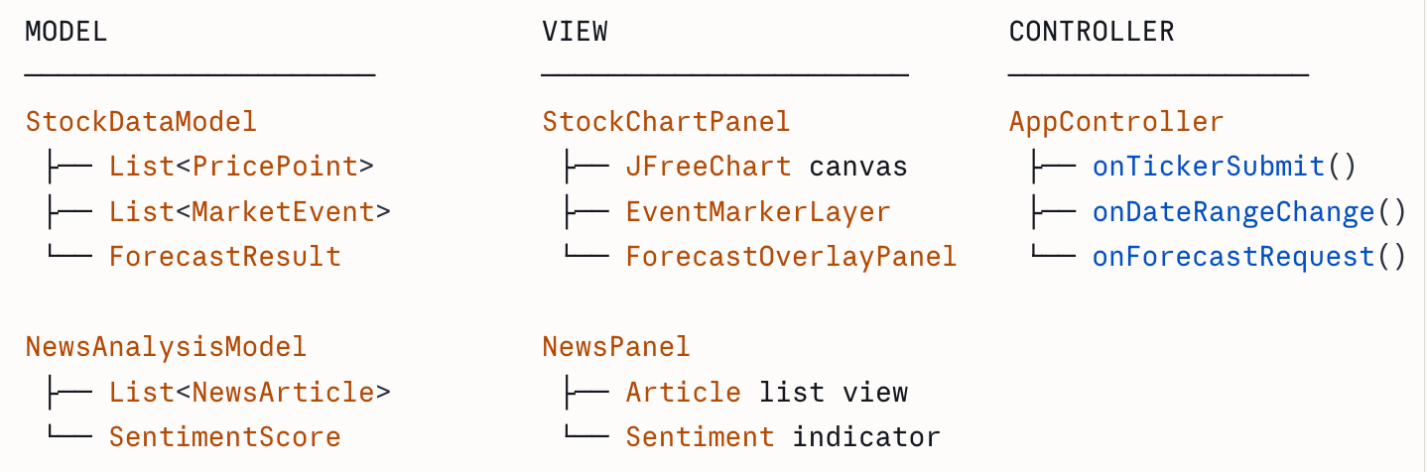

Scholarly Citations (or at least URLs) for resources you relied upon
9. Time for Questions and Answers

