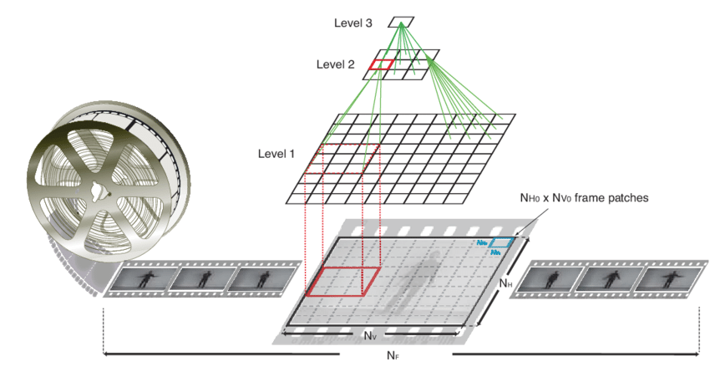
Level 3
Level 2
Level 2
A
TTT
A
IN
Level 1
DAN
NHO X Nvo frame patches

