**Kafka Integration with C#:**

**Hands On:**

1. Create a Chat Application which uses Kafka as a streaming platform and consume the chat messages in the command prompt.
2. Create a Chat Application using C# Windows Application using Kafka and consume the message in different client applications.

**Form1.cs [PRODUCER]**

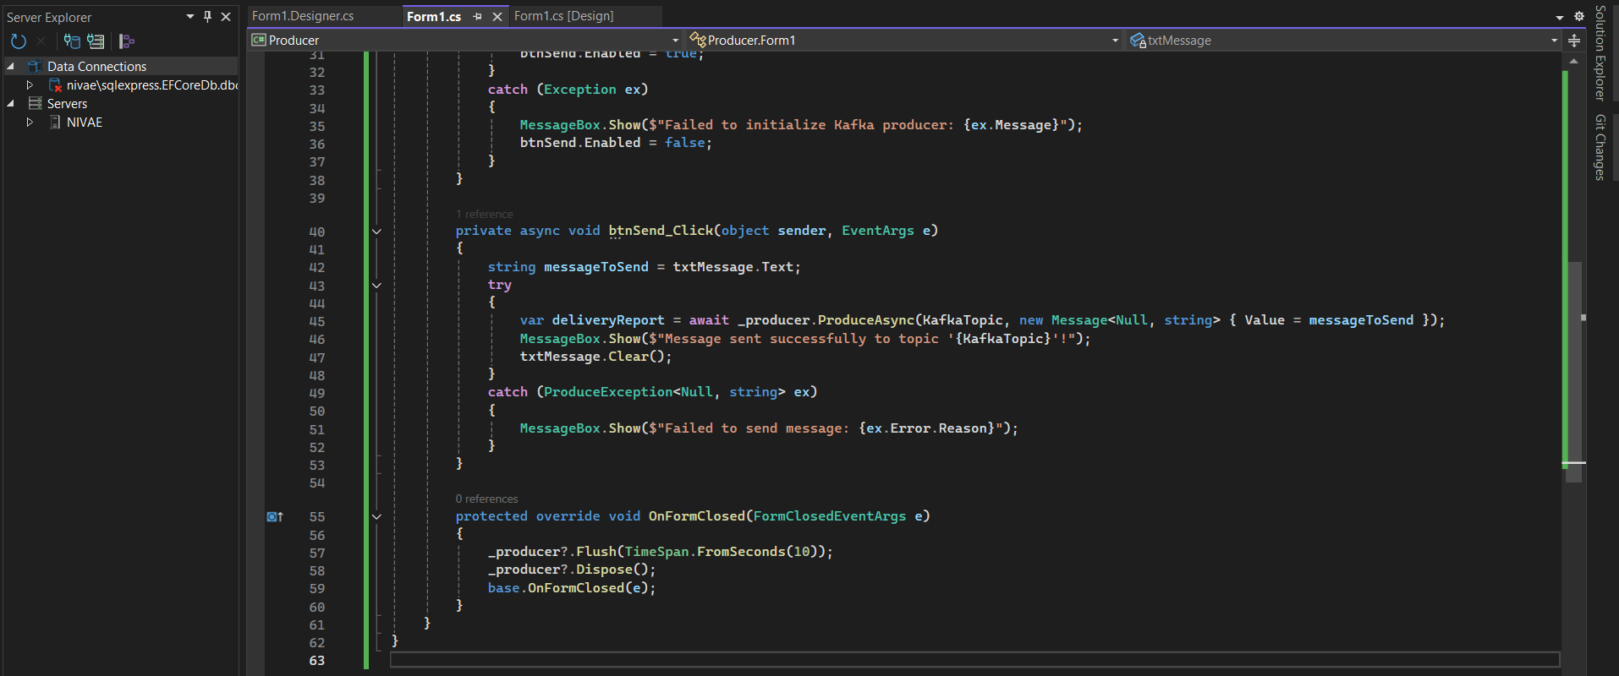

**Form1.Desginer.cs[PRODUCER]**

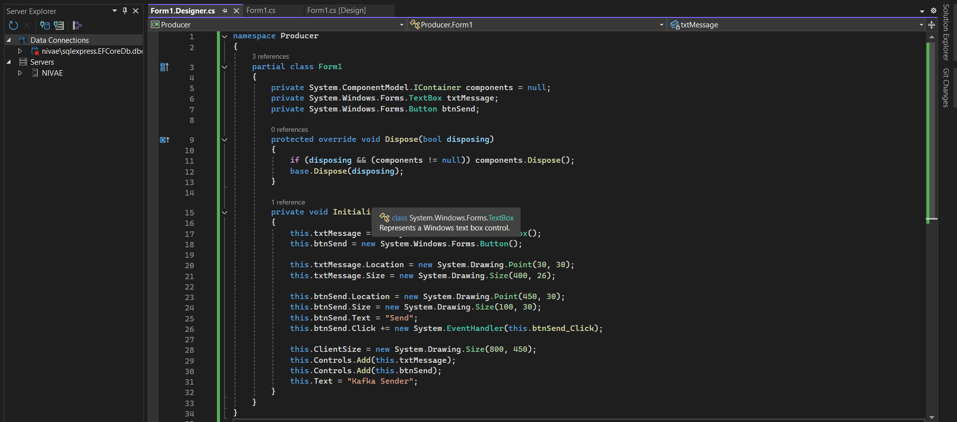

**Form1.cs [CONSUMER]**

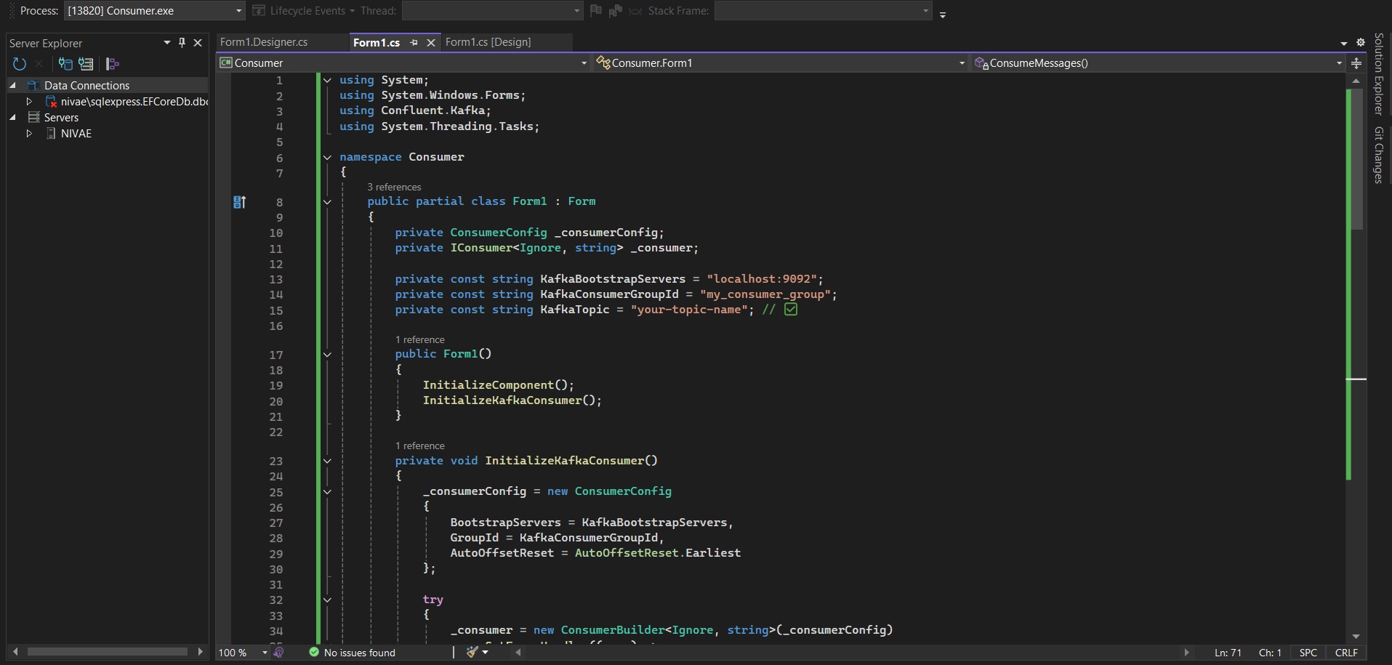

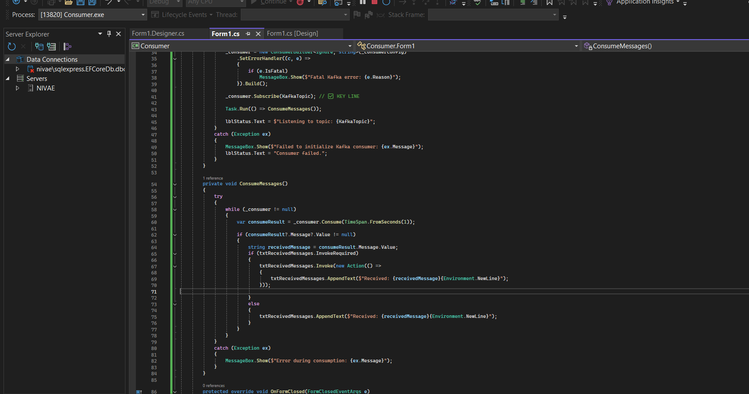

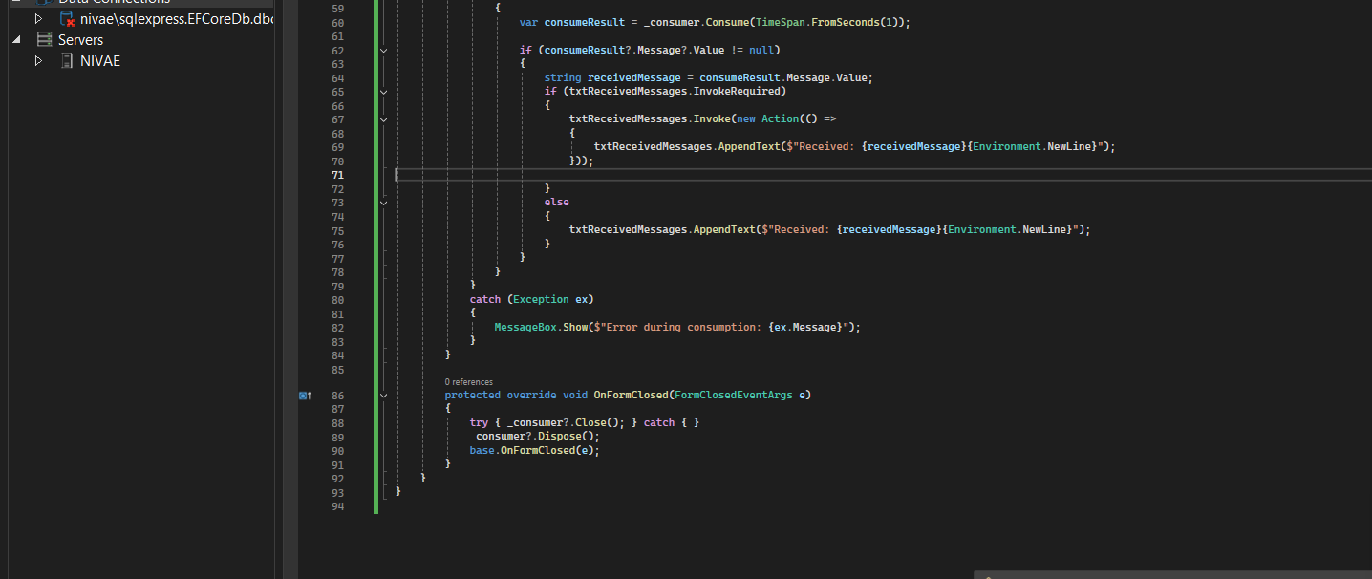

**Form1.Designer.cs[CONSUMER]**

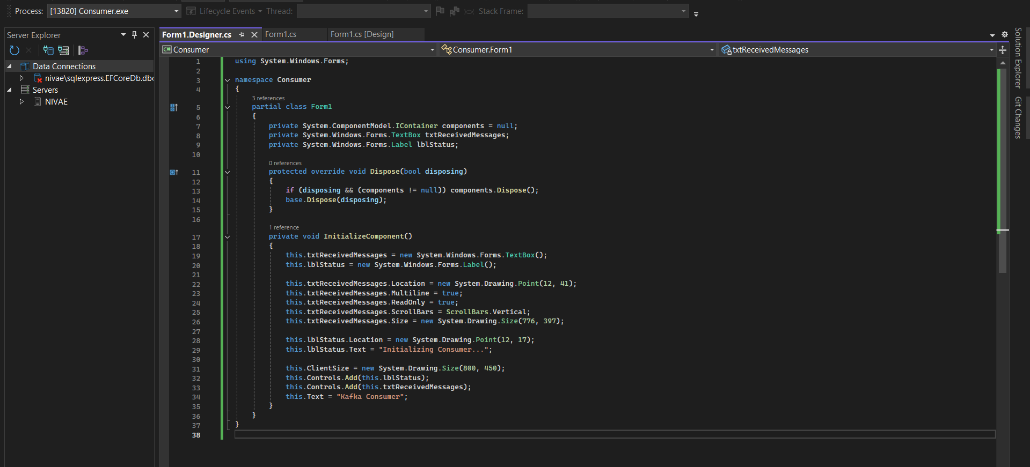

**ZooKepeer and Kafka Server:**

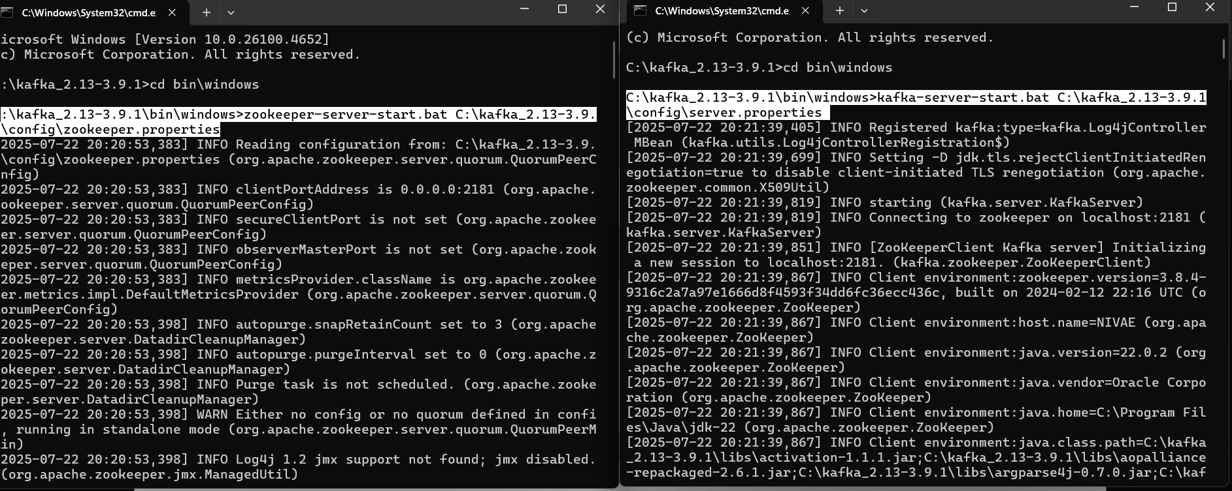

**OUTPUT**

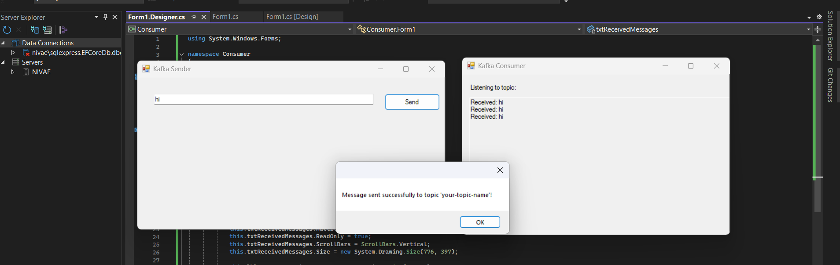

1. Microservices - JWT

**Microservices – JWT**

Question 1: Implement JWT Authentication in ASP.NET Core Web API

