1. Familiar with Git commands like git init, git status, git add, git commit, git push, and git pull.

In this hands-on lab, you will learn how to

1. Setup your machine with Git Configuration
2. Integrate notepad++.exe to Git and make it a default editor
3. Add a file to source code repository

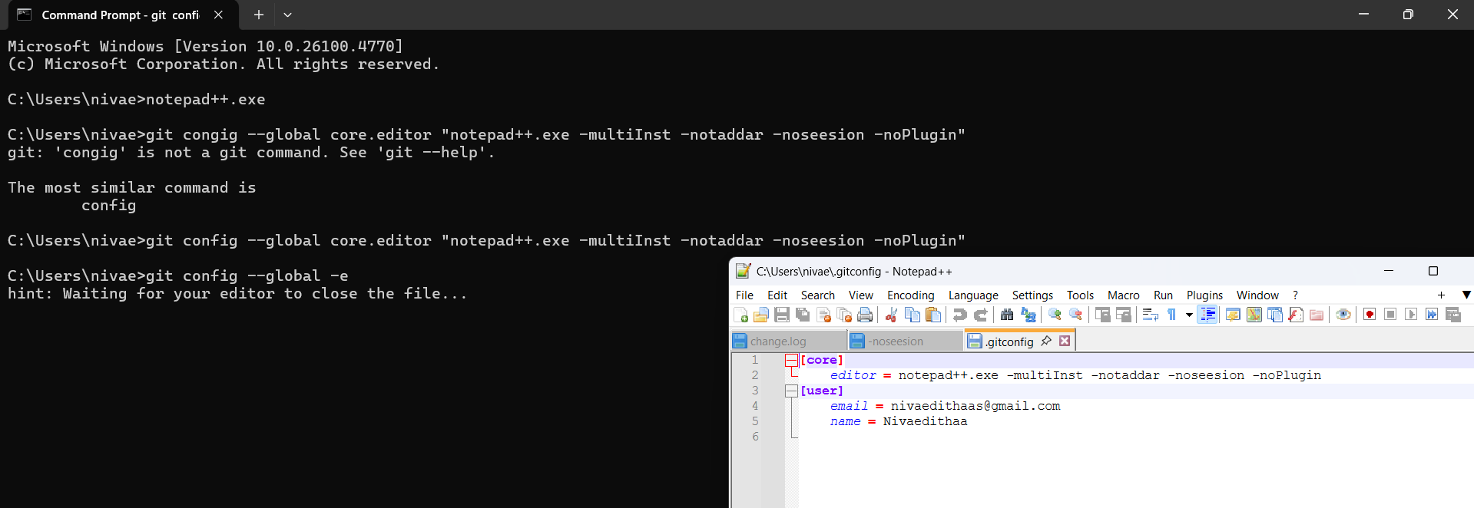

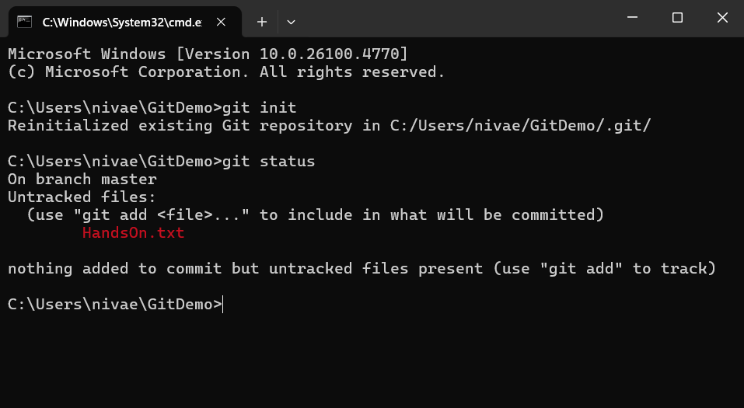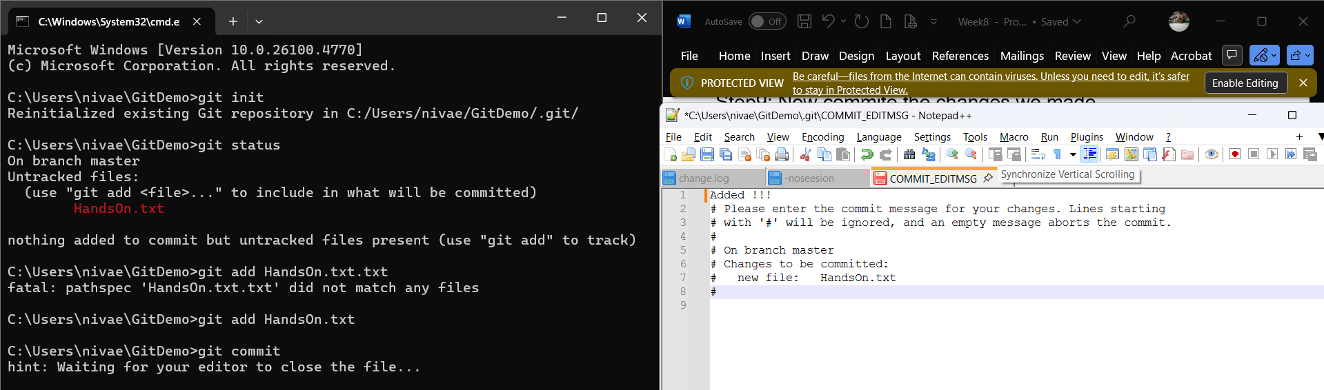

1. Explain git ignore

Explain how to ignore unwanted files using git ignore

In this hands-on lab, you will learn how to:

Implement git ignore command to ignore unwanted files and folders

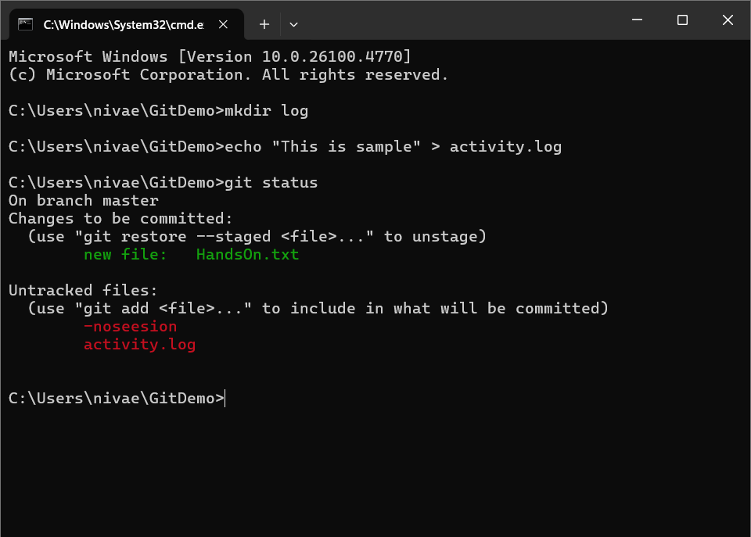

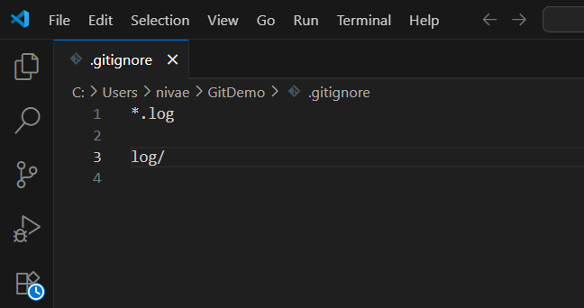

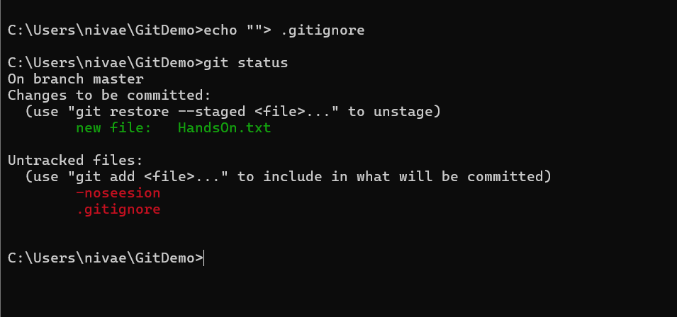

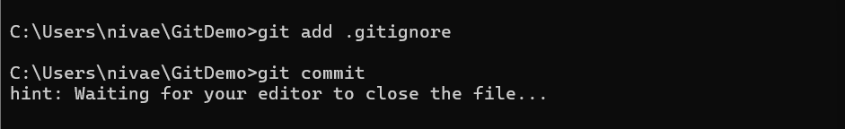

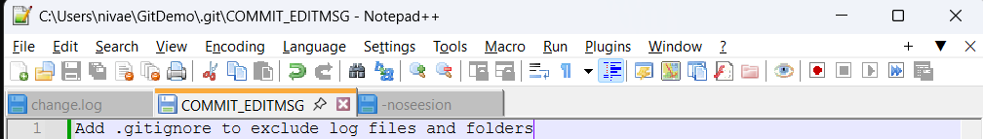

3. Explain git ignore

Explain how to ignore unwanted files using git ignore

In this hands-on lab, you will learn how to:

* Implement git ignore command to ignore unwanted files and folders

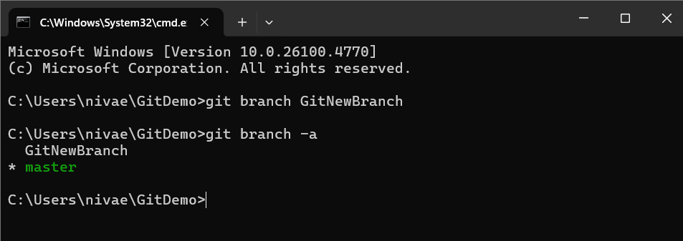

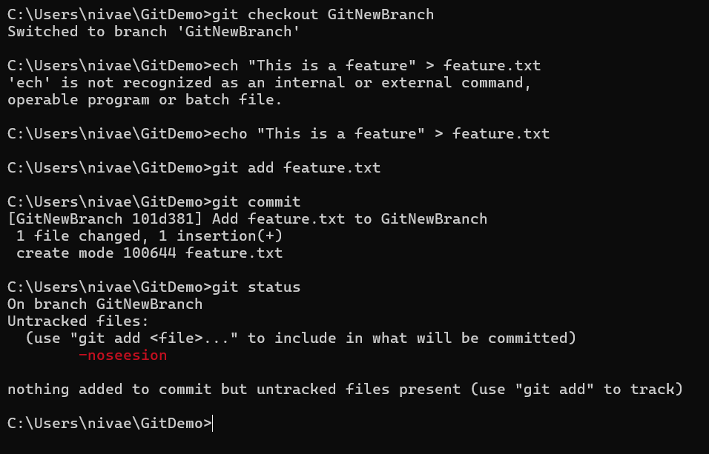

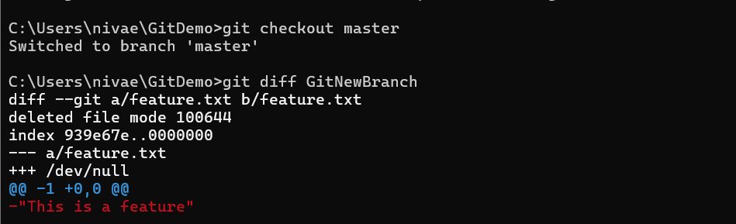

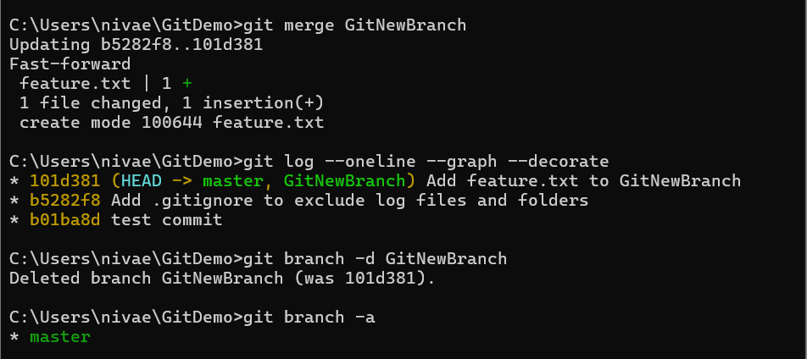

4. Explain git ignore

Explain how to ignore unwanted files using git ignore

In this hands-on lab, you will learn how to:

* Implement git ignore command to ignore unwanted files and folders

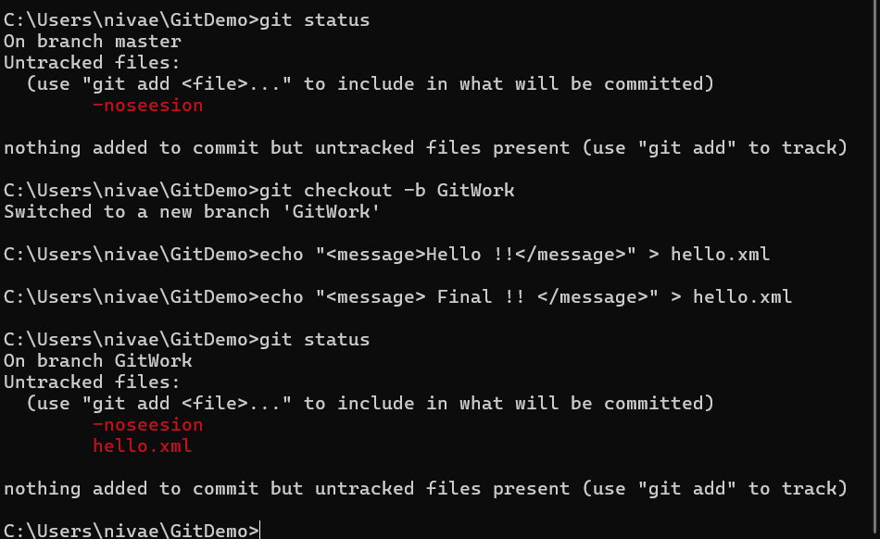

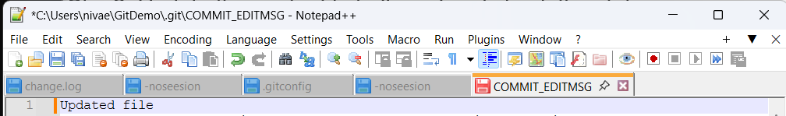

5. Explain git ignore

* Explain how to ignore unwanted files using git ignore

In this hands-on lab, you will learn how to:

* Implement git ignore command to ignore unwanted files and folders

