Week 5 – Evaluating Pricing Strategies Through A/B Testing
eCommerce Pricing Experimentation Framework, Simulated Analysis & Business Impact
Professional analytical blueprint | Simulated data for academic/project purposes

Executive Summary
Pricing is one of the strongest commercial levers in eCommerce because a price change can affect demand, conversion, average order value, gross margin, customer perception, and long-term value at the same time. This report develops a controlled A/B testing framework for evaluating alternative pricing strategies. It compares a control price with a modest-discount scenario and a premium-price scenario using a simulated dataset. The framework defines hypotheses, randomization, primary and guardrail metrics, sample-size planning, statistical analysis, segmentation, experiment governance, and business-impact evaluation. The simulated results demonstrate why conversion rate alone should not determine a pricing decision: revenue per visitor and gross profit per visitor provide additional economic context. All numerical results are illustrative rather than actual company performance.

1. Introduction
An eCommerce pricing experiment should answer a specific business question under controlled conditions. Rather than changing prices broadly and comparing before-and-after results, randomized experimentation helps separate the effect of the pricing treatment from ordinary variation in traffic, seasonality, marketing activity, and customer mix. A well-designed experiment also defines its primary metric before launch, determines an appropriate sample size, and establishes decision rules in advance.
Pricing tests require special care because the treatment directly changes the economics of every exposed order. A discount may increase conversion while reducing contribution margin; a higher price may reduce order volume while increasing revenue per order. Therefore, the test should combine customer-response metrics with unit economics and guardrails.

2. Objectives
- Build a conceptual framework for testing alternative eCommerce pricing strategies.
- Define control and treatment groups, hypotheses, variables, metrics, and decision rules.
- Compare discount, premium, and optional dynamic-pricing scenarios conceptually.
- Simulate an A/B/C pricing experiment and interpret the outcomes.
- Explain appropriate statistical methods for binary and continuous metrics.
- Assess business impact using revenue, margin, and customer-behavior measures.
- Provide a practical blueprint that can be adapted to a real eCommerce experiment.

3. Conceptual Research
Experimentation guidance commonly emphasizes predefining the test design, sample size, minimum detectable effect (MDE), statistical threshold, and analysis plan. Optimizely's current fixed-horizon documentation describes predetermined sample size and the use of concepts such as p-values, MDE, and variance when planning tests. Its experimentation guidance also distinguishes fixed-horizon, Bayesian, and sequential approaches. citeturn0search0turn0search9
Pricing-specific research also highlights the trade-off between raising prices and losing demand versus lowering prices and sacrificing margin. A 2024 Harvard Business Review article reporting on more than 1,000 e-commerce pricing tests discusses pricing experimentation as a way to learn how price changes affect demand and economics. The findings should be interpreted in the context of the study and not treated as a universal pricing rule. citeturn0search6

4. Pricing Strategies to Test
Strategy | Illustrative treatment | Potential upside | Potential risk
Control / Current Price | $50 | Known baseline economics | May leave demand/value unrealized
Discount Pricing | 5% reduction → $47.50 | Higher conversion and order volume | Lower unit margin; promotion dependency
Premium Pricing | 10% increase → $55 | Higher AOV and margin per order | Lower conversion or demand
Dynamic Pricing | Price varies by predefined rules | Can adapt to demand/inventory context | Fairness, customer trust, complexity, and governance risks
For a clean first experiment, the control and one treatment can be tested as a standard A/B test. If traffic is sufficient and the statistical plan accounts for multiple comparisons, an A/B/C design can compare control, discount, and premium treatments simultaneously. Dynamic pricing is better treated as a separate experiment after the pricing rules and governance controls have been validated.

5. Hypotheses
ID | Hypothesis | Null hypothesis | Primary outcome
H1 | A modest discount increases purchase conversion relative to the current price. | Discount conversion ≤ control conversion | Conversion rate
H2 | A premium price increases revenue per visitor despite potentially reducing conversion. | Premium RPV ≤ control RPV | Revenue per visitor
H3 | At least one alternative pricing strategy improves gross profit per visitor without breaching guardrails. | No alternative improves GP/visitor | Gross profit per visitor
H4 | Pricing response differs across customer segments. | Treatment effect is equal across segments | Segment-level treatment effect

6. Testing Methodology
The proposed design uses randomized assignment at the customer or visitor level. Each eligible participant is assigned consistently to one pricing condition, and the assignment persists for the duration of the experiment. This prevents a customer from seeing multiple prices for the same product during the test.
- Population: eligible eCommerce visitors or logged-in customers purchasing the selected product/category.
- Randomization: approximately equal allocation to control and treatment groups.
- Unit of randomization: preferably customer/account where possible; otherwise a stable visitor identifier.
- Test duration: long enough to capture normal weekly patterns and reach the pre-specified sample size.
- Price consistency: all non-price elements should remain unchanged unless they are intentionally part of the treatment.
- Pre-registration: document hypothesis, primary metric, MDE, significance threshold, sample size, exclusions, and stopping rule before launch.
- Exposure logging: record assignment, product, price, timestamp, customer segment, device, channel, order, discount, refund, and margin fields.

7. Metrics Framework
Metric | Type | Role | Why it matters
Conversion rate | Binary | Primary | Measures purchase response
Revenue per visitor | Continuous | Primary/economic | Combines conversion and order value
Gross profit per visitor | Continuous | Primary/economic | Accounts for unit economics
Average order value | Continuous | Secondary | Measures basket value
Units per order | Numeric | Secondary | Detects basket-size effects
Cart rate | Binary | Diagnostic | Shows shopping intent
Checkout completion | Binary | Diagnostic | Identifies transaction friction
Refund/cancellation rate | Binary | Guardrail | Detects post-purchase quality issues
Customer support contacts | Count/rate | Guardrail | Detects confusion or dissatisfaction
Repeat purchase rate | Binary/cohort | Long-term guardrail | Checks retention impact

8. Sample Size & Statistical Planning
Sample size should be determined before the experiment using the baseline metric, desired MDE, significance level, statistical power, expected variance, and number of variations. Optimizely's documentation similarly emphasizes predetermined sample size for fixed-horizon testing and defines MDE as the smallest effect worth detecting. citeturn0search0turn0search4
Planning parameter | Illustrative value | Purpose
Baseline conversion | 2.30% | Starting estimate from historical data
Target MDE | 10% relative | Smallest commercially meaningful improvement
Significance level | 95% | Controls Type I error at 5% under the chosen test
Power | 80% | Controls probability of detecting the specified effect
Allocation | 50/50 for A/B | Balanced traffic allocation
Analysis | Two-proportion test / z-test for conversion; appropriate continuous-metric test for RPV/GPV | Match method to metric
These values are planning assumptions, not a claim that this exact sample is sufficient for every real experiment. A production test should calculate sample size from the actual baseline and variance, and the calculation should account for the number of variants and the chosen statistical framework.

9. Statistical Analysis Plan
- Conversion rate: compare proportions using a two-proportion z-test or an equivalent validated experimentation method.
- Revenue per visitor and gross profit per visitor: compare means using a suitable test such as Welch's t-test when assumptions and distribution characteristics support it; consider bootstrap confidence intervals for skewed revenue data.
- A/B/C tests: control the analysis for multiple comparisons or use an experimentation method designed for multiple variants.
- Report effect size, confidence interval, and practical business impact rather than only a p-value.
- Analyze pre-specified segments such as new/returning, device, acquisition channel, and product category only when sample sizes support reliable inference.
- Do not repeatedly inspect a fixed-horizon test and stop simply because an early result looks favorable; use a predeclared stopping rule or a sequential method.
Statistical significance describes how unusual the observed result would be under a no-difference assumption; it does not by itself establish business value. Optimizely's documentation also notes that higher significance thresholds generally require more data/time. citeturn0search2turn0search8

10. Simulated A/B/C Test
The following results are entirely simulated to demonstrate how a pricing test could be analyzed. Each group contains 30,000 visitors. The control price is $50, Treatment A applies a 5% discount, and Treatment B applies a 10% premium.
Variant | Visitors | Orders | Conversion | Revenue | AOV | Revenue/Visitor | Gross Profit/Visitor
Control – $50 | 30,000 | 750 | 2.50% | $37,500 | $50.00 | $1.25 | $0.38
A – $47.50 | 30,000 | 825 | 2.75% | $39,187.50 | $47.50 | $1.31 | $0.35
B – $55 | 30,000 | 735 | 2.45% | $40,425 | $55.00 | $1.35 | $0.46
The simulated outcome illustrates an important pricing principle: Treatment A produces the highest conversion rate, while Treatment B produces the highest revenue per visitor and gross profit per visitor under the assumed margin rates. Therefore, conversion rate alone would provide an incomplete economic picture. This is an illustration of analytical reasoning, not a recommendation for a real company.
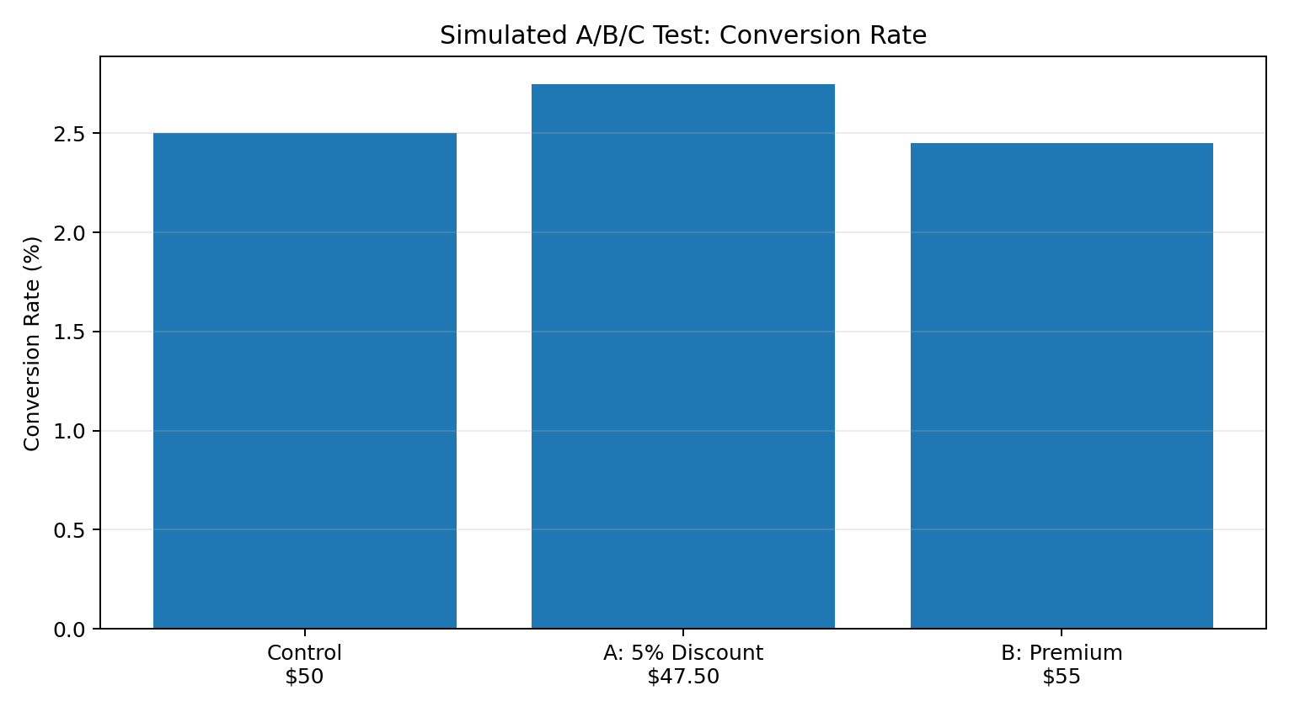
Figure 1. Simulated conversion-rate comparison.
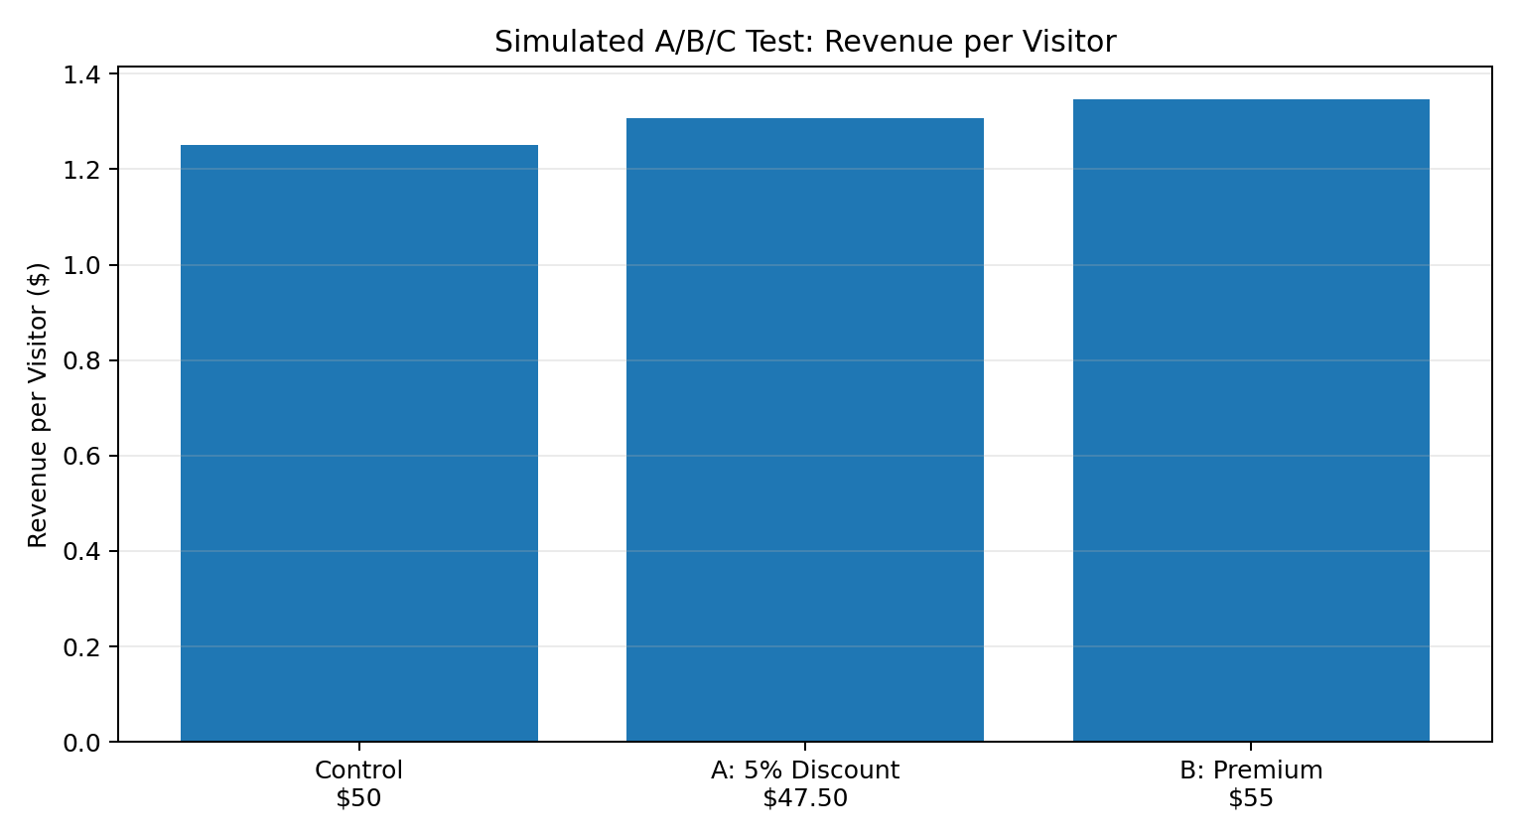
Figure 2. Simulated revenue-per-visitor comparison.
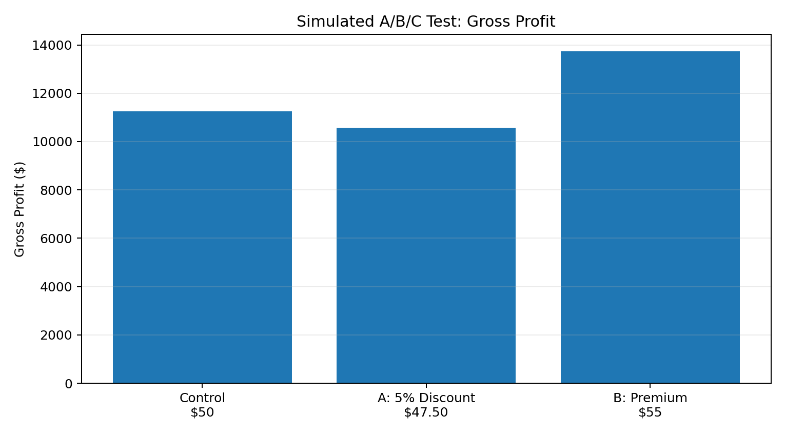
Figure 3. Simulated gross-profit comparison.

11. Simulated Result Interpretation
Observation | Interpretation
Discount has 2.75% conversion vs 2.50% control | The discount increases purchase conversion in the simulation.
Premium has 2.45% conversion | Premium pricing slightly lowers conversion versus control in the simulation.
Premium produces $1.35 RPV vs $1.25 control | Higher order value offsets the lower conversion in this scenario.
Premium produces highest gross profit/visitor | The assumed margin structure makes the premium variant economically attractive in the simulation.
Discount produces lower gross profit/visitor | Higher conversion does not compensate for the assumed margin reduction.
A real decision should only be made after statistical uncertainty is quantified. For each comparison, the analyst should calculate the estimated lift, confidence interval, p-value or posterior probability under the chosen framework, and the incremental revenue and contribution margin with appropriate uncertainty.

12. Segment-Level Analysis
Segment | Expected pricing sensitivity | Metrics to compare | Reason
New customers | Potentially higher price sensitivity | Conversion, first-order margin | Lower familiarity and trust
Returning customers | Potentially lower search friction | Conversion, AOV, repeat rate | Existing relationship
High-value customers | Potentially lower price sensitivity | GP/visitor, retention | Greater economic value
Promotion-sensitive customers | Potentially strong discount response | Conversion, margin, repeat rate | May respond strongly to incentives
Mobile users | Check UX + price response | Conversion, checkout completion | Different interaction constraints

13. Business Impact Assessment
- Revenue impact: estimate incremental revenue per 1,000 or 10,000 eligible visitors.
- Margin impact: incorporate product cost, payment fees, fulfillment cost, discounts, and returns rather than using revenue alone.
- Customer impact: monitor perceived fairness, complaints, cancellations, refunds, and support contacts.
- Retention impact: assess whether price treatment changes repeat purchase behavior or customer lifetime value.
- Brand impact: evaluate whether frequent discounting could condition customers to wait for promotions.
- Operational impact: assess inventory, fulfillment, and promotional capacity before scaling a successful pricing treatment.
- Risk management: dynamic or personalized pricing should be reviewed for consistency, transparency, legal requirements, and customer trust before deployment.

14. Decision Framework
Outcome pattern | Analytical response
Higher conversion + higher GP/visitor | Potentially strong evidence; verify statistical and operational guardrails before scaling.
Higher conversion + lower GP/visitor | Evaluate whether volume growth compensates for margin loss; do not optimize conversion alone.
Lower conversion + higher GP/visitor | Examine RPV, GP/visitor, retention, and strategic positioning before judging the treatment.
No significant difference | Treat as inconclusive or evidence of a small effect, depending on power/MDE; form a new hypothesis if needed.
Negative guardrail movement | Investigate customer and operational harm even if the primary metric improves.

15. Experiment Governance & Quality Controls
- Use stable randomization and prevent users from switching variants during the test.
- Keep pricing exposure consistent across sessions and devices where technically possible.
- Exclude internal traffic, bots, test accounts, and known data-quality anomalies according to a predefined rule.
- Monitor instrumentation and revenue reconciliation during the experiment.
- Avoid changing marketing campaigns, product assortment, or checkout logic in ways that confound the pricing test.
- Document all experiment changes and analysis decisions.
- Use guardrail alerts for refunds, cancellations, payment failures, complaints, and abnormal order patterns.

16. Tools & Technical Implementation
Tool / Technology | Application
GA4 / analytics platform | Event collection and funnel measurement
SQL | Experiment assignment, order, revenue, and cohort extraction
Python | Statistical testing, confidence intervals, bootstrapping, simulation
Excel | Initial summaries and business calculations
Power BI / Tableau | Experiment dashboards and segment monitoring
Experimentation platform | Randomization, exposure logging, experiment analysis

17. 30–35 Hour Work Plan
Workstream | Hours
Research A/B testing and pricing experimentation concepts | 5
Define pricing scenarios, hypotheses and metrics | 4
Design experimental framework and sample-size plan | 5
Create and analyze simulated test data | 7
Statistical interpretation and visualizations | 4
Business impact and recommendations | 4
Documentation, formatting and quality review | 4
Total | 33

18. Limitations
- The numerical test results are simulated and do not represent actual customers or company performance.
- Price elasticity can vary by product, category, customer segment, competition, inventory position, and season.
- A short experiment may not capture long-term retention or reference-price effects.
- Revenue is not equivalent to profit; contribution economics must be measured accurately.
- Subgroup analysis can produce noisy or misleading results when sample sizes are small.
- Dynamic and personalized pricing introduces additional governance, fairness, and customer-trust considerations.

19. Recommendations
- Predefine the primary economic metric before launching the experiment; conversion rate alone should not be the sole decision criterion.
- Use revenue per visitor and gross profit per visitor as key economic measures alongside conversion and AOV.
- Run a clean A/B test before introducing more complex dynamic pricing rules.
- Calculate sample size using historical baseline data, MDE, variance, significance, and power.
- Maintain stable variant assignment and document all exclusions and stopping rules.
- Use customer and product segmentation for interpretation, but pre-specify important segments where possible.
- Monitor refunds, cancellations, support contacts, and repeat purchases as guardrails.
- Scale a pricing treatment only after statistical evidence, unit economics, customer impact, and operational feasibility have been evaluated together.

20. Conclusion
A/B testing provides a disciplined way to learn how alternative prices affect customer behavior and business economics. A strong eCommerce pricing experiment must go beyond asking which variant converts more. It should quantify conversion, order value, revenue per visitor, gross profit, retention, and customer-impact guardrails. The simulated A/B/C scenario demonstrates how a discount can improve conversion while a premium price can produce stronger revenue and margin economics under different assumptions. The central analytical principle is therefore to define the business objective first, design the experiment rigorously, analyze uncertainty correctly, and evaluate the result using both statistical evidence and practical economics.

Appendix A – Suggested Event Schema
Event | Important fields
experiment_exposure | experiment_id, variant_id, timestamp, user_id/session_id
product_view | product_id, category, listed_price, displayed_price
add_to_cart | product_id, displayed_price, quantity
begin_checkout | cart_value, displayed_price, shipping_cost
purchase | order_id, revenue, product_cost, discount, quantity, payment_method
refund | order_id, refund_amount, reason
support_contact | order_id, contact_reason

Appendix B – References
Optimizely Support – Frequentist (Fixed Horizon) statistics and sample-size planning. citeturn0search0
Optimizely Support – Statistical analysis methods overview. citeturn0search9
Optimizely Support – Statistical significance. citeturn0search2
Optimizely – Sample size calculations for A/B tests and experiments. citeturn0search4
Harvard Business Review – Lessons from More Than 1,000 E-Commerce Pricing Tests. citeturn0search6

