WEEK 6 – COMPREHENSIVE RETAIL eCOMMERCE DATA ANALYSIS
End-to-End Analytics Strategy, Customer Behavior, Forecasting, Website Analytics & Pricing Experimentation
Integrated final project report | Simulated analytical environment

Executive Summary
This final report integrates the analytical methods developed across the previous eCommerce tasks into one end-to-end retail analytics lifecycle. The project begins with a data strategy covering acquisition, preparation, governance, and KPI definitions, then moves through customer behavior analysis, sales forecasting, website performance evaluation, and pricing experimentation. Simulated datasets are used to create a consistent analytical narrative without representing the actual performance of a real retailer.
The integrated analysis shows how different analytical layers complement one another. Customer segmentation identifies who behaves differently and where retention or acquisition actions can be targeted. Website metrics reveal how visitors progress through the digital funnel. Forecasting provides a forward-looking view for inventory and financial planning. Pricing experimentation demonstrates why conversion rate must be evaluated together with revenue and margin economics. The final recommendations therefore focus on measurement quality, customer-centric segmentation, forecast-driven planning, conversion optimization, and controlled pricing tests.

1. Project Scope and Objectives
- Integrate the five analytical workstreams completed during the eCommerce project lifecycle.
- Create a coherent path from data collection and KPI design to business recommendations.
- Connect customer behavior, website performance, sales trends, and pricing decisions.
- Use visualizations and simulated data to demonstrate an end-to-end analytical workflow.
- Identify patterns, relationships, inconsistencies, risks, and opportunities across the business.
- Provide an actionable roadmap for continued analytics maturity.

2. End-to-End Project Lifecycle
Stage | Key activities | Primary output
1. Business understanding | Define objectives, decisions and KPIs | Analytics requirements
2. Data strategy | Sources, schema, quality, governance | Reliable data foundation
3. Data preparation | Cleaning, validation, transformation | Analysis-ready datasets
4. Customer analytics | RFM, behavioral clustering, cohorts | Customer segments
5. Website analytics | Acquisition, engagement and funnel metrics | CRO opportunities
6. Forecasting | Trend, seasonality and model validation | Future sales estimates
7. Pricing experimentation | A/B/C design and statistical analysis | Pricing test evidence
8. Synthesis | Cross-analysis interpretation | Strategic insights
9. Action | Prioritization, monitoring and experimentation | Execution roadmap

3. Data Strategy
A retail eCommerce analytics environment should combine transactional, customer, product, marketing, website, and operational information. The data strategy used in this project separates raw source data from cleaned analytical tables and reporting outputs. This supports reproducibility, quality control, and consistent KPI definitions.
Data domain | Example fields | Analytical use
Transactions | Order ID, date, customer, product, quantity, revenue, discount | Sales and customer value
Customers | Customer ID, acquisition date, segment, geography | Segmentation and retention
Products | Product ID, category, price, cost, inventory | Merchandising and margin
Web analytics | Sessions, source, landing page, product views, cart, checkout | Website funnel
Marketing | Campaign, impressions, clicks, spend | Acquisition efficiency
Pricing tests | Variant, displayed price, exposure, order, revenue | Experiment analysis

4. KPI Architecture
Business area | Core KPIs | Decision supported
Revenue | Revenue, orders, AOV, revenue/visitor | Commercial performance
Customer | Recency, frequency, monetary value, repeat rate | Retention and customer value
Website | Sessions, bounce/engagement, duration, CTR | Digital experience
Funnel | Product view, ATC, checkout, conversion | CRO
Forecasting | Trend, MAE, RMSE, forecast | Planning
Pricing | Conversion, RPV, GP/visitor, AOV | Pricing decisions

5. Customer Behavior Analysis
The customer behavior workstream applies RFM principles and behavioral clustering to distinguish customers according to purchase recency, frequency, monetary value, digital engagement, and related attributes. K-Means clustering and PCA were used conceptually to demonstrate how multidimensional customer behavior can be reduced into actionable groups.
Segment | Behavioral profile | Business objective | Example action
Loyal Customers | Low recency; high frequency; high revenue | High | Retention, loyalty, premium cross-sell
Growth Customers | Moderate recency/frequency; rising engagement | Medium–High | Personalization, bundles, cross-sell
Bargain Customers | Promotion-sensitive; lower margin potential | Medium | Targeted offers with margin guardrails
At-Risk Customers | High recency; declining engagement | Low/declining | Win-back, service recovery, relevant reminders
New Customers | Recent first purchase; limited history | Emerging | Onboarding, second-purchase incentives
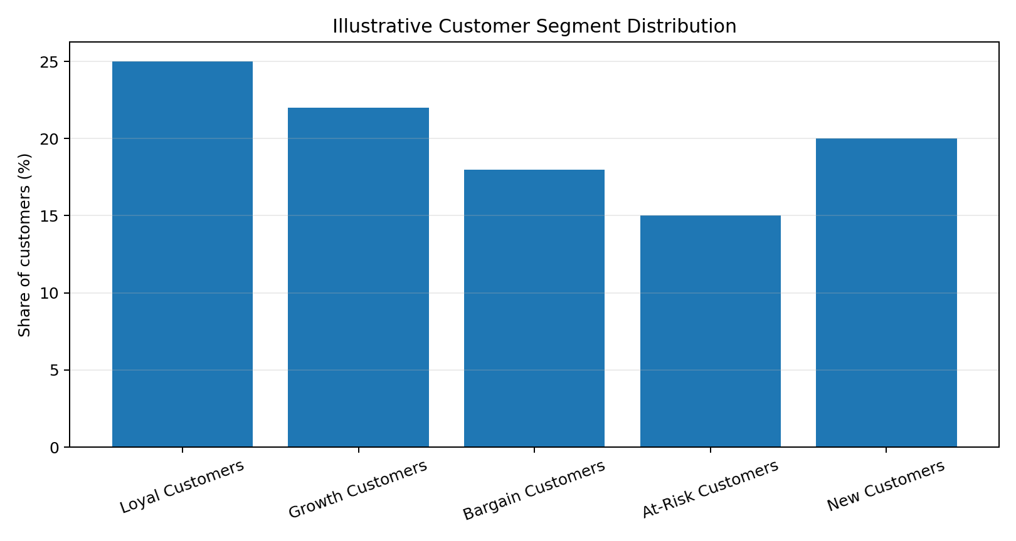
Figure 1. Illustrative customer segment distribution.
The segmentation framework supports differentiated action rather than treating every customer as identical. Loyal customers can be evaluated for retention and cross-sell opportunities, growth customers for development, bargain-sensitive customers for targeted promotions with margin controls, at-risk customers for win-back actions, and new customers for onboarding and second-purchase programs.

6. Customer Insights
- Recency is useful for identifying customers whose engagement may be weakening.
- Frequency separates occasional purchasers from habitual buyers and helps identify loyalty opportunities.
- Monetary value should be interpreted together with margin rather than revenue alone.
- Digital engagement variables can enrich RFM analysis by showing how customers interact before purchasing.
- Segment-level analysis allows marketing and service interventions to be more specific and measurable.

7. Sales Trend & Forecasting Analysis
The forecasting workstream uses monthly simulated sales data to demonstrate trend analysis and time-series forecasting. Moving averages are useful for smoothing short-term noise, while linear trend regression provides a simple directional benchmark. Seasonal-naive forecasting establishes a practical baseline, and Holt-Winters exponential smoothing is used as the primary model because the simulated series contains both trend and recurring seasonal structure.
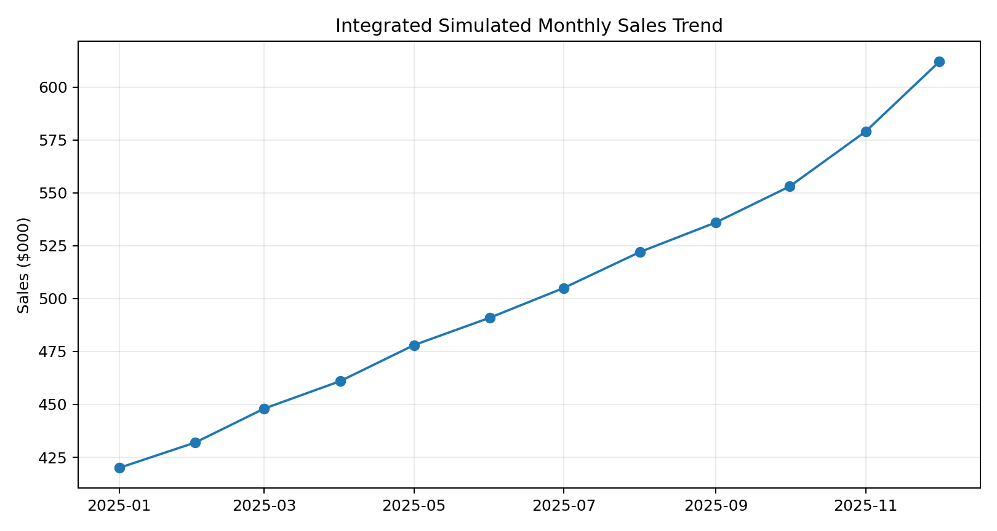
Figure 2. Integrated simulated monthly sales trend.
Method | Purpose | Strength | Limitation
Moving Average | Smooth short-term variation | Simple and interpretable | Lags during rapid changes
Linear Trend | Estimate directional movement | Easy to explain | Does not model seasonality well
Seasonal Naive | Baseline using prior seasonal behavior | Strong benchmark for seasonal series | Assumes recurring seasonal pattern
Holt-Winters | Model trend + seasonality | Flexible and practical | Needs suitable historical structure

8. Forecast Results
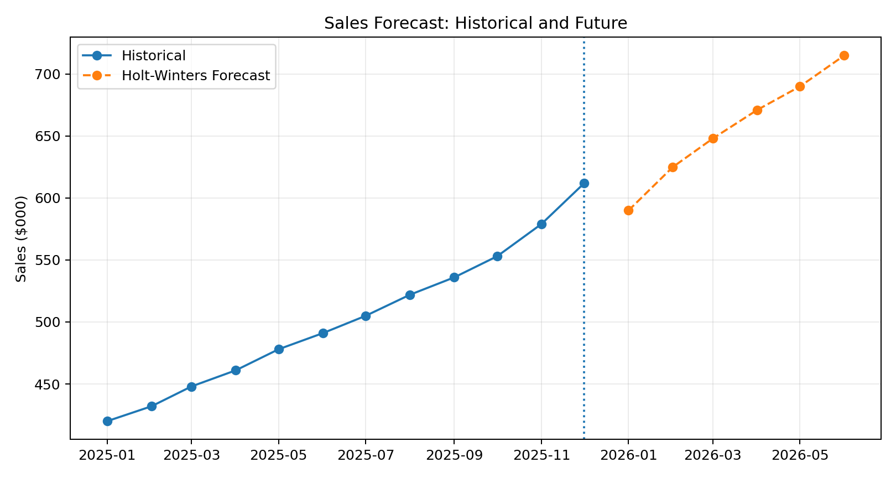
Figure 3. Simulated historical sales and six-month forecast.
Month | Seasonal Naive | Linear Trend | Holt-Winters
Jan 2026 | $565,000 | $585,000 | $590,000
Feb 2026 | $582,000 | $603,000 | $625,000
Mar 2026 | $598,000 | $621,000 | $648,000
Apr 2026 | $610,000 | $639,000 | $671,000
May 2026 | $625,000 | $657,000 | $690,000
Jun 2026 | $640,000 | $675,000 | $715,000
The forecast should be treated as a planning estimate rather than a guarantee. In production, forecasts should be re-estimated as new actual sales arrive, and performance should be tracked using time-ordered holdout validation and metrics such as MAE and RMSE.

9. Website Analytics
The website analytics workstream evaluates acquisition, engagement, product discovery, shopping intent, checkout progression, and completed purchases. The simulated website series shows increasing traffic, declining bounce rate, improving session duration, rising CTR, and gradual improvement in conversion.
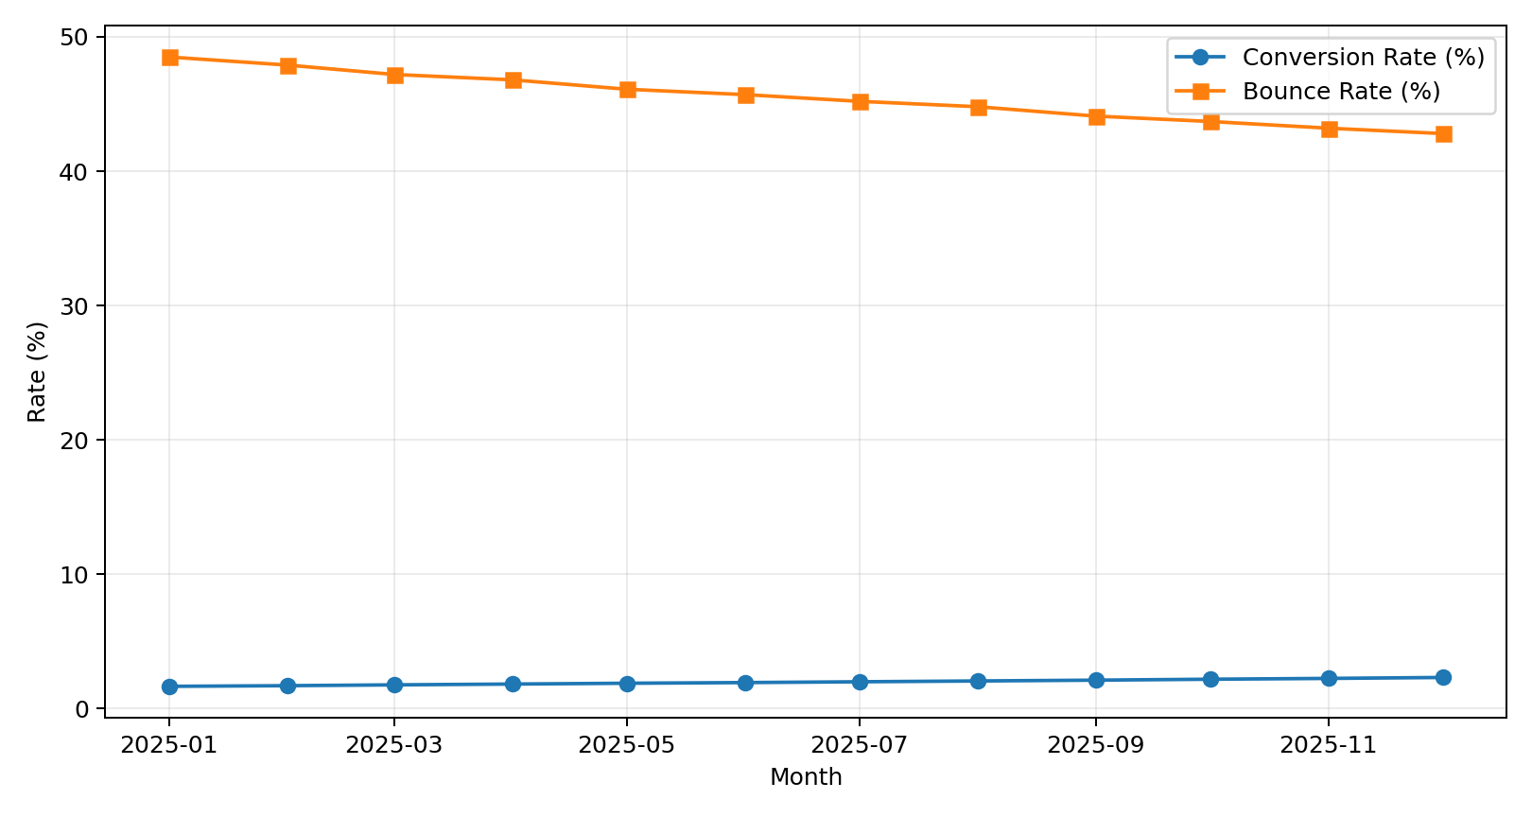
Figure 4. Simulated website KPI trends.
KPI | Beginning of simulation | End of simulation | Interpretation
Sessions | 98,000 | 145,000 | Expanded traffic volume
Bounce rate | 48.5% | 42.8% | Directional improvement in engagement
Avg. duration | 2.35 min | 2.95 min | More interaction under the simulated assumptions
CTR | 2.8% | 3.8% | Improved click response
Conversion | 1.65% | 2.31% | Improved purchase completion
Cart rate | 6.2% | 8.1% | Higher shopping intent
The relationship between engagement and conversion should not be interpreted as proof of causation. Traffic source, device mix, campaigns, promotions, product availability, pricing, and technical changes may affect both metrics. A/B testing is therefore important when determining whether a particular website change caused improvement.

10. Pricing Strategy Evaluation
The pricing workstream uses an A/B/C framework to compare a current price, a modest discount, and a premium price. The central analytical lesson is that conversion rate should not be viewed in isolation. Revenue per visitor and gross profit per visitor connect customer response to business economics.
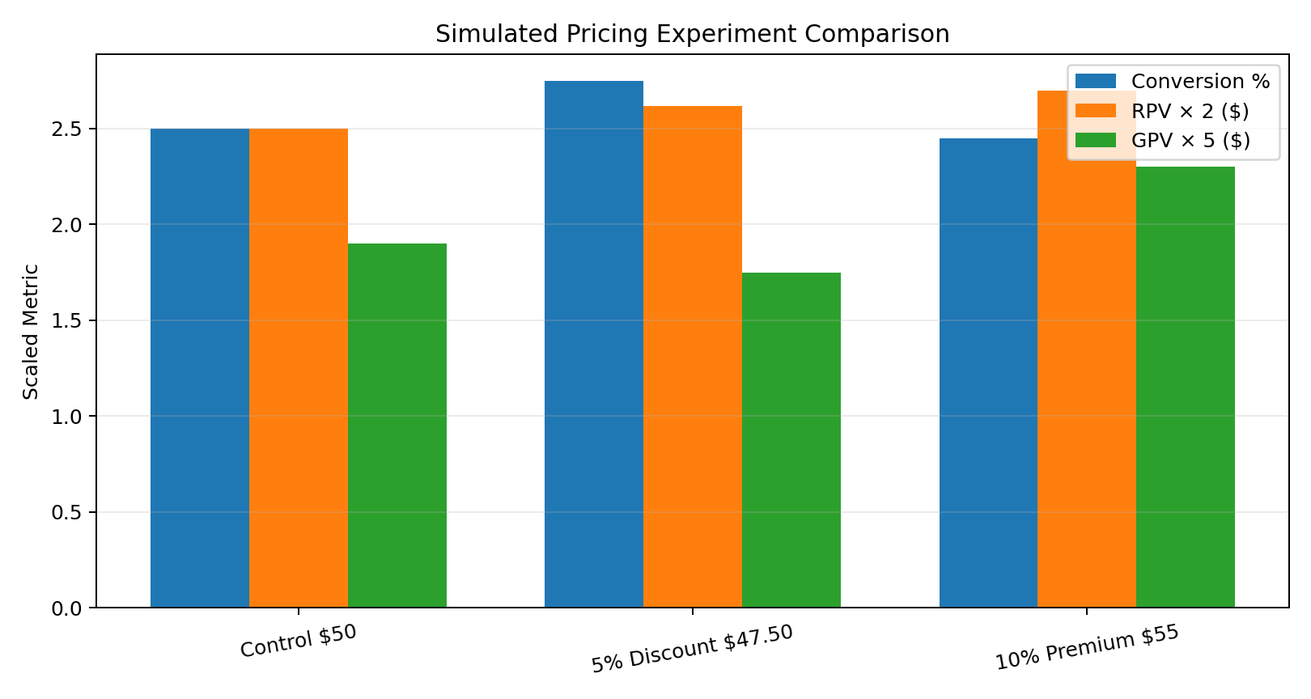
Figure 5. Simulated pricing experiment comparison using scaled metrics.
Variant | Conversion | Revenue/Visitor | Gross Profit/Visitor | Analytical observation
Control – $50 | 2.50% | $1.25 | $0.38 | Baseline
5% Discount – $47.50 | 2.75% | $1.31 | $0.35 | Higher conversion but lower assumed GP/visitor
10% Premium – $55 | 2.45% | $1.35 | $0.46 | Lower conversion but higher assumed economic value
These values are simulated and are intended to demonstrate decision structure rather than recommend a real price. A production experiment should include statistical uncertainty, sample-size planning, refunds, cancellations, customer retention, and contribution-margin calculations.

11. Integrated Cross-Analysis
The most important value of the final project is the connection between analytical workstreams. Each analysis answers a different question, but the outputs can be combined to support a more complete business decision.
Question | Relevant analysis | How the outputs connect
Who are our customers? | Segmentation | Target marketing and retention actions
How are customers interacting with the site? | Website analytics | Identify digital friction
What could sales look like next? | Forecasting | Plan inventory, staffing and finance
How does price affect demand and economics? | A/B pricing test | Evaluate price elasticity and unit economics
Where should resources be focused? | Integrated analysis | Prioritize initiatives by expected measurable impact

12. Patterns, Correlations & Inconsistencies
- The simulated website data shows higher engagement alongside higher conversion, but this is an association within the simulation and not causal evidence.
- Sales, sessions, and conversion all trend upward in the integrated scenario, suggesting a consistent growth narrative, but real data should be checked for campaign and seasonality effects.
- The pricing simulation shows that a treatment can improve conversion while reducing gross profit per visitor, demonstrating why business economics must complement behavioral KPIs.
- Customer segmentation introduces an important explanation layer: aggregate KPIs can hide differences between loyal, new, bargain-sensitive, and at-risk customers.
- Forecasting adds a time dimension that static dashboards lack; however, forecasts are sensitive to structural changes such as promotions, stockouts, competitor actions, and market shifts.
- A potential inconsistency to investigate in real data would be rising traffic without proportional growth in revenue, which can indicate declining traffic quality or funnel leakage.

13. Business Recommendations
Recommendation | Action | Expected analytical value
Build a single KPI layer | Standardize definitions for revenue, sessions, customers, orders, conversion, AOV and margin. | Improves consistency across dashboards and analyses.
Use customer segmentation operationally | Connect segments to campaign, retention, and service workflows. | Improves relevance of customer actions.
Optimize the digital funnel | Investigate landing pages, product pages, search, cart and checkout drop-offs. | Improves conversion efficiency.
Use forecasts for planning | Refresh forecasts with new actuals and monitor error metrics. | Supports inventory and financial planning.
Test pricing scientifically | Use randomized experiments and economic guardrails. | Reduces risk of relying on conversion alone.
Monitor margin, not revenue only | Track gross profit per order and per visitor. | Protects business economics.
Create an experimentation backlog | Prioritize measurable hypotheses across website, pricing and customer experience. | Builds a repeatable optimization process.

14. Future Directions
- Move from simulated data to production-level event and transaction data.
- Introduce customer lifetime value and retention forecasting.
- Develop automated anomaly detection for revenue, conversion, and website KPIs.
- Evaluate advanced forecasting models when data volume and business complexity justify them.
- Build a real-time or near-real-time analytics layer for critical website and sales metrics.
- Use uplift modeling or causal methods for targeted marketing where appropriate.
- Evaluate personalization while maintaining privacy, consent, and governance controls.
- Develop an experimentation center of excellence with standard templates for hypotheses, sample size, analysis, and reporting.

15. Dashboard & Reporting Architecture
Dashboard | Core contents | Primary users
Executive Overview | Revenue, orders, AOV, conversion, margin | Management
Customer Analytics | Segments, cohorts, repeat rate, CLV | Marketing/CRM
Website Funnel | Traffic, engagement, product views, ATC, checkout | Digital/CRO
Sales Forecast | Historical sales, forecast, error metrics | Finance/operations
Pricing Experiments | Variant metrics, lift, confidence, economics | Pricing/product

16. Data Governance & Quality
- Maintain a documented data dictionary and KPI glossary.
- Validate duplicate orders, missing customer IDs, incorrect timestamps, and revenue reconciliation.
- Track analytics instrumentation changes and version the event schema.
- Apply role-based access and appropriate data-retention practices.
- Separate analytical identifiers from unnecessary personally identifying information.
- Reconcile website purchases with the transactional order system.
- Create automated data-quality checks before publishing executive metrics.

17. Technical Stack
Technology | Role in project
Python | Data preparation, simulation, statistical analysis and visualization
Pandas / NumPy | Data manipulation and numerical computation
Matplotlib / Seaborn | Analytical visualizations
SQL | Data extraction, joins, aggregation and KPI computation
Excel | Exploratory analysis and business calculations
Power BI / Tableau | Interactive reporting and dashboarding
GitHub | Project versioning, documentation and portfolio sharing

18. 30–35 Hour Final Project Plan
Workstream | Hours
Integrate previous reports and define final structure | 4
Data strategy and KPI architecture | 4
Customer behavior synthesis | 5
Sales forecasting and validation | 5
Website analytics and funnel analysis | 4
Pricing experiment analysis | 4
Integrated insights and recommendations | 4
Visuals, formatting, QA and final documentation | 3
Total | 33

19. Limitations
- The numerical datasets and cross-analysis values are simulated for demonstration and do not represent a real retailer.
- Benchmark-style interpretations should be validated against the actual business, product category, geography, device mix, and traffic sources.
- Observed correlations do not prove causality without appropriate experimental or causal designs.
- Forecasts can fail when structural changes occur in demand, inventory, pricing, promotions, or competition.
- Customer segmentation quality depends on feature selection, data quality, and the stability of behavioral patterns.
- Pricing experiments must account for statistical uncertainty and long-term customer effects.

20. Conclusion
This final report demonstrates how multiple analytical techniques can be combined into a coherent retail eCommerce decision framework. Data strategy establishes the foundation; customer segmentation explains behavioral differences; website analytics identifies digital-funnel opportunities; forecasting supports forward-looking planning; and pricing experimentation evaluates how commercial interventions affect both customer behavior and economics. The integrated approach is more informative than any individual analysis because it connects what happened, who contributed to it, how the digital journey performed, what may happen next, and which interventions can be tested. The recommended next step for a real organization is to replace simulated data with governed production data and operate the framework as a continuous cycle of measurement, diagnosis, experimentation, and improvement.

Appendix A – Recommended Data Model
Table | Key fields
Fact_Sales | OrderID, DateKey, CustomerKey, ProductKey, Quantity, Revenue, Discount, Cost
Dim_Customer | CustomerKey, AcquisitionDate, Segment, Geography
Dim_Product | ProductKey, Category, Brand, Price, Cost
Fact_WebEvents | SessionID, CustomerKey, Event, ProductKey, Timestamp, Source
Fact_Experiment | ExperimentID, Variant, CustomerKey/SessionID, ExposureTime, Price
Dim_Date | DateKey, Date, Month, Quarter, Year, Week

Appendix B – Key Analytical Questions
- Which customer segments contribute the most revenue and gross profit?
- Which website funnel stages have the largest commercially meaningful leakage?
- Which traffic sources produce quality sessions and profitable customers?
- How accurately can the business forecast sales at monthly and weekly horizons?
- How do alternative prices affect conversion, revenue, margin, and retention?
- Which experiments should be prioritized based on measurable business impact?

Appendix C – GitHub Project
GitHub repository: https://github.com/Nivas5437/Retail-Ecommerce-Week---6.git

