WEEK 2 TASK
Customer Behavior Analysis
and Segmentation
A simulated, data-driven framework for understanding customer value, behavior, and marketing opportunities

Deliverable | Scope
Objective | Analyze eCommerce customer behavior and build an actionable segmentation framework.
Research basis | RFM, cohort analysis, demographic variables, digital behavior and clustering.
Simulation | 600 synthetic customer records generated from theoretical behavioral profiles.
Analytical methods | Descriptive statistics, RFM logic, K-Means clustering, PCA visualization and segment interpretation.
Outcome | Actionable customer segments, behavioral insights, hypotheses and segment-specific marketing strategies.

Prepared: September 2026

Contents
- 1. Introduction
- 2. Research Findings
- 3. Data Sources and Variables
- 4. Segmentation Framework
- 5. Simulation Methodology
- 6. Exploratory Behavioral Analysis
- 7. Cluster Analysis and Interpretation
- 8. Hypotheses
- 9. Segment-Specific Marketing Strategies
- 10. Measurement and Experimentation
- 11. Limitations and Ethical Considerations
- 12. Implementation Roadmap
- 13. 30–35 Hour Work Plan
- 14. Conclusion
- Appendix A. Simulated Dataset Summary
- Appendix B. References

1. Introduction
Customer segmentation divides a broad customer population into groups with meaningful similarities so that analysis, communication and commercial actions can be tailored to different needs. In eCommerce, segmentation can combine purchasing behavior with demographic and digital interaction data. The objective is not simply to create labels, but to identify groups that behave differently enough to justify different decisions.
Google Analytics documentation shows that eCommerce analysis can capture interactions such as product views, add-to-cart, checkout and purchase events when the relevant events are implemented. This provides a useful behavioral framework for connecting digital activity to purchase outcomes. citeturn0search0turn0search1
This report uses a simulated dataset rather than claiming that the findings represent a real retailer. The simulation is designed to demonstrate a complete analytical workflow and to make the assumptions, calculations and marketing interpretation explicit.

2. Research Findings

2.1 Behavioral data in eCommerce
Modern eCommerce analytics can distinguish between event-level and item-level measurements. Google Analytics, for example, documents event-scoped metrics such as purchases and item-scoped metrics such as items purchased. This distinction matters because a customer may trigger one purchase event containing several items; analysts should therefore avoid treating events and quantities as interchangeable. citeturn0search2turn0search6

2.2 Segmentation as an operating model
Retail personalization research emphasizes starting with important data rather than collecting every possible attribute, building multidimensional customer understanding, and using segmentation to identify value triggers and support targeted actions. McKinsey describes detailed customer segmentation and analysis as one component of a personalization operating model and highlights test-and-learn approaches. citeturn0search11

2.3 Research implications
Research observation | Implication for this assignment
Purchase events describe transactions; item-level data describes product interaction | Keep transaction, customer and item concepts separate.
Digital behavior can explain steps before purchase | Include sessions, cart activity and engagement variables when available.
Segmentation should support action | Every segment must have a clear business interpretation and response.
Data quality and context matter | Document simulation assumptions and do not generalize simulated results to a real market.
Personalization should be tested | Use experiments to measure incremental impact rather than assuming a segment strategy works.

3. Data Sources and Variables

3.1 Public and theoretical sources
Source / basis | Use in the framework | Limitation
UCI Online Retail / Online Retail II | Transaction-level practice for customer purchase behavior, RFM and cohorts | Historical public datasets; not representative of every retailer.
Google Analytics ecommerce documentation | Digital behavior/event framework: view, cart, checkout, purchase | Documentation rather than customer-level benchmark data.
Retail personalization research | Segmentation and test-and-learn principles | General research; business context differs by retailer.
Synthetic simulation | Controlled demonstration of segmentation workflow | Patterns are intentionally generated and are not real customer evidence.

The UCI Online Retail family is used as a methodological reference for transaction-level eCommerce analysis. The simulated data in this report is independently generated for educational purposes.

3.2 Variable design
Variable group | Variables | Why it matters
Purchase behavior | Recency, frequency, revenue, AOV | Measures customer activity, value and loyalty.
Digital behavior | Sessions, cart rate, mobile share, email engagement | Measures engagement and digital shopping behavior.
Demographics | Age, annual income | Adds descriptive context; should not automatically determine treatment.
Derived segmentation | RFM score, behavioral cluster, segment | Transforms raw observations into interpretable groups.

4. Segmentation Framework
The framework uses three complementary layers rather than relying on a single segmentation method.
Layer | Method | Criteria | Purpose
Layer 1 | Demographic | Age and income bands | Descriptive profile and context.
Layer 2 | Behavioral | Recency, frequency, revenue, AOV, sessions, cart and engagement | Identify actual shopping behavior.
Layer 3 | Analytical clustering | Standardized behavioral features + K-Means | Discover groups that may not be obvious from simple rules.

4.1 RFM foundation
RFM means Recency, Frequency and Monetary value. Recency measures how recently a customer purchased; frequency measures purchase activity; monetary value measures historical spending. For this simulation, revenue is used as the monetary measure. Because lower recency-days is better, the clustering input reverses its direction so that higher transformed values represent more recent activity.

4.2 Why combine RFM with digital behavior?
RFM captures what customers purchased, but it does not fully describe how they interact with an online store. Adding sessions, cart rate and engagement can distinguish customers who are highly active but not yet high-value from customers who purchase infrequently and are becoming inactive.

5. Simulation Methodology
A synthetic population of 600 customers was generated using five theoretical behavioral profiles: Loyal, Growth, Bargain, At-Risk and New. Each profile was assigned different probability distributions for recency, frequency, AOV and digital engagement. Random variation was then added so that customers within a profile were not identical.

5.1 Analytical workflow
- Generate customer-level demographic, purchase and digital-behavior variables.
- Inspect distributions and basic descriptive statistics.
- Create a behavioral feature matrix using recency, frequency, revenue, sessions, cart rate, email engagement and mobile share.
- Reverse the direction of recency so that recent activity is represented positively.
- Standardize the features to prevent variables with larger numeric scales from dominating.
- Apply K-Means with five clusters as a demonstration choice aligned to the five simulated behavioral archetypes.
- Use PCA to project the multidimensional feature space into two dimensions for visualization.
- Interpret each cluster using average behavior and translate the pattern into an actionable segment label.
Important methodological note: choosing five clusters is a simulation design decision, not evidence that a real business necessarily has five natural segments. In production, the number of clusters should be assessed using business interpretability and statistical diagnostics such as silhouette analysis.

6. Exploratory Behavioral Analysis
The simulated population contains deliberately varied customer behaviors. The following visuals show how behavioral differences can be explored before assigning marketing actions.
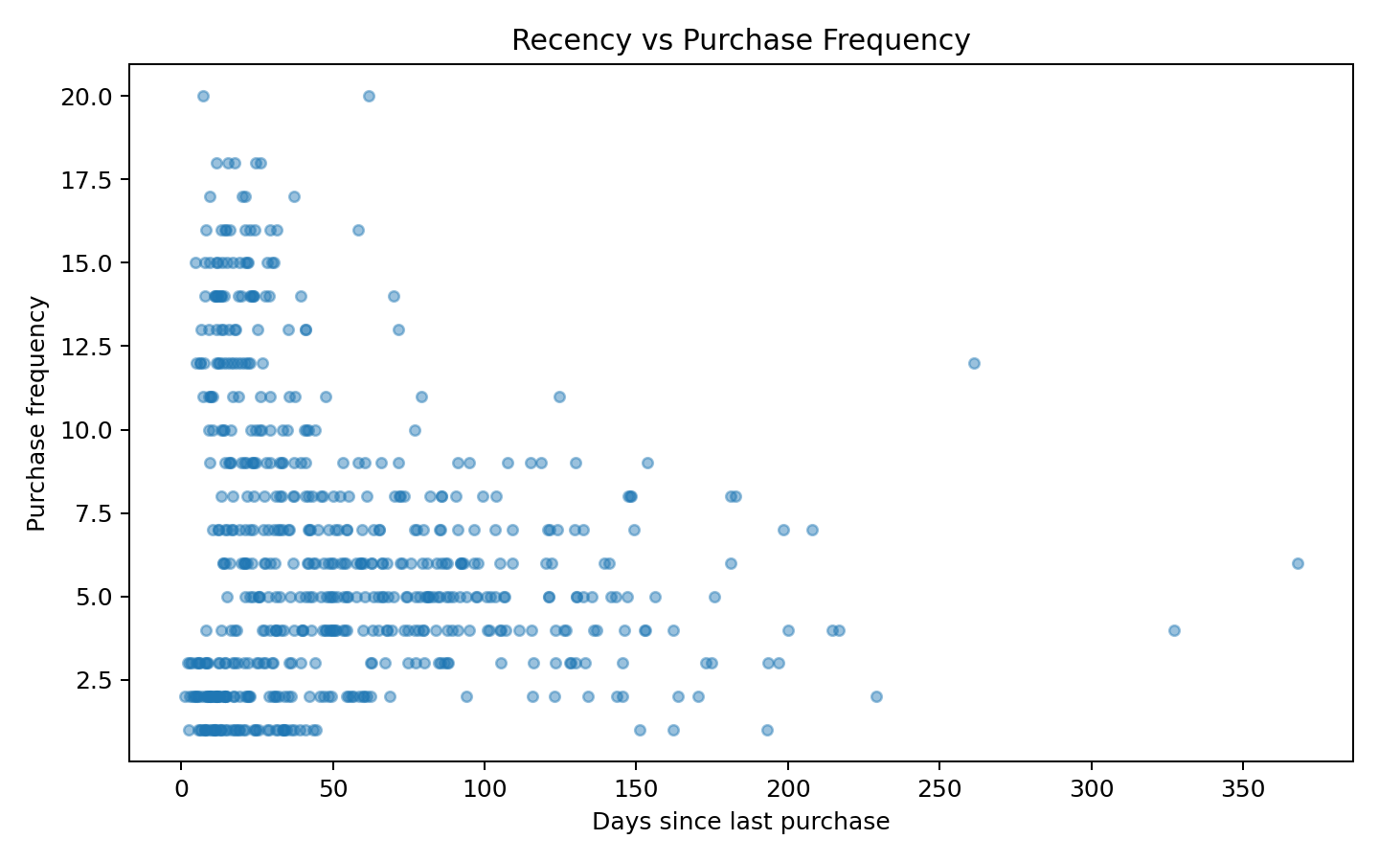
Figure 1. Simulated relationship between recency and purchase frequency.
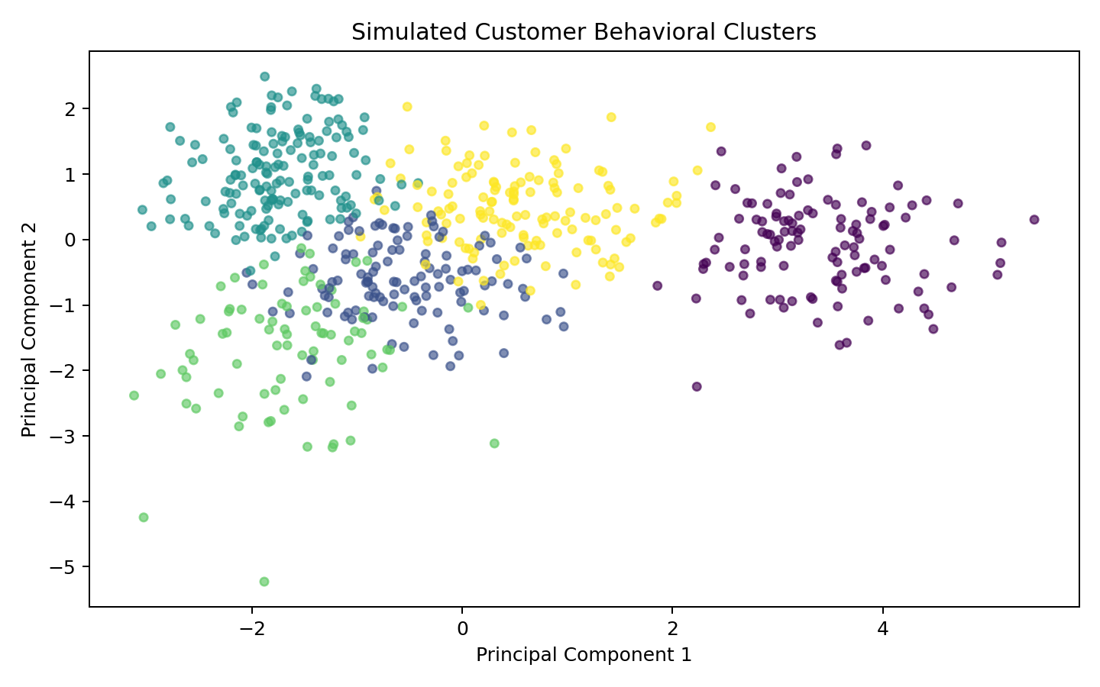
Figure 2. PCA projection of standardized behavioral features.
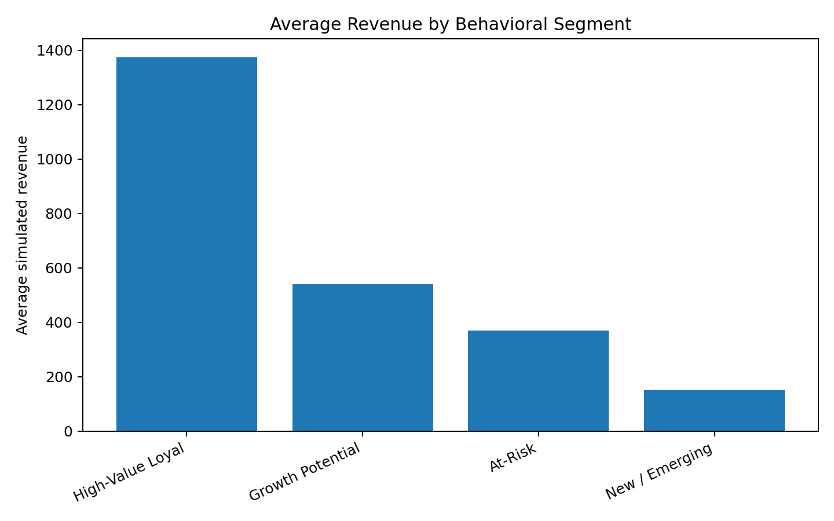
Figure 3. Average simulated revenue by interpreted behavioral segment.

7. Cluster Analysis and Interpretation
Cluster | Interpretation | Customers | Recency days | Frequency | Revenue | AOV | Sessions | Cart rate
1 | At-Risk | 118 | 65.36 | 5.25 | 342.79 | 63.65 | 18.31 | 0.27
3 | At-Risk | 80 | 146.87 | 4.99 | 370.26 | 73.94 | 13.76 | 0.21
4 | Growth Potential | 134 | 46.43 | 6.88 | 539.66 | 79.14 | 21.1 | 0.31
0 | High-Value Loyal | 114 | 20.41 | 13.29 | 1373.16 | 103.9 | 28.54 | 0.43
2 | New / Emerging | 154 | 26.04 | 2.34 | 149.23 | 64.38 | 10.75 | 0.2

The table should be interpreted comparatively rather than as an absolute ranking. A segment with high revenue may also have higher acquisition or servicing costs, while a segment with low current revenue may contain customers with strong future potential. The business decision should therefore consider both current value and future behavior.

7.1 Segment profiles and examples
Segment | Behavioral interpretation | Potential strategy
High-Value Loyal | Recent, frequent and high-value purchasers with strong engagement. | Protect loyalty; early access, personalized recommendations, VIP service; avoid unnecessary discounting.
Growth Potential | Moderate-to-strong engagement with room to increase frequency or basket size. | Cross-sell, bundles, category discovery, replenishment reminders and targeted loyalty benefits.
Value / Bargain | Lower AOV and stronger price sensitivity signals. | Value bundles, threshold offers and price-aware recommendations while monitoring margin.
At-Risk | Longer time since purchase with evidence of previous activity. | Win-back journeys, personalized reminders, service recovery and controlled incentives.
New / Emerging | Recent customers with limited purchase history. | Onboarding, second-purchase nudges, product education and review requests.

8. Hypotheses
Hypothesis | Metric | Suggested method | Expected decision
H1: Customers with stronger engagement are more likely to repeat | Repeat purchase within 90 days | Logistic regression / cohort comparison | Design onboarding and engagement journeys.
H2: At-risk customers can be identified from recency and frequency | 90-day repurchase/churn | Classification model | Prioritize win-back audience.
H3: Bundles can increase AOV for value-oriented customers | AOV / units per order | A/B test | Bundle or threshold-offer design.
H4: High-value customers respond differently to discounts | Revenue, margin, retention | Segment-level experiment | Replace blanket discounts with targeted benefits.
H5: Mobile-heavy behavior is associated with different conversion patterns | Conversion rate | Funnel comparison | Optimize mobile shopping journey.

9. Segment-Specific Marketing Strategies
Marketing actions should be treated as hypotheses to test, not guaranteed outcomes.
Segment | Primary objective | Actions | Guardrail metrics
High-Value Loyal | Recent, frequent and high-value purchasers with strong engagement. | Protect loyalty; early access, personalized recommendations, VIP service; avoid unnecessary discounting.
Growth Potential | Moderate-to-strong engagement with room to increase frequency or basket size. | Cross-sell, bundles, category discovery, replenishment reminders and targeted loyalty benefits.
Value / Bargain | Lower AOV and stronger price sensitivity signals. | Value bundles, threshold offers and price-aware recommendations while monitoring margin.
At-Risk | Longer time since purchase with evidence of previous activity. | Win-back journeys, personalized reminders, service recovery and controlled incentives.
New / Emerging | Recent customers with limited purchase history. | Onboarding, second-purchase nudges, product education and review requests.

An operational playbook should connect segment → trigger → message/action → channel → timing → primary KPI → guardrail KPI. For example, an At-Risk customer trigger might be a defined inactivity window; the response could be a personalized reminder; the primary KPI could be 30-day reactivation; guardrails could include margin and unsubscribe rate.

10. Measurement and Experimentation
- Define segment membership using data available before the intervention to avoid leakage.
- Measure incremental lift against a control group whenever possible.
- Track conversion, repeat purchase, revenue per customer and contribution margin.
- Include guardrails such as return rate, cancellation rate, unsubscribe rate and complaint rate.
- Recalculate segments on a defined schedule and monitor whether customer movement between segments is plausible.
- Do not assume demographic attributes imply customer intent; behavioral evidence should remain central.

10.1 Recommended dashboard
Dashboard page | Visuals | Decision
Segment Overview | Segment size, revenue share, AOV, frequency, recency | Which groups need attention?
Behavior | RFM distributions, sessions, cart rate, engagement | How do behaviors differ?
Customer Journey | View → cart → checkout → purchase funnel | Where is friction occurring?
Retention | Cohort heatmap, repeat rate, churn/repurchase | Which cohorts retain?
Campaign Test | Control vs treatment by segment | Which actions create incremental value?

11. Limitations and Ethical Considerations
- The dataset is synthetic; segment sizes, patterns and averages are simulated rather than observed market facts.
- K-Means requires standardized numeric features and can be sensitive to the chosen number of clusters and initialization.
- RFM summarizes historical behavior but does not directly explain customer motivation.
- Demographic segmentation can create unfair or inappropriate targeting if used as a proxy for sensitive characteristics; use only justified, relevant attributes.
- Public data may have different definitions, time periods and populations. It should not be presented as current evidence about an individual retailer.
- Personalization should respect applicable privacy, consent and data-protection requirements.

12. Implementation Roadmap
Phase | Activities | Deliverable
1. Data discovery | Inventory transaction, customer, digital and product data | Source map + data dictionary
2. Baseline analysis | KPI, RFM and cohort analysis | Customer behavior baseline
3. Segmentation | Feature engineering, clustering, validation | Segment model
4. Activation | Map segments to campaigns and product actions | Segment playbooks
5. Experimentation | A/B tests and holdouts | Incremental impact results
6. Monitoring | Segment migration, KPI trends, model drift | Ongoing customer intelligence dashboard

13. 30–35 Hour Work Plan
Workstream | Hours | Output
Research and methodology review | 4–5 | Research notes + references
Data-source and variable design | 3 | Data dictionary
Synthetic data generation | 3 | 600-row simulation
EDA and visualization | 5 | Charts + behavioral findings
RFM and segmentation design | 4 | RFM framework
Clustering and validation | 4–5 | K-Means + PCA + interpretation
Hypothesis and marketing strategy | 4 | Testable hypotheses + playbooks
Documentation and quality review | 4 | Final report
Final formatting and presentation | 2 | Submission-ready DOC

14. Conclusion
The analysis demonstrates how an eCommerce organization can move from raw customer records to actionable behavioral segments. A robust approach combines purchase history, digital behavior and carefully selected contextual variables rather than relying on a single segmentation dimension.
- Begin with a transparent RFM and cohort baseline.
- Add digital behavior to explain customer journey and engagement differences.
- Use clustering to discover behavioral groups, but validate clusters for stability and business usefulness.
- Translate every segment into a testable action rather than a descriptive label only.
- Measure incremental impact using controlled experiments.
- Continuously refresh segments and monitor movement, retention and customer value.

Appendix A. Simulated Dataset Summary
The following is a compact summary of the synthetic dataset used for the analysis. The full row-level dataset is not embedded in the DOC report so the document remains focused on methodology and findings.
Measure | Value
Simulated customers | 600
Behavioral features used | Recency_Days, Purchase_Frequency, Revenue, Sessions, Cart_Rate, Email_Engagement, Mobile_Share
Clusters | 5
Clustering method | K-Means
Visualization | PCA, 2 components
Random seed | 42
Purpose | Educational simulation only

Appendix B. References
- Google Analytics Help — Ecommerce in Google Analytics — https://support.google.com/analytics/answer/14430645?hl=en
- Google Analytics Help — Ecommerce events — https://support.google.com/analytics/answer/14434488?hl=en
- Google Analytics Help — About ecommerce metrics — https://support.google.com/analytics/answer/13428834?hl=en
- Google Analytics Help — Ecommerce scopes — https://support.google.com/analytics/answer/12947610?hl=en
- Google Analytics Help — Recommended events — https://support.google.com/analytics/answer/9267735?hl=en
- UCI Machine Learning Repository — Online Retail — https://archive.ics.uci.edu/dataset/352/online%2Bretail
- UCI Machine Learning Repository — Online Retail II — https://archive.ics.uci.edu/dataset/502/online%2Bretail
- McKinsey — Personalizing the customer experience: Driving differentiation in retail — https://www.mckinsey.com/industries/retail/our-insights/personalizing-the-customer-experience-driving-differentiation-in-retail
Source note: Research-based statements are referenced to the sources above. Simulated findings are generated specifically for this assignment and should not be interpreted as real customer or market evidence.

