

SIMATS ENGINEERING

Saveetha Institute of Medical and Technical Sciences
Chennai- 602105

Student Name: Jayaprakash Nivas Reg. No.: 192424238
Course Code: DSA0216 Slot: B
Course Name: Computer Vison for Open cv for Modern AI
Course Faculty: Dr. Senthilvadivu S & Dr. Kumaragurubaran T
Project Title: An Intelligent Real-Time Eye Strain and Screen Safety Monitoring System
Module Photographs:
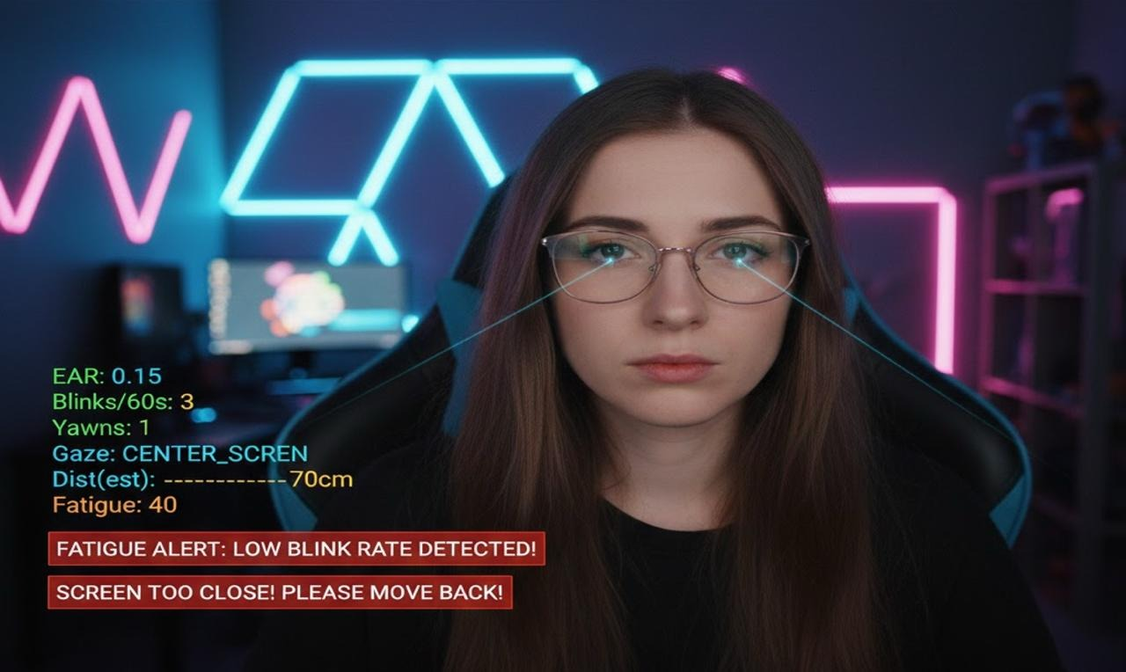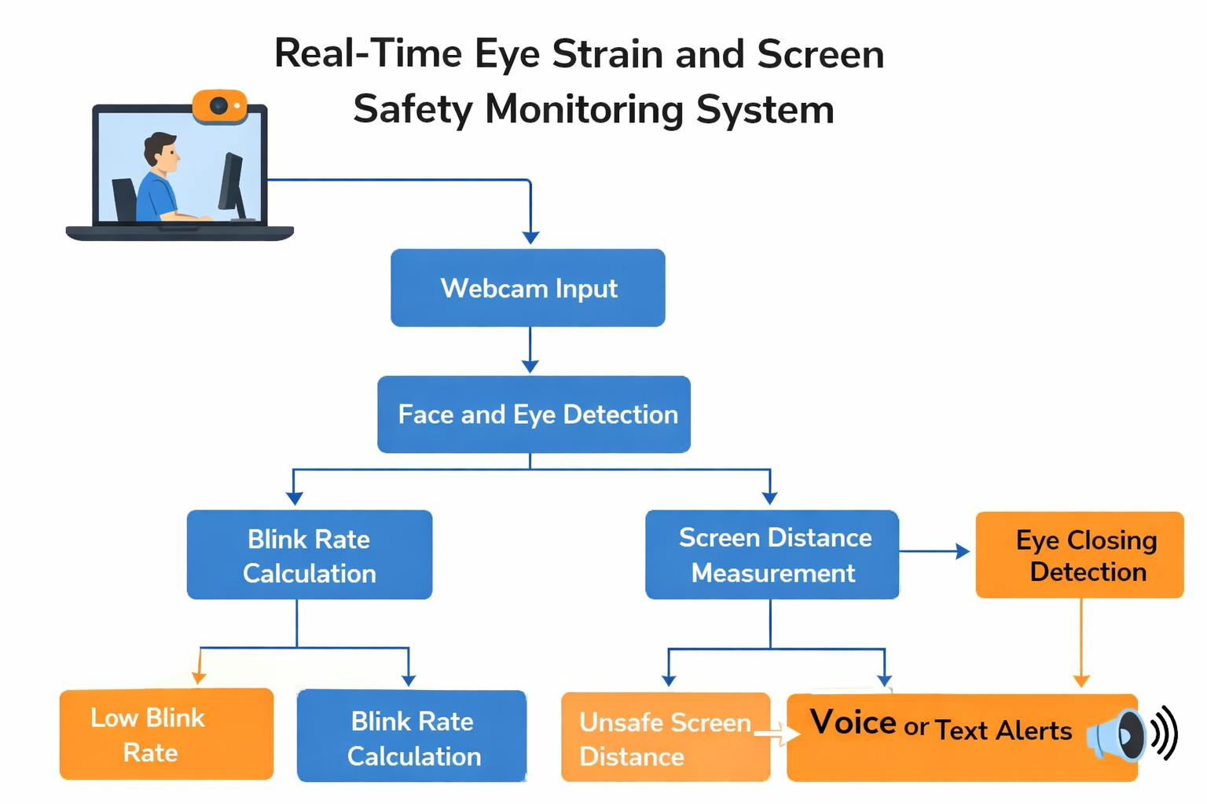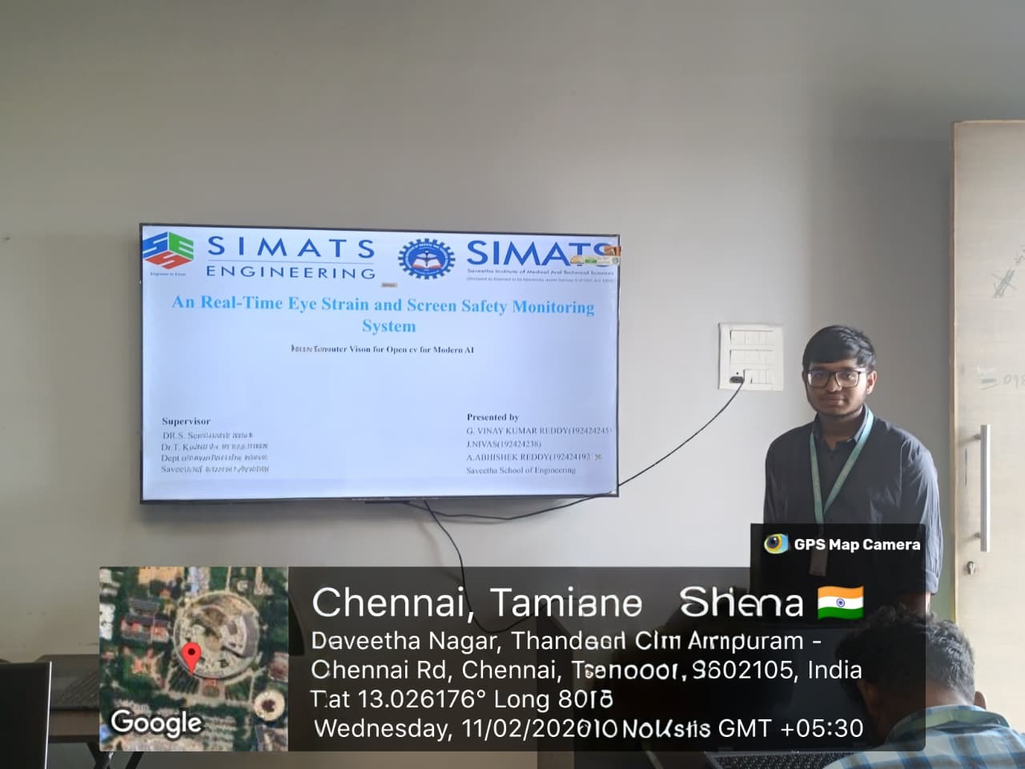
Project Description
Module 3: Multilingual Voice Alert and User Notification System
This module focuses on providing real-time voice alerts and user notifications in multiple languages to ensure effective communication for users with different language preferences. It integrates a multilingual text-to-speech engine that converts system-generated messages into spoken alerts based on the selected language. When an event or warning is detected, the module generates an appropriate notification and delivers it through both audio and on-screen text. It supports customizable settings such as language selection, alert priority, and volume control to enhance user experience. Continuous background processing ensures timely delivery of notifications without affecting system performance. This module improves accessibility, increases user awareness, and ensures that important information is clearly communicated at the right time.

Student Signature Guide Signature

