Functional Requirement Document (FRD) for Online Food Ordering

<19/11/2025>
Version 1.0
Created By
Nivass K R

In case of any queries regarding this document, please reach out to Nivass K R or krnivass04@gmail.com.

Document Revisions

Date | Version Number | Document Changes
19/11/2025 | 1.0 | Initial Draft

Approvals

Role | Name | Title | Signature | Date
Project Sponsor
Business Owner
Project Manager
System Architect

1 Introduction
1.1 Project Summary
1.1.1 Objectives
This online food ordering application's goal is to provide a user-friendly, safe, and effective platform for online food ordering. Users can easily browse restaurants, view menus, personalize items, and place orders thanks to the system. Through organized partner assignments, it guarantees on-time delivery and simplifies order and menu management for eateries. Secure payment methods and real-time order tracking will improve user convenience. The application seeks to facilitate future scalability and feature expansion while offering a seamless end-to-end meal ordering experience.

1.1.2 Background
Fast and easy ways to order food are becoming more and more popular, but traditional methods frequently lead to confusion and delays. During busy periods, restaurants also find it difficult to effectively handle orders. A digital platform is required to address these problems in order to improve overall experience by streamlining ordering, increasing accuracy, and offering real-time tracking.

1.1.3 Business Drivers
- Growing consumer demand for quick, easy, and mobile food ordering makes a contemporary digital platform imperative.
- An effective system is necessary for restaurants and delivery partners to decrease manual errors, optimize operations, and enhance order accuracy.
- The market for online meal delivery is growing quickly and presents substantial revenue opportunities through partnerships, commissions, and delivery fees.
- By decreasing the amount of paper used, streamlining delivery routes, and facilitating safer, contactless ordering, a digital platform promotes sustainability.

1.2 Project Scope
1.2.1 In Scope Functionality
- Android mobile application for customers.
- User registration, login, and profile management.
- Restaurant listing, menu browsing, wish list, and search features.
- Food ordering, cart management, and order customization.
- Secure online payments (UPI, card, wallet) and COD (optional).
- Real-time order status updates and delivery tracking.
- Restaurant partner interface for managing orders and menus.
- Admin panel for managing users, restaurants, orders, and analytics.
- Notification system for order updates and promotions.

1.2.2 Out of Scope Functionality
- iOS or Web application development.
- Delivery partner training or fleet management outside the app.
- Restaurant staff management or inventory tracking systems.
- AI-based advanced forecasting or smart routing algorithms (future enhancement).
- Social media-style features like reviews, comments, or chat (if not planned).
- Integration with third-party delivery services or logistics companies.
- Loyalty rewards or subscription plans in the initial version.

1.3 System Perspective
1.3.1 Assumptions
- Customers will be able to order, track deliveries, and browse restaurants with a steady internet connection.
- Restaurants will use their designated interface to update menu items, prices, and availability on a regular basis.
- Delivery partners will precisely follow the app's navigation and status update protocols.
- Throughout operations, all third-party services (payment gateway, maps, and SMS/notification APIs) will operate dependably.
- Users will have Android smartphones that satisfy the application's minimal hardware and operating system requirements.
1.3.2 Constraints

- The availability of third-party services, server uptime, and network quality all affect how well an application performs.
- GPS accuracy and device location permissions limit the accuracy of real-time delivery tracking.
- Only Android users will be able to access the initial release.
- Advanced features may not be able to be included in the first phase due to budget and development schedule constraints.
- The system has no control over outside variables like weather, traffic, or delays in restaurant preparation.
- The compliance and uptime of third-party gateways are necessary for payment processing, which could lead to delays or malfunctions.

2 Business Process Overview
2.1 Current Business Process (As-is)
About half of the workflow for the online food ordering system is already established, making it a partially implemented business process. Essential features like menu display, restaurant listing, user registration, and simple order placement have been created. The remaining procedures, such as payment integration, real-time tracking, delivery partner workflows, and sophisticated order management features, are built upon these components. To finish the entire end-to-end ordering process, the current modules will be expanded upon by the ongoing development.
2.2 Proposed Business Process (To-Be)
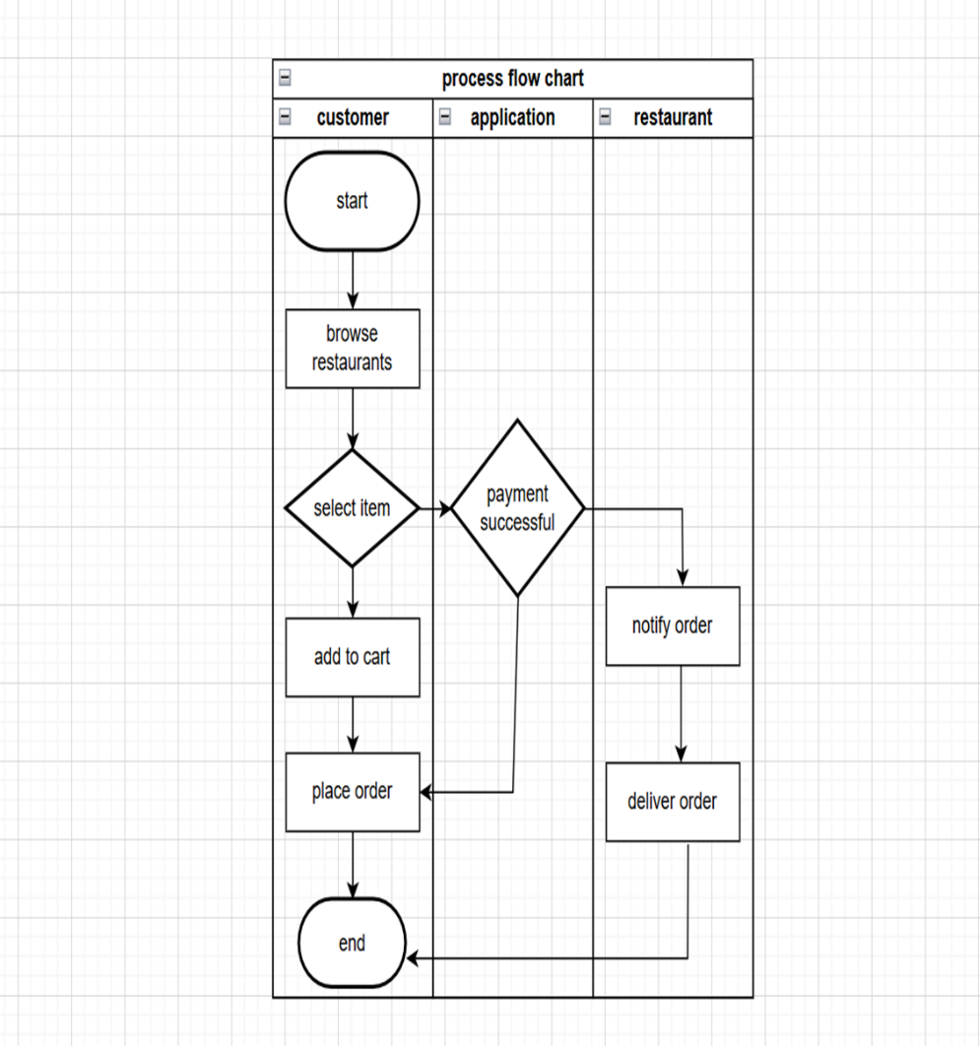

3 Functional Requirements
Various Modules required are as follows:
- User Login Module
- Restaurant Management Module
- Search and Filter Module
- Cart and Order Management Module
- Payment Module
- Tracking Module
- Delivery Partner Module
- Customer Support Module
3.1 User Login Module
This module handles user registration, login, profile management, and address handling. It ensures secure access control and maintains user account information throughout the application.
Positive Workflow
- User installs the app and successfully registers using mobile/email.
- User logs in with valid credentials and accesses the home screen.
- User updates profile details and saves changes successfully.
- User adds or edits delivery addresses without errors.
Exceptional Scenario
- User enters incorrect login credentials → system shows error message.
- OTP verification fails due to network issues or invalid OTP.
- Profile update fails due to server error.
- Session expires automatically due to inactivity.

3.2 Restaurant Management Module
This module manages onboarding, verification, and listing of restaurants along with menu setup and availability. It ensures users always receive accurate and updated restaurant information.
Positive Workflow
- Restaurants are onboarded and verified by the admin.
- Users view restaurants based on location and availability.
- Restaurants update menu items, prices, or availability successfully.
Exceptional Scenario
- Restaurant temporarily unavailable → system hides or marks it inactive.
- Menu update fails due to backend service error.
- Incorrect pricing or item availability not synced due to network issues.

3.3 Search and Filter Module
This module allows users to search for restaurants or food items and apply filters like cuisine, ratings, and pricing. It ensures quick and relevant search results for a better user experience.
Positive Workflow
- User searches for an item or restaurant and receives relevant results.
- User applies filters like ratings, cuisine, or price, and results update correctly.
Exceptional Scenario
- No results found → system displays a friendly "No items available" message.
- Filters fail to load due to server downtime.
- Search bar input not processed due to network interruption.

3.4 Cart and Order Management Module
This module enables users to add, update, or customize items before placing an order. It manages cart totals, order creation, order history, and ensures smooth checkout flow.
Positive Workflow
- User adds items to cart and sees updated totals.
- User customizes items and updates cart successfully.
- User places an order after final confirmation.
- Order ID is generated and visible in order history.
Exceptional Scenario
- Selected item becomes unavailable → system prompts user to update cart.
- Cart totals fail to calculate due to backend error.
- Order placement fails due to server timeout or payment issues.
- Duplicate tap on “Place Order” → system prevents multiple orders.

3.5 Payment Module
This module integrates multiple payment methods including UPI, cards, wallets, and COD. It securely processes transactions and updates payment status for order confirmation.
Positive Workflow
- User selects a preferred payment method and completes the transaction.
- Payment gateway returns success response and order gets confirmed.
- COD option is displayed if supported by the restaurant.
Exceptional Scenario
- Payment fails due to insufficient balance or gateway issues.
- Payment gateway timeout → system shows "Payment Failed" and reverses the process.
- Duplicate payment attempts detected → prevent double charging.
- COD unavailable → system hides or disables COD option.

3.6 Tracking Module
This module provides real-time updates throughout the order lifecycle and enables live GPS tracking of delivery partners. It ensures transparency and accurate communication of order progress.
Positive Workflow
- User receives real-time updates: Order Placed → Accepted → Prepared → Picked → Delivered.
- User tracks delivery partner on a live map with accurate location.
- Notifications are sent at every key event.
Exceptional Scenario
- GPS not enabled → system requests location permission.
- Delivery partner location not updating due to weak network.
- Order stuck in a status due to backend delay.
- Order wrongly marked as delivered → system enables support escalation.

3.7 Delivery Partner Module
This module supports delivery partners with order assignments, route navigation, and status updates. It ensures timely and efficient delivery handling through structured workflows.
Positive Workflow
- Delivery partner logs in and views assigned orders.
- Partner accepts the order and picks it up from the restaurant.
- Partner updates delivery status and completes the order.
Exceptional Scenario
- Delivery partner declines or misses order → auto-assign to next available partner.
- GPS not available → app prompts to enable location.
- Partner unable to find customer location → contact option enabled.
- Delivery partner’s app crashes or logs out → system auto reassigns order.

3.8 Customer Support Module
This module enables users to raise support tickets and access help resources. It ensures issues are tracked, escalated, and resolved through a structured support process.
Positive Workflow
- User raises a support ticket from the help section.
- Support team receives the ticket and responds promptly.
- Issue is resolved and ticket is closed.
Exceptional Scenario
- Ticket submission fails due to network/server issues.
- Support response delayed due to high load.
- Ticket escalated automatically if unresolved within set SLA.

Business Rules
- Account creation or login is required before placing an order.
- Only serviceable restaurants within the delivery radius are displayed.
- Menu details must always show real-time prices and availability.
- Offers/discounts apply only when eligibility criteria are met.
- Orders cannot proceed with unavailable items.
- Successful payment is mandatory before order confirmation (except COD).
- COD is shown only for restaurants that support it.
- Orders can be canceled only within the allowed cancellation window.
- Refunds follow platform-defined timelines and policies.
- Delivery is assigned only to available nearby delivery partners.
- Delivery partner location must update during active delivery.
- Users must be notified of payment failures, delays, or cancellations.
- Customer support queries must be logged and escalated if unresolved.
- Restaurant partners can update menu and availability only through authorized backend access.
- Taxes and delivery charges must be calculated dynamically.
- Each order must have a unique order ID.
- Ratings and reviews are allowed only after successful order completion.
- User data must be securely stored and protected.
- Users must accept Terms & Conditions during registration.
- Sessions must auto-expire after a period of inactivity.

4 Non-Functional Requirements
4.1 Performance Requirements
- The app should load the home screen within 3 seconds under normal network conditions.
- Search results and restaurant details must be displayed within 2–3 seconds.
- The system should handle high concurrency (multiple users ordering during peak hours) without performance degradation.
4.2 Security Requirements
- All user data, passwords, and payment information must be encrypted using industry standards (e.g., HTTPS, SSL/TLS).
- Payment processing must comply with PCI-DSS standards.
- Only authenticated users can access restricted areas, and role-based access should be enforced for admin, restaurant, and delivery partners.
4.3 Availability and Reliability
- The system should maintain 99% uptime excluding scheduled maintenance.
- App should gracefully handle network failures and retry where necessary.
- Backend services must be resilient and capable of automatic recovery from failures.
4.4 Maintainability Requirements
- Code should follow clean architecture principles for easy updates and feature enhancements.
- System should allow quick fixes without impacting other modules.
- Logs must be generated for debugging, error tracking, and system audits.
4.5 Logging and Monitoring
- Application must log major events, errors, and transaction failures.
- Admins should have access to monitoring tools for real-time system health tracking.

APPENDIX B- Data Dictionary
There are various Data Dictionaries in this project for example I explained one so remaining can be created in the same format.
Requirement No 4.1
Data Element | Field Type | Field Length | M/N | Business Rule | Error message
User_ID | Integer | 36 | M | Must be unique for each user | "Invalid User ID"
Full_Name | Varchar | 100 | M | Cannot be empty; must contain alphabets | "Enter a valid name”
Email | Varchar | 100 | M | Must be unique; must follow email format | "Invalid email address"
Mobile_Number | Integer | 15 | M | Must contain only digits; must be 10–15 characters | "Enter a valid mobile number"
Password | varchar | 255 | M | Must be encrypted; minimum 8 characters | "Invalid password"

APPENDIX C-Mock ups
Here in this section we can add the images of the project.
At last we can also add the glossary of terms along with the related documents but it is not a mandatory to attach in this document.

