BUSINESS REQUIREMENTS DOCUMENT
Project Name: Online Food Ordering

Version and Approvals

Version | Date | Author | Reason for change
1 | 16/11/2025 | Nivass K R

Contents

VERSION AND APPROVALS | 2
EXECUTIVE SUMMARY | 4
PROJECT DETAILS | 5
PROJECT OVERVIEW | 6
BUSINESS REQUIREMENTS | 9
USE CASE DIAGRAMS | 11
HIGH LEVEL PROCESS FLOW DIAGRAM | 12
BUSINESS RULES | 13
FUTURE ENHANCEMENTS | 13

EXECUTIVE SUMMARY
This BRD aims to identify business requirements for the development of an Online Food Ordering Application. The proposed application is envisioned to offer users an efficient platform to browse through restaurants, customize their food orders, make secure payments online, and facilitate real-time tracking of deliveries.

Since digital food services continue to expand rapidly, customers' expectations about the speediness of ordering, transparency, and dependability of delivery experiences are also rapidly growing. The application will be able to handle these demands by providing an intuitive user interface, variety in restaurants, personalized recommendations, and smooth processing of orders. To the restaurant partners, it means increased visibility, better order management, and business growth.

This will be a system with three major user groups: customers, restaurant partners, and delivery personnel, who are supported by dedicated interfaces and role-based functionalities.

PROJECT DETAILS

Project Name | Online Food Ordering
Project Type | Android Mobile Application
Project Start Date
Project End Date
Project Sponsor
Primary Driver | Convenience & Time-Saving, Streamlined Order Management, Real-Time Delivery Tracking, Secure Digital Payments.
Secondary Driver | Personalized Recommendations, Offers, Discounts & Loyalty Programs, Restaurant Performance Analytics, Operational Efficiency for Delivery Partners, Scalability for Future Expansion.
Division
Project Manager

PROJECT OVERVIEW
This document defines the high-level requirements for the project name-Online Food Ordering. It will used as the basis for the following activities:
- Creating solution designs
- Developing test plans, test Scripts, test cases
- Determining project completion
- Assessing project success

Objective
To develop a user-friendly, secure, and scalable Android-based Online Food Ordering Application that simplifies the ordering process for customers, streamlines order and menu management for restaurants, and enhances delivery efficiency through real-time tracking—ultimately providing a seamless and reliable end-to-end food ordering experience.

Stakeholders
S. No | Stakeholders
1. | Customers (End Users)
2. | Restaurant Partners
3. | Delivery Personnel
4. | Admin / System Administrator
5. | Development Team
6. | Product Manager / Business Analyst
7. | Marketing & Sales Team
8. | Payment Gateway Providers
9. | Customer Support Team
10. | Investors / Management

Risks
- App may face performance issues or crashes on different Android devices.
- Payment gateway integration might fail or cause transaction errors.
- Real-time order tracking may be inaccurate due to GPS or network issues.
- Restaurants may delay or mishandle orders, affecting customer experience.
- Delivery partners may miss delivery timelines or fail to pick up orders on time.
- User data or payment information may be exposed due to security vulnerabilities.
- Strong competition from established food delivery apps may impact adoption.
- Low user engagement or uninstall rates due to poor UI/UX design.
- Project may exceed estimated budget or development timeline.
- Server downtime or API failures may disrupt ordering and tracking.
- Negative customer reviews may impact brand reputation.
- Dependence on third-party services (payment gateway, maps, SMS APIs) may cause delays.
- Difficulty onboarding restaurants and delivery partners may slow growth.
- Potential legal or compliance issues related to user data handling.

Limitations
- Real-time tracking accuracy depends on GPS and network quality, which cannot be fully controlled.
- Service availability is restricted to restaurants and delivery partners onboarded within specific locations.
- Order delivery time may vary due to traffic conditions, weather, or partner availability.
- Performance may vary across different Android devices, screen sizes, and OS versions.
- Users may face delays or failed transactions due to third-party payment gateway issues.
- Menu accuracy and availability rely on restaurants updating information consistently.
- App features may be limited during the initial release due to budget or timeline constraints.
- Heavy dependency on stable backend servers—downtime can halt the entire ordering process.
- Limited control over restaurant food quality, packaging, or delivery partner behavior.

Assumptions
- Users have stable internet connectivity to place orders and track deliveries.
- Restaurants will actively update their menus, prices, and availability.
- Delivery partners will follow app instructions and deliver orders on time.
- Payment gateway services will remain available and functional.
- Users will have Android devices with supported OS versions.
- Admin will manage onboarding, verification, and system operations responsibly.
- All third-party APIs (maps, SMS, notifications) will perform reliably.

Project Scope
In Scope
- Android mobile application for customers.
- User registration, login, and profile management.
- Restaurant listing, menu browsing, wish list, and search features.
- Food ordering, cart management, and order customization.
- Secure online payments (UPI, card, wallet) and COD (optional).
- Real-time order status updates and delivery tracking.
- Restaurant partner interface for managing orders and menus.
- Admin panel for managing users, restaurants, orders, and analytics.
- Notification system for order updates and promotions.
Out Of Scope
- iOS or Web application development.
- Delivery partner training or fleet management outside the app.
- Restaurant staff management or inventory tracking systems.
- AI-based advanced forecasting or smart routing algorithms (future enhancement).
- Social media-style features like reviews, comments, or chat (if not planned).
- Integration with third-party delivery services or logistics companies.
- Loyalty rewards or subscription plans in the initial version.

BUSINESS REQUIREMENTS
High-level Requirements
Following are the high-level requirements from the user perspective
- Ability to register, log in, and manage personal profile.
- Option to browse nearby restaurants based on location.
- Viewing of restaurant details, menus, prices, and item availability.
- Search and filter functionality for cuisines, ratings, and pricing.
- Adding, removing, and updating items in the cart.
- Customization of food items such as addons, quantity, and special instructions.
- Display of accurate order totals including taxes and delivery fees.
- Smooth and secure checkout process for placing orders.
- Multiple payment methods including UPI, cards, wallets, and COD.
- Receipt and order confirmation generated after payment.
- Real-time updates on order status throughout the process.
- Map-based tracking of delivery partner during delivery.
- Push notifications for order progress, offers, and payment alerts.
- Access to customer support for help or issue resolution.
- Fast, stable, and responsive performance across Android devices.
- Secure handling of personal data and payment information.
Prioritization of requirements
The requirements in this document are prioritized as follows:
Value | Rating | Description
1 | Critical | - Ability to register, log in, and manage personal profile.  - Option to browse nearby restaurants based on location.  - Viewing of restaurant details, menus, prices, and item availability.  - Adding, removing, and updating items in the cart.  - Display of accurate order totals including taxes and delivery fees.  - Smooth and secure checkout process for placing orders.  - Multiple payment methods including UPI, cards, wallets, and COD.  - Receipt and order confirmation generated after payment.  - Real-time updates on order status throughout the process.  - Secure handling of personal data and payment information.
2 | High | - Search and filter functionality for cuisines, ratings, and pricing.  - Customization of food items such as addons, quantity, and special instructions.  - Map-based tracking of delivery partner during delivery.  - Push notifications for order progress, offers, and payment alerts.
3 | Medium | - Access to customer support for help or issue resolution.  - Fast, stable, and responsive performance across Android devices.

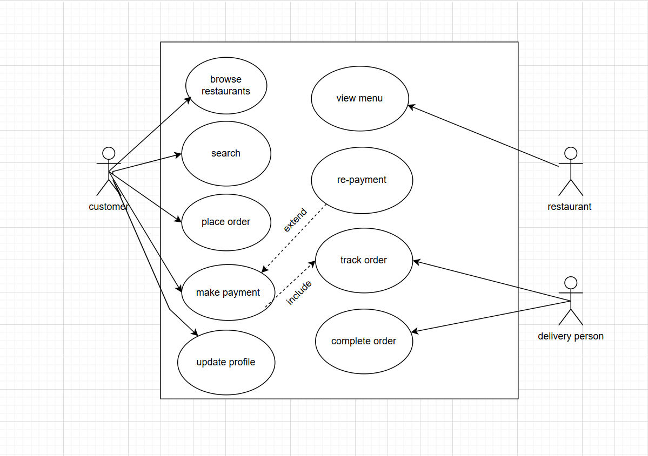
USE CASE DIAGRAMS

HIGH LEVEL PROCESS FLOW DIAGRAM
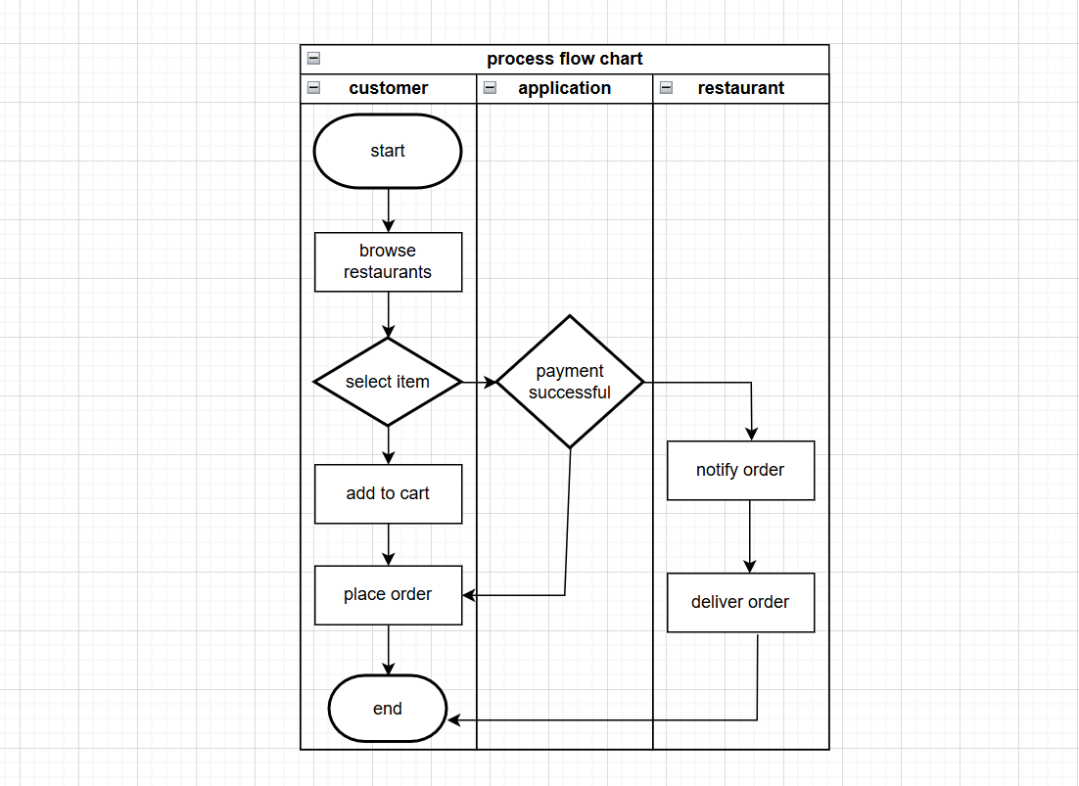
BUSINESS RULES
- Account creation or login is required before placing an order.
- Only serviceable restaurants within the delivery radius are displayed.
- Menu details must always show real-time prices and availability.
- Offers/discounts apply only when eligibility criteria are met.
- Orders cannot proceed with unavailable items.
- Successful payment is mandatory before order confirmation (except COD).
- COD is shown only for restaurants that support it.
- Orders can be canceled only within the allowed cancellation window.
- Refunds follow platform-defined timelines and policies.
- Delivery is assigned only to available nearby delivery partners.
- Delivery partner location must update during active delivery.
- Users must be notified of payment failures, delays, or cancellations.
- Customer support queries must be logged and escalated if unresolved.
- Restaurant partners can update menu and availability only through authorized backend access.
- Taxes and delivery charges must be calculated dynamically.
- Each order must have a unique order ID.
- Ratings and reviews are allowed only after successful order completion.
- User data must be securely stored and protected.
- Users must accept Terms & Conditions during registration.
- Sessions must auto-expire after a period of inactivity.

FUTURE ENHANCEMENTS
- AI-based personalized food recommendations.
- Subscription or loyalty reward programs.
- In-app wallet and faster refund processing.
- Scheduled ordering for future delivery times.
- Multi-language support.
- Group ordering with split payments.
- Real-time chat with restaurant or delivery partner.
- Voice-based search and smart assistant integration.

