OUTPUT:

Limits:

upper and lower limit of real part: -2,1

upper and lower limit of imaginary part: -1,1

Cases:

1. Without calculating the constant value outside the for loop and time taken is 1.594 seconds

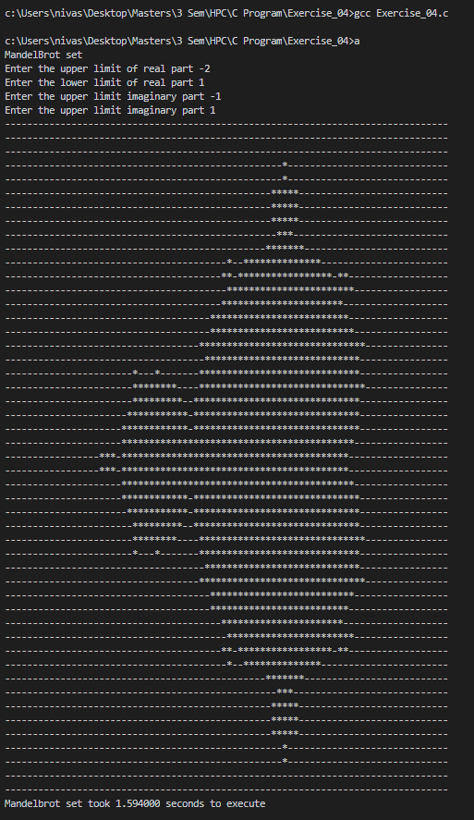

1. Calculating the constant value outside the for loop and time taken is 1.526 seconds

