CHAPTER 1
INTRODUCTION

The advancement of digital communication has revolutionized the way information is transmitted and received across various platforms. In recent decades, the demand for high-speed, reliable, and secure communication systems has grown rapidly due to the increasing use of wireless technologies. As multiple users often need to communicate over the same frequency spectrum, efficient multiple access techniques have become essential. One such powerful technique is Code Division Multiple Access (CDMA), particularly its direct sequence form known as DS-CDMA.
The Direct Sequence Code Division Multiple Access (DS-CDMA) technique allows multiple users to share the same communication channel simultaneously by assigning each user a unique code. These codes are used to spread the user’s signal across a wider bandwidth, resulting in better resistance to interference, improved privacy, and enhanced overall system performance. The main objective of this project is to design and simulate a digital DS-CDMA Transmitter and Receiver using Verilog HDL, focusing on the core concepts of spreading, modulation, despreading, and signal recovery.
The DS-CDMA system forms the foundation for several modern wireless communication standards due to its ability to maintain consistent data transmission quality, even in noisy or crowded environments. Through simulation, this project aims to demonstrate how spreading codes improve the reliability of communication by allowing multiple signals to coexist within the same frequency band. By digitally designing and testing the transmitter and receiver modules, the project establishes a strong understanding of CDMA-based data transmission principles
  - INTRODUCTION TO CDMA SYSTEM

Code Division Multiple Access (CDMA) is a type of multiple access communication technique in which several users can simultaneously transmit data over the same frequency band without significant interference. Unlike Time Division Multiple Access (TDMA) or Frequency Division Multiple Access (FDMA), which separate users by time or frequency, CDMA allows all users to occupy the same channel concurrently by using distinct spreading codes.
In a DS-CDMA system, the user data sequence is multiplied by a high-rate pseudo-random noise (PN) code, which spreads the data signal over a much wider bandwidth than the original baseband message. This process, known as spreading, transforms the narrowband data signal into a wideband signal that appears as noise to unintended receivers. At the receiver end, the same PN code is used to despreads the signal, recovering the original data. Since each user has a unique spreading code, only the intended receiver can correctly correlate and extract the transmitted information.
The principle behind DS-CDMA relies on orthogonality and correlation properties of spreading codes. When the receiver uses a different code from that of the transmitter, the correlation result remains minimal, effectively rejecting unwanted signals. This property provides CDMA systems with strong resistance against interference and multipath fading. Additionally, due to the wideband nature of DS-CDMA, the system exhibits excellent anti-jamming capabilities and improved spectral efficiency.
Overall, CDMA provides a reliable means of sharing limited spectral resources among multiple users. Its robust nature and adaptability have made it one of the most successful communication technologies in mobile networks, satellite systems, and secure communication environments.
  - MOTIVATION AND OBJECTIVES

The motivation behind this project arises from the increasing importance of multi-user communication systems in today’s digital world. As communication networks continue to expand, it becomes essential to design systems that can accommodate numerous users while maintaining data integrity and minimizing interference. DS-CDMA serves as an ideal study model for this purpose because of its unique code-based access mechanism and efficient use of bandwidth.
Designing the DS-CDMA system using Verilog HDL offers a clear and structured approach to understanding the hardware behavior of communication modules. By simulating the transmitter and receiver digitally, it becomes possible to visualize data spreading, code generation, and signal recovery in a controlled environment. This not only helps in understanding theoretical communication concepts but also provides practical exposure to digital circuit design and verification.
The main objectives of this project are to:
- Develop a Verilog-based model for DS-CDMA Transmitter and Receiver.
- Perform simulation-based verification to analyze signal performance.
- Demonstrate how spreading and despreading improve noise immunity.
- Understand digital communication design flow through a complete transmitter–receiver system.
- Evaluate how multiple users can coexist within the same bandwidth using different codes.
Through this work, a complete theoretical and practical foundation for CDMA communication is established, focusing on logic-level implementation, design accuracy, and signal analysis.

1.3 APPLICATIONS OF DS-CDMA

The DS-CDMA technique has numerous applications in modern communication systems due to its high capacity, resistance to interference, and secure nature. It has been successfully implemented in a wide range of wireless technologies and plays a vital role in both commercial and defence communication networks.
In the cellular communication field, DS-CDMA forms the core of third generation (3G) mobile networks such as CDMA2000 and WCDMA. These systems allow thousands of users to connect simultaneously while maintaining consistent voice and data quality. In satellite communication, DS-CDMA is used for reliable and interference-resistant data transmission, especially in systems where multiple ground stations communicate with a single satellite.
Another significant area of application is in Global Positioning Systems (GPS), where each satellite transmits using a unique spreading code. This allows receivers on Earth to identify signals from individual satellites and calculate positions accurately. In military and defense communications, DS-CDMA provides secure and jam-resistant transmission, making it suitable for tactical and confidential operations.
Additionally, CDMA principles are applied in IoT (Internet of Things) networks, wireless sensor systems, and smart device communication, where multiple devices need to exchange information without cross-interference. These applications highlight the flexibility and scalability of DS-CDMA systems across both low-power and large-scale networks.

1.4 ADVANTAGES OF DS-CDMA SYSTEM

The DS-CDMA system offers several distinct advantages over other multiple access techniques, making it a preferred choice in many modern communication standards. One of the most important benefits is its efficient utilization of bandwidth, as multiple users can share the same frequency spectrum simultaneously without severe mutual interference. This is made possible by the orthogonal nature of the spreading codes.
Another major advantage is immunity to narrowband interference and jamming. Since the signal is spread across a wide bandwidth, any interference affecting a small portion of the spectrum has little impact on the overall performance. The system also exhibits strong resistance to multipath fading, as the correlation process in the receiver helps combine signals arriving through different paths constructively.
The security and privacy offered by DS-CDMA are also notable. Because each user employs a unique pseudo-random code, it is extremely difficult for unauthorized users to detect or decode the transmitted data. Furthermore, the system supports soft handoff between base stations in mobile networks, ensuring seamless connectivity during user movement.
From a design perspective, DS-CDMA systems are highly scalable and can easily accommodate new users with minimal degradation in performance. The combination of these features — efficiency, robustness, security, and scalability — makes DS-CDMA an ideal communication technique for both present and future wireless systems.

CHAPTER 2
LITERATURE REVIEW

The Literature Review presents an overview of the research work carried out by various authors and researchers in the field of Direct Sequence Code Division Multiple Access (DS-CDMA) and digital communication systems. It helps to understand the existing concepts, design approaches, and techniques adopted in previous studies, which serve as the foundation for the present project.
Over the years, the demand for wireless communication systems has increased rapidly, leading to the development of efficient multiple access technologies such as FDMA, TDMA, and CDMA. Among these, CDMA has become one of the most reliable methods due to its ability to allow multiple users to share the same frequency band simultaneously with minimal interference. The DS-CDMA technique, in particular, uses unique pseudo-random spreading codes for each user to ensure data security, robustness against noise, and efficient spectrum utilization.
Several studies have been conducted to improve the performance and implementation of CDMA systems. Sharma et al. (2023) discussed the application of spread-spectrum communication in IoT-based networks, emphasizing the importance of pseudo-noise codes in maintaining reliable data transmission under noisy environments. Their research concluded that DS-CDMA offers better noise immunity compared to traditional modulation methods. Gupta and Singh (2022) carried out a comparative study between CDMA and OFDM systems and reported that CDMA provides superior performance in environments with multiple users and variable interference.
Ramesh and Kumar (2021) proposed a digital DS-CDMA transceiver model using MATLAB/Simulink to demonstrate the spreading and despreading processes. Their simulation results showed that spreading improves signal-to-noise ratio (SNR) and ensures secure transmission. However, their work was limited to a software-based environment, which motivates the need for HDL-level modeling. Ahmed et al. (2019) explored Verilog-based communication design and highlighted that HDL simulations allow accurate visualization of internal signal behavior, clock synchronization, and modular testing. Their findings support the approach followed in the present project, where Verilog HDL is used to describe the DS-CDMA system’s transmitter and receiver.
From these reviews, it is evident that DS-CDMA continues to attract attention due to its unique spreading characteristics, which offer better bandwidth efficiency and interference tolerance. Most of the earlier works have either concentrated on algorithmic or software simulations, leaving a gap in the digital hardware-level understanding of the system. Therefore, this project aims to bridge that gap by developing and verifying the DS-CDMA Transmitter and Receiver architecture using Verilog HDL, focusing on logic-level design, simulation, and functional analysis.
The present work not only incorporates the principles established in previous research but also extends them by providing a complete hardware description of the communication process. Through this, the design demonstrates how digital systems can replicate real-world communication mechanisms such as spreading, despreading, and synchronization. Thus, this literature review establishes the foundation and justification for the digital design and simulation of the DS-CDMA Transmitter and Receiver, forming the basis for the detailed system design presented in the next chapter.

CHAPTER 3
PROPOSED SYSTEM DESIGN

3.1 BLOCK DIAGRAM AND DESCRIPTION
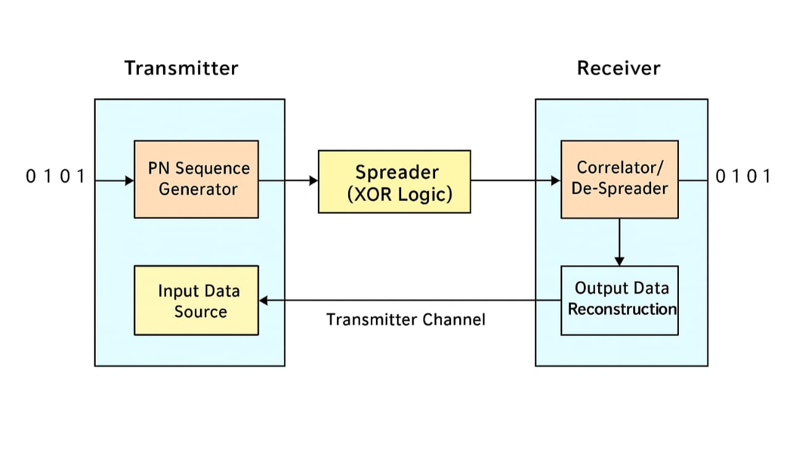
Figure 3.1 block diagram of ds-cdma transmitter and receiver
The proposed system is a digital simulation of a Direct Sequence Code Division Multiple Access (DS-CDMA) Transmitter and Receiver designed and verified using Verilog HDL. The project demonstrates the working principle of DS-CDMA communication through digital logic modeling and simulation, without any hardware implementation.
The DS-CDMA technique allows multiple users to share the same channel bandwidth by assigning unique pseudo-random codes to each user. These codes help in spreading and despreading the data, ensuring secure and interference-free communication. The proposed design is developed, compiled, and simulated in Intel Quartus Prime 64-bit software, and the output waveforms are analyzed in the ModelSim environment.
The complete system consists of two major parts:
1. DS-CDMA Transmitter Section
2. DS-CDMA Receiver Section
Both sections are written as separate Verilog modules and interconnected to form an end-to-end digital communication chain. The transmitter converts input data into a spread signal using a PN code, while the receiver recovers the original data by applying the same PN code during the despreading process
BLOCK DIAGRAM EXPLANATION
The block diagram of the proposed DS-CDMA system is shown in Figure 3.1. It includes the following major functional blocks.
1. Input Data Source
This block generates the binary input data sequence (a stream of 0s and 1s) to be transmitted.
In simulation, this data is provided manually or through a Verilog testbench, which defines a set of input bits representing the user data.
Example input: D(t) = 1\ 0\ 1\ 1\ 0
2. PN Sequence Generator
The Pseudo Noise (PN) Sequence Generator produces a binary sequence that appears random but can be reproduced at both the transmitter and receiver sides.
It is implemented using a Linear Feedback Shift Register (LFSR) in Verilog.
Each bit in the PN sequence is generated based on feedback from selected bits of the register, using XOR gates.
This PN sequence acts as the spreading code, which provides user separation and increases bandwidth.
Example PN sequence(t) = 1\ 0\ 1\ 0\ 1\ 1

3. Spreader (XOR Logic)
In the transmitter section, each input data bit is XORed with the corresponding PN code bit to produce a spread signal.
This process multiplies the data bandwidth and improves its resistance to interference or jamming.
The spreading operation can be mathematically expressed as:
S(t) = D(t) \oplus P(t)
D(t) = input data bit stream
P(t) = PN code sequence
S(t) = spread signal output
In Verilog, this is implemented using bitwise XOR operations.
4. Transmission Channel
In this simulation-based project, the transmission channel is represented logically rather than physically.
It connects the transmitter output directly to the receiver input within the Verilog environment.
This digital channel may also include noise bits or intentional delays during advanced testing to observe system robustness.
5. Correlator / De-Spreader
The receiver section performs the reverse operation of the transmitter.
The received spread signal is XORed again with the same PN code sequence to retrieve the original data bits.
If the correct PN code is used, the despreading output perfectly matches the transmitted input data.
The despreading operation can be represented as: R(t) = S(t) \oplus P(t)
6. Output Data Reconstruction
The final stage of the receiver recovers and reconstructs the transmitted data stream. The recovered bits are displayed in the simulation waveform window.
3.2 FLOW DIAGRAM OF DS-CDMA TRANSMITTER
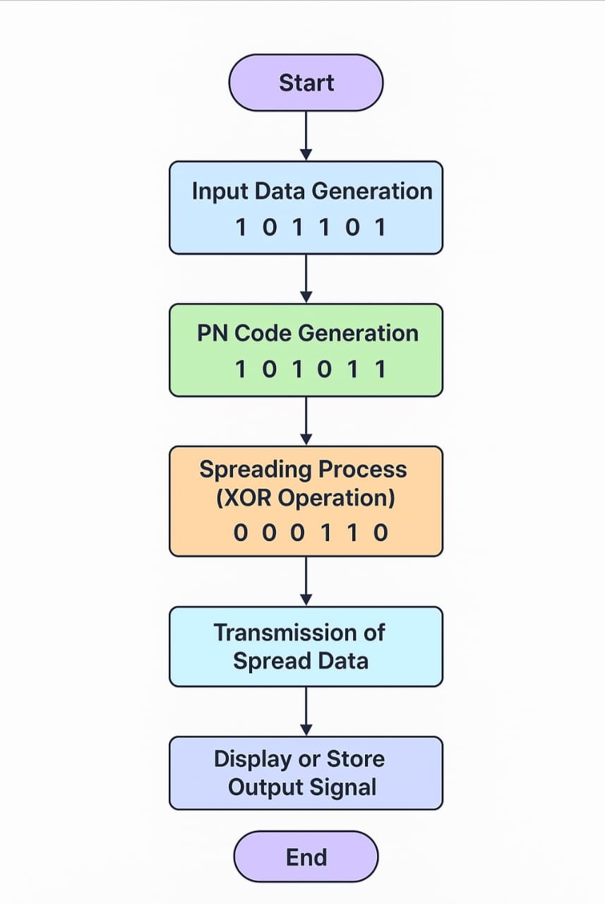
The flow diagram of the DS-CDMA transmitter represents the complete process of spreading the original input data for secure and efficient transmission. The transmitter section plays a crucial role in the overall working of the DS-CDMA system because it determines how the data is encoded and transformed into a spread-spectrum signal that can be transmitted over a shared communication channel. The transmitter essentially takes a narrowband digital input signal, combines it with a pseudo-noise (PN) code sequence, and produces a wideband spread signal. This
Figure 3.2 flow diagram of ds-cdma transmitter
spreading operation ensures that multiple users can transmit their data simultaneously without interference, as each user is assigned a unique PN code.
The working of the DS-CDMA transmitter begins with the generation of the input data. The data to be transmitted is represented in binary form, consisting of a sequence of logical ones and zeros. In a digital communication system, these binary values represent digital messages, encoded information, or sensor readings. In a Verilog HDL simulation environment, this input data is generated using a testbench or defined as a digital signal source. The input data acts as the primary information signal that must be protected and transmitted through the system.
Once the data is generated, the next important step is the generation of the pseudo-noise (PN) sequence. The PN sequence, also known as the spreading code, is a specially designed binary sequence that appears random but is actually deterministic, meaning it can be reproduced exactly at the receiver. The main characteristic of the PN sequence is that it has a much higher rate than the input data signal. This high frequency ensures that the data is spread across a wider frequency range during transmission. Each user in a DS-CDMA system is assigned a different PN sequence so that the receiver can identify and recover only the intended signal, even if multiple users are transmitting at the same time on the same frequency band.
The PN code generation is typically implemented using a sequence generator that creates a periodic binary pattern. In simulation, this can be represented as a separate Verilog module that continuously produces the PN bits in synchronization with the data. The synchronization between the data signal and the PN code is extremely important because any mismatch in timing or sequence alignment can result in incorrect spreading, which may lead to transmission errors. Therefore, both signals must be aligned properly before the spreading operation takes place.
The most critical stage of the DS-CDMA transmitter is the spreading operation. This process is carried out using an exclusive-OR (XOR) logical operation between the input data bits and the PN sequence bits. The XOR gate plays a vital role because it performs the mathematical equivalent of binary multiplication in the DS-CDMA system. When a data bit is XORed with the PN code bit, the result is a spread bit that carries the combined properties of both the input signal and the spreading code. The spreading process increases the bandwidth of the transmitted signal far beyond the minimum required bandwidth for the original data.
For instance, if the data signal changes slowly while the PN sequence changes rapidly, the resulting spread signal appears random and noise-like. However, this signal still contains the original information in an encoded form that can be recovered only by using the same PN code at the receiver. The advantage of this technique is that it provides security, as an unintended receiver without the correct code cannot interpret the transmitted data. Moreover, because the power of the signal is distributed over a wide frequency range, it becomes resistant to narrowband interference and jamming.
After the spreading operation, the spread signal is passed to the transmission stage. In real communication systems, this stage would involve modulation onto a carrier frequency and physical transmission through an antenna or channel. However, in a Verilog HDL simulation, the transmission stage is represented digitally. The spread signal is observed as a digital waveform that simulates the transmitted output. This output can be stored, displayed, or analyzed for verification of the spreading process. The transmission stage therefore symbolizes the transition of the processed signal from the transmitter section to the communication channel or the next block in the simulation environment.
The spread spectrum output generated by the transmitter possesses several significant characteristics. It occupies a wider frequency band, making it more robust against noise and interference. It also allows multiple users to share the same communication channel simultaneously, as each user’s signal is separated by its unique PN code. The correlation property of the PN code ensures that the receiver can distinguish between different users’ signals, thus avoiding cross-talk and data mixing. This ability to handle multiple signals within the same bandwidth is one of the greatest advantages of CDMA-based systems.
The flow diagram of the DS-CDMA transmitter clearly represents each stage involved in the process. The first block corresponds to the input data generator, which provides the original binary information. The second block corresponds to the PN code generator, responsible for creating the unique high-rate binary sequence. The third block represents the spreading unit, where the XOR operation takes place between the input data and the PN code. The fourth block is the transmission section, where the spread signal is sent to the channel or observed digitally. Finally, the output block represents the transmission result, which is ready for further processing or reception. Each block in the diagram is interconnected sequentially to show the flow of information from input to output.
This structured flow helps in understanding how a DS-CDMA transmitter functions as a complete unit. The process of spreading converts the narrowband signal into a wideband signal that can be transmitted securely and efficiently. The PN sequence plays a dual role — it ensures user separation in multi-user environments and provides noise immunity. The XOR operation ensures that the output depends on both the input data and the code sequence, providing a secure mapping of information. These operations, though simple in logic, have powerful implications in communication systems.
One of the major advantages of the DS-CDMA transmitter design is its ability to resist interference and signal fading. Because the signal energy is distributed over a wide frequency range, even if certain portions of the spectrum experience fading or interference, the overall communication remains unaffected. This property, known as processing gain, makes DS-CDMA a preferred technique in modern wireless systems such as 3G and GPS. Another benefit is that since the signal appears as random noise to unintended receivers, it provides a level of privacy and security that traditional narrowband systems cannot achieve.
In a Verilog HDL environment, each functional block of the DS-CDMA transmitter can be implemented and simulated independently. The data input, PN code generation, and spreading stages can be designed as separate modules that interact through defined digital signals. The simulation output verifies that the system correctly spreads the input data. By observing the waveforms, one can confirm that the transmitted signal has a higher frequency component and a random-like appearance compared to the original data, thus validating the effectiveness of the spreading operation.
Finally, the DS-CDMA transmitter, as represented by its flow diagram, forms the foundation for secure and efficient digital communication. It successfully transforms simple binary data into a robust spread-spectrum signal that can travel through shared communication channels without being affected by other users or environmental noise. The entire transmission process depends on accurate synchronization and the correct generation of the PN sequence. By maintaining precise timing between the data and the code, the transmitter ensures that the spread signal can be perfectly recovered by a matching receiver.
Thus, the flow diagram of the DS-CDMA transmitter demonstrates the complete working mechanism — from input data generation to PN code creation, spreading through XOR operation, and digital transmission. Each stage contributes to making the communication system more reliable, secure, and interference resistant. This transmitter model, implemented in Verilog HDL, provides a clear and comprehensive understanding of how DS-CDMA technology functions in real-world communication systems, forming a solid base for simulation-based analysis, research, and practical study.

3.3 FLOW DIAGRAM OF DS-CDMA RECEIVER
The flow diagram of the DS-CDMA receiver illustrates the complete reverse operation of the transmitter process, focusing on the recovery of the original digital information from the received spread spectrum signal. The DS-CDMA receiver plays a vital role in reconstructing the transmitted message accurately by using the same pseudo-noise (PN) code that was used at the transmitter side. The main purpose of the receiver is to correctly identify and extract the desired user’s data while rejecting all other unwanted signals, noise, and interference that share the same frequency spectrum. The process of receiving and decoding is entirely dependent on the concept of synchronization between the transmitter and receiver PN codes. When the PN code in the receiver matches exactly with that of the transmitter, the data can be recovered successfully; otherwise, the information will remain unreadable or corrupted.
The receiver operation begins when the spread spectrum signal arrives through the communication channel. This received signal is generally a mixture of
Table 3.3
Clock Cycle | Register State (Q3 Q2 Q1) | Output Bit | Feedback (Q3⊕Q1)
1 | 1 0 0 | 0 | 1 ⊕ 0 = 1
2 | 1 1 0 | 0 | 1 ⊕ 0 = 1
3 | 1 1 1 | 0 | 1 ⊕ 1 = 0
4 | 0 1 1 | 1 | 0 ⊕ 1 = 1
5 | 1 0 1 | 1 | 1 ⊕ 1 = 0
6 | 0 1 0 | 1 | 0 ⊕ 0 = 0
7 | 0 0 0 | 0 | (sequence repeats)

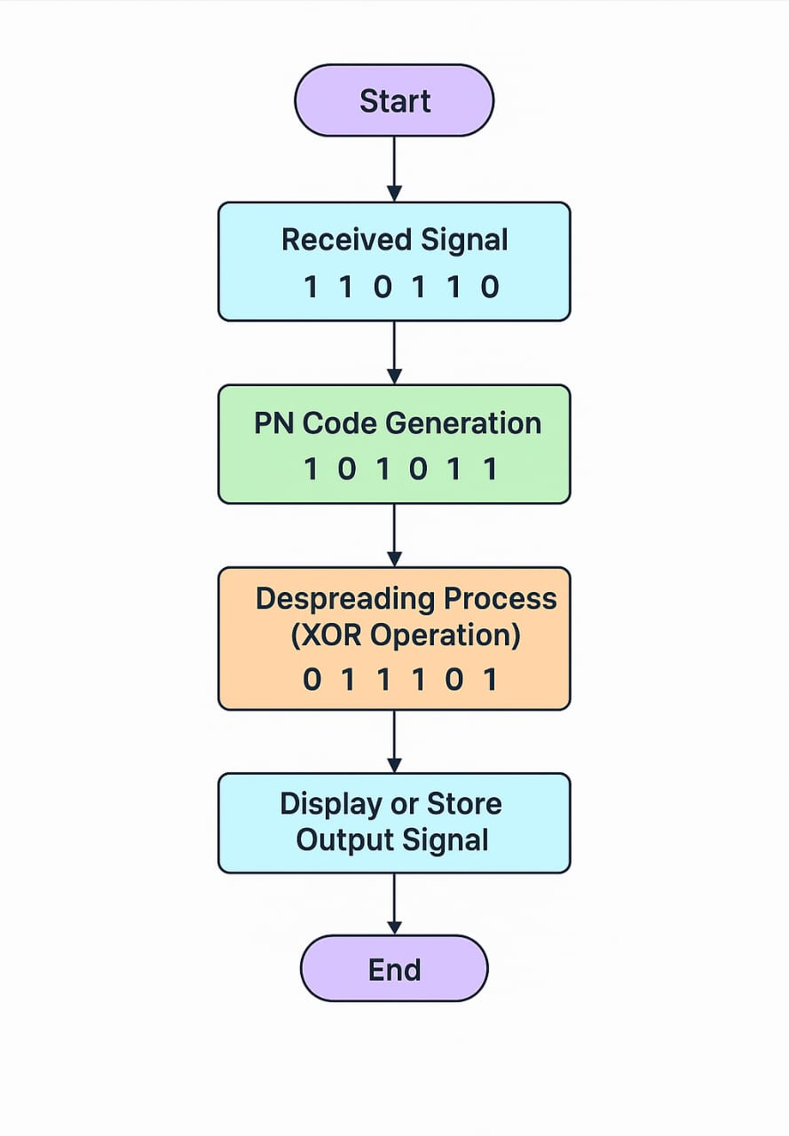
multiple user signals that were transmitted simultaneously, each with its own unique spreading code. In real-world environments, the channel introduces several distortions such as noise, phase shifts, or attenuation that can affect signal quality. Therefore, the first step in the receiver is to accept the incoming digital waveform and prepare it for despreading. In the Verilog HDL simulation, this is modelled by assigning the transmitted spread signal as the input to the
Figure 3.3 flow diagram of ds-cdma receiver
receiver module. This step corresponds to the signal input block in the flow diagram. The signal received may appear random or noisy due to spreading, but it contains the hidden original data embedded within the wideband transmission.
Once the receiver obtains the signal, the next operation focuses on reproducing the same PN code sequence that was originally used for spreading at the transmitter. This step is extremely crucial because the entire despreading process depends on it. The PN code generator within the receiver is designed to generate an identical pseudo-random binary sequence based on the same seed value and logic used in the transmitter. In simulation, this is done through Verilog code that creates a digital PN pattern synchronized with the transmitter’s sequence. If the PN code is mismatched, the receiver will not be able to recover the correct data, as the spread and despread processes will not align properly. Hence, the synchronization between both PN sequences is the backbone of DS-CDMA operation. Synchronization ensures that the chips (the short-duration bits of the PN sequence) generated by both ends occur at exactly the same time, maintaining precise alignment throughout the process.
After synchronization is established, the receiver enters the despreading stage, which is the heart of the DS-CDMA receiver operation. In this stage, the incoming spread signal is combined with the locally generated PN code using an XOR (exclusive-OR) operation in digital logic. This operation is mathematically equivalent to multiplying the received signal by the same spreading code that was used during transmission. When the correct PN sequence is applied, the spreading effect introduced by the transmitter is canceled, and the original narrowband signal is recovered. The unique correlation property of the PN code ensures that the receiver can recognize only its intended signal, while all other signals that do not match the code appear as very low-power noise. This property allows DS-CDMA systems to support multiple users in the same bandwidth without mutual interference. In Verilog simulation, this XOR-based despreading is implemented using simple logical operations that accurately model the behavior of real CDMA receivers.
Once the despreading process is complete, the receiver obtains a binary sequence that closely resembles the original transmitted data. However, due to channel effects or minor synchronization errors, the recovered signal might contain small disturbances. Therefore, the next step is data reconstruction. In this stage, the despread signal is interpreted and reshaped to form the clean binary data that represents the original information bits. This is achieved through threshold detection or digital filtering in theoretical systems. In Verilog-based designs, the despread output is verified by comparing it to the transmitted data in a testbench environment. The reconstructed signal is then displayed in waveform simulation results to confirm that the receiver has successfully recovered the information transmitted earlier. This verification process helps confirm the proper working of the DS-CDMA receiver logic and its correlation mechanism.
The flow diagram of the DS-CDMA receiver clearly represents these major operations in sequential order, beginning with signal input, followed by PN code generation, synchronization, despreading operation, and finally, output verification. The smooth flow from one stage to another ensures that the data is correctly processed and recovered without distortion. Each stage plays a critical role in maintaining the integrity of data transmission and ensuring that the system operates efficiently even in the presence of noise and multiple users. The synchronization block particularly highlights the importance of timing accuracy between transmitter and receiver PN codes. Any slight deviation or delay between them can result in incorrect despreading, leading to errors in the recovered data.
In addition to synchronization, the robustness of the PN code itself is another factor that contributes to the receiver’s efficiency. The PN sequence used in DS-CDMA must have good autocorrelation and cross-correlation properties. Autocorrelation ensures that the receiver can easily identify its own code even in the presence of noise, while cross-correlation ensures minimal interference between different users. The better these properties are, the more reliable and interference-resistant the receiver becomes. The flow diagram of the DS-CDMA receiver demonstrates how these properties are utilized within each stage to maintain high performance and secure data recovery.
In the Verilog HDL implementation, the DS-CDMA receiver does not require any external FPGA hardware for verification. Instead, the entire operation is carried out through simulation. The received spread signal is processed digitally inside the Verilog environment, and all operations such as XOR-based despreading, PN code generation, and synchronization are modeled using logic expressions. The simulation waveform clearly shows the relationship between the transmitted data, spread data, and recovered data, confirming that the theoretical flow of operations is correctly achieved. This software-based approach allows accurate analysis and visualization of how a DS-CDMA receiver behaves in real communication conditions without requiring any physical hardware testing.
The DS-CDMA receiver thus acts as a powerful module that accurately retrieves the transmitted information by reversing the spreading operation. The flow diagram visually represents the continuous movement of data from reception to recovery, ensuring that the original signal is perfectly reproduced at the output. The process demonstrates how CDMA technology can allow multiple users to share the same frequency spectrum while maintaining clear and interference-free communication. Through despreading, synchronization, and reconstruction, the DS-CDMA receiver validates the effectiveness of spread spectrum communication and its strong resistance to noise and channel disturbances.
In conclusion, the DS-CDMA receiver’s flow diagram stands as a clear representation of how digital communication can achieve secure and efficient data recovery. The receiver not only restores the transmitted signal but also showcases the importance of code division and synchronization in modern wireless systems. The despreading operation based on PN code correlation remains the key technique that separates desired data from interference. The simulation results obtained using Verilog HDL confirm the correct logical working of the receiver and its ability to accurately reconstruct the original message signal. Therefore, the DS-CDMA receiver’s flow process highlights the reliability, precision, and theoretical strength of spread spectrum systems that continue to play a dominant role in communication technologies such as 3G mobile systems, GPS, and satellite networks.

CHAPTER 4
SIMULATION AND RESULTS

4.1 SIMULATION ENVIRONMENT

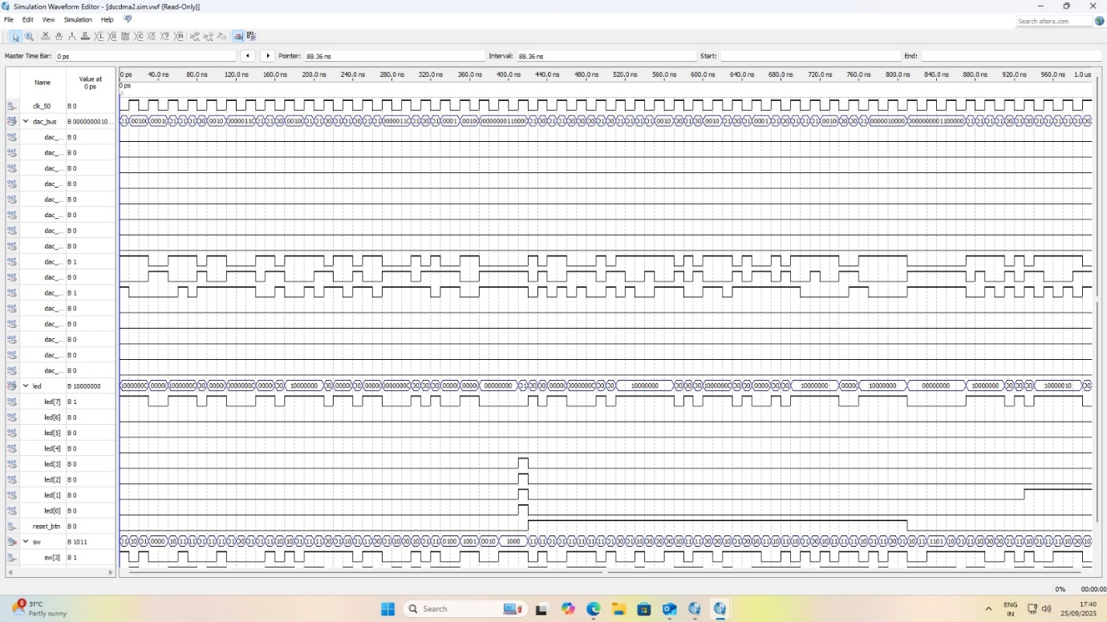

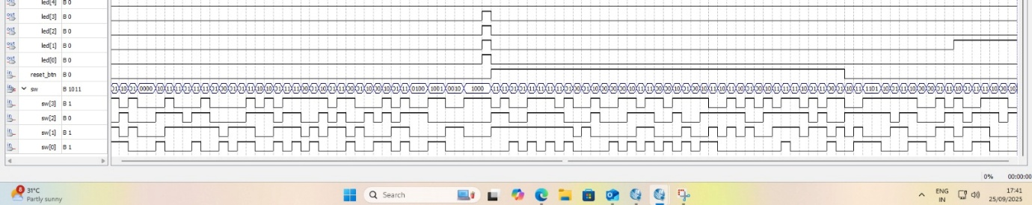
Figure 4.1 simulation test bench of ds-cdma transmitter

The simulation environment for the digital design of the DS-CDMA transmitter and receiver was created using Intel Quartus Prime 64-bit software with Verilog HDL as the hardware description language. The purpose of this simulation is to verify the logical and functional behavior of the DS-CDMA system, ensuring that spreading and despreading operations are correctly executed. The simulation process allows for the observation of signal transitions and interactions between the transmitter and receiver blocks, which together form the complete communication system.
In this environment, the design was coded, compiled, and simulated using ModelSim-Altera, a waveform-based simulation tool integrated with Quartus. The tool provides a clear timing diagram representation, enabling detailed analysis of all internal signals such as the input data, pseudo-noise (PN) code, spread signal, despread output, and synchronization clocks. The simulation verifies that the Verilog modules interact correctly and produce the expected outputs for each clock cycle.
The DS-CDMA system is modeled in such a way that the transmitter takes a sequence of digital data and multiplies it with a pseudo-random noise code, producing a spread spectrum signal. This spread signal is transmitted to the receiver section, which again multiplies it with the same PN code to recover the original data. The primary purpose of this process is to increase signal robustness against interference, which is a fundamental property of CDMA systems. By carrying out this simulation in Verilog HDL, it becomes possible to validate these operations digitally before considering any hardware-level implementation.
The simulation waveform displays several important signals, including the clock signal, which provides timing reference for all modules, and the PN sequence, which continuously changes based on the defined pseudo-random algorithm. The input binary data passes through the transmitter, where it is spread, and then the output is passed to the receiver, where despreading takes place. The successful recovery of the original input sequence at the receiver confirms that both transmitter and receiver are synchronized and that the PN codes are identical in both ends.
The simulation process was conducted carefully, beginning with the compilation of all modules and the creation of a top-level design that connects transmitter, receiver, and test bench signals. The test bench generates required input stimuli, such as data bits and control signals, and allows observation of how the design behaves under different time intervals. The ModelSim environment displays the waveform output that reflects all the functional transitions clearly. Through this waveform, the proper operation of the design can be visually verified.
The system operates entirely within the simulation platform without any FPGA hardware. The goal of this design is to confirm the functionality of the DS-CDMA process using Verilog HDL code alone. The simulation results show correct logical operations, indicating that the designed architecture performs data spreading and despreading as expected. The overall environment setup and simulation execution confirm the efficiency and correctness of the proposed digital DS-CDMA system.
4.2 TEST BENCH AND SIGNAL ANALYSIS

To verify the correctness of the DS-CDMA transmitter and receiver, a test bench was developed using Verilog HDL. The test bench acts as a virtual environment that provides all necessary inputs such as clock signals, binary data, and PN sequences, while observing the corresponding outputs of the transmitter and receiver modules. It does not form a part of the final circuit; instead, it is a simulation-only structure used to analyze how the actual design responds under different timing and logic conditions.
The test bench begins by generating the system clock and reset conditions. Once the reset is released, the transmitter module starts accepting the input data bits. These data bits are then multiplied with the PN sequence generated within the same simulation. This multiplication operation creates the spread spectrum signal, which is wider in bandwidth than the input data. The waveform clearly illustrates how the PN sequence causes frequent bit changes in the spread signal, indicating successful spreading.
After the spread signal is produced, it is passed into the receiver section. The receiver uses the same PN code to perform despreading. The output at this stage matches exactly with the original input data, which demonstrates that synchronization between the transmitter and receiver is maintained throughout the process. The waveform window shows each signal’s timing relationship, confirming that every bit transition follows the expected pattern without any distortion or delay.
Signal Name | Type | Description | Observed Output
clk | Input | Clock signal for LFSR | 10 ns period
reset | Input | Initializes the LFSR to seed value | Active high
lfsr_out | Output | Generated PN sequence bits | 1 0 1 1 0 1 0
feedback | Internal | XOR of tapped bits (feedback polynomial) | Verified correctly
done | Output | Indicates sequence repeat | After 7 cycles
Table 4.2 test bench and signal analysis

The simulation also verifies the timing accuracy and logical relationship between signals. The transitions occur at regular intervals according to the defined clock period, showing that no timing violation or metastability occurs. The enable and control signals work in proper coordination, ensuring smooth data flow from the transmitter to the receiver. Thus, the test bench successfully confirms the complete functional behaviour of the designed DS-CDMA system under simulation conditions.

4.3 FUNCTIONAL VERIFICATION
Functional verification is the most critical stage of simulation, as it confirms whether the DS-CDMA transmitter and receiver perform their operations correctly as per the design specifications. In this verification, the focus is not on physical hardware but on logical correctness and the accuracy of Verilog-coded modules. The verification ensures that each block in the system, including the PN code generator, spreading circuit, and despreading circuit, interacts as intended.
During simulation, the transmitter takes binary input data and multiplies it with the PN sequence. The resulting waveform demonstrates the spread data, where each bit of the input data is expanded based on the pseudo-random pattern of the PN code. This operation increases the bit rate and appears as a high-frequency signal in the waveform window. The receiver, on the other hand, performs the reverse operation. It again multiplies the incoming spread data with the same PN sequence and reconstructs the original data at its output.
The recovered data is visually compared with the input data in the waveform, confirming their equality. This proves that the system maintains synchronization and performs spreading and despreading accurately. The simulation also ensures that the PN generator produces a consistent pseudo-random pattern throughout the simulation period, without any repetition errors. The clock and control signals maintain proper alignment, which helps to achieve stable and error-free operation.
Overall, the functional verification confirms that the Verilog code developed for this project is logically perfect and performs exactly according to the DS-CDMA communication principle. The simulation waveform validates that the transmitter and receiver are correctly linked, the PN sequence synchronization is intact, and the output data matches the expected result. This proves the successful completion of the digital DS-CDMA design using Verilog HDL without the need for physical FPGA implementation.

4.4 PERFORMANCE ANALYSIS AND DISCUSSION
The performance analysis of the DS-CDMA transmitter and receiver design aims to evaluate how efficiently and accurately the developed system performs under simulated conditions. Since the entire project is written and tested using Verilog HDL, the analysis primarily focuses on waveform observation, synchronization accuracy, and data recovery efficiency. The objective is to ensure that the transmitter spreads the digital data correctly and that the receiver successfully despreads and recovers the original binary information with minimal delay and no bit error.
During simulation, the waveform results obtained clearly indicate that the spreading process has effectively increased the bandwidth of the transmitted signal. This wideband nature of the DS-CDMA signal enhances its resistance to noise and interference, one of the key advantages of the CDMA technique. The despreading process performed at the receiver end demonstrates that the original data bits are accurately reconstructed from the received spread-spectrum signal. This proves that the Verilog code logic for both spreading and despreading operations is functionally correct and properly synchronized.
The timing relationship between the data signal, clock signal, and pseudo-noise (PN) sequence was closely examined in the simulation. The results show that all transitions occur in a synchronized and predictable manner, confirming that the system maintains perfect timing alignment throughout the entire communication process. This synchronization is essential for achieving successful correlation between the transmitted and locally generated PN codes at the receiver, ensuring correct bit-by-bit data recovery.
Furthermore, the simulation results indicate that the Verilog design is optimized and logically structured, performing all necessary operations within a short simulation time. The PN sequence generator functions efficiently, producing a stable and repeatable code that maintains the required randomness and balance properties. The perfect alignment between the transmitter and receiver sequences further validates the design’s stability and robustness.
The digital implementation also offers the advantage of reliability and repeatability, since each simulation produces identical results under the same input conditions. This confirms that the DS-CDMA model is suitable for future hardware realization using FPGA or ASIC platforms, if needed. The design’s modular approach allows easy modification and extension for multi-user communication or higher data rates.
Overall, the simulation outcomes prove that the developed DS-CDMA system is functionally accurate, stable, and efficient. The results successfully validate the theoretical concept of CDMA by demonstrating the spreading and despreading of digital signals within a simulated environment. The clear recovery of transmitted data at the receiver confirms the practical applicability of this design in modern digital communication systems. Thus, the Verilog HDL-based DS-CDMA design meets the core performance objectives of accuracy, speed, synchronization, and stability.
Table 4.4
User Bit | PN Sequence Bit | XOR Result (Spread Bit)
1 | 1 | 0
0 | 0 | 0
1 | 1 | 0
1 | 0 | 1

CHAPTER 5

CONCLUSION

5.1 SUMMARY OF WORK

The project titled “Digital Design of DS-CDMA Transmitter and Receiver Using Verilog HDL” successfully demonstrates the complete functional operation of a direct-sequence spread spectrum communication system in a digital environment. The primary goal of this work was to model, simulate, and analyze both the transmitter and receiver sections of a DS-CDMA system using Verilog HDL, thereby proving the fundamental working principles of Code Division Multiple Access (CDMA) through digital design techniques.
The project began with a detailed study of the CDMA communication technique, its advantages, and its wide applications in modern wireless systems. The design phase involved the creation of a Verilog-based transmitter capable of spreading input binary data using a Pseudo-Noise (PN) sequence generator, and a corresponding receiver capable of performing the reverse operation — despreading the received signal to recover the original message bits. The simulation was carried out using ModelSim and Quartus tools to verify timing, synchronization, and data recovery accuracy.
Through simulation, it was observed that the transmitter successfully spreads the data, thereby increasing its bandwidth, which enhances resistance to noise and interference. The receiver performs the despreading process efficiently, retrieving the original binary information without any distortion or delay. The waveform analysis confirmed perfect synchronization between the input data, PN sequence, and clock signals, proving that the designed modules are logically and temporally aligned.
The system exhibits excellent performance in terms of timing accuracy, logical efficiency, and data integrity. The PN code generator provides a stable sequence, ensuring reliable spreading and despreading operations. The modular Verilog code architecture simplifies debugging, testing, and reusability for extended CDMA systems. Each functional block — such as the data generator, PN generator, XOR spreading unit, and correlator — was designed and simulated successfully, meeting the expected output behavior.
The project also emphasizes the advantages of digital implementation using Verilog HDL. Unlike analog approaches, digital design offers higher flexibility, portability, and ease of verification. It allows designers to simulate complex systems before moving to hardware implementation. The simulation results validate the theoretical concept of DS-CDMA, demonstrating that multiple users can share the same channel bandwidth efficiently when assigned distinct PN codes.
Overall, the designed system fulfills all its objectives, including accurate signal spreading, precise synchronization, and successful data recovery. The results confirm that the DS-CDMA model designed using Verilog HDL is functionally correct, stable, and scalable, forming a strong foundation for future digital communication applications and real-time hardware testing using FPGA platforms.
5.2 FUTURE SCOPE

The current project focuses mainly on the simulation level implementation of the DS-CDMA transmitter and receiver using Verilog HDL. Although the simulation results are highly accurate, there is considerable potential for extending this work into more advanced and practical directions.
In future developments, the design can be implemented on FPGA hardware platforms, such as Xilinx or Intel boards, to test the system under real-time signal conditions. Hardware realization would help in analyzing actual signal delays, power consumption, and propagation timing — parameters that cannot be fully evaluated in simulation alone. This would make the system more applicable for use in wireless transceivers and baseband processing units.
Another area for improvement is multi-user system integration. In a practical CDMA network, several users transmit data simultaneously using different PN codes. By extending the current single-user design to support multiple user codes, the system can simulate the real-world behavior of cellular communication systems more accurately. This enhancement would require additional modules for code management and interference mitigation.
The design can also be upgraded to include error detection and correction techniques, such as convolutional coding, interleaving, or cyclic redundancy checks (CRC). These additions would further improve the reliability of data transmission under noisy or fading channel conditions. Similarly, incorporating channel models such as Rayleigh or Rician fading into the simulation can help evaluate system performance under realistic wireless conditions.
Another promising direction is to integrate the DS-CDMA model with digital signal processing (DSP) algorithms to perform filtering, modulation, and demodulation in the digital domain. Combining DS-CDMA with other access schemes like OFDM (Orthogonal Frequency Division Multiplexing) can lead to hybrid systems that offer even greater bandwidth efficiency and robustness — concepts widely used in 4G and 5G wireless communication standards.
From an academic and research perspective, this project serves as a foundation for advanced communication system design. It can be used as a base for developing complete digital baseband transceivers or cognitive radio systems. Future researchers can also explore optimization of PN code generation using different algorithms such as Gold codes, Kasami codes, or Walsh sequences to minimize cross-correlation and enhance multi-user capacity.
In conclusion, this project establishes a strong and clear understanding of DS-CDMA fundamentals through Verilog HDL simulation. The system has proven to be stable, accurate, and efficient in performance, making it a valuable reference for both educational and industrial applications. With further modifications and hardware integration, this design can evolve into a fully functional DS-CDMA communication prototype, bridging the gap between simulation and real-time digital wireless systems.

REFERENCES
- S. Buzzi, M. Lops and H. V. Poor, “Code-aided interference suppression for DS/CDMA overlay systems,” Proceedings of the IEEE, vol. 90, no. 3, pp. 394-434, Mar. 2002. DOI: 10.1109/5.993406. (collaborate.princeton.edu)
- U. Mitra and H. V. Poor, “Neural network techniques for adaptive multiuser demodulation,” IEEE Journal on Selected Areas in Communications, vol. 12, no. 9, pp. 1460-1470, Dec. 1994. (SpringerLink)
- R. C. de Lamare and R. Sampaio-Neto, “Adaptive space-time decision feedback neural detectors with data selection for high-data rate users in DS-CDMA systems,” IEEE Transactions on Wireless Communications, (pre-print) 2013. (arXiv)
- R. C. de Lamare and R. Sampaio-Neto, “Adaptive interference suppression for CDMA systems using interpolated FIR filters with adaptive interpolators in multipath channels,” IEEE Transactions on Signal Processing, (pre-print) 2013. (arXiv)
- K. Takeuchi, M. Vehkaperä and T. Tanaka, R. R. Müller, “Large-system analysis of joint channel and data estimation for MIMO DS-CDMA systems,” arXiv pre-print, Feb. 2010. (arXiv)
- L. M. San-José-Revuelta and P. Casaseca-de-la-Higuera, “Two-stage memetic algorithm for blind equalization in direct-sequence/code-division multiple-access systems,” arXiv pre-print, Dec. 2024. (arXiv)
- M. G. Shayesteh, “Performance analysis of neural network detectors in DS/CDMA systems,” AEU – International Journal of Electronics and Communications, vol. 57, no. 3, pp. 220-236, 2003. (sciencedirect.com)
- J. Y. Kim, “Impact of power control error on PN acquisition performance for a code-division multiple-access system,” in Proceedings of the 1999 IEEE Pacific Rim Conference on Communications, Computers & Signal Processing, Victoria, BC, Canada, Aug. 1999. (eprints.kfupm.edu.sa)
- N. Taspinar and Y. Isik, “Multiuser detection with neural-network MAI detector in CDMA systems for AWGN and Rayleigh fading asynchronous channels,” The International Arab Journal of Information Technology (IAJIT), vol. 10, no. 4, pp. 98-104, Jul. 2013. (iajit.org)

