CHAPTER 1 – INTRODUCTION

  - OVERVIEW OF SMART BAG SYSTEM
The Smart Bag Alert System is a modern innovation that combines Internet of Things (IoT) and embedded system technology to help users avoid the common problem of forgetting essential items. In day-to-day life, people often carry multiple necessary belongings such as ID cards, wallets, keys, or documents. Forgetting even one of these items can cause inconvenience or disrupt planned activities. The proposed system aims to eliminate this issue by providing an automated, intelligent solution that checks the presence of all required items inside a bag and alerts the user in real time.
The system operates using an ESP32 microcontroller integrated with an RFID reader, RFID tags, LED indicator, and push button. Each essential item is labelled with a unique RFID tag that stores its identification data. When the user powers on the bag, the RFID reader scans all the tagged items and sends the collected information to the ESP32. The push button is used to start or stop the scanning process, giving the user control over when the bag should perform item detection. The LED indicator is used to display the system’s health status — where the green light indicates that the system is scanning and functioning properly, while the red light signifies a system fault or malfunction.
If every item is present, the ESP32 confirms that the bag is ready through the LED indication. However, if any item is missing, the ESP32 immediately transmits a real-time notification via the Telegram application using Wi-Fi communication, alerting the user before they leave home.

The Smart Bag Alert System ensures convenience, accuracy, and reliability in everyday use. Its efficient integration of hardware and software showcases the potential of IoT-based automation in simplifying human tasks. Moreover, it demonstrates how low-cost, compact, and energy-efficient embedded systems can be used to develop user-friendly smart solutions for daily life challenges.

  - NEED FOR SMART ALERT SYSTEM
In the fast-paced modern world, individuals often have multiple responsibilities and tasks to manage simultaneously. As a result, people tend to forget carrying essential items when they leave for work, college, or travel. Such situations can lead to loss of time, unnecessary stress, missed opportunities, or security risks. For instance, forgetting an office ID card may prevent access to workplace facilities, while leaving behind a wallet or key can create serious inconvenience.
A Smart Alert System is therefore highly necessary to overcome this everyday problem through automation and intelligence. The Smart Bag Alert System plays a crucial role in ensuring that all important belongings are verified automatically without manual effort. By integrating RFID and IoT technologies, the system efficiently scans and identifies each tagged item inside the bag. If any item is not detected, it alerts the user instantly through a Telegram message on their smartphone. This eliminates human error, enhances preparedness, and saves valuable time.
Additionally, this system is not limited to personal use; it can also be applied in educational institutions, corporate environments, and travel management systems to ensure safety and accountability of essential materials. It promotes a smart lifestyle, reflecting the growing influence of IoT in transforming daily human activities into more organized, efficient, and reliable processes.
In short, the need for this system arises from the demand for automation, accuracy, and convenience in modern living. It demonstrates how technology can assist humans in achieving a more secure, connected, and stress-free lifestyle.

1.3 OBJECTIVE OF THE PROJECT
The primary objective of the Smart Bag Alert System is to design and implement an intelligent bag that can automatically detect the presence or absence of essential items using RFID and IoT technologies. The system aims to create a user-friendly, compact, and cost-effective solution that ensures users never forget their necessary belongings.
The major objectives of this project are:
- To design an automated bag system that verifies the presence of items using RFID tags and an ESP32 microcontroller.
- To enable real-time communication between the system and the user through Wi-Fi and the Telegram application.
- To develop a reliable alert mechanism that notifies users instantly when any item is missing.
- To integrate an LED indicator that visually displays the system’s operational status and readiness.
- To provide manual control through a push button for scanning, resetting, or re-verifying items.
- To ensure efficient data comparison and decision-making through embedded programming on the ESP32.
- To minimize human error and enhance user convenience using smart technology.
- To demonstrate the application of embedded systems, IoT, and automation in real-world daily life.
- To develop a prototype that can be further expanded for commercial smart luggage applications.

1.4 APPLICATION OF SMART BAG SYSTEM
1. For Students:
Students often carry several items such as notebooks, ID cards, and stationery. This system helps them ensure that all required materials are inside their bag before leaving for school or college. If anything is missing, a Telegram alert is sent immediately.
2. For Office Employees:
Professionals who carry files, ID cards, or electronic devices can use this system to prevent leaving important items behind. The Smart Bag checks all tagged objects automatically, reducing last-minute confusion and improving work efficiency.
3. For Travelers:
Travelers can use the system to confirm that their essential documents such as passports, tickets, and wallets are inside the bag before starting a journey. It adds an extra layer of safety and peace of mind while traveling.
4. For Elderly People:
The system is useful for elderly individuals who may forget to carry medicines, keys, or mobile phones. The alert notification helps them stay reminded of their important belongings.
5. In Educational and Corporate Institutions:
The system can be implemented in educational institutions or companies where RFID-based identification is already used. It ensures the availability of authorized materials or devices in designated areas.

1.5 CONCLUSION
The Smart Bag Alert System is a simple and effective solution to help users avoid forgetting important items in their bags. The system uses an RFID reader, RFID tags, and an ESP32 microcontroller to check the presence of all essential items. When any item is missing, a Telegram alert is sent instantly to the user’s smartphone.
An LED indicator is used to show that the system is active and working properly, while a push button allows the user to manually start or reset the scanning process. The project is easy to use, reliable, and cost-effective, making it suitable for students, office workers, and travelers.
This project demonstrates how IoT and Embedded Systems can improve daily life by automating small but important tasks. In the future, features like GPS tracking or mobile app integration can be added to make the system even smarter and more useful.

CHAPTER 2 – LITERATURE REVIEW
The literature review helps to understand the previous research and existing technologies related to RFID, IoT, and alert-based systems. Several studies have been carried out in this field, and their findings are summarized below.

2.1 LITERATURE REVIEW SUMMARY
R. Kumar et al. (2022) developed an RFID-Based Smart Bag Monitoring System using an RFID reader and microcontroller to detect missing items through RFID scanning. The system displayed alerts on a local screen. It reduced manual checking but lacked internet connectivity for remote alerts.
S. Gupta and A. Mehta (2023) designed an IoT-Based Object Tracking System using ESP32 with Wi-Fi for real-time monitoring. Data were transferred to IoT platforms for remote access. This system proved reliable for continuous tracking and smart data management.
M. Rahman et al. (2021) proposed a Smart School Bag Using Arduino with RFID tags to remind students about missing items. A buzzer alert was used for notification. It was simple and effective but limited to local operation only.
P. Singh (2022) implemented a Telegram-Based IoT Alert System using ESP32 and Telegram cloud for instant mobile alerts. The system enabled cloud-based notifications and improved user interaction. It served as a strong base for modern IoT alert systems.

2.2 SUMMARY
From the above studies, it is observed that RFID and IoT-based technologies are widely used for object tracking and automation. Most systems use RFID for detection and microcontrollers like ESP32 or NodeMCU for control. However, many existing works focus only on buzzer alerts or local displays, which limit the range and efficiency of communication. In this project, the Smart Bag Alert System introduces a more advanced approach by integrating Telegram messaging for real-time notifications. This feature allows users to receive instant alerts on their smartphones, even when they are away from the bag, making the system highly responsive and convenient. The use of IoT-based communication ensures seamless connectivity, reliability, and ease of use.
In addition, the system provides enhanced user interaction through a push-button mechanism that enables manual start or stop of the scanning process. A dedicated LED indicator ensures system health monitoring, allowing the user to verify the proper functioning of the device. The compact and lightweight design makes it ideal for daily use by students and professionals. Moreover, the system’s architecture can be easily expanded to include GPS tracking or cloud data logging in future versions. The integration of Telegram API eliminates the need for third-party apps, ensuring fast and secure message delivery. By automating item detection and notification, this project reduces human error and enhances convenience. Overall, the Smart Bag Alert System represents a practical, cost-effective, and intelligent solution that bridges the gap between conventional alert systems and modern IoT-enabled smart devices.
Furthermore, the proposed system promotes smart living by combining automation with user-friendly features. It can be customized for school, office, or travel applications with minimal hardware modification.
CHAPTER 3 – EXISTING SMART BAG FRAMEWORK AND ITS CHALLENGES
3.1 EXISTING SYSTEM
In earlier systems, most alert mechanisms were designed with basic hardware components such as RFID readers, buzzers, and simple microcontrollers. When an item was missing, the system produced a buzzer sound or LED indication as a local alert. While this method served its purpose, it required the user to be physically near the bag to notice the alert.
So12me projects used LCD displays to show which items were missing, while others stored item data temporarily in the controller’s memory. These systems worked only within a limited range and did not have the ability to communicate with the user remotely. As a result, if the user left home or office without an important item, the system could not send any notification once they moved away from the bag.
Although these traditional systems were simple and functional, they lacked real-time connectivity, automation, and intelligence. In today’s fast-moving world, users expect smarter devices that can communicate with them directly through their smartphones. The existing models failed to meet these expectations due to their dependency on local alerts and non-networked operation.

3.2 DRAWBACKS
The existing alert systems suffer from several limitations that reduce their efficiency and user convenience. Firstly, these systems operate only within a short range, which means users cannot receive alerts once they move away from the detection area. Secondly, the output indicators such as buzzers and LEDs may go unnoticed in noisy surroundings or under bright lighting conditions, thereby reducing the reliability of alerts.
Moreover, the absence of internet connectivity restricts the system from sending real-time notifications to the user’s smartphone or other devices. This makes the design less adaptable to modern IoT-based applications. Additionally, the system is not scalable or user-interactive, which limits its scope for future enhancements. Finally, the lack of data communication and intelligent control features results in poor flexibility and reduced automation capability.0
Overall, these drawbacks highlight the need for an advanced, IoT-enabled alert system that ensures real-time communication, better user interaction, and improved performance under different environmental conditions.
In contrast, the proposed Smart Bag Alert System using Telegram Notification overcomes all these limitations. It uses RFID technology for accurate item detection and the ESP32 microcontroller with Wi-Fi for cloud-based communication. Unlike older systems, it sends an instant message alert via Telegram whenever an item is missing — no matter where the user is.
This makes the system modern, smart, and user-friendly, bridging the gap between hardware automation and real-time IoT communication. It transforms a simple idea into a reliable everyday companion that ensures the user never forgets their essentials again.

CHAPTER 4 - PROPOSED SYSTEM

4.1 BLOCK DIAGRAM OF SMART BAG SYSTEM
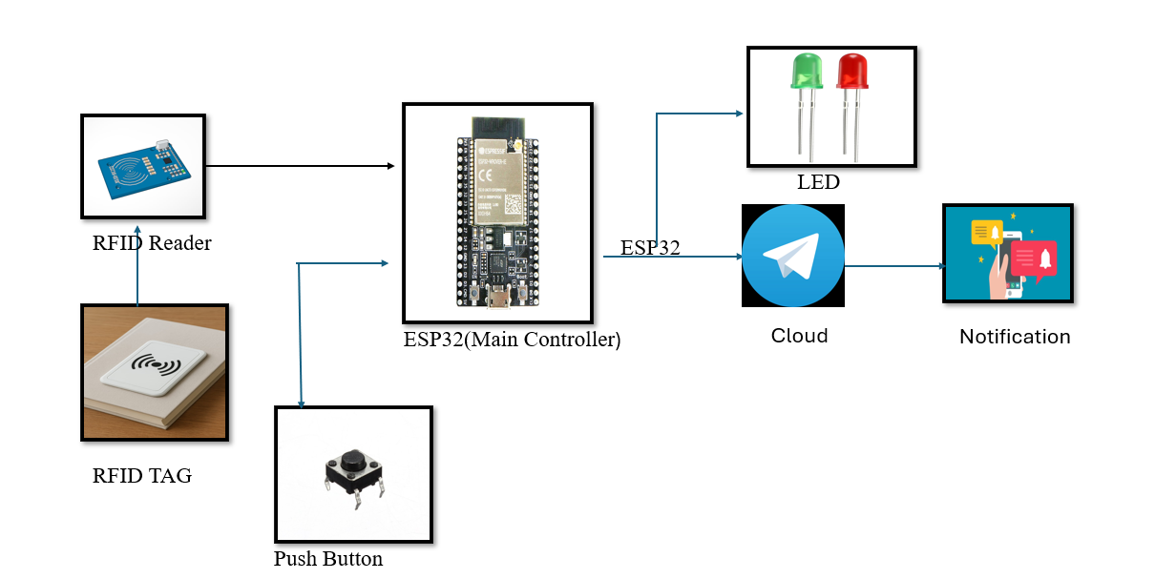
Figure 4.1
The proposed Smart Bag Alert System is an IoT-based solution designed to ensure that users never forget their essential belongings. It integrates RFID technology with the ESP32 microcontroller and a Telegram cloud platform to provide instant alert notifications. Whenever the user prepares to leave, the system scans all pre-registered items inside the bag using RFID tags. If any item is found missing, a real-time alert is sent to the user’s smartphone via Telegram, making the system more efficient and user-friendly than traditional reminder methods.
The system uses a push button to start or stop the scanning process, giving the user manual control over the operation. An LED indicator is included to display the system’s health status, ensuring smooth operation and easy monitoring. The cloud-based connectivity enables users to receive alerts even when they are away from the bag, providing greater flexibility and convenience. This smart design minimizes human error, supports daily routines such as work, study, or travel, and can be enhanced in the future with features like GPS tracking or mobile app integration for advanced functionality.

4.2 WORKING PRINCIPLE
The Smart Bag Alert System using Telegram Notification works based on the integration of RFID technology, an ESP32 microcontroller, and cloud-based communication through Telegram. The main aim of this system is to prevent users from forgetting their essential belongings, such as ID cards, wallets, or keys, when leaving a place. This is achieved by automatically identifying the presence of items and sending a real-time alert to the user’s smartphone if any item is missing.
Each item that the user wants to track is attached with an RFID tag, which stores a unique identification number. Inside the smart bag, an RFID reader is placed to scan and read these tags whenever the user initiates the process. The ESP32 microcontroller serves as the central processing unit, responsible for receiving data from the RFID reader and verifying the presence of all required items.
When the user presses the push button, the system becomes active. The RFID reader starts scanning for all the registered tags within its range. The ESP32 then compares the detected tag IDs with the pre-stored IDs in its memory. If every registered item is detected, it means that all the essential belongings are inside the bag.

During this process, the LED indicator plays two roles:
1. It acts as a system health indicator — when the device is powered ON and connected to Wi-Fi successfully, the LED briefly glows blue or green, showing that the system is active and working properly.
2. It also serves as a status indicator — if all items are found, the green LED glows continuously, confirming that everything is in place. If any registered tag is missing, the red LED turns ON, warning the user visually that something is left out.
In the case of missing items, the ESP32 immediately connects to the internet via Wi-Fi and uses the Telegram Bot API to send a real-time notification message to the user’s Telegram account. This message clearly indicates which item (based on tag ID or name) is missing from the bag. The user can then quickly check and ensure all their belongings are packed before leaving.
This entire operation runs efficiently and consumes minimal power, making it ideal for portable use. The Telegram-based alert system provides better reliability and instant communication compared to older methods like Blynk or SMS.
Overall, the working principle of the Smart Bag Alert System combines RFID detection, Wi-Fi connectivity, and Telegram cloud alerts to create a smart, interactive, and dependable solution. The inclusion of the LED for system health monitoring ensures that users are aware when the device is active and functioning properly, enhancing both safety and convenience in daily life.

4.3 - ADVANTAGE OF THE PROPOSED SYSTEM
The proposed Smart Bag Alert System using Telegram Notification has several advantages that make it reliable, efficient, and user-friendly. The system provides real-time alerts through the Telegram application whenever an item is missing, allowing the user to take immediate action and avoid forgetting essential belongings. The use of Telegram Cloud ensures faster and more secure message delivery compared to traditional communication methods.
The system includes an LED indicator that displays the health and status of the device. It helps the user easily identify whether the system is functioning correctly and connected to Wi-Fi. The push button is used to start or stop the scanning process, giving users manual control over when the system should check for the items inside the bag. This makes operation simple and convenient, as all functions can be managed with a single button — even by users with no technical knowledge.
In addition, the system consumes very low power, making it suitable for continuous and portable use. The components such as the ESP32, RFID reader, and LEDs are compact, lightweight, and affordable, ensuring a cost-effective and space-efficient design.
Overall, the Smart Bag Alert System offers a smart, practical, and energy-efficient solution for daily life. It improves user safety, convenience, and reliability by automatically reminding users about their essential items before leaving home.

CHAPTER 5 – HARDWARE DESCRIPTION

5.1 ESP32 MICROCONTROLLER

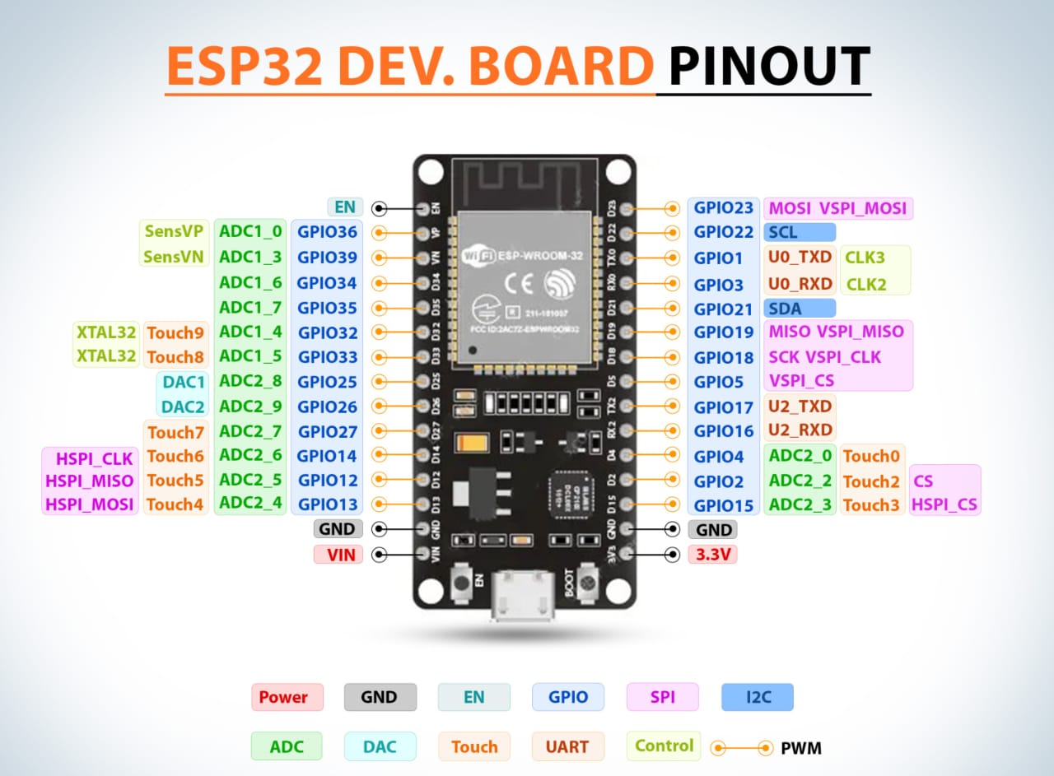
Figure 5.1
The ESP32 is a powerful, low-cost, and energy-efficient microcontroller designed for Internet of Things (IoT) and embedded applications. It is developed by Espressif Systems and has become one of the most popular choices among developers due to its integrated Wi-Fi and Bluetooth connectivity, high processing capability, and flexibility for various automation and communication projects. The ESP32 combines both microcontroller and wireless transceiver functions on a single chip, significantly reducing the need for external components and ensuring compact system design.
In this project, the ESP32 acts as the main control unit of the Smart Bag Alert System. It interfaces with the RFID reader to detect the presence of tagged items inside the bag, processes the received data, and sends instant alert messages to the user through the Telegram cloud using the internet connection. This integration of communication and control into a single platform makes the ESP32 an ideal choice for real-time IoT-based applications.
The ESP32 is built with a dual-core Tensilica LX6 processor running at speeds up to 240 MHz, offering excellent multitasking capabilities. This allows one core to handle system-level operations while the other manages user applications, resulting in smooth and efficient performance. It also features 520 KB of internal SRAM and can support external flash memory, enabling storage of large programs and data logs.
Another important advantage of the ESP32 is its wide range of peripheral interfaces, including GPIO (General Purpose Input/Output) pins, ADC (Analog to Digital Converter), DAC (Digital to Analog Converter), SPI (Serial Peripheral Interface), I2C (Inter-Integrated Circuit), and UART (Universal Asynchronous Receiver-Transmitter). These interfaces allow the ESP32 to connect easily with various sensors, actuators, and communication modules. In this project, the GPIO pins are used to interface the LED indicator and push button, while the serial communication pins (UART) are utilized to interface with the RFID reader.
One of the most significant features of the ESP32 is its built-in Wi-Fi transceiver, which allows it to connect directly to the internet or a local wireless network without requiring additional hardware. This feature is critical in the Smart Bag Alert System since it enables real-time communication between the microcontroller and the Telegram cloud platform. As a result, users can receive instant notifications about missing items on their smartphones from anywhere, even if they are far from the bag.
The Bluetooth (Classic and BLE) capability of ESP32 further enhances its versatility. This feature can be utilized in future versions of the project for short-range wireless communication between the bag and nearby smart devices, such as smartphones or smartwatches. This ensures scalability and opens up opportunities for integrating multiple smart functions into a single device.
Programming the ESP32 is user-friendly and can be done using the Arduino IDE, which supports a wide range of libraries and examples. The open-source environment makes it easy for developers to upload, debug, and modify programs as per project requirements. The Wi-FiClientSecure library and HTTPClient are typically used for establishing secure communication with cloud platforms like Telegram. Additionally, its compatibility with the ESP-IDF (Espressif IoT Development Framework) allows advanced users to perform professional-level programming and customize system operations.
In terms of power efficiency, the ESP32 supports multiple power modes such as Active Mode, Modem Sleep, Light Sleep, and Deep Sleep. These modes help reduce energy consumption, which is crucial for portable or battery-operated devices like the Smart Bag. By using appropriate sleep modes, the system can conserve battery power when not actively scanning, thereby extending its operational lifetime.
The ESP32 also features enhanced security mechanisms, including hardware encryption (AES, SHA, RSA, and ECC), secure boot, and flash encryption, which help protect data during cloud communication. This ensures that sensitive information such as user data and item tracking details remain secure from unauthorized access.
Moreover, the ESP32’s robust design and stable performance make it suitable for environments that require continuous operation. It can handle multiple tasks simultaneously—such as reading RFID data, monitoring system health through LED indicators, and managing communication with the Telegram server—without affecting response speed. The microcontroller’s interrupt handling and real-time event management capabilities also make it reliable for time-critical applications.
Another key advantage of using the ESP32 in this system is its compact size and cost-effectiveness. The module can be easily embedded into the Smart Bag without increasing its weight or complexity. The affordability of the ESP32 also makes the overall system economical, providing a high-performance solution at a low cost, which is ideal for student and commercial IoT projects.
In summary, the ESP32 serves as the central processing and communication unit of the Smart Bag Alert System. It efficiently manages data collection from the RFID reader, processes information, and sends real-time notifications through the Telegram application. Its advanced features such as integrated Wi-Fi and Bluetooth, multi-core processing, multiple interfacing options, and power-saving modes make it a highly suitable microcontroller for IoT-based automation systems. Thus, the inclusion of the ESP32 significantly enhances the system’s performance, scalability, and overall reliability, making it a perfect choice for implementing smart, connected, and user-friendly applications.

5.2 RFID READER AND TAG
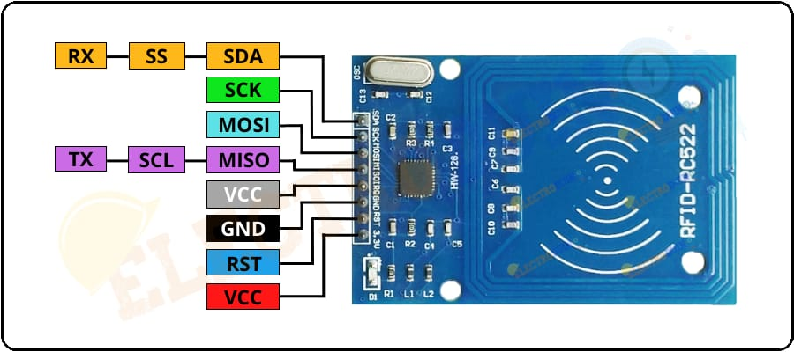
Figure 5.2

The RFID Reader (RC522) and RFID Tags form the core of the identification and tracking process in the Smart Bag Alert System. The RC522 reader module operates at a frequency of 13.56 MHz and uses the SPI communication protocol to interface efficiently with the ESP32 microcontroller. Each RFID tag is embedded with a Unique Identification Number (UID) that enables the system to recognize and differentiate between various essential items placed inside the bag.
When the user presses the push button, the system is activated, and the RFID reader begins scanning the surrounding area for any registered RFID tags. The detected tag IDs are then compared with the pre-stored database in the ESP32’s memory. If any tag is not detected, the system immediately identifies the missing item and triggers both a visual alert through an LED indicator and a real-time notification via the Telegram application.
This mechanism ensures accurate, contactless, and automatic detection of items without the need for manual checking. The RFID-based approach also minimizes human error, enhances user convenience, and operates effectively even in low-light conditions. Moreover, the system can support multiple RFID tags simultaneously, ensuring scalability for various applications such as student bags, office kits, or travel luggage.
The compact size and low power consumption of the RC522 make it ideal for portable IoT applications, while its reliable detection range and high-speed data transfer contribute to faster identification and real-time response. This integration of RFID with IoT technology offers a smart, efficient, and user-friendly solution for everyday tracking and alert systems.
.

CHAPTER 6- SOFTWARE DESIGN AND IMPLEMENTATION

6.1 ARDUINO PROGRAMMING
The Arduino (ESP32) program serves as the brain of the Smart Bag Alert System, managing all processes from tag detection to alert transmission. It detects RFID tags, verifies the presence of each item, and sends instant alerts through the Telegram cloud when an item is missing. Each essential object, such as a Maths book or Science book, is assigned a unique RFID tag ID, allowing the system to accurately identify individual items. The ESP32 continuously communicates with the RFID reader to scan and update the status of the tags in real-time.
When all tags are successfully detected, the green LED glows steadily to indicate that the system is functioning properly and all required items are present. However, if any tag is not detected, the red LED starts blinking to notify that one or more items are missing. The blinking frequency is programmed to vary depending on the number of missing items, providing a clear visual indication to the user.
The code is designed with non-blocking timing control using the millis() function, ensuring real-time response without interrupting other operations. It efficiently manages Wi-Fi connectivity and Telegram Bot communication, ensuring that messages are sent instantly and only when necessary, thus avoiding message spamming. The system also includes error-handling routines to manage connection failures and automatically attempt reconnection to maintain stability.
Additionally, the program is optimized for low power consumption, making it ideal for portable and battery-operated applications. The modular coding structure enhances readability and allows easy future upgrades, such as adding more RFID tags or integrating a buzzer or mobile app interface. Overall, the ESP32 program ensures fast, reliable, and intelligent control for the Smart Bag Alert System, providing an efficient and user-friendly IoT-based solution for everyday us

6.2 TELEGRAM ALERT CONGIFURATION
The Telegram alert system is configured using the Telegram Bot API, which enables the ESP32 microcontroller to send instant messages to the user via the internet. This integration of IoT with a cloud-based messaging platform makes the communication process faster, smarter, and more reliable. The setup begins by creating a dedicated bot using BotFather, a special tool in Telegram used to generate new bots and manage their permissions. Once the bot is created, a unique bot token is obtained, which serves as the authentication key for communication between the ESP32 and the Telegram server.
Next, the user’s chat ID is linked to the bot, allowing the system to deliver personalized notifications directly to the respective user. The ESP32 uses its inbuilt Wi-Fi connectivity to establish a secure connection with the Telegram cloud and transmit data whenever an alert condition occurs.
When the RFID reader detects that any registered item is missing from the bag, the ESP32 immediately processes the data and sends a clear and specific message to the user through Telegram, such as:
💬 “Your Maths book is missing from your bag.”
💬 “Your Science book is missing from your bag.”
💬 “Alert! Both books are missing from your bag.”
These notifications are designed to be short, clear, and easy to understand, ensuring that users can take quick action without confusion. To avoid unnecessary alerts, the system is programmed to remain silent when all tagged items are present. In such cases, the green LED indicator glows steadily, confirming that the system is healthy and the bag is fully packed with all required items.
The Telegram-based alert system offers several advantages over traditional buzzer or LED-only alert systems. It provides real-time communication, allowing the user to stay informed even when away from the bag. The notifications are instant, reliable, and secure, as they are transmitted through encrypted Telegram servers, ensuring the privacy and integrity of the messages.
Furthermore, this configuration supports multi-device access, meaning users can receive alerts not only on their smartphones but also on tablets or desktop versions of Telegram. This makes the system flexible and suitable for a wide range of users. The integration also demonstrates how IoT and cloud services can work together to create practical, user-friendly solutions for everyday problems.
In summary, the Telegram Alert Configuration forms the core communication module of the Smart Bag Alert System. It transforms the project from a simple RFID-based setup into a modern IoT-enabled smart solution, capable of real-time monitoring, instant alerts, and intelligent communication. This approach showcases how technology can effectively assist students in maintaining organization, reducing the chances of losing study materials, and building a more disciplined, tech-driven learning routine.

CHAPTER 7- RESULT AND DISCUSSION

7.1 HARDWARE AND PROTOTYPE
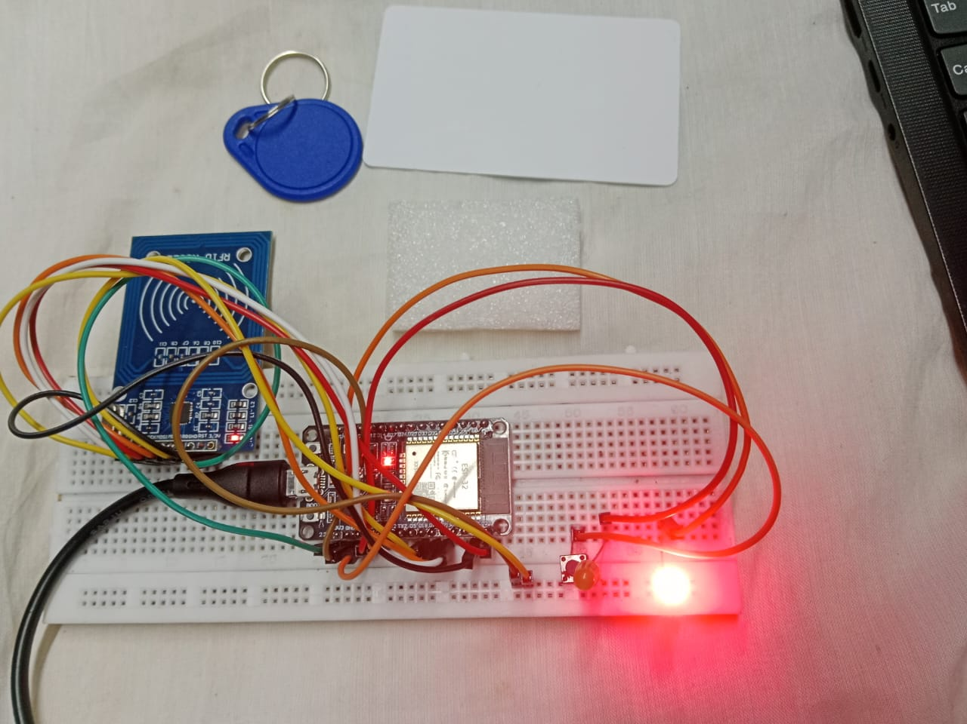
Figure 7.1
Implementation and Testing
The Smart Bag Alert System prototype was successfully designed and implemented using ESP32, RFID reader and tags, LED indicator, push button, and a regulated power supply unit. The ESP32 microcontroller serves as the main control unit, managing data from the RFID module, controlling the LED indicator, and handling cloud communication through Telegram using its built-in Wi-Fi. The ESP32 was programmed using the Arduino IDE, ensuring compatibility with both the RFID and Wi-Fi libraries. Its dual-core processor allowed smooth parallel execution of tag detection and message communication tasks.
The RFID reader detects the presence of items tagged with unique RFID tags attached to essential belongings such as books, wallets, or ID cards. Each tag’s unique identification number is pre-stored in the ESP32 memory. When powered on, the RFID reader scans all nearby tags and sends the detected data to the ESP32, which compares them with the stored list to determine whether all required items are present or missing. This comparison process happens in real-time, ensuring immediate feedback to the user. The system can easily be expanded to include more tags if required, providing flexibility for different user needs.
The system uses a push button to start and stop the scanning process. When the user presses the button, the system begins checking all tagged items; pressing it again halts the operation. This manual control allows the user to manage scanning as needed, reducing power consumption and providing greater convenience. The LED indicator is used to display the system’s health status — the green LED glows steadily when the system is functioning properly and connected to Wi-Fi, while the red LED indicates system damage or an unhealthy condition. A short blinking pattern is also used to indicate scanning in progress, making it easy for users to identify the current operation mode.
The prototype circuit was first assembled on a breadboard for initial testing and later transferred to a compact prototype board for a neat, portable setup. All components were securely connected, ensuring proper data communication and stable power supply. The 5V DC regulated power source provided consistent operation during the entire testing phase. The overall design emphasized minimal power usage, making it suitable for integration into everyday school or travel bags. A protective casing was also designed to safeguard the electronic components from external damage or accidental contact.
During performance testing, the system showed fast tag detection, stable Wi-Fi connectivity, and instant Telegram notifications whenever an item was missing. The LED indicator and push button performed their intended functions accurately, and the ESP32 maintained reliable communication throughout the process. The Telegram alert system displayed messages such as “Item Missing: Notebook” or “All Items Present,” ensuring clarity and real-time feedback for the user. The overall system response time was observed to be less than three seconds, indicating efficient data handling and network performance. Overall, the prototype achieved its main goal of real-time item monitoring and user alert, proving to be efficient, compact, and user-friendly for smart bag applications.
7.2 OUTPUT SNAPSHOTS AND TESTING

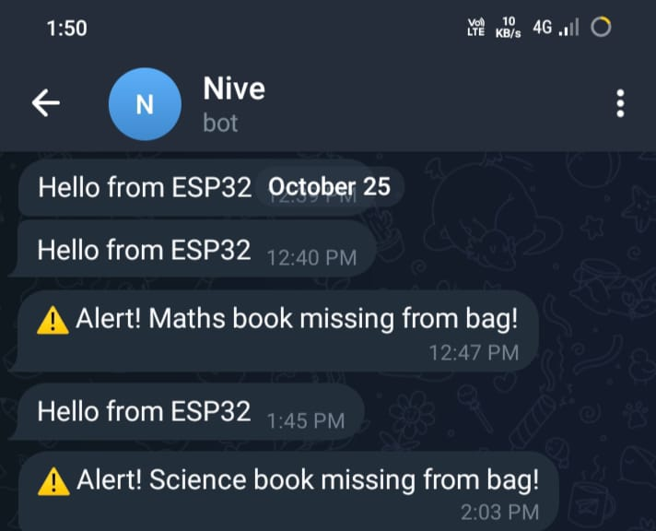

The performance of the Smart Bag Alert System was tested under various conditions to ensure reliability and real-time operation. The system was powered on, and Wi-Fi was successfully connected. The RFID reader continuously scanned for tags, and the LEDs indicated the system’s working condition.
TEST CASE 1 – ALL ITEMS PRESENT:
When both the Maths and Science book tags were detected, the green LED turned ON, showing that the system was healthy. No Telegram message was sent during this condition to avoid unnecessary notifications.
TEST CASE 2 – ONE ITEM MISSING:
When one RFID tag (for example, the Maths book) was removed, the red LED started blinking slowly. The ESP32 immediately sent a message through Telegram:
💬 “Your Maths book is missing from your bag.”
TEST CASE 3 – BOTH ITEMS MISSING:
When both RFID tags were removed, the red LED blinked rapidly, and the Telegram message displayed:
⚠ “Alert! Both books are missing from your bag.”
TEST CASE 4 – ITEMS PLACED BACK:
When the tags were placed back near the RFID reader, the LED automatically returned to green, indicating a healthy system.
These observations prove that the system can accurately detect missing items and send instant alerts through Telegram. The Telegram messages were clear, quick, and easy to read. The system was tested multiple times, and it maintained consistent performance without false triggers.
The testing results demonstrate that the Smart Bag Alert System works effectively for daily life usage. It is highly reliable for students or professionals who frequently carry important items and tend to forget them. The combination of RFID technology and Telegram cloud notification makes this project both innovative and practical.

CHAPTER 8 - CONCLUSION AND FUTURE SCOPE

8.1 CONCLUSION
The Smart Bag Alert System using Telegram Notification has been successfully designed, developed, and tested to address one of the most common challenges faced by students — forgetting or misplacing essential items such as books, ID cards, or stationery. By integrating RFID technology with IoT-based communication, the system provides an innovative and automated solution for item tracking inside a bag. The ESP32 microcontroller functions as the central processing unit, effectively coordinating data transfer between the RFID reader, RFID tags, and the Telegram cloud, thereby ensuring that real-time alerts reach the user’s smartphone without delay.
During the prototype testing phase, the system exhibited high accuracy and reliability in identifying items and detecting missing components. The RFID reader successfully scanned the tags even in short-range and dynamic conditions, while the ESP32 efficiently processed and compared tag IDs with pre-stored data. Whenever an item was found missing, the system triggered a red LED alert and immediately sent a Telegram notification to the user. The push button provided manual control for starting or stopping the scanning process, while the green LED served as a system health indicator, confirming that all items were present and the system was functioning normally.
The project demonstrates an effective integration of hardware and software into a compact, low-cost, and power-efficient prototype. It highlights the potential of IoT in everyday applications and promotes a smart, organized, and technology-driven lifestyle for students. The system’s ability to provide instant feedback, real-time alerts, and user-friendly operation makes it a practical solution for daily use.
In addition, the project encourages the use of automation in the education sector, supporting digital learning environments and minimizing manual efforts. The scalability of the design allows for the integration of additional features such as GPS tracking, buzzer or voice alerts, mobile app control, and cloud-based data logging to enhance system functionality. With future improvements, the Smart Bag can evolve into an intelligent personal assistant that not only tracks items but also reminds users about schedules, assignments, or upcoming events.
In conclusion, the Smart Bag Alert System is a successful demonstration of how embedded systems and IoT can combine to create smart educational accessories that improve both convenience and security. This innovation marks a significant step toward developing intelligent, connected, and sustainable solutions for modern-day challenges, reinforcing the growing impact of IoT in personal and educational domains.

8.2 FUTURE SCOPE
The Smart Bag Alert System using Telegram Notification has immense potential for future development and can be transformed into a more advanced and intelligent version with the integration of additional smart features. The current system effectively detects the presence of items inside the bag and provides instant alerts through the Telegram application. However, by incorporating modern sensors and technologies, the system can evolve into a complete smart student companion that enhances both security and convenience.
In the future, GPS tracking can be integrated to locate the bag if it is lost or misplaced. This feature will allow users or parents to track the bag’s location in real-time through a mobile application, ensuring higher safety and recovery in case of theft. Similarly, voice alerts or custom mobile notifications can be added for better user interaction, making the system more intuitive and responsive.
Another important improvement is the inclusion of a battery health monitoring system, which will help in maintaining the efficiency and longevity of the device. By monitoring the power status, users can ensure uninterrupted operation without the risk of sudden shutdowns. The system can also be connected to school or parent applications for attendance tracking, daily activity updates, and safety monitoring, providing an advanced level of connectivity between students, parents, and institutions.
In addition, AI-based item recognition can be introduced to automatically identify different books, notebooks, and stationery items, eliminating the need for manual tagging. This will make the system more flexible and intelligent in real-world usage
Furthermore, future versions of the system can include a water sensor to detect if water is poured inside the bag, helping to protect valuable items such as books, electronics, or documents from getting damaged. A smell sensor can also be added to identify any unpleasant odors or spoiled food items inside the bag, alerting the user to clean or remove them promptly.
With these future enhancements, the Smart Bag Alert System can evolve into an all-in-one intelligent companion for students — improving safety, hygiene, and daily organization while promoting the integration of IoT and AI in education.

APPENDIX

A 1.1 SPECIFICATION OF ESP32 MICROCONTROLLER

PARAMETER | SPECIFICATION
Microcontroller | Tensilica Xtensa Dual-Core 32-bit LX6
Operating Voltage | 3.0V to 3.6V (typically 3.3V)
Flash Memory | 4 MB (external)
SRAM | 520 KB
Clock Frequency | Up to 240 MHz
Wi-Fi Standard | 802.11 b/g/n
Bluetooth | Bluetooth v4.2 BR/EDR and BLE
GPIO Pins | 30 (configurable for input/output functions)
Communication Interfaces | UART, SPI, I2C, I2S, PWM, ADC, DAC
Operating Temperature | –40°C to +125°C
Programming Platform | Arduino IDE / MicroPython / ESP-IDF

A 1.2 SPECIFICATION OF RFID READER AND TAGS

PARAMETER | SPECIFICATION
Module Name | RC522 RFID Reader
Operating Voltage | 3.3V
Operating Frequency | 13.56 MHz
Communication Interface | SPI / I2C / UART
Reading Distance | 2 cm – 5 cm
Supported Tags | ISO/IEC 14443A standard (MIFARE cards and tags)
Data Transfer Rate | Up to 10 Mbps
Antenna Type | Integrated PCB antenna
Tag Type Used | Passive RFID tag (13.56 MHz)
Tag Memory Capacity | 1 KB (for MIFARE Classic 1K)
Applications | Access control, identification, and inventory tracking

REFERENCES

- Sharma, R. Gupta, and P. Singh, “IoT-Based Smart School Bag for Safety and Tracking System,” International Journal of Innovative Research in Computer and Communication Engineering, Vol. 9, No. 3, pp. 1250–1255, 2023.
- K. Ramesh and S. Kumar, “Design and Implementation of RFID-Based Smart Bag Tracking System,” IEEE International Conference on Internet of Things (IoT), 2022, pp. 89–93.
- M. Priya, D. R. Babu, “ESP32 Microcontroller for IoT Applications,” International Journal of Advanced Research in Electronics and Communication Engineering, Vol. 10, No. 6, 2022.
- S. N. Patil and A. S. Deshmukh, “Telegram Bot Integration for IoT Notifications,” Proceedings of the International Conference on Smart Systems and IoT, 2021.
- ESP32 Technical Reference Manual, Espressos Systems, 2023.
[Online Available: https://www.espressif.com/en/products/socs/esp32/documentation]
- MFRC522 RFID Reader Module Datasheet, NXP Semiconductors, 2024.
[Online Available: https://www.nxp.com/docs/en/data-sheet/MFRC522.pdf]
Here are additional updated references that you can include in your project report:
- Bhavadharani M., Evelyn David, Harishma D., Dr. N. Anita, “IoT-Based Smart Bag with Image Recognition for Automated Luggage Item Tracking,” International Journal of Engineering Research & Technology (IJERT), Vol. 14, Issue 04 (April 2025). (IJERT)
- Pankaj D. Baviskar, Rohan Lahuraj Salunkhe, “Real-Time Asset Tracking and Management: A Novel Framework Using IoT, RFID, and AI,” ISJEM Journal, June 2025. (Isjem)
- Tiago M. Fernández-Caramés, Paula Fraga-Lamas, Manuel Suárez-Albela, Luis Castedo, “Reverse Engineering and Security Evaluation of Commercial Tags for RFID-Based IoT Applications,” arXiv preprint, Feb. 2024. (arXiv)
- Angel Niebla-Montero, Ivan Froiz-Miguez, Paula Fraga-Lamas, Tiago M. Fernández-Caramés, “Practical Evaluation of Wize and Bluetooth 5 Assisted RFID for an Opportunistic Vehicular Scenario,” arXiv preprint, Oct. 2024. (arXiv)
If you’d like, I can find 5-10 more very recent papers (2023-2025) that specifically focus on RFID/IoT in education or smart-bag systems so you have a stronger literature base.

