**REQUIREMENTS**

ARDUINO UNO :

This microcontroller is based on the ATmega328P. There are total of 20 pins (0-19) out of which 6 are analog inputs, 14 are digital input output pins(6 pins provide PWM voltage) which can also be used as general purpose pins, a ceramic resonator of frequency 16 MHz, an USB connection, a power jack and a reset button. It has an operating voltage of 5V. It contains everything needed to support a microcontroller.

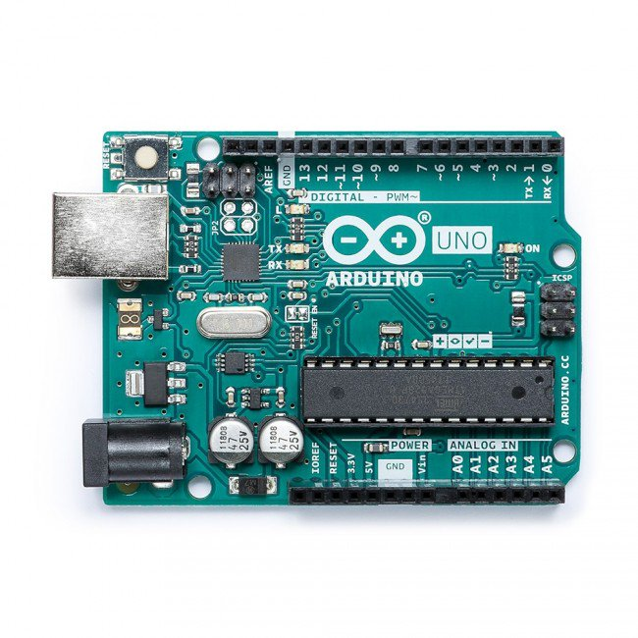

LCD :

Liquid Crystal Display, which we are using in our project is JHD 1602A. This display consists of 16 columns and 2 rows.

PIN SUMMARY OF LCD 1602A

Pin 1: VSS.

Pin 2: To VDD 5V input.

Pin 3: VL to adjust LCD contrast with the help of 10K potentiometer. Low VL indicates light contrast and high VL indicates dark contrast.

Pin 4: RS for register select. Data registers used for high RS. Similarly, instruction register for low RS. Pin 5: R/W signal stands for read/write. When R/W bit is high, it indicates a read operation. If R/W bit is low, it indicates write operation.

Pin 6: Clock Enable- Edge triggering.

Pin 7 to 14: Represents from Bit 0 to Bit 7.

Pin 15: back light Anode.

Pin 16: back light cathode.

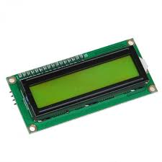

Membrane Keypad :

In our project we used 4X4 matrix membrane keypad. This 16 button keypad provides user interface component for Arduino project. this is programmed using the library . It has the following features: 1. Easy interface to Arduino.

2. Ultra-thin design.

3. Cheap and economical

SUMMARY about Keypad pins:

1. Maximum operation rating: 24VDC

2. Insulation Resistance : 100M ohm , 30 mA.

3. Interface: 8 pins can be accessed in the form of 4X4 matrix.

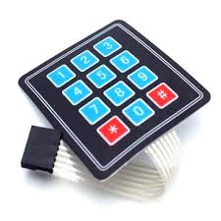

Servo Motor:

The servo used in the project is SG90 Micro Servo weighing about 9g.It has the following operating conditions:

Modulation Analog Torque 25.0 oz-in (1.8kg/cm)

Speed 0.12 s/60 deg

Weight 0.32 oz (9.8g)

Motor type 3 pole

Gear type Plastic

Rotation/Support Bushing

Pulse Width 500-2400 micro-sec

