**LINUX ADMINISTRATION**

**ASSIGNMENT**

**DAY 3**

1.Create a blank file named "myfile"

2. Open "myfile" in vi editor

3. Write your name, address, email id, phone number and blood group in 5 different lines

4. Build one single expression to see the line with your name and blood group in myfile

1.

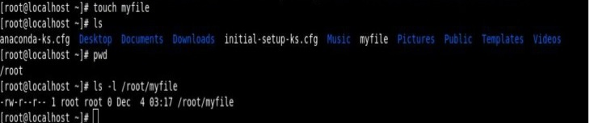

2.

