**LINUX ADMINISTRATION**

**ASSIGNMENT**

**DAY 5**

1. Add a 10GB disk to the CentOS.

2. Create 2 Partitions 4GB and 6GB of Space respectively.

3. Format 4GB with xfs and 6GB with ext4 file system.

4. Mount 4GB and 6GB in /data and /music directory respectively.

5. Create one file of 1GB in each of the mount point created above.

6. Verify the disk Consumption and disk space free in the mounted partitions.

1.



2.

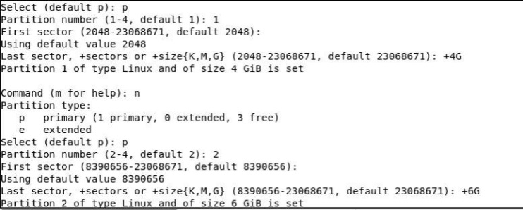

3.

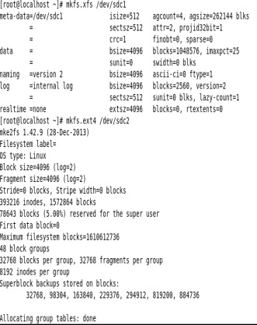

4.



5.

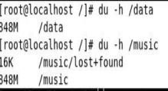

6.

