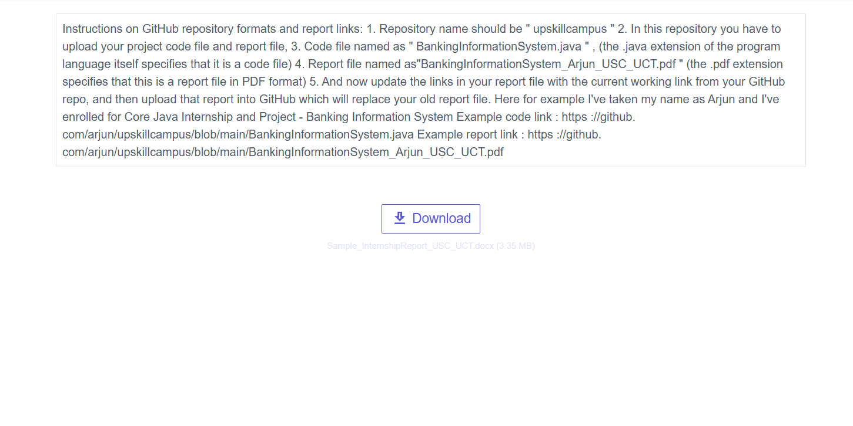

INDUSTRIAL INTERNSHIP REPORT ON

“Banking Information System”

Prepared by
NIVEDHA
Java Fullstack Internship
Christ College of Engineering and Technology
Duration: 6 weeks

Executive Summary
This report provides details of the Industrial Internship provided by Upskill Campus and The IoT Academy in collaboration with Industrial Partner UniConverge Technologies Pvt Ltd (UCT). The internship was focused on the project/problem statement provided by UCT and was completed in a 6-week period. The project undertaken was 'Banking Information System'. This internship provided exposure to industrial problems and the practical experience of designing and implementing solutions.

TABLE OF CONTENTS
1 Preface ........................................3
2 Introduction ...................................4
2.1 About UniConverge Technologies Pvt Ltd .....4
2.2 About upskill Campus ........................8
2.3 Objective ...................................9
2.4 Reference ..................................9
2.5 Glossary ...................................10
3 Problem Statement .............................11
4 Existing and Proposed solution ................12
5 Proposed Design/ Model ........................13
5.1 High Level Diagram (if applicable) ........13
5.2 Low Level Diagram (if applicable) .........13
5.3 Interfaces (if applicable) ................13
6 Performance Test ..............................14
6.1 Test Plan/ Test Cases .....................14
6.2 Test Procedure ............................14
6.3 Performance Outcome ........................14
7 My learnings ..................................15
8 Future work scope ............................16

Preface
This document summarises the work completed during the six-week internship. The program was structured to introduce industry-standard workflows and technologies, providing hands-on experience in full-stack Java development. The Banking Information System project required designing, implementing, testing and documenting a small-scale banking application that supports account creation, deposit, withdrawal and balance inquiry.
Acknowledgements: I thank my mentors from Upskill Campus, The IoT Academy and UniConverge Technologies for guidance and support.

Introduction
About UniConverge Technologies Pvt Ltd
UniConverge Technologies (UCT) is a digital transformation company established in 2013. UCT provides industrial solutions focused on sustainability and ROI, leveraging technologies such as IoT, Cloud (AWS/Azure), Machine Learning, Java Full Stack, and more. UCT's IoT platform supports standard protocols and provides dashboards, analytics, alerts, and integration capabilities.
About upskill Campus (USC)
upSkill Campus is a career development platform offering self-paced learning with mentorship, internships, and project-based experiences. It collaborates with The IoT Academy and industry partners to provide practical learning paths.
The IoT Academy
The IoT Academy is the EdTech division of UCT, offering executive programs in collaboration with academic institutions and industry partners.

Objectives of this Internship program
☛ Get practical experience of working in the industry.
☛ Solve real world problems.
☛ Improve job prospects.
☛ Enhance understanding of the field and its applications.
☛ Personal growth in communication and problem solving.

Problem Statement
The assigned problem statement was to develop a 'Banking Information System' — a small-scale full-stack application to manage bank accounts, enable deposits, withdrawals, and provide account information. The system should demonstrate a clear separation between frontend and backend, persist data in a relational database (MySQL), and be modular for future expansion.

Existing and Proposed solution
Existing small banking applications often lack clear modular structure and robust data persistence. This project proposes a Java Fullstack approach with a web frontend (HTML/CSS/JS) and a Java backend (Servlets or Spring Boot) connected to a MySQL database. This structure improves maintainability, scalability, and paves the way for further features such as authentication, transaction history, and reporting.

Proposed Design/ Model
High Level Architecture:
Client (Browser) <--> Frontend (HTML/JS) <--> Backend (Java Servlets/Spring Boot) <--> Database (MySQL)
Low Level Design: Provide class diagrams, DB schema, and API endpoints in this section when available.

Performance Test
Constraints to consider: concurrency, database transaction integrity, response time, and resource usage. Due to limited scope/time, performance testing included simple functional testing and basic load checks using concurrent requests.
Test Plan/Test Cases: Include account creation, deposit, withdrawal, invalid inputs, and database persistence checks.

My learnings
Through this internship, I improved my understanding of full-stack application development lifecycle, worked with databases, implemented REST/Servlet endpoints, and learned best practices for modular design.

Future work scope
Planned extensions include authentication & authorization, transaction history & reconciliation, online payments integration, cloud deployment (AWS/Azure), and advanced reporting.

Reference
[1] Reference 1
[2] Reference 2
[3] Reference 3

Glossary
Term - Definition
Acronym - Explanation

