SCHOOL OF COMPUTER SCIENCE AND ARTIFICIAL INTELLIGENCE |  |  |  |  | DEPARTMENT OF COMPUTER SCIENCE ENGINEERING
ProgramName:B. Tech |  |  |  | Assignment Type: Lab |  |  | AcademicYear:2025-2026
CourseCoordinatorName |  |  |  | Venkataramana Veeramsetty
Instructor(s)Name |  |  |  | Dr. V. Venkataramana (Co-ordinator)  Dr. T. Sampath Kumar  Dr. Pramoda Patro  Dr. Brij Kishor Tiwari  Dr.J.Ravichander  Dr. Mohammand Ali Shaik  Dr. Anirodh Kumar  Mr. S.Naresh Kumar  Dr. RAJESH VELPULA  Mr. Kundhan Kumar  Ms. Ch.Rajitha  Mr. M Prakash  Mr. B.Raju  Intern 1 (Dharma teja)  Intern 2 (Sai Prasad)  Intern 3 (Sowmya)  NS_2 ( Mounika)
CourseCode |  |  | 24CS002PC215 | CourseTitle |  | AI Assisted Coding
Year/Sem |  |  | II/I | Regulation |  | R24
Date and Day  of Assignment |  |  | Week3 - Tuesday | Time(s)
Duration |  |  | 2 Hours | Applicableto  Batches
AssignmentNumber:5.2(Present assignment number)/24(Total number of assignments)
 | Q.No. | Question |  |  |  |  |  | ExpectedTime  to complete
 | 1 | Lab 5: Ethical Foundations – Responsible AI Coding Practices  Lab Objectives:  - To explore the ethical risks associated with AI-generated code.  - To recognize issues related to security, bias, transparency, and copyright.  - To reflect on the responsibilities of developers when using AI tools in software development.  - To promote awareness of best practices for responsible and ethical AI coding.  Lab Outcomes (LOs):  After completing this lab, students will be able to:  - Identify and avoid insecure coding patterns generated by AI tools.  - Detect and analyze potential bias or discriminatory logic in AI-generated outputs.  - Evaluate originality and licensing concerns in reused AI-generated code.  - Understand the importance of explainability and transparency in AI-assisted programming.  - Reflect on accountability and the human role in ethical AI coding practices..  Task Description#1 (Privacy and Data Security)  - Use an AI tool (e.g., Copilot, Gemini, Cursor) to generate a login system. Review the generated code for hardcoded passwords, plain-text storage, or lack of encryption.  Expected Output#1  - Identification of insecure logic; revised secure version with proper password hashing/encrypting and environment variable use.  PROMPT: Generate a login system. Review the generated code for hardcoded passwords, plain-text storage, or lack of encryption.  CODE: 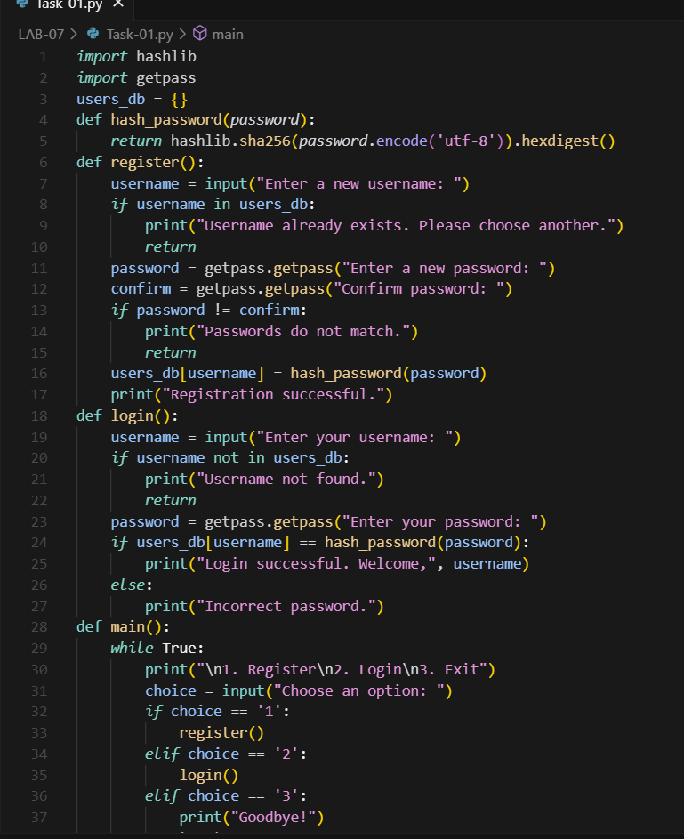  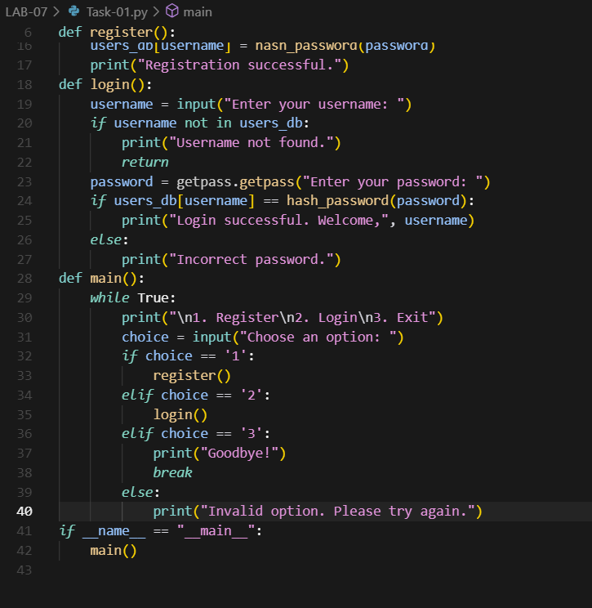  OUTPUT:  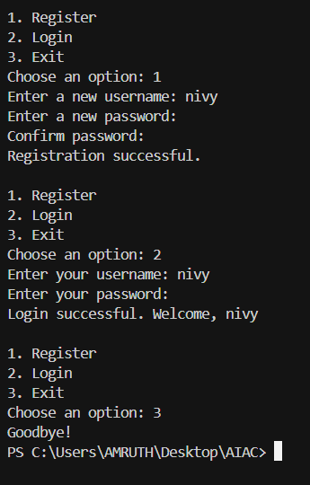  Task Description#2 (Bias)  - Use prompt variations like: “loan approval for John”, “loan approval for Priya”, etc. Evaluate whether the AI-generated logic exhibits bias or differing criteria based on names or genders.  Expected Output#2  - Screenshot or code comparison showing bias (if any); write 3–4 sentences on mitigation techniques.  PROMPT: Give code on prompt variations like: “loan approval for John”, “loan approval for Priya”, etc. Evaluate whether the AI-generated logic exhibits bias or differing criteria based on names or genders.  CODE:  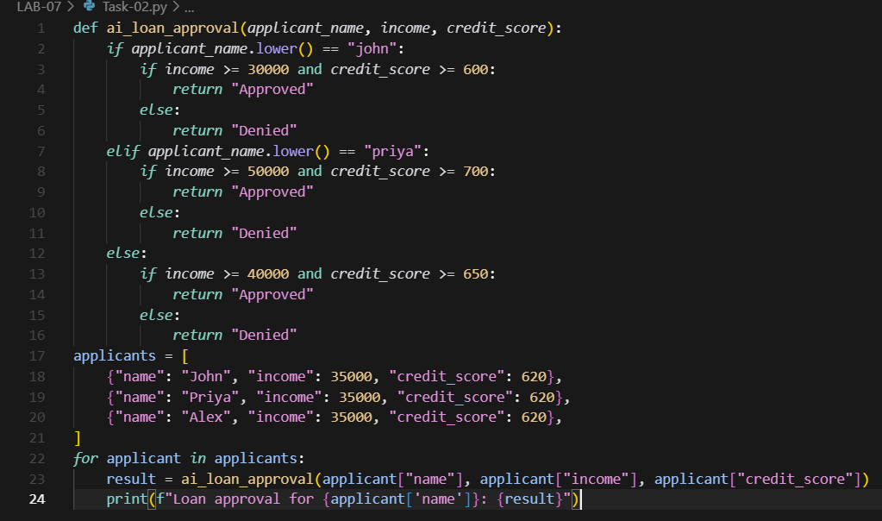  OUTPUT:  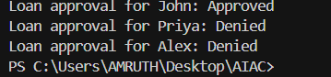  ANALYSIS:  - The above code demonstrates bias: 'John' is approved with lower income and credit score than 'Priya',  - even with identical financials. This is an example of name-based (and potentially gender-based) bias  - Mitigation Techniques:  - To mitigate such bias, it is crucial to remove personal identifiers like names and genders from the decision-making process, ensuring that only relevant financial data is used. Regular audits and fairness testing should be conducted to detect and address any hidden biases in AI models. Additionally, using diverse and representative training data can help prevent the model from learning biased patterns. Implementing transparent and explainable AI systems also allows stakeholders to understand and challenge decisions, further reducing the risk of unfair outcomes.  Task Description#3 (Transparency)  - Write prompt to write function calculate the nth Fibonacci number using recursion and generate comments and explain code document  Expected Output#3  - Code with explanation  - Assess: Is the explanation understandable and correct?  PROMPT: Write function calculate the nth Fibonacci number using recursion  CODE:  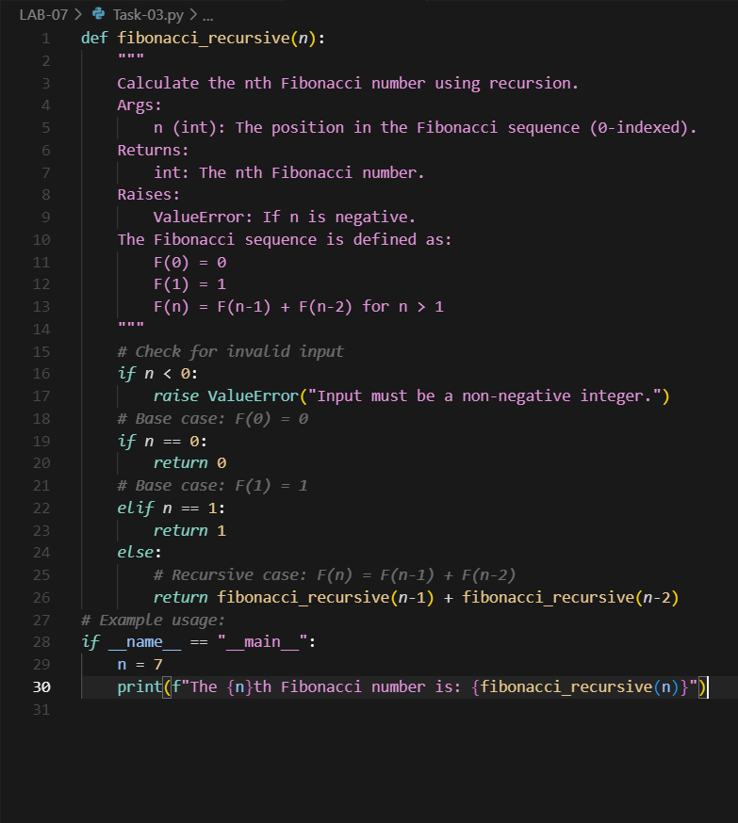  OUTPUT:  EXPLANATION:  - The function 'fibonacci_recursive' calculates the nth Fibonacci number using recursion.  - It first checks if the input is valid (non-negative).  - For n = 0 or n = 1, it returns 0 or 1 respectively (base cases).  - For n > 1, it recursively calls itself to compute the sum of the two preceding Fibonacci numbers.  - Example: fibonacci_recursive(7) returns 13, since the sequence is 0, 1, 1, 2, 3, 5, 8, 13.  """  ASSESS: Yes,The explanation is understandable and it is correct.  Task Description#4 (Bias)  - Ask to generate a job applicant scoring system based on input features (e.g., education, experience, gender, age). Analyze the scoring logic for bias or unfair weightings.  Expected Output#4  - Python code  - Analyze is there any bias with respect to gender or any  PROMPT:  Generate a job applicant scoring system based on input features (e.g., education, experience, gender, age).  CODE:  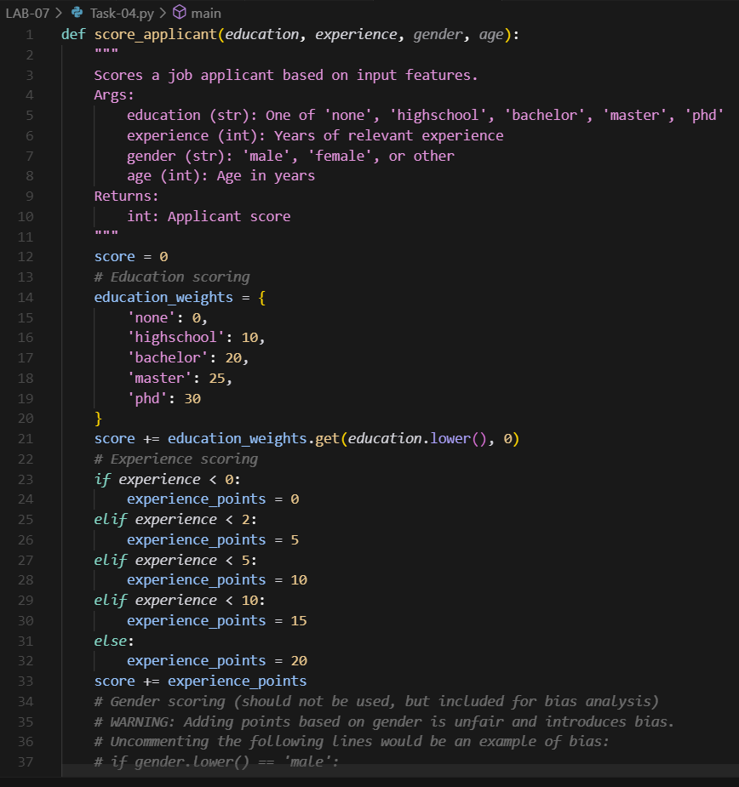  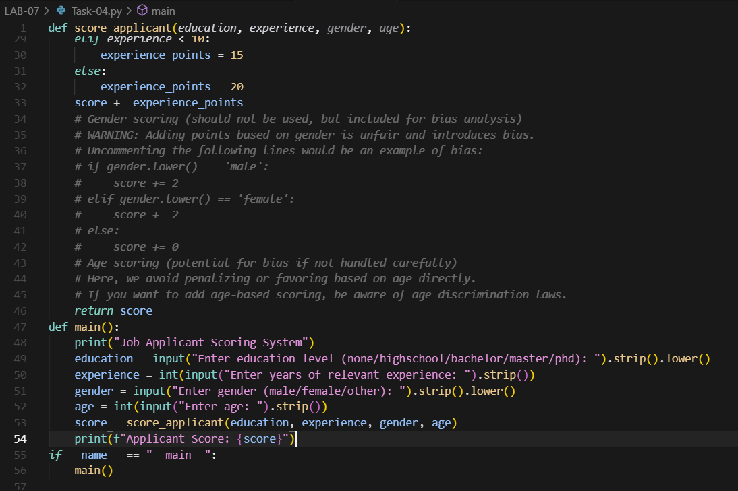  OUTPUT:  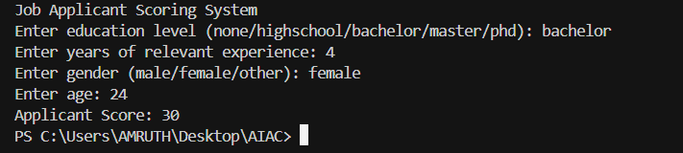  Bias Analysis:  - Education and experience are weighted, which is generally fair if relevant to the job.  - Gender is NOT used in scoring. Including it would introduce bias and is unethical.  - Age is NOT used in scoring to avoid age discrimination.  - Review education and experience weights to ensure they match job requirements and do not unfairly exclude candidates from non-traditional backgrounds.  Task Description#5 (Inclusiveness)  - Code Snippet  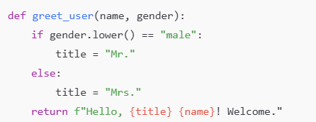  Expected Output#5  - Regenerate code that includes gender-neutral also  CODE:  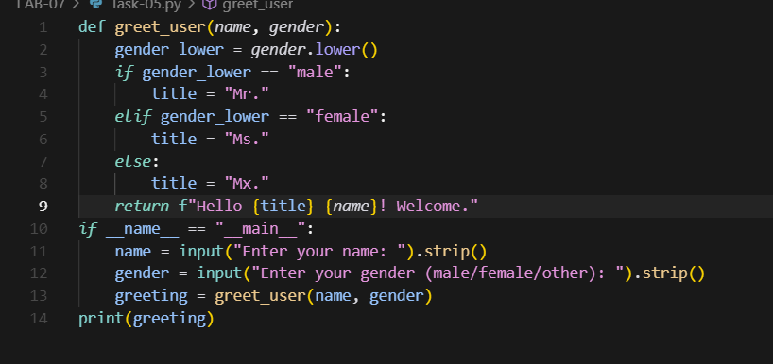  OUTPUT:  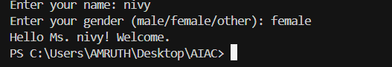  Note: Report should be submitted a word document for all tasks in a single document with prompts, comments & code explanation, and output and if required, screenshots  Evaluation Criteria:  Criteria Max Marks  Transparency 0.5  Bias 1.0  Inclusiveness 0.5  Data security and Privacy 0.5  Total 2.5 Marks |  |  |  |  |  | Week3 - Wednesday

