**STATE-CHART DIAGRAM**

**AIM:**

To design a state-chart diagram for the Online Exam Registration System.

**DEFINITION:**

A state diagram is a type of diagram used in computer science and related fields to describe the behaviour of systems. State diagrams require that the system described is composed of a finite number of states; sometimes, this is indeed the case, while at other times this is a reasonable abstraction. Many forms of state diagrams exist, which differ slightly and have different semantics.

**STATE-CHART DIAGRAM:**

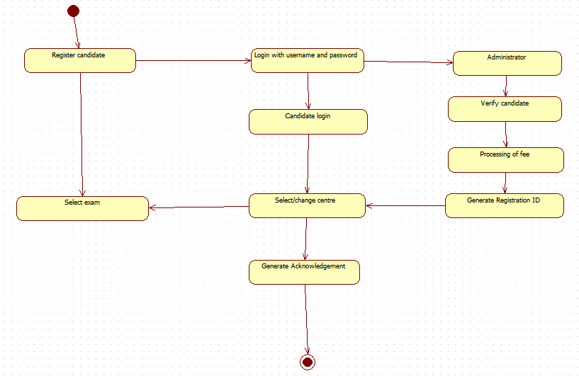

**RESULT:**

Thus a state-chart diagram has been designed for the Exam Registration System.