**ACTIVITY DIAGRAM**

**AIM:**

To draw an activity diagram for the online exam registration system.

**DEFINITION:**

Activitydiagrams are graphical representations of workflows of stepwise activities and actions with support for choice, iteration and concurrency. In the Unified Modeling Language, activity diagrams are intended to model both computational and organizational processes (i.e. workflows). Activity diagrams are constructed from a limited number of shapes, connected with arrows. The most important shape types:

* Rounded rectangles represent actions;
* Diamonds represent decisions;
* Bars represent the start (split) or end (join) of concurrent activities;
* Black circle represents the start (initial node) of the workflow;
* Encircled black circle represents the end (final node).

**ACTIVITY DIAGRAM:**

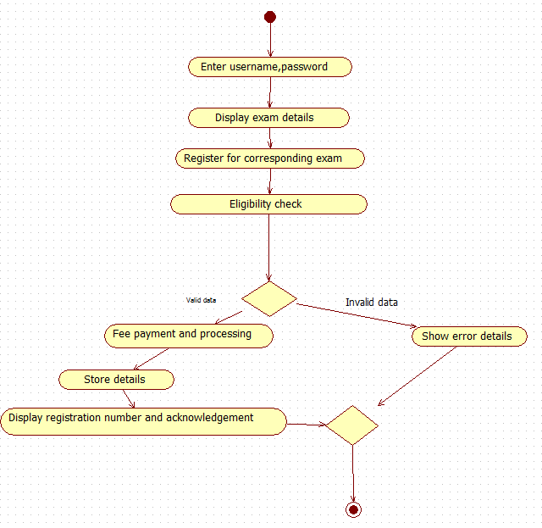

**DESCRIPTION:**

The student initially registers with the system giving all their details. They now get a private account with a unique username and password. When the student logs in, all exams available are displayed. The student choses one of the exams and he registers for that particular exam by choosing the date, venue, etc. the next step is the eligibility check where the student’s DOB, qualification and number of prior attempts are checked if they match the particular exam’s criteria. Once the student is found to be eligible, the fee payment and processing is done. The details are stored in the database and a final acknowledgement is displayed.

**RESULT:**

Thus an activity diagram was drawn for the online exam registration system.