AI-Driven Data Analytics Curriculum – Version 8
Module Number: 1 Module Name: Excel
Module End Assignment Title: AI-Powered Healthcare Data
Insights and Dashboarding
Problem Statement:
The healthcare industry generates vast amounts of data daily, providing valuable insights for healthcare providers and policymakers to improve patient care, allocate resources effectively, and manage healthcare costs. This project aims to analyze a comprehensive healthcare dataset comprising medical examinations, hospitalization details, and customer profiles to extract insights into patient health profiles, medical histories, and healthcare costs. By exploring relationships between various health metrics, identifying trends, and visualizing key patterns, we aim to deliver actionable insights to healthcare stakeholders for informed decision-making through rigorous data cleaning, transformation, exploration, and analysis.
Project Steps and Objectives:
Data Cleaning: (5 marks)
- Check for the number of missing values marked with '?' in each column of the "Medical Examinations" table and "Hospitalization Details" table.

Under “Medical Examination” table,
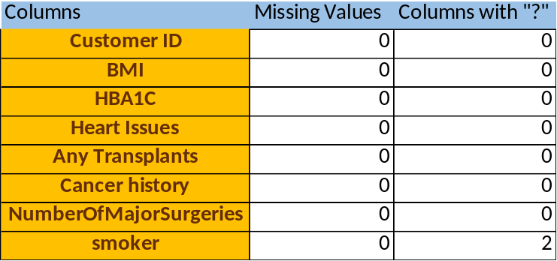
Since we have only 2 values with “?”,we cannot fill with other aggregation as it directly implies on health. We are replacing the value to “Unknown”.

Under “Hospitalization details” table,
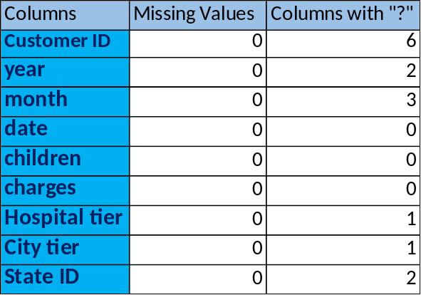

- Fill in the missing values of ‘month’ with Sep and ‘year’ with its average, rounded to the nearest integer.

Missing values in “Month” column under “Hospitalization details” has been imputed as “Sep” using IF function under a new column Month_filling null.

Firstly year column is formatted as Number. Then filled missing values using formula =IF(B2="?",ROUND(AVERAGE(B2:B2344),0),B2).

3.) Determine the most frequently occurring values in the ‘smoker’, 'hospital tier', and 'city tier' columns and fill in the missing values accordingly,
Since “smoker”, 'hospital tier', and 'city tier' columns are in text format, the most frequent value is found using index, mode and match functions. It is imputed using IF function.
Formula: =IF(H636="?",INDEX($H$2:$H$2336, MODE.MULT( MATCH($H$2:$H$2336, $H$2:$H$2336, 0))),H636)
MATCH turns the list of words into a list of numbers.
MODE.MULT() finds the most frequently occurring number.
INDEX() converts that number back to the category text.

4) If any 'State ID' values are missing, consider filling them with 'Unknown' or using another appropriate strategy.
This step has been done using IF() function.

Data Transformation: (5 marks)
1.) Split the ‘name column in the “Customer Names” table into 3 meaningful columns: ‘Title’,‘First Name’, and ‘Last Name’.
“Customers Name” column has been segregated into 5 columns such as “Title”, ”First Name”, “Middle name”,”Name Suffixes” and “Last name” using LEFT(),RIGHT(),MID() and FIND() functions.

2.) Convert the "NumberOfMajorSurgeries" column in the "Medical Examinations" table to
numerical data by replacing non-numeric characters with meaningful numerical values.
“NumberOfMajorSurgeries" column has text value “No major Surgery”, this value can be replaced using number “0”. This is done using “Find and Replace” option. 1074 cell values has been replaced.

3.) Check for inconsistencies in the 'Heart Issues' and 'Smoker' columns and propose corrective
actions if necessary.
By using Trim() and Proper() functions, the values has been Capitalized and removed unwanted spaces.

4.) Create a new column named “Weight Status” that categorizes BMI into different categories
as below:

BMI Weight Status
Below 18.5 Underweight
18.5 – 24.9 Normal Weight
25.0 – 29.9 Overweight
30.0 and Above Obesity

New Column “Weight Status”is created and values are imputed using below formula.
=IFS(C2<18.5,"Underweight",AND(C2>=18.5,C2<=24.9),"Normal weight",AND(C2>=25,C2<=29.9),"Overweight",C2>=30,"Obesity")

5.) Merge the ‘year’, ‘month’, and ‘date’ columns in the “Hospitalization Details” table into one
column named ‘Date of Birth’ and format it in the ‘DD-MMM-YYYY’ custom format.

New column “Date of Birth” is created using below formula
=VALUE(date&"-"&month&"-"&year) and converted to Date format.

6.) Calculate the ‘Age’ of each customer based on their ‘Date of Birth’ and the date of
collection of the dataset, which is 8th June 2023.

Date of collection(DOC) is set on one cell and converted to DATE format. Age can be calculated in 2 methods.
Method1: By Subracting DOB and DOC
Method 2: To get exact age including months and days,the below formula is applied.
=DATEDIF(H2,$T$2,"y") & " Years " &
DATEDIF(H2,$T$2,"ym") & " Months " &
DATEDIF(H2,$T$2,"md") & " Days"

7.) Format the ‘charges’ column as currency ($).

Charges column is converted to Currency using Format option under Numbers.

8.) Create new column ”Diabetic Status” based on HbA1c value.

New column “Diabetic Status” is created based on the below condition under IFS.

HbA1c (%) | Status
Below 5.7% | Normal
5.7% – 6.4% | Prediabetes
6.5% or higher | Diabetes

AI-Driven Data Exploration, Analysis & Visualization: (15 marks)

Activity 1: Data Preparation – (2 marks) (should be done manually)

Create a new sheet named “Healthcare”, and combine all three tables into one, using
Customer ID as the common column, utilizing XLOOKUP/Data Model manager.

Retain the following necessary columns: Customer ID, First Name, BMI, HBA1C, Heart
Issues, Any Transplants, Cancer History, Number of Major Surgeries, Smoker, Weight
Status, Diabetes Status, Date of Birth, Charges, Hospital Tier, City Tier, State ID, and Age.

New Sheet “HealthCare” is created. “Customer_ID” from Customer Table is pasted here. Using this column as the common column and using VLOOKUP(),Values has been pulled. The new consolidated sheet has following columns:
Customer ID, First Name, BMI, HBA1C, Heart
Issues, Any Transplants, Cancer History, Number of Major Surgeries, Smoker, Weight
Status, Diabetes Status, Date of Birth, Charges, Hospital Tier, City Tier, State ID, and Age.

Activity 2: Manual Dashboard Build (5 marks) (should be done manually)

● Create a pivot table manually (Insert → PivotTable) using the combined healthcare
dataset.
● Add charts:
○ Pie/Donut Chart: Cancer history distribution among smokers vs non-smokers.
○ Column Chart: Charges by Weight Status.
● Draw the insight manually and marked it down in the sheet

1. Cancer history distribution among smokers vs non-smokers.
Two pivot tables are created with following conditions.

Pivot Table 1: Rows : Cancer History
Values : Count of Customer ID
Filter : Smoker-Yes

Pivot Table 2: Rows : Cancer History
Values : Count of Customer ID
Filter : Smoker-No

Using the values in above pivot tables, Two Pie-Charts are created showing cancer history among smokers and non-smokers. Stored under the sheet ”Piechart”

Insight Derived: Non-smokers represent the majority of the customer base, accounting for nearly four-fifths of the total population. When analyzed proportionally, smokers exhibit a slightly higher incidence of cancer compared to non-smokers, indicating smoking as an important contributing risk factor.

2. Charges by Weight Status.
Follwing pivot table is created.
Pivot Table : Rows : Weight Status
Values : Average of Charges

Using the values, a new column chart is created showing the relationship between the “Weight Status” and “Charges”. Stored under the sheet “Column Chart”.

Insight Derived: Healthcare expenditure demonstrates a positive association with increasing weight categories. Individuals classified as overweight and obese incur substantially higher average medical charges compared to those in normal or underweight categories, suggesting increased healthcare utilization and risk burden associated with excess body weight.

Activity 3: AI-Powered Summary Statistics & Visualization( 5 marks) (AI-driven task)

Automatically generate and visualize overall healthcare statistics.
- Highlight the combined dataset (new sheet named “Healthcare”).
Using Quick Analysis>Formatting, Highlighted columns such as “Any Transplant”, ”Cancer History”, ”Weight Status”, ”Number of Major Surgeries” and “Charges”.

2. Use Quick Analysis→ to calculate dynamic counts and averages
● Total customers count,
● Total hospitalization count,
● Total healthcare costs,
● Average costs and medical metrics
Using Quick Analysis>Totals, above calculations were done and results are found at the bottom of each cell.

3. Use Quick Analysis → Recommended Charts (Column/Bar/Doughnut) to visualize
distributions of all pivots created in the previous step using AI tools.
● Expected Output: Pivot chart/quick analysis chart visualizing totals.
Using Quick Analysis> Tables, one of the recommended pivot table that can help with the analysis is selected and created in the different sheet. Also by using Quick Analysis> Charts, we can choose charts that suits our study.

Activity 4: Dashboard Creation (3 marks)
● Build an interactive dashboard that consolidates all key insights using the above
visualisations. Ensure visual clarity and ease of interpretation for all chart types.
● Insert slicers for weight status and diabetes status, and wherever possible.
● Arrange charts and slicers into a simple dashboard layout
● Add a heading (e.g., Healthcare Dashboard – AI Analysis).
● Ensure consistency in chart formatting for clear interpretation.
Pivot tables are created to help our grouping within the dataset and also to create pivot charts. Three dashboards are created as listed below:
-Weight Based Dashboard
-Age based Dashboard
-Diabetes based Dashboard
-Consolidated Healthcare Analytics Dashboard
Interactive Dashboard that consolidates all key insights is build within the sheet “HEALTHCARE ANALYTICS DASHBOARD”.

