This report is an attempt to discuss the path ‘alloying’ has taken, from the beginning till today, the journey has been beautiful, with astonishing and life-changing discoveries; to high end research that has been going on in the field of metallurgy and alloy making .

I start with the fundamental structure of Materials Science, the famous tetrahedron. The traditional materials science tetrahedron emphasizes the interdisciplinary research on materials structure, processing, properties and performance. But, there is a newer way to streamline our efforts and study, to create new and applicable materials, the systems materials engineering triangle. It illustrates the importance of system-level planning of the research efforts starting from individual components and followed by interface optimization. We are still working on the traditional approach but we can switch to this for more efficient designing and output.
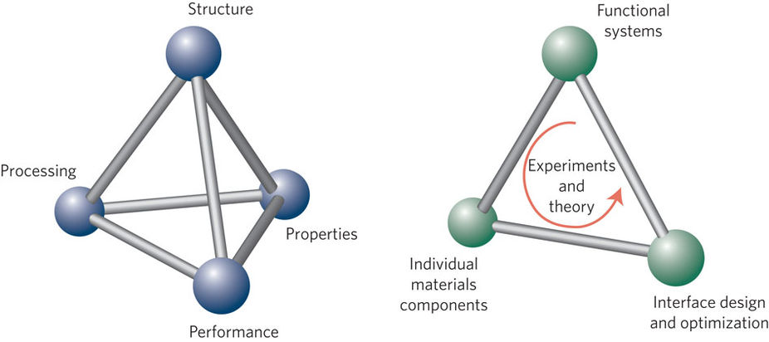
Fig 1.
“Systems materials engineering emphasizes the study of the interactions between individual components of a system, and how these interactions give rise to the function and performance of the final system.” [1]

This brings out the need to focus just not on the individual properties of materials but on the system in which they’d be applied as a whole.
Integration is the key, integration of the designed materials into the bigger picture. This will help in improving the properties we are working on, the characteristics we require; in a more systematic and streamlined way.
Table of content
- A Brief History and Context
- Key Concepts and Definitions
- Phases
- Properties
a. Functional Properties
b. Mechanical Properties
5. Economic Perspective
6. Conclusion

A Brief History and Context

Metallurgy, the art and science of making metals and alloys in forms and with properties suitable for practical use, is known to be an ancient art. It has brought us out of Stone Age, through Bronze age and Iron Age (in which we are arguably still living) to the age of more Advanced and Highly Functional alloys.

Alloying started off as an accident.
Brass, a simple alloy of copper and zinc, from the late Neolithic period and bronze, an alloy of copper and tin known to be in use from as early as 3000 BC. What is an alloy? A metallic solid ( or liquid ) formed from an intimate combination of two or more elements.

Initially, alloying focused on having one principle element ( or at most two ) and adding the rest in very small percentages. Steel for example, the revolutionary material, is fundamentally Iron, with tiny bits of carbon and of some other elements.

Taking a larger leap in time, we directly come to the advent of alloys with multiple (five or more) principle elements, called High Entropy Alloys.
Entropy is a measure of randomness of a system.
$G=H-TS$ (1)
Entropy (S) helps lowering the Gibbs free energy and is supposed to stabilize the system. Higher the entropy, lower is the energy.
Entropy is of various kinds i.e. it arises due to a variety of factors, configurational, thermal, and vibrational. Here, we consider the configurational entropy. Configurational entropy increases as the number of possible microstates increases where microstate is the microscopic arrangement of atoms or particles.
$S_{conf}=k lnΩ$, (2)
Where $Ω$counts the ways of finding the internal coordinates of a system for thermodynamically equivalent macroscopic states
Let N be total number of atoms with N₁ of type 1, N₂ atoms of type 2 and so on, N_{n} atoms of type n.
N= N₁+N₂+….+N_{n}
$$Ω=\frac{N!}{N_{1}{!N}_{2}!……..N_{n}!}$$
After applying Stirling’s approximation for the factorial of a large integer m:
$$\ln{m!=\sum_{u}{\ln{u≈\int_{1}^{m}{\ln{u du=m\ln{m-m}}}}}}$$
ln Ω= N ln N-N –( N₁ ln N₁- N₁ +….+N_{n} ln N_{n} - N_{n})
$$\ln{Ω=-\left(N_{1}\ln{\frac{N_{1}}{N}}+N_{2}ln\frac{N_{2}}{N}+…+N_{n}ln\frac{N_{n}}{N}\right)}$$
$$\begin{aligned} \\ ln\end{aligned}{Ω=-N\left(\frac{N_{1}}{N}\ln{\frac{N_{1}}{N}}+\frac{N_{2}}{N}ln\frac{N_{2}}{N}+…+\frac{N_{n}}{N}ln\frac{N_{n}}{N}\right)}$$
$S_{conf}=-kN(c_{1}lnc_{1}+c_{2}lnc_{2}+…+c_{n}lnc_{n}$ , c_{i} is the mole fraction of i^{th} component,
N=nN_{A} , n is the total number of moles of mixture, N_{A} is Avogadro’s number.
$$S_{conf}=-knN_{A}\sum_{i=1}^{n}{c_{i}lnc_{i}}=-n R\sum_{i=1}^{n}{c_{i}lnc_{i}}$$

Let us consider an equiatomic alloy at its liquid state or regular solid solution state, n = 1 and c_{i}= $\frac{1}{n}$ for all n components
$∆S_{conf}=-klnw=-R\left(\frac{1}{n}ln\frac{1}{n}+\frac{1}{n}ln\frac{1}{n}+….+\frac{1}{n}ln\frac{1}{n}\right)=-Rln\frac{1}{n}=R ln n$(3)

Key Concepts and Definitions

High entropy alloys (HEAs) are chemically complex single-phase alloys with simple crystal structure. They are a novel class of alloy systems with five or more elements near equiatomic composition with the potential of achieving extraordinary functional and mechanical properties.

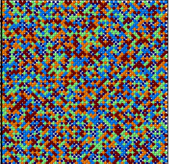
It is assumed that the high configurational entropy in these alloys stabilizes the single phase despite a significant energetic cost, as the disordered arrangement of atoms implies large atomic-scale lattice distortions.
The simultaneous presence of crystalline order and compositional disorder endows single phase HEAs with unusual thermodynamic and kinetic properties.
HEAs have been shown to possess interesting mechanical properties, such as low weight to strength ratio, combination of high strength and toughness, considerable temperature independence of properties etc.
The systemized research of HEAs is barely 13 years old. The first results on multi-component and high entropy crystalline alloys were published in 2004.

The flag bearers of this approach are
a.) Opening a vast, unexplored realm of alloy compositions.
b.) The potential to influence solid solution phase stability through control of configurational entropy.
Equimolar or near equimolar alloy studies explore the interior regions of multi-dimensional composition space, away from the vertices, edges and faces, HEA studies additionally emphasize the search for single-phase solid solutions.
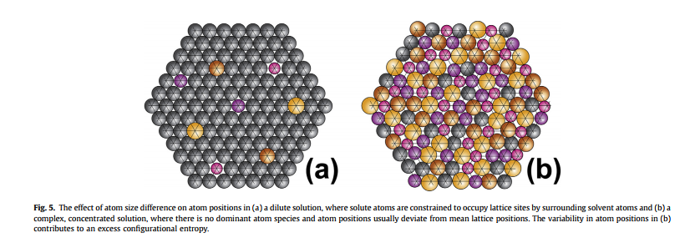
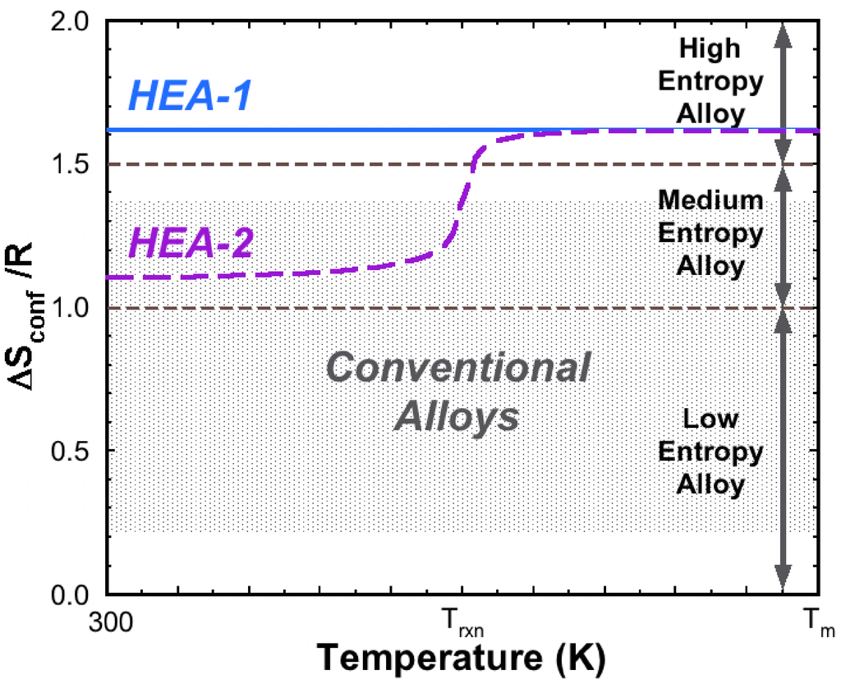
Fig. 3
Lattice in normal alloy vs. in HEAs
Fig. 2
∆S_{conf} HEAs > 1.61R

- High Entropy - Thermodynamics - complex phase formation
- Lattice Distortion - Structure - mechanical and physical behavior
- Sluggish Diffusion - Kinetics - slow down phase transformation
- Cocktail Effect - Properties - excess to the quantities predicted by the
mixture rule

Although, the high entropy effect is the signature concept of HEAs, and we claim that this increase in entropy stabilizes the formation of single phase solid solution, but the degree of this has to be accessed against other thermodynamic concepts, and variables.

Severe Lattice Distortion in HEAs is claimed to decrease the intensity of X-ray diffraction peaks, to increase hardness, to reduce electrical and thermal conductivity and to reduce the temperature dependence of these properties. But, calculated values of the lattice parameter do not show very large or extraordinary distortion. Hence, shear modulus mismatch between constituent atoms may also contribute to hardening, and electrical and thermal conductivities can be influenced by the electronic structures associated with variations in local bond states. Therefore, the distortion is measured in terms of both lattice parameter and shear modulus misfits.

Sluggish Diffusion is expected in HEAs based on secondary observations that include formation of nano-crystals and amorphous phases upon solidification, difficulty in substitutional diffusion and high activation energies (Q).Although, these propositions seem theoretically true, little experimental evidence exists for the exhibited effects and it remains a proposed hypothesis to be thoroughly tested.

The Cocktail effect ( “Alloyed pleasures: multi-metallic cocktails” by Ranganathan (2003) ) is a beautiful metaphor for enhanced structural and functional properties shown by the HEAs, above and beyond those predicted by the rule of mixtures. In psychology, there is an entire school of thought going by the name Gestalt which proposes that ‘Whole is Greater than Sum of its Parts’. The ‘cocktail’ effect reminds us to remain open to non-linear, surprising results that can come from unusual combinations of elements and microstructures in the vast composition space of HEAs.


Fig. 4 Psychology to Material Science

Major Alloy Families in HEAs[2]
HEAs be classified into seven alloy families. These families include

Table 1.
FAMILY | ELEMENTS | APPLICATION
3d transition metal HEAs | Al, Co, Cr, Cu, Fe, Mn, Ni, Ti and V. | Extensions of stainless steels and super-alloys  (prototypical single-phase disordered solid solution alloy- ‘Cantor alloy’ (CoCrFeMnNi) )
Refractory metal HEAs | Cr, Hf, Mo, Nb, Ta, Ti, V, W, and Zr; (Al) | New high temperature structural metals
Light metal HEAs | Al, Be, Li, Mg, Sc, Si, Sn, Ti and Zn. | With low density for aerospace and transportation applications
Lanthanide (4f) transition metal HEAs | Dy, Gd, Lu, Tb and Tm, plus the element Y | Scientific Curiosity, SS high entropy alloys (HEAs) with the HCP crystal structure.
HEA brasses and bronzes | Al, Cu, Mn, Ni, Sn and Zn. | Achieve higher levels of strength via concentrated solid solutions
Precious metal HEAs | Ag, Au, Co, Cr, Cu, Ni, Pd, Pt, Rh and Ru | Catalysis
Interstitial compound (boride, carbide and nitride) HEAs | 3d transition metal or refractory metal HEA families + C/B/N | Thin Films

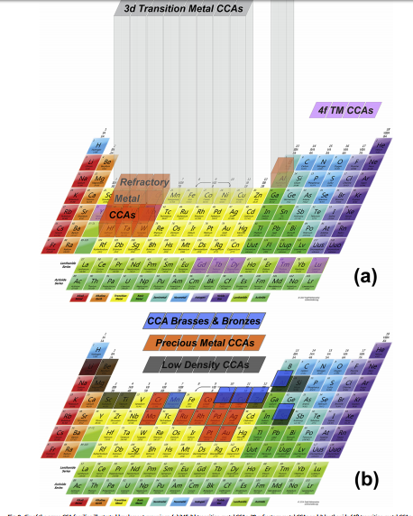
Fig. 5 HEA families on Periodic Table ( CCAs – Complex, Concentrated Alloys)

Phases [3]

Phase selection rules for cast HEAs, among solid solutions, intermetallic compounds and the amorphous phase, have been formulated using a parametric approach, utilizing parameters based on two considerations, i.e. thermodynamics and geometry effect. The mixing enthalpy, the atomic size mismatch and some of their derivatives play crucial rules.
Inspired by the equivalency of stabilizing elements, role of VEC (Valence Electron Concentration) in phase selection between FCC and BCC type solid solutions in HEAs; the valence electron concentration rule has been applied successfully to control the phase selection between FCC and BCC type solid solutions, two most commonly seen types of solid solutions in HEAs.

∆G_{mix}= ∆H_{mix} - T∆S_{mix} (4)

To formulate and present the rules for phase selection, we first define the following :
(Here, c_{i} is the atomic percent or mole fraction, r_{i} is the atomic radius, ᵡ_{i} is the Pauling Electronegativity, VEC_{i} is the valence electron concentration of i th component )

The Entropy of mixing
$∆S_{mix}=-R\sum_{i=1}^{n}{c_{i}lnc_{i}}$ (5)

The Enthalpy of Mixing
$∆H_{mix}= \sum_{i=1,j>1}^{n}{4∆H_{AB}^{mix}c_{i}}c_{j}$ (6) ∆H_{AB}^{mix} is the enthalpy of mixing for the binary equiatomic AB alloys;

The Atomic size mismatch δ
$δ=\sqrt{\sum_{i=1}^{n}{c_{i}{\left(1-\frac{r_{i}}{\sum_{j=1}^{n}{c_{j}r_{j}}}\right)}^{2}}}$ (7)

The electronegativity difference
$∆ℵ=\sqrt{\sum_{i=1}^{n}{c_{i}{\left(ℵ_{i}-\sum_{j=1}^{n}{c_{j}ℵ_{j}}\right)}^{2}}}$ (8)
The Valence Electron Concentration
$VEC=\sum_{i=1}^{n}{c_{i}{\left(VEC\right)}_{i}}$ (9)

- Solid solutions vs. Intermetallic compounds vs. amorphous phase
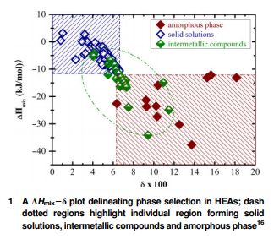
∆H_{mix} is around zero and δ < 0.06 for solid solution formation
Fig. 6 ∆H_{mix} – δ plot delineating phase selection in HEAs;

- ∆H_{mix} vs. δ² , HEAs and HE-Bulk Metallic glasses( amorphous )
Solid Solutions
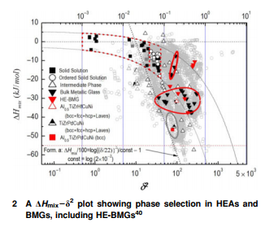
The variability in atom positions due to size mismatch, contributes to excess configurational entropy (Fig.3) The motivation of using δ² instead of δ started from the intention to use another parameter that can also characterize the atomic size mismatch, S_{conf} (often normalized by the Boltzmann constant k, so S_{conf}/k ), to replace δ. Then, they found out that a correlation between S_{conf}/k and δ² : S_{conf}/k~ δ² actually exists
Fig. 7 A plot of ∆H_{mix} – δ² showing Phase Selection between HEAs – BMGs including HE-BMGs

BMGs
- γ vs. δ plot to show distinction between solid solutions, intermetallic compounds and metallic glasses.
Essentially, γ suggests that the solid solubility in multicomponent alloys is more determined by the largest and the smallest atom. γ is called the packing factor.
$γ={\left(1-\sqrt{\frac{{\left(r_{s}+\overline{r}\right)}^{2}-{\overline{r}}^{2}}{{(r_{s}+\overline{r})}^{2}}}\right)}/{\left(1-\sqrt{\frac{{\left(r_{L}+\overline{r}\right)}^{2}-{\overline{r}}^{2}}{{(r_{L}+\overline{r})}^{2}}}\right)}$ (10)
Where r_{s} and r_{L} are the atomic radii for smallest and largest atoms and $\overline{r }=\sum_{i=1}^{n}{c_{i}r_{i}}$
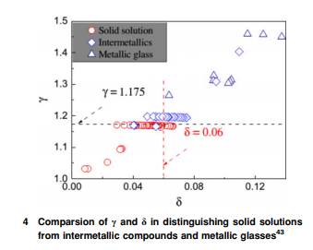

Fig. 8 Comparison of γ and δ in distinguishing solid solutions from intermetallic compounds and metallic glasses

- Yang and Zhang proposed a new parameter Ω out of thermodynamics origin, to replace ΔHmix in the previous ΔH_{mix}-δ scheme.
Ω is called the thermodynamic factor
$Ω=\frac{T_{m}{∆S}_{mix}}{{∆H}_{mix}}$ And $T_{m}=\sum_{i=1}^{n}{c_{i}{\left(T_{m}\right)}_{i}} ;$ (11)
T_{m} is the melting temperature of i^{th} component.
The new phase selection rule for solid solutions becomes Ω>1.1 and δ<0.066.

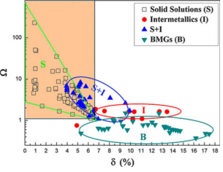
Fig. 9 Ω – δ plot showing phase selection in HEAs and BMGs

To summarize, we aim for a smaller δ and δ², less negative ∆H_{mix}, larger Ω and smaller γ for formation of solid solutions in HEAs. These factors can be seen as an extension of Hume-Rothery rules. And, the approach is the Parametric Approach for phase selection.

Inoue’s three empirical rules for the easy formation of BMGs are that
- The alloy must contain at least three components, since formation of glass becomes easier with increasing number of components
ii.) A significant atomic size difference of > 12% between constituent elements
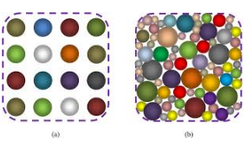
iii.) Large negative heat of mixing.
Fig. 10 HEA vs. BMG representation

The second and third criteria clearly give a clear distinction between HEAs and BMGs
(Comparing to Hume-Rothery rules for solid solution formation)

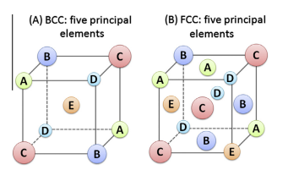
- What determines crystal structure of solid solutions?

Fig. 11 FCC and BCC in HEAs

HEAs are normally of FCC or BCC structure, or a mixture of both, also rarely HCP is also observed. Experimentally, it has been known that in HEAs, their crystal structures can significantly affect their mechanical behavior.
- FCC structured HEAs are quite ductile, but their strengths are relatively low.
- BCC structured HEAs are generally much harder, but also quite often brittle, particularly under tension.
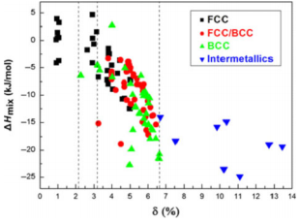
Therefore, it is crucial to design HEAs of the desired crystal structure.

Fig. 12 Dependence of solid solution types on ∆H_{mix} and δ in HEAs
The 𝚫Hmix - 𝜹 plot shown above roughly says that FCC structured solid solutions form at smaller and less negative 𝚫Hmix, while BCC structured solid solutions form at larger 𝜹 and more negative 𝚫Hmix.
Evidences from experiments have shown that elements like Al and Cr are BCC phase stabilizers, and Ni and Co are FCC phase stabilizers
When the equivalent Co % was larger than 45 at-%, the alloys had an FCC structure, and when the equivalent Cr % was larger than 55 at-%, the alloys had a BCC structure.

This equivalency of alloying elements in stabilizing a particular crystal structure naturally reminds of the well-known effect of electron concentration on the crystal structure in conventional alloys.
There are two different notions of electron concentration:
- e/a, the average number of itinerant (delocalized) electrons per atom,
- Valence electron concentration (VEC), the number of total electrons, including d electrons involved in the valence band.

HEAs generally contain transition metals (TM). Considering that the determination of e/a values for TMs is known to be highly problematic, VEC seems to be a more straightforward electron concentration parameter, at least to start with.
Clearly, -> FCC type solid solutions form at VEC>8.0,
->BCC type solid solution phases at VEC<6.87,
-> A mixture of FCC and BCC phases at 6.87<VEC<8.

Recently, Poletti and Battezzati evaluated the phase selection between FCC and BCC type solid solutions in HEAs, using both e/a and VEC. They claimed that FCC solid solutions are stabilized at VEC>7.5 and 1.6<e/ a<1.8, while BCC solid solutions are stabilized at VEC>7.5 and 1.8<e/a<2.3. [4]
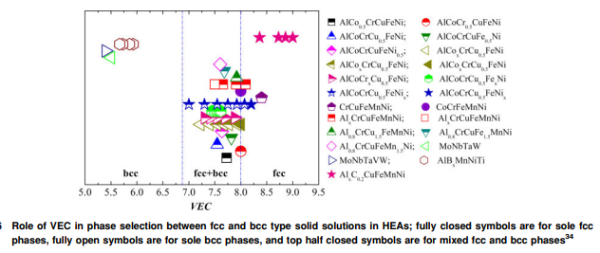
Fig. 12 Role of VEC in phase selection between FCC and BCC type solid solutions;
Fully closed symbols are for sole FCC phases, fully open are for sole BCC phases and top half closed symbols are for mixed FCC and BCC phases

Future work along these criteria and newer parameters can help give deeper insight in crystal structure selection in HEAs

The formation of a single-phase random solid solution is favored in the alloys where the majority of constituent binary pairs have a large mutual solid solubility (from Hume-Rothery Rules) and a small enthalpy of mixing.

HEAs obtained through non-equilibrium processing routes like splat quenching, magnetron sputtering, and laser cladding usually exhibit single-phase structure because of lack of time available for the formation of second phases or even intermetallic phases.

Properties [2]

High Entropy Alloys are expected to have spectacular properties, both functional and mechanical. Although, the functional properties of HEAs are less explored than mechanical properties and high temperature resistance; research on thermal, electrical and magnetic properties is also gaining momentum.

Thermal Properties:
Single-phase FCC alloys (low Al content) have almost half the thermal conductivity of single-phase BCC alloys (high Al content). Within single-phase regions, thermal conductivity decreases with increasing Al content. These behaviors are analyzed in terms of lattice distortions and an increased phonon mean free path due to lattice thermal expansion at higher temperatures.
Thermal expansion coefficient 𝞪 decreases with increase in Al and increases with increase of Mn.

Electrical properties:
The electrical resistivity of the FCC phase is higher than that of the BCC phase at the same composition, and the resistivity in the two-phase field follows a linear average of the volume fraction of the BCC and FCC phases.
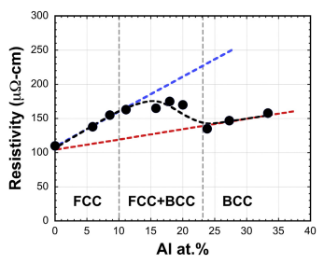

Fig. 13 Resistivity of HEAs vs. % Al, also showing crystal structure of alloy

Magnetic Properties:
CoFeNi is a single-phase alloy with an FCC crystal structure and is ferromagnetic with a saturation magnetization (Ms) of 151 emu/g. For reference, Ms for pure Fe is 218 emu/g and for pure Ni is 55 emu/g. The FCC structure transforms to FCC + BCC/B2 with Al additions in AlxCoFeNi. As Al increases from x= 0 to 1 the alloys remain ferromagnetic, but Ms decreases to 102 emu/g. The magnetostriction effect is very small, which is essential to ensure that materials are not stressed in an external magnetic field. Adding Al and Si together in (AlSi)xCoFeNi (0< x <0.8), the properties at x= 0.2 give Ms, coercivity, electrical resistivity, yield strength and strain without fracture, that make the alloy an attractive soft magnetic material.
- The magnetic properties in HEAs are influenced by composition through the fraction of magnetic elements present .
- Processing and thermal history also influence magnetic properties through the phases formed. As-processed material typically has different microstructures and magnetic properties compared to annealed materials.
Other functionalities include hydrogen storage, catalysts ( Cu_{x}FeCoNiMn has been used as a substrate for graphene growth), thermoelectric properties, response to irradiation and shape memory response.

Mechanical Properties:
Mechanical properties depend profoundly on composition and microstructure.
- Composition sets elastic properties and atomic interactions that dictate dislocation behaviors. Composition also defines the phases present and their volume fractions, which influence properties through the intrinsic properties of the phases.
- Size, Shape and Distribution of phases.
- Defects are critical microstructural components that play a major role in mechanical properties. Atomic-level defects include vacancies, dislocations and grain boundaries, and microscopic or macroscopic defects include pores, chemical segregation, cracks and residual stresses.
All of these must be considered for a clear understanding of mechanical properties.
Under mechanical properties we study, tensile, compression, hardness and refractory behavior.
HEAs have many practical applications especially for those requiring high strength, high hardness, high-temperature softening resistance, and creep resistance.

Qiao et al. studied the compressive characteristics of a single-phase BCC HEA with the composition of AlCoCrFeNi at 77 K. Comparing with the compression properties at different temperatures, the yielding strengths and fracture strengths of the AlCoCrFeNi HEA increase by 29.7% and 19.9%, respectively, when the temperatures decrease from 298 to 77 K. However, the fracture strains change gently while the fracture modes at 298 and 77 K are inter-granular and trans-granular. [5]
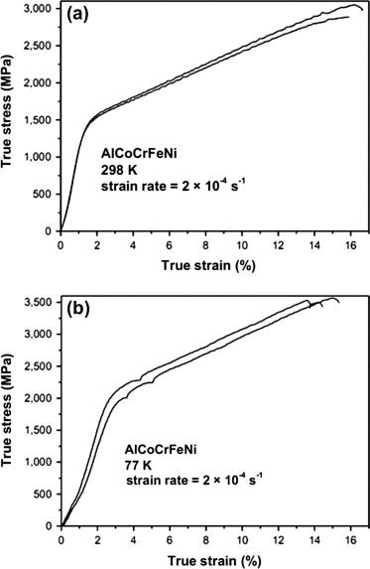

Fig.14 The compressive true stress–strain curves of the AlCoCrFeNi HEA at (a) 298 and (b) 77 K.

The yield strengths and fracture strengths at cryogenic temperatures increase distinguishingly, compared to the corresponding mechanical properties at ambient temperature.

As a major accomplishment, broad relationships between composition, microstructure and mechanical properties are established, especially in 3d transition metal HEAs. Perhaps the most important and most widely studied is the effect of Al concentration. Tensile strength increases and ductility decreases with increasing Al.

The hardness of Al_{x}CoCrCuFeNi increases with Al content due to the transition from a single-phase FCC structure, to BCC + FCC and then to single-phase BCC.

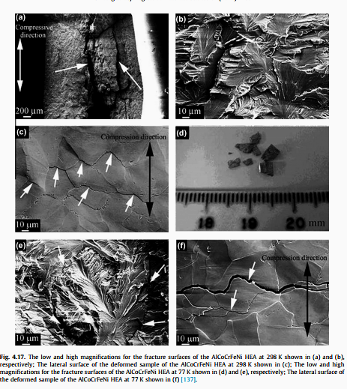

Fig. 15 The low and high magnifications for the fracture surfaces of AlCoCrFeNi HEA at 298K shown in (a) and (b) respectively; The lateral surface of the deformed sample of AlCoCrFeNi HEA at 298K shown in (c); The low and high magnification for fracture surfaces of AlCoCrFeNi HEA at 77K are shown in (d) and (e) respectively; The lateral surface of the deformed sample at 77K is shown in (f)

- Removing Cr reduces strength. Increasing Cr above 26 at.% introduces the 𝞼 phase, which further increases strength and decreases ductility.

- Cu is also associated with nano-twinning that is an important mechanism for work-hardening, especially below RT.

Single-phase FCC alloys have Vickers Hardness in the range of 100-200 Hv, single-phase BCC alloys have hardness >600 Hv and BCC + FCC alloys have hardness values that increase from the lower to the higher levels with increasing BCC content.
Compressive yield strengths can be very high in alloys with significant volume fractions of BCC and/or B2 phases, and range from 1300 to 2400 MPa with values as high as 3300 MPa.

Table 2(a.)
Alloy | Microstructure | Processing | S⁻¹  (strain rate) | T(K) | σ_{yield} (MPa) | σ_{ultimate}  (MPa) | ε % | Ref.
CoCrMnNi | FCC | As Cast, heat treated at 1100°C/24 h, Cold Rolled 90%, 1000°C/1 h | 0.001 | 77 | 499 | 1283 | 62 | [6],[10]
 |  |  |  | 673 | 186 | 555 | 28 | [6],[10]
AlCoCrCuFeNi | BCC/B2+FCC + FCC+𝝈 | As Cast, heat treated at 960°C/50 h, forged at 950° C | 0.0001 | 1073 | 8 | 17 | 325 | [7]
AlCoCrCuFeNi | BCC/B2+FCC + FCC+𝝈 | As Cast, heat treated at 960°C/50 h, forged at 950° C | 0.01 | 1073 | 105 | 142 | 60 | [7]

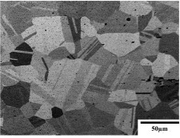
Alloy: CoCrMnNi [6]
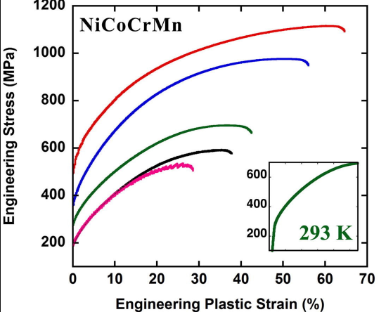
Fig. 17 BSE-SEM image of CoCrMnNi sample after cold-rolling and annealing
673 K
77K
Fig.16 Engineering Plastic Strain (%) vs. Engineering Stress (%)

In general, the flow stress (σ_{flow}) decreases with increasing temperature, and the stress–strain curve systematically shift up with decreasing temperature. The 673K curve shows serrations from yield point onwards. Such serrations are often associated with dynamic strain aging i.e. the dynamic break-away/locking of dislocations from/by mobile solute atoms at intermediate temperatures.
Primary source of the temperature dependence of the yield strength is the temperature-dependent height of the Peierls barrier.
$σ_{p}≈σ_{p}\left(0\right) exp\left(\frac{-2πω_{0}}{2bT_{m}}T\right)$ (12)
Where σ_{p} is the Peierls stress at T temperature,${ σ}_{p}\left(0\right)$ is the Peierls stress at 0 K, $ω_{0}$ is the dislocation width at 0K, b is the magnitude of the Burger’s vector, T_{m} is the melting temperature.
($σ_{p}\left(0\right)$ for BCC metals is relatively higher as compared to FCC metals. A major factor contributing to this difference is the relative widths of the dislocations and also,
As the temperature increases, the Peierls barrier decreases. This is due to the increase in the width of dislocations with increase in temperature. As the dislocation width increases, subsequently work hardening takes place and yield stress increases. The yield (σ_{yield}) and ultimate (σ_{ultimate}) strengths both decrease continuously with increasing temperature over the full range of temperatures.
According to rule of mixtures, T_{m} of the alloy should be around 1799K. 673K is less than
0.4 T_{m} and therefore we are in the cold work region. The strength increases while the ductility decreases. Increase in ductility with increase in temperatures is expected to occur at further higher temperatures.
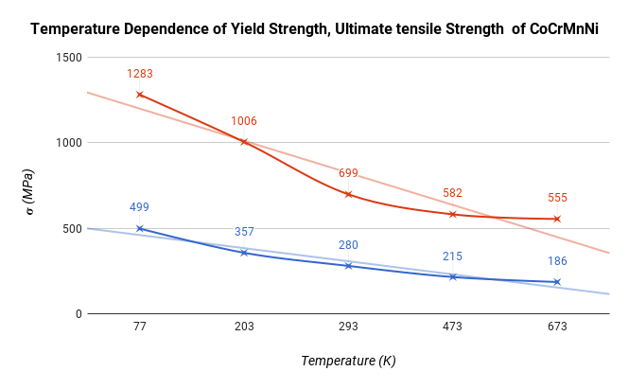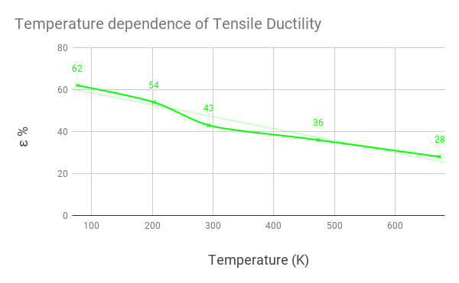
Fig. 18 Temperature dependence of σ_{yield} (blue), σ_{ultimate} (red) and
ε % (green)

At 77K, liquid nitrogen temperature, we observe higher ductility. This is explained by two phenomenon. First, at low temperature, nano-scale deformation twins were observed (which were absent at temperatures above RT. One of the hypothesis is that twinning can provide an additional deformation mode to accommodate plasticity. Also, deformation twinning, by continually introducing new interfaces and decreasing the mean free path of dislocations during tensile testing (“dynamic Hall–Petch”), produces a high degree of work hardening and a significant increase in the ultimate tensile strength at low temperatures. This increased work hardening prevents the early onset of necking instability and is a reason for the enhanced ductility observed at 77 K.
Thus, the effect of temperature is illustrated.
Alloy: AlCoCrCuFeNi [7]
The effect of change in strain rate $\dot{ε}$ on strength is studied for this alloy.
$σ={\left[C{\dot{ε}}^{m}\right]}_{ε,T}$ (13)
C → a constant
m → index of strain rate sensitivity; 0 ≤ m≤ 1

With increasing strain rate (by orders of magnitude) the yield stress and ultimate tensile stress increases.
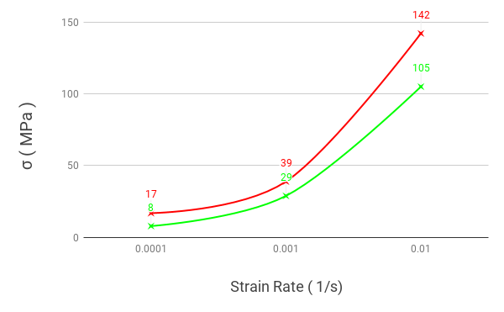
Fig. 19 Effect of Strain Rate ($\dot{ε}$) on yield strength ( green ) and ultimate tensile strength ( red)

Alloy MoNbTaW and MoNbTaVW [8]
The strong resistance to high-temperature softening, as compared to the superalloys, is likely due to slow diffusion of elements in the refractory HEAs at temperatures up to 1600 °C, which directly relates to high melting points, T_{m}, of these alloys. The average grain size in the Nb₂₅Mo₂₅Ta₂₅W₂₅ alloy was 200 μm, whereas The V₂₀Nb₂₀Mo₂₀Ta₂₀W₂₀ alloy had a much finer grain size, on the order of 80 μm. Vanadium reduces the density and refines the grain size.

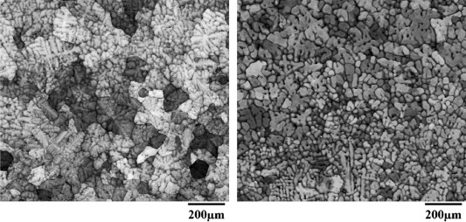
Fig. 20 Backscatter electron images of polished cross-sections of
MoNbTaW (left) and MoNbTaVW (right)

In Nb₂₅Mo₂₅Ta₂₅W₂₅ sample, large grains compressed along the loading direction were observed after deformation at 1400 °C. In contrast, no evidence of grain compression was seen on images of the V₂₀Nb₂₀Mo₂₀Ta₂₀W₂₀ alloy sample deformed at 1400 °C.
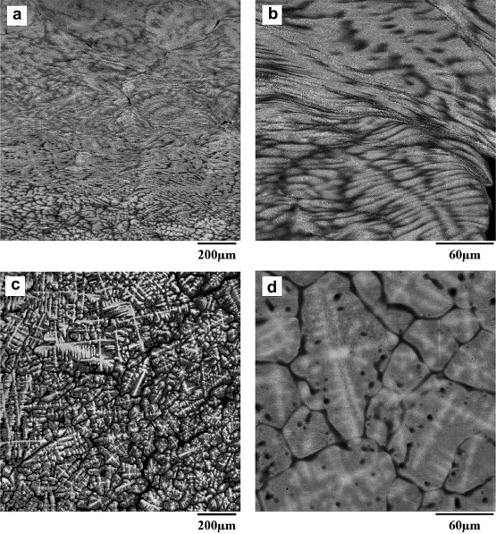
Fig. 21 SEM backscatter images of the (a,b) Nb₂₅Mo₂₅Ta₂₅W₂₅
and (c,d) V₂₀Nb₂₀Mo₂₀Ta₂₀W₂₀ alloys after compressive deformation at 1400 °C. Depicted cross-sections are parallel to the loading direction (vertical).
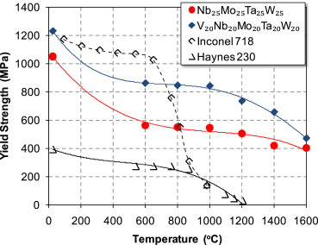
Fig. 22 Temperature dependence of yield strength of MoNbTaW (red), MoNbTaVW (blue) and two superalloys, Inconel 718 and Haynes 230
Table 2(b.)
Alloy | Microstructure | Processing | S⁻¹  (strain rate) | T(°C) | σ_{yield} (MPa) | σ_{ultimate}  (MPa) | ε % | Ref.
MoNbTaW  (density13.75g/cc) | BCC(dendritic) | As Cast | 0.001 | 1873 | 405 | - | >40 | [8]
MoNbTaVW  (density12.36 g/cc) | BCC(dendritic) | As Cast | 0.001 | 1873 | 477 | - | 13 | [8]

The Ashby charts help in material selection by plotting two properties on different axes and representing different classes of materials like a scatter plot. We can choose the material according to the property requirement. This has established a database or directory of materials and so far HEAs have not been extensively represented in these plots. By careful characterization of designed alloys, varying elements and at. % , we should seek to create a similar representation HEAs for easier selection.
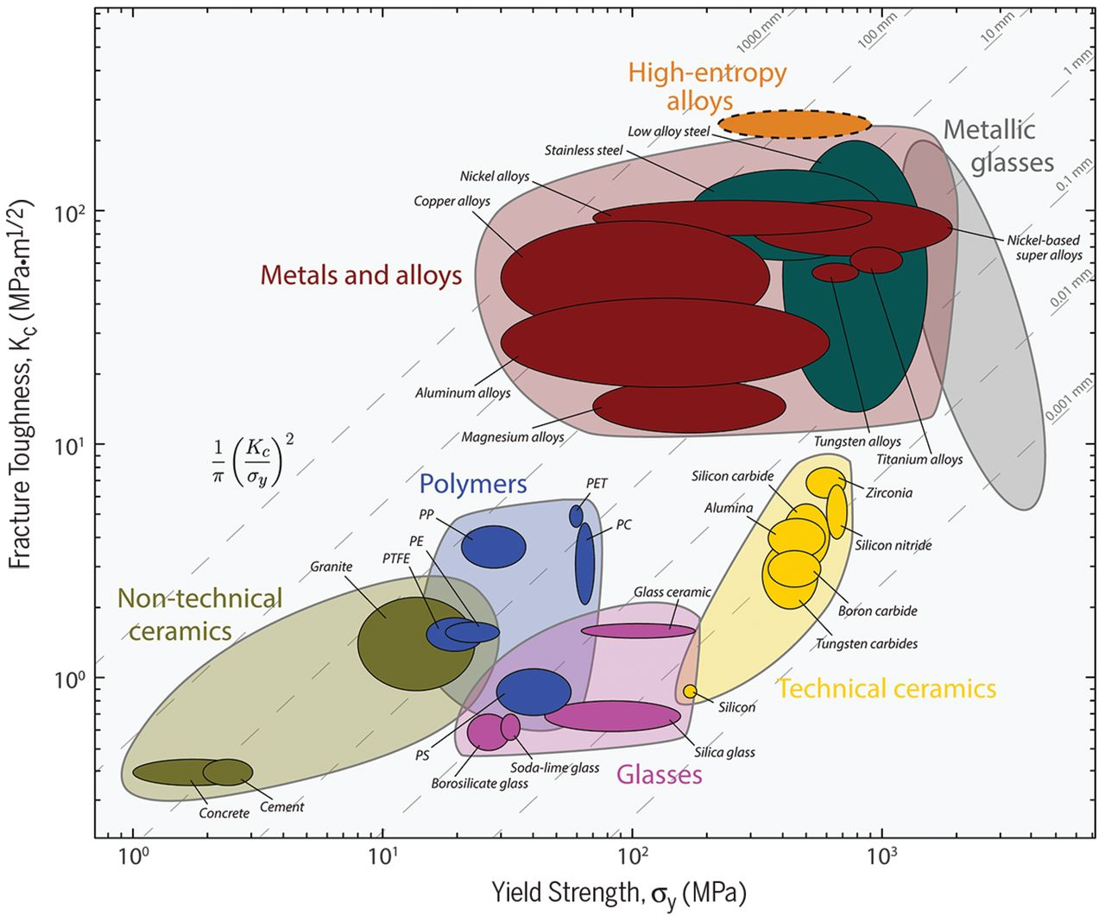

Fig. 23 Ashby diagram of Fracture toughness vs. Yield strength showing HEAs in orange

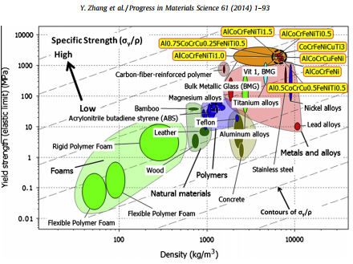

Fig. 24 Yield Strength vs. density; HEAs (dark dashed circle) compared with other materials, particularly structural alloys. Grey dashed contours (arrow indication) label specific strength, from low ( right bottom ) to high (left top). HEAs are among the materials with highest strength and specific strength.

High Temperature Application related properties:
Refractory metal HEAs are still in relatively early stages of exploration.

The compressive yield stress, σ yield, drops with increasing temperature, and the rate of drop increases around 1000 K for most alloys.
Several alloys retain a useful yield stress near 400 MPa at 1373 K.

Two refractory HEAs stand out. MoNbTaW and MoNbTaVW each contain W and retain useful strengths up to about 2000 K, but and their densities, are high. This motivated development of HEAs with lower density refractory elements such as Cr, Ti, V and Zr, and by adding Al and/or Si.

Density (ρ) is important for any component in a transportation system, and is especially important for rotating parts since much of the service stress comes from self-loading. Thus, the specific yield strength σ/ρ is a more valid parameter to consider and improve.
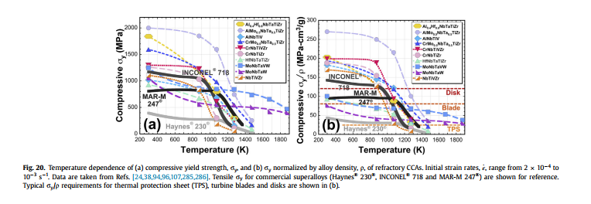
Fig.25 Temperature dependence of (a) compressive yield strength$σ_{y}$ and (b) yield strength normalized by alloy density of R-HEAs$σ_{y}/ρ$. Initial strain rates range from 2 x 10⁻⁴ to 10⁻³ s⁻¹.
Tensile strength for commercial super alloys is shown for reference. Typical $σ_{y}/ρ$ for thermal protection sheets, disks and turbine blades in also shown in (b)

R-HEAs have a wide variety of applications in Jet Engine Parts, Tip of Re-entry Vehicles, Gas Turbines where strength is required at high temperatures and where mechanical properties should remain more or less unaffected even at temperatures as high as 0.8T_{m}. Deep understanding of phase distribution, microstructure in HEAs is required to engineer such alloys.
These seek to replace Ceramics which are at present the monopoly in high temperature applications, but are brittle and have low fracture resistance.

Economic Perspective [9]
This section explores practicality related to alloy economics and resource usage.

Most HEA research focuses on two main compositional domains, namely those based on refractory elements and those based on commodity metals. The latter typically involve metals such as Cr, Co, Fe, Ni, Mn, and Cu. The former use metals such as V, Cr, Ti, Mo, Nb, Ta, W, Zr, and Hf.
The compound forming elements Al and Ti are often added to both families.

Just like Ashby charts helped in the process of material selection for mechanical design, a similar framework which can help evaluate the feasibility of scale up and manufacture of potential HEAs can be designed.
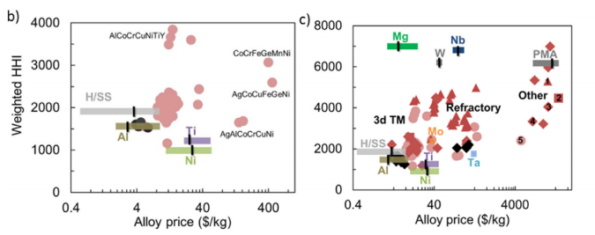
Fig. 26 Alloy price ($/kg) versus weighted alloy supply concentration( HHI for several base-alloy systems as well as HEAs proposed in the literature (H/SS = high strength steel and stainless steel)

Recyclability HEA systems have occasionally been described as “more recyclable” than conventional alloys in some of the current literature(due to almost equimolar concentration present, and not traces which are hard to recover); however, this assertion has not been justified with specific analysis to date.
From an economic perspective, metals that are more expensive in an HEA system might drive interest in recycling.
Recycling rates for minor metals are typically rather low because they are used in small amounts.
If HEA systems require a much larger amount of those metals in a single application, this would give recyclers better incentive to recover these materials.
Based on this assertion, it is important to consider which existing recycling stream an HEA could enter.
If a proper balance of improved properties and economic viability can be established, HEAs may expand the role that metal alloys play in a variety of applications.
However, in order to establish such a value proposition, HEA development should consider aspects of design beyond improvement in technical performance at as early a stage as possible, lest the excitement over their properties be dashed against the reality of their technological viability.

Conclusion
This report presented an overview of the vast and dynamic world of HEAs touching a variety of topics and concepts, stating important observations from literature and discussing them as far as possible.
New developments in phase selection rules for HEAs are expected to tackle challenges like the formation of secondary phases in single solid solutions, solid solution types other than FCC and BCC structures, and also further development of high entropy BMGs exploring their potential applications. Also, we need much deeper understanding of solid solutions at atomic level to compute, simulate and predict properties of future HEAs; and advanced characterization techniques (like APT) followed by careful analysis of the acquired data can take us long way forward.
The exploration of functional HEA materials represents a major opportunity for future work. This shall include more studies exploring a broader range of functional materials such as piezoelectric, optical sensor materials, and more.
Refractory metal HEAs have mechanical properties that show potential applications in re-entry vehicles, gas turbines, jet engines. Very less tensile data is measured and few maximum use temperatures reported for them. For, R-HEAs to make entry on a large scale and replace ceramics (currently high temperature monopoly), vast prospects lie in an application based system material design approach as discussed in the beginning of this report.
Economic perspectives, including availability/abundance of elements, cost of extraction/ processing and recyclability of the worked alloy are also concerns that need to be addressed simultaneously.

Out of literally billions of possible element combinations, barely a hundred have been studied so far. This vastness of possibilities challenge us, the scientific community, to look beyond the glass ceiling that has bounded the field of materials science.

References
[1] P. Yang, J.-M. Tarascon, Towards systems materials engineering, Nat. Mater. 11 (2012) 560–563. doi:10.1038/nmat3367.
[2] D.B. Miracle, O.N. Senkov, A critical review of high entropy alloys and related concepts, Acta Mater. 122 (2017) 448–511. doi:10.1016/j.actamat.2016.08.081.
[3] S. Guo, Phase selection rules for cast high entropy alloys: an overview, Mater. Sci. Technol. 31 (2015) 1223–1230. doi:10.1179/1743284715Y.0000000018.
[4] M. G. Poletti: ‘Electronic and thermodynamic criteria for the occurrence of high
entropy alloys in metallic systems’, Acta Mater, 2014, 75, 297–306
[5] J. W. Qiao et al., "Microstructural Characteristics and Mechanical Behaviors of
AlCoCrFeNi High-Entropy Alloys at Ambient and Cryogenic Temperatures",
Material Science Forum, Vol. 688, pp. 419-425, 2011
[6] [268] Z. Wu, H. Bei, G.M. Pharr, E.P. George, Temperature dependence of the me- chanical properties of equiatomic solid solution alloys with face-centered cubic crystal structures, Acta Mater 81 (2014) 428e441.
[7] A.V. Kuznetsov, D.G. Shaysultanov, N.D. Stepanov, G.A. Salishchev, O.N. Senkov, Tensile properties of an AlCrCuNiFeCo high-entropy alloy in as- cast and wrought conditions, Mater. Sci. Eng. A 533 (2012) 107e118.
[8] O.N. Senkov, G.B. Wilks, J.M. Scott, D.B. Miracle, Mechanical properties of Nb25Mo25Ta25W25 and V20Nb20Mo20Ta20W20 refractory high entropy alloys, Intermetallics 19 (2011) 698e706.
[9] X. Fu, et al., Materials selection considerations for high entropy alloys, Scripta Materialia (2017)
[10] F. Otto, A. Dlouhý, C. Somsen, H. Bei, G. Eggeler, E.P. George, The influences of temperature and microstructure on the tensile properties of a CoCrFeMnNi high-entropy alloy, Acta Mater. 61 (2013) 5743–5755. doi:10.1016/j.actamat.2013.06.018.



